NAME………………………………………ADM NO………………STREAM/ CLASS………………
Candidate’s Signature…………………INDEX NO………………………. DATE……………………...
231/2
BIOLOGY
JULY- 2025
TIME: 2 HOURS
MOKASA 2 JOINT EXAMINATIONS
FORM 4
INSTRUCTIONS TO CANDIDATES
- Write your name, Admission number, class, date, Index Number and sign in the spaces provided above.
- This paper consists of two sections: A and B. Answer ALL questions in section A in the spaces provided. In section B, answer question 6 (compulsory) and either question 7 or 8 in the spaces provided after question 8.
For Examiners’ use only
Section | Questions | Maximum Score | Candidate’s Score
A |  | 8
A |  | 8
A |  | 8
A |  | 8
A |  | 8
B |  | 20
B |  | 20
B |  | 20
Total Score |  | 80

SECTION A- 40 MARKS (Answer ALL questions in the spaces provided)
- Use the pedigree below to answer the questions that follow.
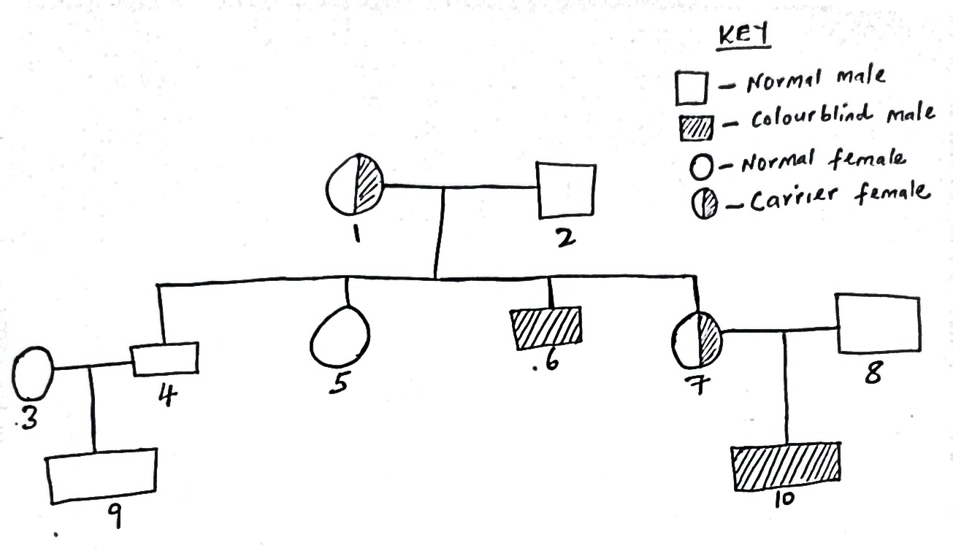
With reference to the pedigree and using symbol R for the dominant gene and r for the recessive gene, state the;
- (i) Genotype of individuals 4 and 7. (2 Marks)
……………………………………………………………………………………………………………………………………………………………………………………
(ii) Gametes of the parents. (2 Marks)
………………………………………………………………………………………………………………………………………………………………………………………………………………………………………………………………………………………………
- Marriage between two closely related individuals can have far reaching effects among the offspring’s. Justify this statement using a cross between individuals 4 and 7.
(4 Marks)
………………………………………………………………………………………………………………………………………………………………………………………………………………………………………………………………………………………………………………………………………………………………………………………………………………………………………………………………………………………………………………………………………………………………………………………………
- The graph below represents the secretion of two hormones during menstrual cycle. Study it and answer the questions that follow.
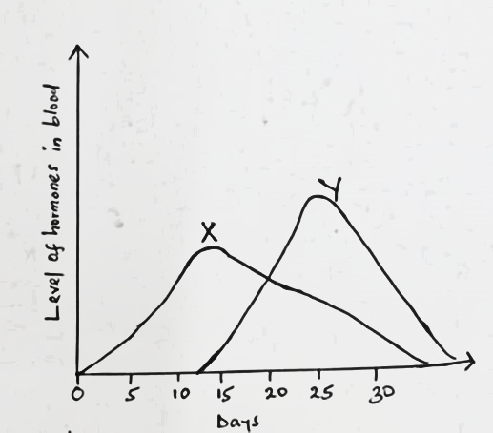
- Name hormone X and Y and state the site of production.
Hormone X (1 Mark)
…………………………………………………………………………...................
Site of secretion (1Mark)
………………………………………………………………………………………
Hormone Y (1 Mark)
………………………………………………………………....................................
Site of secretion (1 Mark)
………………………………………………………………………………………..
- State the role of hormone X and hormone Y during menstrual cycle. (2 Marks)
X……………………………………………………………………………………… ..……………………………………………………………………………………………………………………………………………………………………………………
Y………………………………………………………………………………………. .…………………………………………………………………………………………
- Other than hormone X and Y which is the other hormone that is secreted in high concentration on 14th day of the menstrual cycle. Name the source.
Hormone……………………………………………………………(1 Mark)
Source………………………………………………………............ (1 Mark)

- The diagram below illustrates some molecules. Use it to answer the following questions.
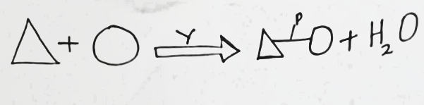
- (i) Name process Y……………………………………………………………… (1 Mark)
(ii) Name bond P………………………………………………………………… (1 Mark)
(iii) Name the building units that leads to formation of molecules held by bond P.
(1 Mark)
…………………………………………………………………………………….
- Give three properties of the molecule shown above. (3 Marks) ...……………………………………………………………………………………………………………………………………………………………………………………………………………………………………………………………………………………………………………………………………………………………………………………………
- How can the above molecules held by bond P be tested? (2 Marks)
..……………………………………………………………………………………………………………………………………………………………………………………………………………………………………………………………………………………………………………………………………………………………………………………………
- Use the diagram below to answer the questions that follow.

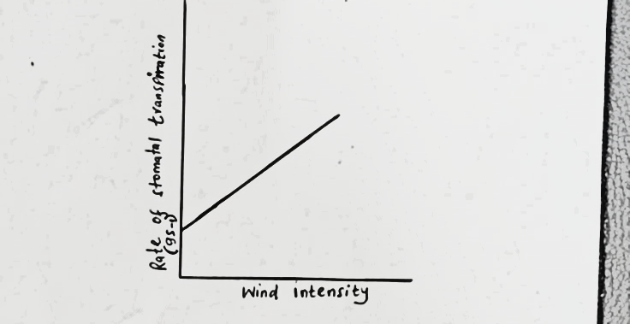

- (i) Explain how the above factor affects the rate of transpiration when its intensity is low. (2 Marks)
………………………………………………………………………………………………………………………………………………………………………………………………………………………………………………………………………………………………………………………………………………………………………………………………
(ii) Explain how high atmospheric pressure influence the rate of transpiration. (2 marks) ………………………………………………………………………………………………………………………………………………………………………………………………………………………………………………………………………………………………………………………………………………………………………………………………
b) Mention two benefits of transpiration in plants. (2 Marks)
………………………………………………………………………………………………………………………………………………………………………………………………………………………………………………………………………………………………………………………………………………………………………………………………

c) Explain giving reasons how the rate of transpiration would be affected if this experiment was to be conducted using cactus plant. (2 Marks)
………………………………………………………………………………………………………………………………………………………………………………………………………………………………………………………………………………………………………………………………………………………………………………………………………………………………………………………………………………………………
- a) Euglena is positively photo-tactic. Of what significance is this characteristic. (1 mark)
………………………………………………………………………………………………………………………………………………………………………………………………

- A seedling was placed in a horizontal position in the dark as shown below.
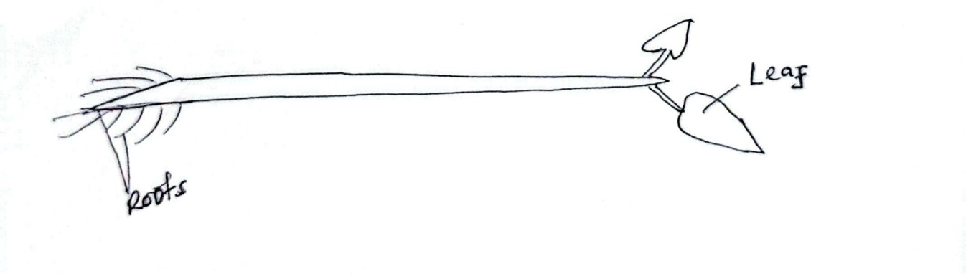
- Make a sketch of the seedling after 5 days. (2 Marks)

- Explain why the root of the seedling appeared as shown in (c) above. (3 Marks)
…………………………………………………………………………………………………………………………………………......................................................................................................................................................................................................................................................................................................................................................
- Name two plant hormones that break seed dormancy. (2 Marks)
……………………………………………………………………………………………………………………………………………………………………………………

SECTION B-40 MARKS (Answer question 6 (compulsory) and either question 7 or 8 in the spaces provided after question 8)
- The data below shows the changes in the concentration of various substances in a river following the discharge of untreated sewage into it. Study it and answer the questions that follow.

Distance downstream  (in Km) | Concentration of substances (arbitrary units)
Distance downstream  (in Km) | Organic matter | Nutrient ions | Dissolved oxygen
0 | 200 | 200 | 200
0.5 | 200 | 200 | 200
1 | 400 | 235 | 130
1.5 | 380 | 295 | 65
2.0 | 275 | 340 | 85
2.5 | 235 | 345 | 130
3.0 | 210 | 290 | 155
3.5 | 210 | 255 | 200
4.0 | 210 | 220 | 210
4.5 | 200 | 215 | 205
5.0 | 200 | 200 | 200

- Using a suitable scale, plot a graph of concentration of substances against distance downstream. (8 Marks)

- Account for the changes in the concentration of;
- Organic matter. (2 Marks)
……………………………………………………………………………………………………………………………………………………………………………………………………………………………………………………………………………………………………………………………………………………
- Dissolved oxygen. (3 Marks)
…………………………………………………………………………………………………………………………………………………………………………………………………………………………………………………………………………………………………………………………………………………………………………………………………………………………………………
- Describe the changes you would expect to observe with respect to;
- Fish population. (2 Marks)
……………………………………………………………………………………………………………………………………………………………………………………………………………………………………………………………………………………………………………………………………………………
- Water plants and photosynthetic algae. (4 Marks)
………………………………………………………………………………………………………………………………………………………………………………………………………………………………………………………………………………………………………………………………………………………………………………………………………………………………………………………………………………………………………………………………
- State one way of controlling the type of pollution illustrated above. (1 Mark)
………………………………………………………………………………………………………………………………………………………………………………………………

7. (a) (i) Name two types of herbivores based on the kind of plant material they primarily eat and how they obtain or digest it. (2 Marks)
(ii) How are the above named types of herbivores adapted to suit their dentition type of food they eat. (6 Marks)
(b) Describe how the structures of human eye adjust to bring an image from near and far object into focus on the retina. (12 Marks)
8. (a) Describe the following homeostatic roles of the liver
(i) Detoxification. (2 Marks)
(ii) Haemoglobin elimination. (4 Marks)
(iii) Thermoregulation. (4 Marks)
(b) Discuss factors that affect germination in plants. (10 Marks)
..………………………………………………………………………………………………………………………………………………………………………………………………………………………………………………………………………………………………………………………………………………………………………………………………………………………………………………………………………………………………………………………………………………………………………………………………………………………………………………………………………………………………………………………………………………………………………………………………………………………………………………………………………………………………………………………………………………………………………………………………………………………………………………………………………………………………………………………………………………………………………………………………………………………………………………………………………………………………………………………………………………………………………………………………………………………………………………………………………………………………………………………………………………………………………………………………………………………………………………………………………………………………………………………………………………………………………………………………………………………………………………………………………………………………………………………………………………………………………………………………………………………………………………………………………………………………………………………………………………………………………………………………………………………………………………………………………………………………………………………………………………………………………………………………………………………………………………………………………………………………………………………………………………………………………………………………………………………………………………………………………………………………………………………………………………………………………………………………………………………………………………………………………………………………………………………………………………………………………………………………………………………………………………………………………………………………………………………………………………………………………………………………………………………………………………………………………………………………………………………………………………………………………………………………………………………………………………………………………………………………………………………………………………………………………………………………………………………………………………………………………………………………………………………………………………………………………………………………………………………………………………………………………………………………………………………………………………………………………………………………………………………………………………………………………………………………………………………………………………………………………………………………………………………………………………………………………………………………………………………………………………………………………………………………………………………………………………………………………………………………………………………………………………………………………………………………………………………………………………………………………………………………………………………………………………………………………………………………………………………………………………………………………………………………………………………………………………………………………………………………………………………………………………………………………………………………………………………………………………………………………………………………………………………………………………………………………………………………………………………………………………………………………………………………………………………………………………………………………………………………………………………………………………………………………………………………………………………………………………………………………………………………………………………………………………………………………………………………………………………………………………………………………………………………………………………………………………………………………………………………………………………………………………………………………………………………………………………………………………………………………………………………………………………………………………………………………………………………………………………………………………………………………………………………………………………………………………………………………………………………………………………………………………………………………………………………………………………………………………………………………………………………………………………………………………………………………………………………………………………………………………………………………………………………………………………………………………………………………………………………………………………………………………………………………………………………………………………………………………………………………………………………………………………………………………………………………………………………………………………………………………………………………………………………………………………………………………………………………………………… ……………………………………………………………………………………………………………………………………………………………………………………………………………………………………………………………………………………………………………………………………………………………………………………………………………………………………………………………………………………………………………………………………………………………………………………………………………………………………………………………………………………………………………………………………………………………………………………………………………………………………………………………………………………………………………………………………………………………………………………………………………………………………………………………………………………………………………………………………………………………………………………………………………………………………………………………………………………………………………………………………………………………………………………………………………………………………………………………………………………………………………………………………………………………………………………………………………………………………………………………………………………………………………………………………………………………………………………………………………………………………………………………………………………………………………………………………………………………………………………………………………………………………………………………………………………………………………………………………………………………………………………………………………………………………………………………………………………………………………………………………………………………………………………………………………………………………………………………………………………………………………………………………………………………………………………………………………………………………………………………………………………………………………………………………………………………………………………………………………………………………………………………………………………………………………………………………………………………………………………………………………………………………………………………………………………………………………………………………………………………...

