231/2
BIOLOGY –MARKING SCHEME
JULY- 2025
TIME: 2 HOURS
MOKASA 2 JOINT-EXAMINATIONS
FORM FOUR

- Use the pedigree below to answer the questions that follow.
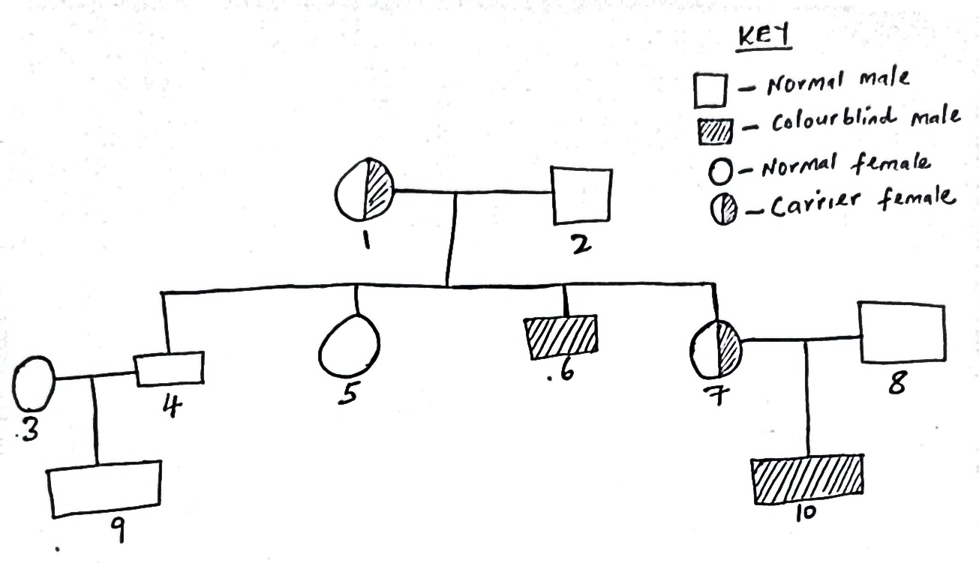
With reference to the pedigree and using symbol R for the dominant gene and r for the recessive gene, state the;
- (i) Genotype of individuals 4 and 7. (2 Marks)
4- X^{R} Y
7-X^{RY}X^{r}
(ii) Gametes of the parents. (2 Marks)
–Mother-
X^{r}
X^{R}

-Farther-
Y
X^{R}

- Marriage between two closely related individuals can have far reaching effects among the offspring’s. Justify this statement using a cross between individuals 4 and 7. (4 Marks)
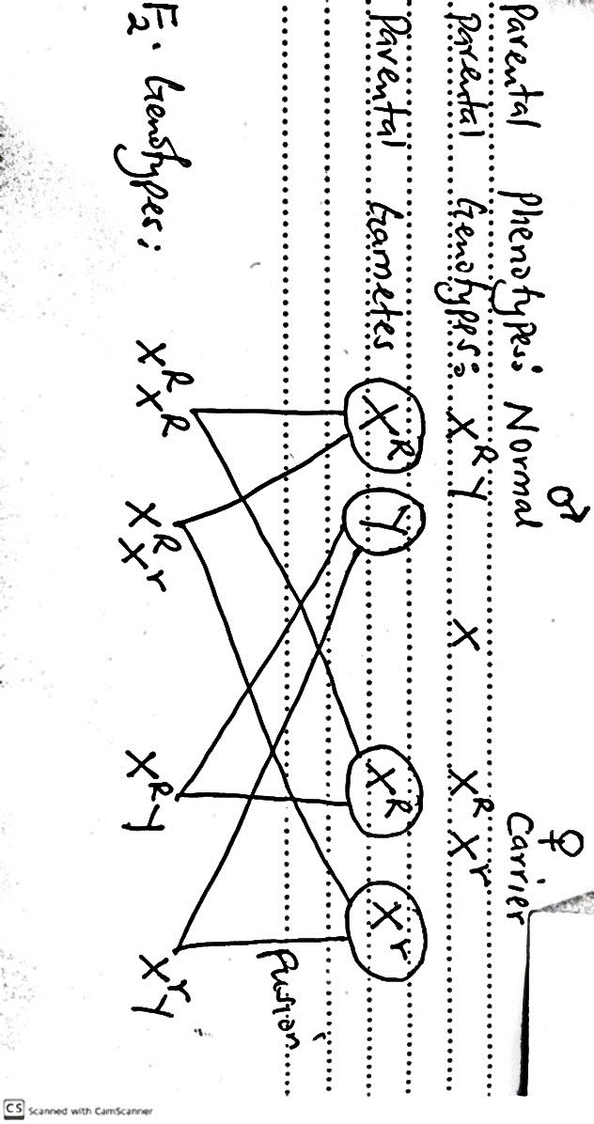
- The graph below represents the secretion of two hormones during menstrual cycle. Study it and answer the questions that follow.
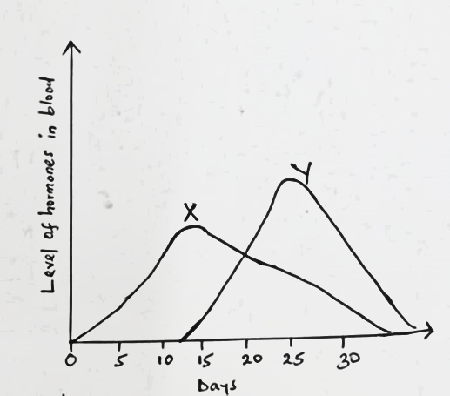
- Name hormone X and Y and state the site of production.
Hormone X (1 Mark)
-Oestrogen
Site of secretion (1Mark)
-Ovaries
Hormone Y (1 Mark)
-Progesterone
Site of secretion (1 Mark)
-Ovaries/ corpus luteum
- State the role of hormone X and hormone Y during menstrual cycle.
(2 Marks)
X -Stimulates healing and repair of endometrium
-Stimulates the pituitary gland to release luteinizing hormone
Y
-Stimulates thickening and supply of blood to the endometrium
- Other than hormone X and Y which is the other hormone that is secreted in high concentration on 14th day of the menstrual cycle. Name the source.
Hormone. (1 Mark)
-Luteinising hormone
Source. (1 Mark)
-Pituitary gland

- The diagram below illustrates some molecules. Use it to answer the following questions.
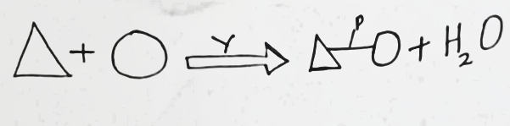
- (i) Name process Y. (1 Mark)
-Condensation
(ii) Name bond P. (1 Mark)
-Peptide bond
(iii) Name the building units that lead to formation of molecules held by bond P. (1 Mark)
-Amino acids

- Give three properties of the molecule shown above. (3 Marks)
- Amphoteric
- Forms colloidal suspension
- Affected by temperature and ph

- How can the above molecules held by bond P be tested ? (2 Marks)
-Add 2ml of sodium hydroxide solution to equal amount of food sample and shake. Add 3 drops of Copper (II) sulphate.
- Use the diagram below to answer the questions that follow.

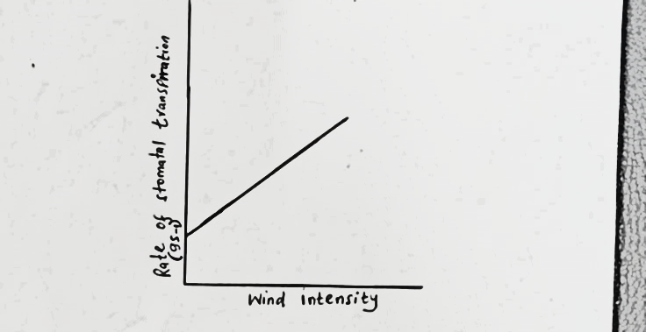

- (i) Explain how the above factor affect the rate of transpiration when its intensity is low. (2 Marks)
- Little water/ moisture is blown/ carried; leading to low saturation deficit which leads to low rate of transpiration.
(ii) Explain how high atmospheric pressure influence the rate of transpiration. (2 marks)
- Reduces the rate of transpiration; since it leads to high weight/ force of atmosphere acting on the plant.

b) Mention two benefits of transpiration in plants. (2 Marks)
- Enable the plant to lose excess water
- Leads to transportation of water and mineral salts
-Cools the plant

c) Explain giving reasons how the rate of transpiration would be affected if this experiment was to be conducted using cactus plant. (2 Marks)
-Contain viscous/ thick/sticky cell sap; which requires high latent heat of vaporization leading to low rate of transpiration.
- a) Euglena is positively photo-tactic. Of what significance is this characteristic. (1 mark)
- Enables it to acquire light for photosynthesis.
- A seedling was placed in a horizontal position in the dark as shown below.
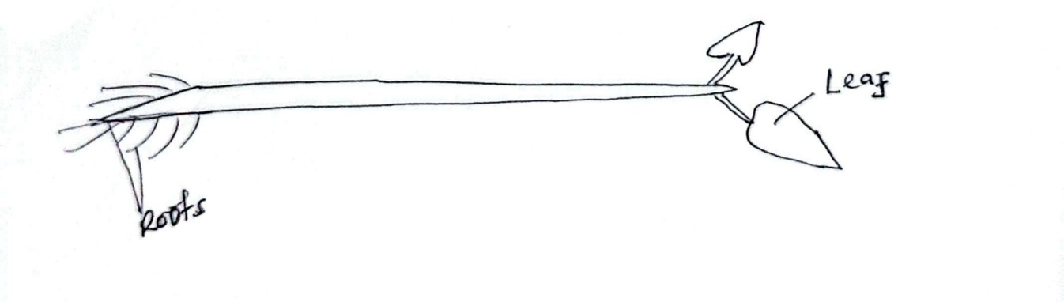
- Make a sketch of the seedling after 5 days. (2 Marks)

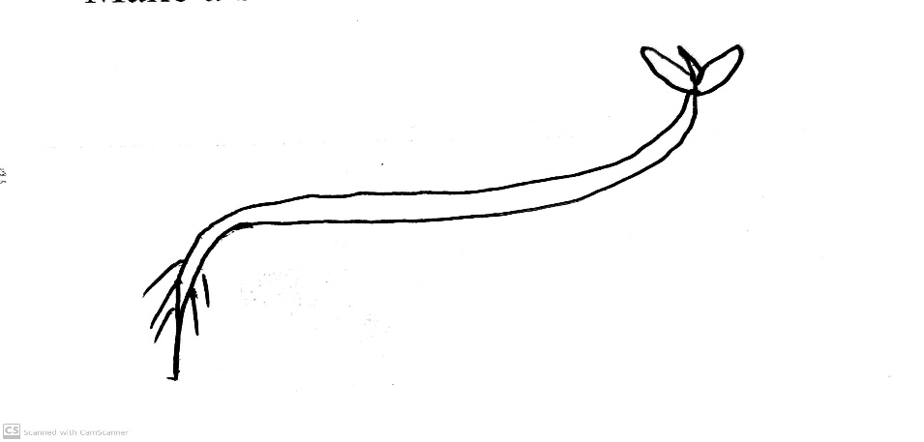
- Explain why the root of the seedling appeared as shown in (i) above.
(3 Marks)
- Gravity pulls auxins to lower part of the root; high concentration of the hormones/auxins in the lower part of the root inhibits growth; while low concentration of hormones at the upper part of the root stimulates faster growth/ more cell elongation causing the root to grow as it bends downwards.
- Name two plant hormones that break seed dormancy. (2 Marks)
-Gibberellin
-Ethylene
-Cytokinin

SECTION B

- The data below shows the changes in the concentration of various substances in a river following the discharge of untreated sewage into it. Study it and answer the questions that follow.

Distance downstream  (in Km) | Concentration of substances (arbitrary units)
Distance downstream  (in Km) | Organic matter | Nutrient ions | Dissolved oxygen
0 | 200 | 200 | 200
0.5 | 200 | 200 | 200
1 | 400 | 235 | 130
1.5 | 380 | 295 | 65
2.0 | 275 | 340 | 85
2.5 | 235 | 345 | 130
3.0 | 210 | 290 | 155
3.5 | 210 | 255 | 200
4.0 | 210 | 220 | 210
4.5 | 200 | 215 | 205
5.0 | 200 | 200 | 200

- Using a suitable scale, plot a graph of concentration of substances against distance downstream. (8 Marks)

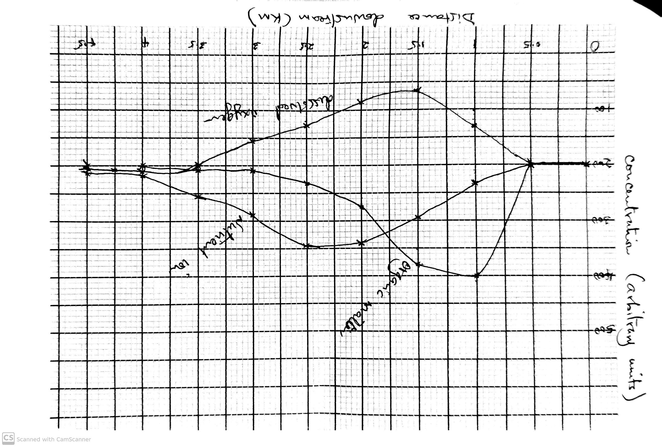
Scale- (1mark)
Plotting- (3marks)
Curves- (2marks)
Axis- (1mark)
Labels- (1mark)

- Account for the changes in the concentration of;
- Organic matter. (2 Marks)
-At point of discharge, concentration of organic matter is high, but decreases downstream; they are broken down by saprophytes into simple soluble products. e.g. (phosphate ions, sulphate ions)
- Dissolved oxygen. (3 Marks)
-It decreases downstream then results to normal; the saprophytes/ bacteria/ fungi respire using up dissolved oxygen; during the breakdown of organic matter oxygen dissolves from the air; returning its level to normal.
- Describe the changes you would expect to observe with respect to;
- Fish population. (2 Marks)
-Fish population decreases downstream and increases at the point where oxygen concentration becomes normal; Upstream oxygen concentration is low leading to dead of fish.
- Water plants and photosynthetic algae. (4 Marks)
-Downstream algae and water plants proliferate/ increases in number; This is stimulated by nutrients released from decomposed organic matter; This leads to eutrophication; further downstream the concentration of nutrients decreases as they are used up and the number of water plants also decreases.
- State one way of controlling the type of pollution illustrated above.
(1 Mark)
- Enactment of law to control water pollution
- Treatment of industrial effluents before releasing them into water bodies
- Practicing organic farming
- Encouraging use of renewable sources of energy
- Encouraging use of biological methods of controlling pests and diseases
- Treatment of domestic effluents before releasing them into the water bodies

7. (a) (i) Name two types of herbivores based on the kind of plant material they primarily eat and how they obtain or digest it. (2 Marks)
- Grazers
-Browsers
(ii) How are the above name types of herbivores adapted to suit their dentition type of food they eat. (6 Marks)
- Most of them lack upper incisor and canines instead they have horny pad against which grass/vegetation are pressed and cut by the lower incisors.
- Incisors have a chisel shaped crown with sharp pointed edge f0r cutting vegetation.
- They have a gap in the lower jaw separating the canine from the pre-molars so that to provide space for the manipulation of food by the tongue for separation of newly cut vegetation from the one being chewed at the back of mouth.
- The crown of their pre-molars and molars have a broad surface with cusps and ridges for grinding food.
- Their teeth continuously grow throughout their lifetime to replace the enamel which gets worn out due to continuous grinding of food.
- Their jaws move side by side to enable the pre-molars and molars grind the vegetation

(b) Describe how the structures of human eye adjust to bring an image from near and far object into focus on the retina. (12 Marks)
Near/Close object
-The circular muscles of the iris contract while radial muscles relax; causing the pupil to constrict/ the diameter become small in size; thus, allow low amount of light into the eye;
-The ciliary muscles contract; relaxing the tension of the suspensory ligaments (loosening); Increasing the lens curvature that causes greater refraction of light being focused on retina.
Far object
-The radial muscles of the iris contract while circular muscles relax; causing the pupil to dilate/ the diameter to become large in size; thus, allows more amount of light into the eye;
-The ciliary muscles relax; increasing the tension of the suspensory ligaments (tightens); Reducing the lens curvature that causes less refraction of light being focused on retina
8. (a) Describe the following homeostatic roles of the liver.
(i) Detoxification. (2 Marks)
-The liver makes toxic substances less/ non –toxic; by combining with other substances oxidation and reduction;
(ii) Haemoglobin elimination. (4 Marks)
-The liver breaks down haemoglobin of a dead red blood cell into haem and globin group; Globin is digested into amino acids; The haem is broken down into urochrome, biliverdin and bilirubin; Urochrome is removed through the urinary system. The biliverdin and bilirubin are removed through the alimentary canal.
(ii) Thermoregulation (4 Marks)
-When the temperature is above normal the hypothalamus detects and sends an impulse to the liver; to carryout endothermic reaction (absorption of heat from blood) hence lowering the body temperature to normal.
-When the temperature is below normal, the hypothalamus detects and sends an impulse to the liver; to cause exothermic reaction for more production of heat into the blood, thus, raising the body temperature to normal.
(b) Discuss factors that affect germination in plants. (10 Marks)
Water
- For the activation of (hydrolytic and respiratory) enzymes.
- Softening the seed coat so that to allow emergence of radicle and plumule.
- Hydrolysis of the food material into simple sugars.
- Provide medium for the enzymatic activity.
- Medium for the transportation of dissolved food into the growing regions.

Oxygen
- Oxidation of food to release energy required for the cell division/ growth and development.
Temperature
- For the activation of (hydrolytic and respiratory) enzymes.
Enzymes
For the catalyzation during breakdown of stored food to release energy. E.g.
- Diastase enzyme- Catalyzes breakdown of carbohydrates into (sucrose)/ glucose.
- Lipase enzyme- Catalyzes breakdown of lipids into fatty acids and glycerol.
- Protease enzyme- Catalyzes breakdown of proteins into amino acids.
Hormones
-Stimulates germination/ growth.
-Counteracts the effects of germination inhibitors.
Viability
- A seed with health embryo and food reserve is available ensures that its alive and able to germinate.

