mokasa ii examinations
Kenya Certificate of Secondary Education
231/1 BIOLOGY Paper 1
July/August, 2025 Exam – 2 hours
Name: Index no:
School: Sign: Date:
Adm No.: …………………… Class List No. ………………………. Stream: ………………

Instructions to candidates
- Write your name, class and Admission number in the spaces provided above.
- Append your signature and write the date of examination in the spaces provided above.
- Spelling errors especially of Biological terms shall be penalized.
- Answer ALL questions in the spaces provided.

For Examiner’s Use Only:
Question | Maximum  Score | Candidate’s  Score
1 – 31 | 80
TOTAL

This paper consists of 10 printed pages. Candidates should check to ascertain that all pages are printed as indicated and that no question is missing.
- (a)Define the term cell specialization (1mark)
…………………………………………………………………………………………………………………..
(b) Name the cell organelles that would be most abundant in (2marks)
  - Skeletal muscle cells ………………………………………………………………………………
  - Palisade cells ……………………………………………………………………………………….
- Given a temporary slide of onion cells, a microscope and a ruler, describe how you can estimate the size of each cell. (3 marks)
……………………………………………………………………………..………………………………………………………………………………..……………………………………………………………………………….………………………………………………………………………………..………………………………………………………………………………..………………………………………………………………………………………………
- Give two characteristics of living organisms that involve direct movement of substances into the body of a living organism (2 marks)
……………………………………………………………………………………………………………………………………………………………………………………………………………………………………………………………………………………………………….
- The diagram below illustrates a structure found in a cell, Study it and answer the questions that follow.
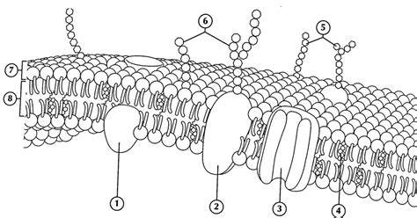

(a) Identify the organelle shown above (1mark)
…………………………………………………………………………………………………………………………………….
(b) Identify the structures 2 and 8 (2marks)
2. …………………………………………………………………………………………………………………
8. …………………………………………………………………………………………………………………..
(c) Give the role of the structure 3. (1mark) ……………………………………………………………………………………………………………………………………………………………………………………………………………………………………………………………………………………

- Is diffusion an energy driven process? Explain. (2marks)
………………………………………………………………………………………………………………………………………………………………………………………………………………………………………………………………………………………………………………………………………………………………………………………………………………………………
- Define the term binomial nomenclature (1mark)
………………………………………………………………………………………………………………………………………………………………………………………………………………………………………………………………………………………………………………………………………………………………………………………………………………………………

- State the causative agents for the following diseases. (2marks)
- Gonorrhea
……………………………………………………………………………………………………………………
- Amoebic dysentery
……………………………………………………………………………………………………………………..

- Oxygen, Glucose and amino acids are some of the products of photosynthesis. What is the fate of each of these products? (3 marks)

Oxygen
…………………………………………………………………………………………………………………………………
Glucose
………………………………………………………………………………………………………………………………..
Amino acids
……………………………………………………………………………………………………………………………….
- The diagram below represents a muscle found in an organ of a mammal:
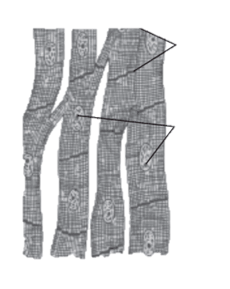
- Identify the type of muscle (1mark)
……………………………………………………………………………………………………………………….
- Name the parts labeled A and C. (2mark)
A ………………………………………………………………………………………………………………….
C …………………………………………………………………………………………………………………..

- State one adaptation of the muscle indicated above. (1mark)

…………………………………………………………………………………………………………………………………

- Other than turgor pressure, suggest two other ways in which herbaceous stems obtain mechanical support. (2mk)
……………………………………………………………………………………………………………………………………………………………………………………………………………………………………………………………………………………

- Study the diagram below of a neuron in human being.
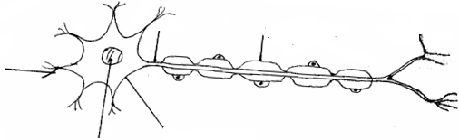
B
A
Cell body
Nucleus
Myelin sheath
Effectors dendrites

  - Identify the neuron. (1mk)
………………………………………………………………………………………
  - Name the parts labeled
A ……………………………………………………………………………. (1mk)
B …………………………………………………………………………… (1mk)
  - Using an arrow indicate the direction of movement of a nerve impulse along the neuron. (1mk)

- The paddles of a whale and the fins of a fish adapt these organisms to aquatic habitats.
  - Name the evolutionary process that may have given rise to these structures. (1mk)

……………………………………………………………………………………………………………………………

  - What is the name given to such structures? (1mk)
………………………………………………………………………………………………………………………..

  - Identify two evidences that support organic evolution. (2mk)
………………………………………………………………………………………………………………………………………………………………………………………………………………………………………………………
- Name the type of response shown by:
  - Leaves of Mimosa pudica when they fold after being touched. (1mk)

………………………………………………………………………………………………………………..

  - Euglena when it swims towards the source of light. (1mk)

…………………………………………………………………………………………………………………….

  - Maggots moving from the lit chamber to the chamber painted black. (1mk)

……………………………………………………………………………………………………………………

  - Roots of plants when they grow downwards. (1mk)

……………………………………………………………………………………………………………………

- Below is a section of nuclei acid strand. Study it and then answer questions that follow:
T – G – C – A – G – A – T – C
  - Identify the type of nucleic acid strand. (1mk)
………………………………………………………………………………………………………………..
  - Give reason for your answer in (b) (i) above. (1mk)
………………………………………………………………………………………………………………….
  - Write down the base sequence of the complimentary strand. (1mk)
……………………………………………………………………………………………………………………
- Distinguish between the following terms:
  - Genotype and phenotype. (1mk)
……………………………………………………………………………………………………………………………………………………………………………………………………………………………………………………………………………………………………………………………………………………………………………………….
  - Dominant and recessive alleles. (1mk)
………………………………………………………………………………………………………………………………………………………………………………………………………………………………………………………………………………………………………………………………………………………………………………………
- After an ecological study of nutritional relationships in an ecosystem, a student constructed the following food web.

Large bird

mussels
Zooplanton
Small Fish
Bird K
Bird L
Bird J

algae

- Name the ecosystem in which the ecological study was done. (1mk)
…………………………………………………………………………………………………………………………
- State one short term effect of the eradication of all zooplankton from this ecosystem.
(1mk)
…………………………………………………………………………………………………………………………….
- What trophic level is the large bird? (1mk)
…………………………………………………………………………………………………………………………….

- The diagram below shows the structure a cell during a certain stage of cell division.

- Identify the stage shown. (1mark)
……………………………………………………………………………………………………………………………
- Give two reasons for your answer in (a) above. (2marks)
………………………………………………………………………………………………………………………………………………………………………………………………………………………………………………………..
- The diagram below represents a certain plant species.
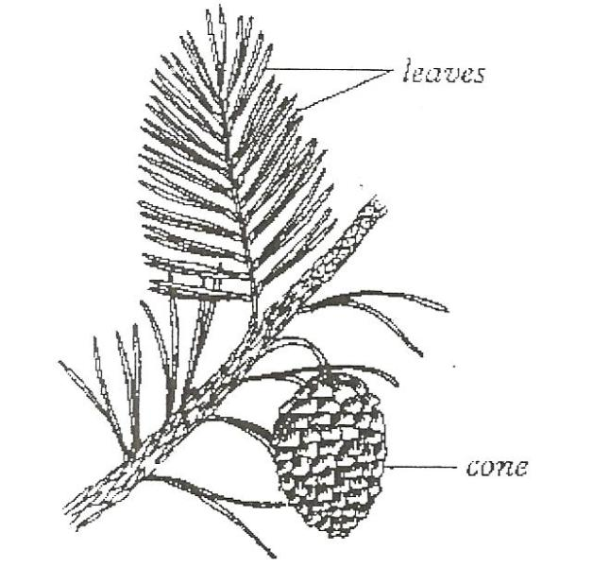

- Name the division to which the plant belongs. (1mk)
……………………………………………………………………………………………………………………………..
- State two differences between members of sub- division Gymnospermaphyta and Angiospermaphyta. (2mk)
……………………………………………………………………………………………………………………………………………………………………………………………………………………………………………………………………
- Name division in which plants show alternation of generations. (1mk)
…………………………………………………………………………………………………………………………………..

- a) What are the advantages of fruit and seed dispersal? (2mk)
……………………………………………………………………………………………………………………………………………………………………………………………………………………………………………………………………………………………………………………………………………………………………………………………………………………………..
b) State two characteristics of fruits and seeds dispersed by animals. (2mk)
…………………………………………………………………………………………………………………………………………………………………………………………………………………………………………………………………………………..
- (a) State two roles of water in seed germination (2 marks)
………………………………………………………………………………………………………………………………………………………………………………………………………………………………………………………………………………………………………..

(b) Explain the difference in germination rate between seedlings at 5℃ and 35℃ (1mark)
…………………………………………………………………………………………………………………………………………………………………………………………………………………………………………………………………………………………………………
- The table below shows blood components and how they become modified in the process of urine formation.

Component | Blood plasma  g/100cm³ | Glomerular filtrate  g/100cm³ | Urine  g/100cm³
Glucose | 0.15 | 0.15 | 0.00
Proteins | 7.89 | 0.00 | 0.00
Mineral salts | 0.68 | 0.68 | 0.50
Urea | 0.10 | 0.10 | 1.50

State one possible reason for each of the following observations.
- No protein in the glomerular filtrate. (1 mark)
...................................................................................................................................................
- No glucose in urine. (1 mark)
………………………………………………………………………………………………………………………………………………
- Increased level of urea in urine. (1 mark)
....................................................................................................................................................

- State any two adaptations of the polar mammals to their environment (2 marks)

.............................................................................................................................................

……………………………………………………………………………………………………………………………………….

- Name the hormone involved in ionic balance in the kidney (1mark)

……………………………………………………………………………………………………………………………………..

- The diagram below shows part of a mammalian respiratory system.

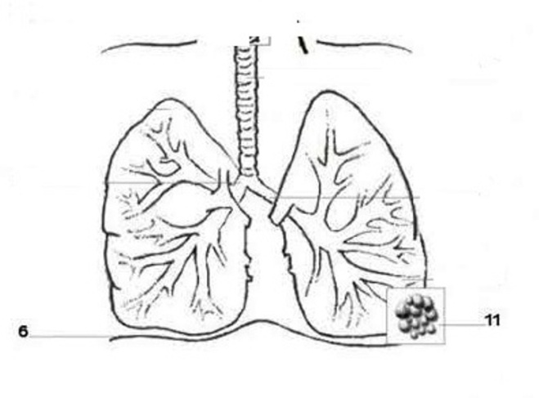
S
T

- Explain two ways in which the part labeled T is adapted to its functions.(2 marks)
…………………………………………………………………………………………………………………………………………………………………………………………………………………………………………………………………………………………………………………………………………………………………………………………………………………………………………………………………………………………………………………………………………

- How does the part labeled S facilitates breathing in? (1 mark)
……………………………………………………………………………………………………………………………………………………………………………………………………………………………………………………………………………………………………………………………………………………………………………………………………….
- State a characteristic of an efficient respiratory surface which is absent in amoeba (1mark)
………………………………………………………………………………………………………………………………..
- State the function of spiral bands of chitin in the trachea of terrestrial insects (1mark)
……………………………………………………………………………………………………………………………….
- What is the role of the following in a germinating seed? (2 marks)
- Oxygen
……………………………………………………………………………………………………………………………

- Cotyledon
…………………………………………………………………………………………………………………………..

- (a) Why would you give an athlete glucose and not sucrose after a race? (1mark)

…………………………………………………………………………………………………………………………………

- State any two differences between open and closed circulatory systems (2 marks)
……………………………………………………………………………………………………………………………………………………………………………………………………………………………………………………………………………………
- In blood test, a few drops of anti-B serum were added to two samples of blood. It was noted that agglutination occurred. What were the possible blood groups of the two blood samples? (2 marks)

……………………………………………………………………………………………………………………………….
- State an adaptation of blood to high altitude (1 mark)

…………………………………………………………………………………………………………………………………..

.

