mokasa ii examinations
Kenya Certificate of Secondary Education
231/1 BIOLOGY Paper 1
July/August, 2025 Exam – 2 hours
Name: Index no:
School: Sign: Date:

Instructions to candidates
- Write your name, class and Admission number in the spaces provided above.
- Append your signature and write the date of examination in the spaces provided above.
- Spelling errors especially of Biological terms shall be penalized.
- Answer ALL questions in the spaces provided.

For Examiner’s Use Only:
Question | Maximum  Score | Candidate’s  Score
1 – 31 | 80
TOTAL

This paper consists of 11 printed pages. Candidates should check to ascertain that all pages are printed as indicated and that no question is missing
- (a)Define the term cell specialization (1mark)
This is the structural modification of the cells to perform specific functions.
(b) Name the cell organelles that would be most abundant in (2marks)
  - Skeletal muscle cells Mitochondria
  - Palisade cells Chloroplasts
- Given a temporary slide of onion cells, a microscope and a ruler, describe how you can estimate the size of each cell. (3 marks)
Measure the field of view diameter with a ruler under the microscope.
Count how many cells fit across that diameter.
Divide the field of view diameter by the number of cells to estimate the size of one cell.
- Give two characteristics of living organisms that involve direct movement of substances into the body of a living organism (2 marks)
Nutrition;Reproduction
- The diagram below illustrates a structure found in a cell, Study it and answer the questions that follow.
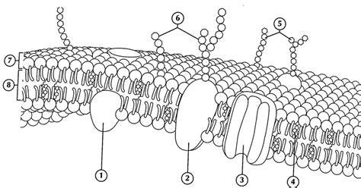

(a) Identify the organelle shown above (1mark)
Cell membrane/plasmalemma/plasma membrane
(b) Identify the structures 2 and 8 (2marks)
2. Protein molecule
8. Lipid bilayer
(c) Give the role of the structure 3. (1mark) Allow passage of materials in and out of the cell

- Is diffusion an energy driven process? Explain. (2marks)
Diffusion is not energy driven process or it is a passive process. This is because molecules/ particles move along the diffusion/ concentration gradient.

- Define the term binomial nomenclature (1mark)
A system of naming living organisms in which it is given a name consisting of two parts(genus and specific).

- State the causative agents for the following diseases. (2marks)
- Gonorrhea
Neisseria gonorrhoeae
- Amoebic dysentery
Entamoeba histolytica

- Oxygen, Glucose and amino acids are some of the products of photosynthesis. What is the fate of each of these products? (3 marks)

Oxygen
Some is used for respiration, some released to the environment as a by product
Glucose
Used as a fuel in respiration, excess converted to starch and stored in the tissues of plants Amino acids

- The diagram below represents a muscle found in an organ of a mammal:
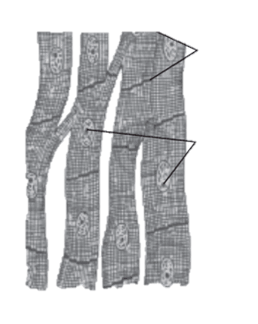
- Identify the type of muscle (1mark)
Cardiac muscles
- Name the parts labeled A and C. (2mark)
A Intercalated disc
C Nucleus
- State one adaptation of the muscle indicated above. (1mark)

Cells are joined by intercalated discs that transmit impulses rapidly throughout the heart.
It has more mitochondria (than skeletal muscles) to provide energy for contraction.

- Other than turgor pressure, suggest two other ways in which herbaceous stems obtain mechanical support. (2mk)
Twining round stems; Use of tendrils; Use of hooks

- Study the diagram below of a neuron in human being.
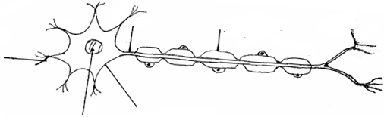
B
A
Cell body
Nucleus
Myelin sheath
Effectors dendrites

  - Identify the neuron. (1mk)
Motor neouron
  - Name the parts labeled
A Receptor dendrites (1mk)
B Axon (1mk)
  - Using an arrow indicate the direction of movement of a nerve impulse along the neuron. (1mk)

- The paddles of a whale and the fins of a fish adapt these organisms to aquatic habitats.
  - Name the evolutionary process that may have given rise to these structures. (1mk)

Divergent evolution/Adaptive radiation
  - What is the name given to such structures? (1mk)
Homologous Structures
  - Identify two evidences that support organic evolution. (2mk)
Comparative anatomy; Fossil records; geographical distribution of organisms; Cell biology; Comparative serology
- Name the type of response shown by:
  - Leaves of Mimosa pudica when they fold after being touched. (1mk)

Haptonasty/Thigmotripisms;

  - Euglena when it swims towards the source of light. (1mk)
Positive photo taxis

  - Maggots moving from the lit chamber to the chamber painted black. (1mk)

Negative photo taxis

  - Roots of plants when they grow downwards. (1mk)

Positive geotropism

- Below is a section of nuclei acid strand. Study it and then answer questions that follow:
T – G – C – A – G – A – T – C
  - Identify the type of nucleic acid strand. (1mk)
DNA
  - Give reason for your answer in (b) (i) above. (1mk)
Has thymine
  - Write down the base sequence of the complimentary strand. (1mk)
A-C-G-T-C-T-A-G
- Distinguish between the following terms:
  - Genotype and phenotype. (1mk)
Genotype is the genetic constitution of an organism while phenotypic is the physical expression of a trait
  - Dominant and recessive alleles. (1mk)
Dominant alleles are those that can be expressed phenotypically in both homozygous and heterozygous state, recessive alleles are those that can only be expressed phenotypically in homozygous state

- After an ecological study of nutritional relationships in an ecosystem, a student constructed the following food web.

Large bird

mussels
algae
Zooplanton
Small Fish
Bird K
Bird L
Bird J

- Name the ecosystem in which the ecological study was done. (1mk)
Aquatic
- State one short term effect of the eradication of all zooplankton from this ecosystem.
(1mk)
Population of small fish will drop due to starvation
- What tophic level is the large bird? (1mk)
Tertiary /Quaternary consumer

- The diagram below shows the structure a cell during a certain stage of cell division.

- Identify the stage shown. (1mark)
metaphase
- Give two reasons for your answer in (a) above. (2marks)

The nuclear membrane disappears hence chromosomes are free in the cytoplasm.
- The chromosomes arrange themselves at the centre/equator of the cell.
The chromosomes are attached to spindle fibres at

- The diagram below represents a certain plant species.
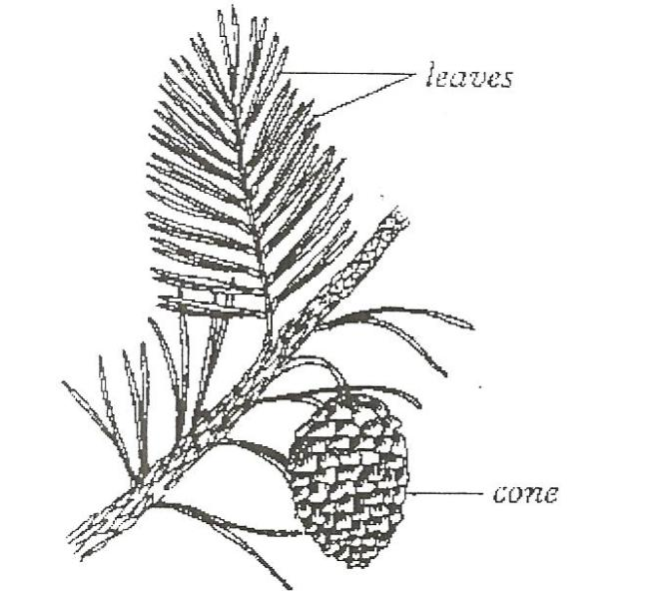

- Name the division to which the plant belongs. (1mk)
Spermatophyta
- State two differences between members of sub- division Gymnospermaphyta and Angiospermaphyta. (2mk)
Gymnospermaphyta | Angiospermaphyta
Produces cones | Produces fruits
Xylem tissues has tracheids only | Xylem has both vessels and tracheids
Phloem lacks companion cells | Phloem has companion cells

- Name division in which plants show alternation of generations. (1mk)
Bryophyta;Pteridophyta

- a) What are the advantages of fruit and seed dispersal? (2mk)
Reduced competition; Escape from predators and pathogens; Colonization of new habitats; Increased biodiversity

b) State two characteristics of fruits and seeds dispersed by animals. (2mk)
Fruits have hook like structures to stick on passing animals; Fruits are succulent; brightly coloured; scented to attract animals; seed coats are tough to resist digestive systems of animals
- (a) State two roles of water in seed germination (2 marks)

Water activates enzymes involved in germination.
Provides a medium for enzymes to act and breakdown stored food into soluble form.
It hydrolyzes and dissolves the stored food substances.
It softens the seed coat which swells and bursts to facilitate emergence of radicle.
It acts as a medium of transport of dissolved food substances to the growing regions of radicle and plumule.

(b) Explain the difference in germination rate between seedlings at 5℃ and 35℃ (1mark)
Germination at 5⁰C is low since the enzymes are inactive; germination is high since 35⁰Cis optimum
- The table below shows blood components and how they become modified in the process of urine formation.

Component | Blood plasma  g/100cm³ | Glomerular filtrate  g/100cm³ | Urine  g/100cm³
Glucose | 0.15 | 0.15 | 0.00
Proteins | 7.89 | 0.00 | 0.00
Mineral salts | 0.68 | 0.68 | 0.50
Urea | 0.10 | 0.10 | 1.50

State one possible reason for each of the following observation.
- No protein in the glomerular filtrate. (1 mark)
Protein molecules are too large to pass through the walls of the glomerular capillaries;
- No glucose in urine. (1 mark)
All glucose was reabsorbed at the proximal convoluted tubule / along the nephron;
- Increased level of urea in urine. (1 mark)
Reabsorption of some water by the nephron concentrates urea;

- State any two adaptations of the polar mammals to their environment
(2 marks)
- Thick fur to insulate their bodies;
- Stores fat in the adipose tissue to insulate the body;
- High rate of metabolism to provide heat to the body;

- Name the hormone involved in ionic balance in the kidney (1mark)

Aldosterone;

- The diagram below shows part of a mammalian respiratory system.

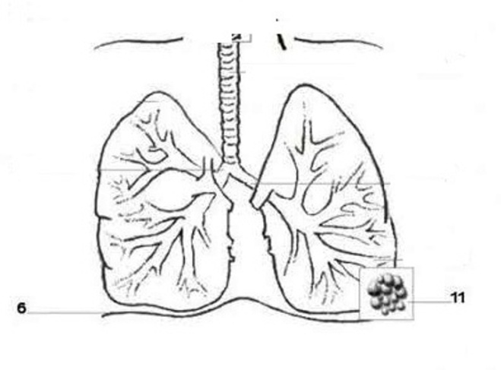
S
T

- Explain two ways in which the part labeled T is adapted to its functions.
(2 marks)
- It is moist to dissolve respiratory gases
- It is highly vascularized for increasing concentration gradient for respiratory gases
- It has thin surface for quick diffusion of respiratory gases.

- How does the part labeled S facilitates breathing in?
(1 mark)
- Contract and flattens; increases the volume of the thoracic cavity

- State a characteristic of an efficient respiratory surface which is absent in amoeba
(1mark)
Not supplied with a dense network of blood capillaries for gaseous exchange

- State the function of spiral bands of chitin in the trachea of terrestrial insects (1mark)
Keep the trachea open/ prevent it from collapsing
- What is the role of the following in a germinating seed? (2 marks)
(a) Oxygen
For oxidation of food / respiration to provide energy for germination
(b) Cotyledon
Food storage necessary during germination

- (a) Why would you give an athlete glucose and not sucrose after a race? (1mark)
Glucose is a simple sugar (monosaccharide) that the body can absorb directly in to the blood stream;
- State any two differences between open and closed circulatory systems (2 marks)
CLOSED OPEN
Blood is confined in blood vessels blood is confined in body cavity
Blood flows under high pressure blood flows under low pressure
- In blood test, a few drops of anti-B serum were added to two samples of blood. It was noted that agglutination occurred. What were the possible blood groups of the two blood samples? (2 marks)
Blood group AB
Blood group B
- State an adaptation of blood to high altitude (1 mark)
The number of red blood cells increases with increase in altitude

.

