NYAGA SECONDARY SCHOOL
MOCK EXAMINATION 2025
231/3
PAPER 3
FORM FOUR
BIOLOGY
MARKING SCHEME
ai)
Test tube | Contents | Amount of Effervescence
A | Chopped w
A | Dilute hydrochloric Acid | NO/little/small/few bubbles
A | Dilute hydrogen Peroxide
B | Chopped W | A lot /high /large /more bubble /effervescences /fizzing
B | Dilute sodium hydrogen Carbonate
B | Dilute hydrogen Peroxide
C | Cube W | Moderate/medium/average/bubbles/effervescence/fizzing
 | Dilute Sodium hydrogen Carbonate
 | Dilute hydrogen Peroxide
ii) Acid denature enzymes; hence hindering its action (catalase)
iii) Surface area
pH
b) No bubbles /effervescence since no enzyme (catalase) will be denatured/destroyed.
c)(i) Hydrogen Peroxide Enzyme Water + Oxygen gas
Catalase
Rej chemical equations
ii) Detoxification
iii) Liver/ muscles
Question 2
a)(i) Leaf (1mark)
ii) Has (leaf) Lamina; Veins;Petiole/Sheath/leaf apex/leaf margin/ midrib (3marks)
b(i) Division Spermatophyta (Rej. wrong spelling) (1mark)
Reason – Leaves; veins (presence) (2marks)
-They have chlorophyll hence are photosynthetic
c) Photosynthesis (3marks)
Gaseous Exchange
Transpiration
Storage of food /water /plant excretory products
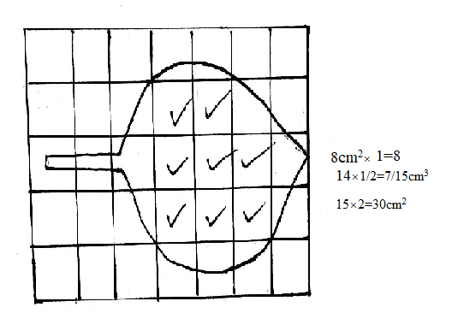

Marking point
Evidence of tracing on Graph paper 1mark
Counting of full and ½ boxes and add 1mark
Multiply final answer by (×2) for the two surfaces
Total marks =3marks
Total for Questions (12marks)

Question 3
a) A-Scapula. (3marks)
B-Humerus
C-Ulna and Radius
b)i) Ball and Sockets (2marks)
(ii) Hinge joint
c) Glenoid cavity that articulates with head of humerous. (4marks)
Has spine (increase S.A) for muscle attachment
Has flat and broad surface for muscle attachment.
Has Acromion for articulation with Clavicle /collar bone (provide support)
Has metacromion and Acromion for muscle attachment
d)(i) Olecranon process (1mark)
ii) -prevent overstretching of the arm. (2marks)
- Muscle, tendons and ligaments attachment.
Total for Questions (12marks)

