NAME …………………………..……………….. DATE:…………………………

INDEX NO. ……….……….…………………...…..… SIGNATURE ……………..…………..

231/ 2
BIOLOGY
PAPER 2
TIME: 2 HOURS

NYAGA SECONDARY SCHOOL
MOCK EXAMINATION 2025

FORM 4
Kenya Certificate of Secondary Education

INSTRUCTIONS TO CANDIDATES
- Write your name and index number in the spaces provided above.
- Answer ALL the questions in the spaces provided in section A and in section B follow the instructions given.
- All working MUST be clearly shown where necessary.

FOR EXAMINER’S USE ONLY.
Section | Maximum score | Candidate’s score
A | 40
B | 40
Total score | 80

SECTION A
- The diagram below shows a phenomenon which occurs during cell division.

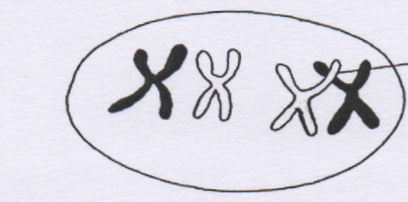
T

- Identify the phenomenon exhibited in the diagram above (1mk)
………………………………………………………………………………………………………………………………………….…………………………………………………..
- Identify the type of cell division in which this phenomenon occurs (1mk)
………………………………………………………………………………………………………………………………………………………………………………………………

(c) Name the part labeled T and state its biological importance (2mks)
T……………………………………………………………………………………………………………………………………………………………………….………………….
Importance………………………………………………………………………………………………………………………………………………………….……………………
(d). Name two organs in a human being where this type of cell division occurs (2mks)
…………………………………………………………………………………………………………………………………………………………………………...………………….
……………………………………………………………………………………………
(e) On the table below, state the significant events that occur during cell division (2mks)
Stage in cell division | Meiosis I | Mitosis
Metaphase
Anaphase

2. The diagram below represents growing seedling which were subjected to unilateral light at the beginning of an experiment.

Mica sheet

Sunlight direction

P R

a) i) State the result of P and R. (2 marks) P ..........................................................................................................................................................
R ..........................................................................................................................................................

ii) Account for your answer in (a) (i) above. (2 marks)

...................................................................................................................................................................

...................................................................................................................................................................
................................................................................................................................................................... b) (i) If the apical bud of seedling P was removed, what results would be expected after 5 days.
(1 mark)

................................................................................................................................................................... ii) Explain your observation in (b) (i) above. (2 marks)
...................................................................................................................................................................

...................................................................................................................................................................

................................................................................................................................................................... c) What is the significance of the practice in b (i) above in agriculture? (1 mark)
...................................................................................................................................................................

...................................................................................................................................................................

3. In man inheritance of blood groups is controlled by multiple alleles A, B and O. The alleles A and B are Co-dominant while O is recessive. A woman homozygous for blood group A married a man homozygous for blood group B
(a) State the genotype of both parents (2mks)
…………………………………………………………………………………………
…………………………………………………………………………………………

(b) Using a punnet square, show the genotypes of F₁ generation (4mks)
……………………………………………………………………………………………………..
……………... ………………………………………………………………………………………
………………………………………………………………………………………………………
……………………………………………………………………………………………………..

(c) State the genotype of a person with blood group O (1 mk)
…………………………………………………………………………………………
…………………………………………………………………………………………
(d) State one applications of knowledge of blood group inheritance in man (1 mk)
…………………………………………………………………………………………
…………………………………………………………………………………………………………………………………………………………………………………………………………
4. The diagram below shows part of a longitudinal section of a young root.
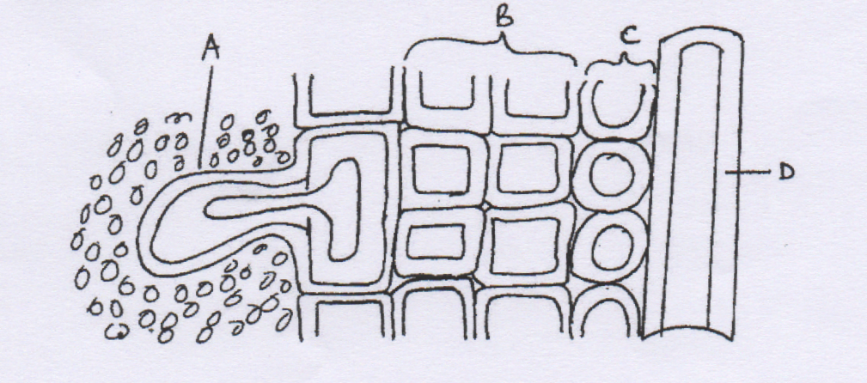
(a) Name the parts labelled A, B, C and D. (4 marks)
A……………………………………………………………………………………………………
B……………………………………………………………………………………………………
C……………………………………………………………………………………………………
D……………………………………………………………………………………………………
(b) State the function of the part labeled A. (1 mark)
………………………………………………………………………………………………………
………………………………………………………………………………………………………
………………………………………………………………………………………………………
………………………………………………………………………………………………………

(c) How is the tissue labelled D adapted to it function. (3 marks)
………………………………………………………………………………………………………
………………………………………………………………………………………………………
………………………………………………………………………………………………………
………………………………………………………………………………………………………

5. A group of students set up an experiment to investigate a certain physiological process. The set up was as shown in the diagram below.

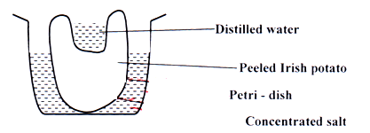

(a) What physiological process was being investigated? (1 mk)
………………………………………………………………………………………………….
(b) (i) State two major observation that was made after some time. (2mks)
………………………………………………………………………………………………….
……………………………………………………………………………………………………
(ii) Account for the above observation in b (i) above. (4mks)
………………………………………………………………………………………………….
……………………………………………………………………………………………………
………………………………………………………………………………………………….
……………………………………………………………………………………………………
(c) State the significance of the biological process involved in the experiment. (1 mk)
………………………………………………………………………………………………….
……………………………………………………………………………………………………
SECTION B
Answer question 6 and either 7 or 8
Temperature(°C) | 0 hr | 2nd hour | 3rd hour | 4th hour | 5th hour | 6th hour | 7th hour
30 | 0.0 | 9.0 | 13.0 | 20.0 | 21.5 | 23.0 | 24.5
35 | 0.0 | 8.0 | 16.5 | 25.0 | 25.5 | 26.5 | 27.0
40 | 0.0 | 12.0 | 23.0 | 30.0 | 26.0 | 26.0 | 10.0
6. In an experiment on respiration, the rate of carbon (IV) oxide production per seedling was recorded under different temperatures as shown in the table below

(a) Using the same axes, plot graph on grid provided to show the carbon (IV) oxide production at each temperature against time. (8 marks)



(b) What is the optimum temperature for respiration? (1mark)
……………………………………………………………………………………………….
…………………………………………………………………………………………………
(c) What was the amount of carbon (IV) oxide produced at temperature of 40°C after:
(I) 1 ½ hours? (1 mark) ………………………………………………………………………………………
(ii) 5 ½ hours? (1 mrk)
…………………………………………………………………………………………………
(d) Suggest reasons for the behaviour of the graph at temperature of 40°C (2 marks)
……………………………………………………………………………………………….……………………………………………………………………………………………………………………………………………………………………………………………………………………………………………………………………
(e) Differentiate between endotherms and ectoderms (2mks)
……………………………………………………………………………………………….
…………………………………………………………………………………………………
……………………………………………………………………………………………….
…………………………………………………………………………………………………

(f) Write down the application of aerobic respiration in industries (5mks)
………………………………………………………………………………………………
………………………………………………………………………………………………
………………………………………………………………………………………………
………………………………………………………………………………………………

- (a) Explain the economic importance of fungi (10mks)
(b) Explain the role of the liver in regulation of blood sugar. (10 mks)
8. a) Describe the features and mechanisms that prevent self-pollination in flowering plants. (l0mks)
(b) Explain any five adaptations of the ileum to the process of absorption. (10mks)

