NYAGA SECONDARY SCHOOL
MOCK EXAMINATION 2025
BIOLOGY PAPER 2
MARKING SCHEME
SECTION: A
I (a) Crossing Over (1mk)
(b) Meiosis (1mk)
(c) Chiasma,Rej Chrasmata
Allows crossing over to take place hence variation
(d)Testes and Ovary (2mks)
Stage in cell division | Meiosis 1 | Mitosis
Metaphase | Homologous chromosomes move to the equator in pairs | Homologous chromosomes move to the equator independently
Anaphase | Homologous chromosomes separate and move to opposite poles | Chromatids separate and move to opposite poles

a) i) P - Will bend towards light;
R Continue growing upright;
ii) P- Light causes lateral migration of auxins to dark side of the seedling causing faster growth on darkside than lightside hence curvature;
R - Mica sheet reflect light hence uniform distribution of IAA in the seedling;

i) Sprouting of lateral buds into branches;
ii) Apical shoot is source of IAA; Low IAA concentration stimulate lateral bud to sprout out;

c) Increased yields;
3. (a) AA and BB (2mks)
(b) (4mks)
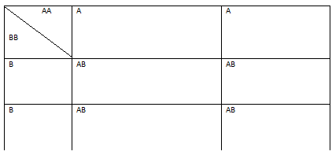

C) 00 (1mk)
d. In blood transfusion,
Determining disputed paternity (1mk)
4. (a) A-Root hair
B-Cortex;
C- Endodermis
D-Xylem (1mk)
b) Absorbs water and mineral salts
c. –Has long tube which is continuous from roots to leaves
- Lignified making it very strong and prevent it from collapsing
- Has narrow lumen to increase capillarity
5 (a ) Osmosis
b) (i) Distilled in the Irish potato would reduce in level
-Level of concentrated solution would increase in the Petri dish
(ii) Concentrated salt solution in the Petri-dish has higher osmotic pressure than
the cells of the irish potato; these cells lost water to the salt solution by osmosis;
these cells become more concentrated and drew water from the neighbouring
cells; this process continued until the cells in contact with water in the potato
drew it up.
(c) - Support in herbaceous plants
- Absorption of water
- Opening and closing of stomata
- Movement and water between plants
- Feeding in insectivorous plants
- Folding of leaves of mimosa pudica when touched
SECTION B
6 a) Graph
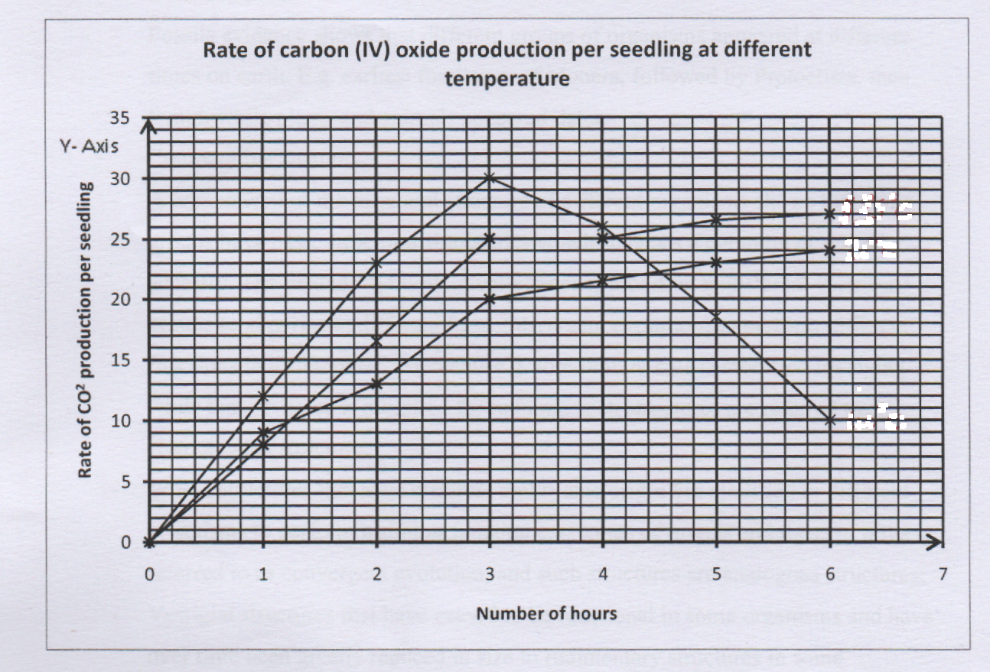
40⁰c
30⁰c
35⁰c

(b) 40°C
(c) (i) 17.4; (ii) 13.6;
(d) The rate of respiration at maximum as evidenced by the high rate of CO₂ production; After the 3rd hour, the food stored in seedling were exhausted leading to steady decline in rate of CO₂ production as rate of respiration falls;
(e) Endotherms regulate their body temperature by carrying out both physiological and behavioural activities; while ectotherms regulate their body temperature by carrying out behavioural activities only;
(fl Production of ethanol used in brewing industries/as a preservative; Production of CO₂ used in baking/soft drinks industries; Production of dairy products like ghee, yoghurt and cheese; Production of organic acids like citric and butyric acids; Production of biogas; Production of power alcohol;
- (a) Explain the economic importance of fungi. (9mks)
- Some cause food spoilage;
- Some cause diseases to human e.g ring worm;
- Some fungi e.g Penicillium is used in the production of antibiotics;
- Some fungi e.g mushrooms are used as food;
- Some cause diseases to crops e.g tomato plight;
- Saprophytic fungi are important in nutrient recycling through decomposition;
- Yeast is used in brewing of alcohol; and baking of bread;
- Mycorrhizal association is important in forest development;
- Some fungi produce toxic substances e.g Aspergillus flavus;
(b) Describe the adaptations of flowers to insect pollination. (11mks)
- Have large brightly coloured petals; which attract insects;
- Presence of nectaries; that secrete sweet scented nectar; which serve as bait for the insects;
- Have small; sticky stigma; which enables the pollen grains from the insects body to stick onto it;
-Anthers are small; and held firmly onto the filaments; to ensure that the y don't break when the insects rub against them as they crawl into the flower;
- Have large; heavy and sticky pollen grains so as to stick on the insects' body;
- The anthers produce few but large grains; to increase the chances of their transfer to a stigma for pollination;
-Flowers normally have shapes that are convenient for the insects body thus the insects land and fit comfortably e.g. flower petals forming a corolla tube;

8 .A) Features and mechanisms that prevent self-fertilization in flowering plants.(10mks)
- Hermaphrodites and monoecious plants
- These have both male and female reproductive structures in same flowers but self pollination fertilization may not occur due flowers being brightly colored, have nectar have scent to attract insects to cause cross pollination;
- The dioecious plants e.g. pawpaw have sexual structures on different plants
- In protandry, the male parts o flower mature before the female parts in the same flower.
- In protogyny, female pans of the flower mature before the male parts of the flower, ensuring pollen from flower causes fertilization in the female part of the flower.
- Self compatibility or self sterility: The pollen grains fail to stick onto the stigma of same plant or fail to germinate.
a) Adaptations of ileum to process of absorption of food materials
- It is long; to provide a large surface area for absorption of food.
- It is narrow; to bring digested food into close contract with the walls of ileum for easier absorption;
- Is highly folded; to reduce/slow down movement of food and so allow more time for absorption. It also increases the surface area for absorption
- The inner surface of ileum has large numbers of villi and microvillus which increases the surface area for absorption.
- Presence of thin layer of cells; (lining epithelium) allows faster diffusion of digested food materials.
- Presence of a dense network of capillaries in the villi into which digested food substances are absorbed.
- - Presence of lacteals in villi for absorption of fatty acids and glycerol (Accept any five)

