Name: ______________________________ Adm No: ____________Class:_____
Candidate’s Signature: __________________Date: __________________________

231/1
BIOLOGY
Paper 1
JULY/AUGUST 2025
Time: 2 HOURS

NYAGA SECONDARY SCHOOL
MOCK EXAMINATION 2025
Kenya Certificate of Secondary Education

Instructions to Candidates
- Write your name and index number in the spaces provided above
- Sign and write the date of examination in the spaces provided above
- Answer all questions in the spaces provided
- This paper consists of 8 printed pages
- Candidates should check the question paper to ascertain that all pages are printed as indicated and that no questions are missing
- Candidates should answer questions in English

For Examiners Use Only
1 | 2 | 3 | 4 | 5 | 6 | 7 | 8 | 9 | 10 | 11 | 12 | 13 | 14

15 | 16 | 17 | 18 | 19 | 20 | 21 | 22 | 23 | 24 | 25 | 26 | 27 | 28 | 29
GRAND TOTAL

- Name the tissues that carry out the following functions in mammals.
a) Binds and supports the various organs in the body. (1mark)

b) Is responsible for movement. (1mark)

- How do plant cell walls differ from cell membranes. (1mark)

- Name the cell organelle involved in formation of lysosomes. (1 mark)

- Give two advantages of using cover slip when preparing a specimen for observation under a light microscope. (2 marks)

- Explain why deficiency of vitamin K leads to excessive bleeding even in small cuts. (2 marks)

- Distinguish between plasmolysis and haemolysis. (2marks)

- a) In land plants water logging slows down the uptake of certain minerals. Suggest a reason for this. (2marks)

b) Name four processes in living organism that depend on active transport. (4 marks)

- The equation below shows a chemical reaction that takes place in green plants under certain conditions.
Carbon (IV) oxide + water glucose + X
a) Name the process represented by the equation above. (1mark)

b) Name two types of cells in which this process occurs. (2 marks)

- Explain two advantages of closed circulatory system over open circulatory system. (2marks)

- Describe how the following parts of the mammalian ear are adapted to their functions
(3marks)
a) Pinna.

b) cochlea.

c) ossicles.

- A flower was observed to be scented.
a) Identify the phylum of living organisms that transfer pollen grains within the species of plants having the flower. (1 mark)

b) Name a physiological process that aids the organisms in (a) above effect the transfer of pollen grains while giving a reason. (2 marks)

- Explain why the presence of air bubble in a xylem vessel would cause drying up of a plant.
(2 marks)

- a) Identify a useful excretory plant product obtained from raw paw paw fruits. (1 mark)

b) Give the use of the plant excretory product named in (a) above. (1 mark)

- Name the method by which the following excretory products are removed from plants.
a) Excess water. (1 mark)

b) Carbon (IV) oxide from cellular respiration. (1 mark)

- a) State the functions of pseudopodia in amoeba species. (2 marks)

b) Name one type of specialized cells in human body which shows a similar mode of feeding as amoeba species. (1 mark)

- The figure below shows a model which was used by a group of Form 2 students to show the effect of or action of intercostal muscles on the movement of ribs.

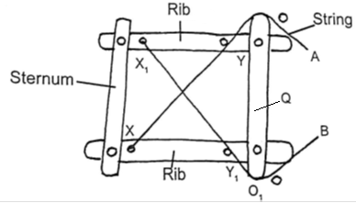

a) How does the sternum move when; (2 marks)

i) String A is pulled tight.

ii) String B is pulled tight.

b) Between string A and B, which one represents; (2 marks)

i) External intercostal muscles?

ii) Internal intercostal muscles?

- Explain how Malpighian layer of the skin is adapted to perform its function.
(2 marks)

- Explain what happens to excess amino- acids in the liver of humans (3 marks)

- a) What is peristalsis? (1 mark)

b) Explain how the process above is brought about.
(2marks)

c) The table below shows three enzymes A, B and C and their respective optimum pH.
Enzyme | Optimum pH
A | 6.8
B | 2.0
C | 8.0
i) Name the most likely region of the alimentary canal of a mammal where enzyme
B would be found. (1 mark)

ii) Give a reason for your answer in (a) (i) above. (2marks)

- Explain why maize stalks do not undergo secondary growth yet they increase in girth.
(3 marks)

- Potato cylinders were weighed and kept in distilled water overnight. They were then
reweighed.

2.5 g 2.4g 2.7g 3.0 g 3.1 g 3.2g
At the beginning of the Experiment. At the end of the experiment
a) Calculate the average mass of a potato cylinders after reweighing. Show your working.
(2 marks)

b) Explain why mass of the cylinders had increased. (2 marks)

- Differentiate between sperm and ovum. (3marks)

- Name the type of responses exhibited by: - (2marks)
a) Marine crabs burrowing into the sand to avoid dilution of their body fluids

b) Chlamydomonas plant moving towards a region of high light intensity

- Define the term “Gene mutation.” (1mark)

- What is the role of seed dormancy in plant life cycle? (2 marks)

- Examine the diagram of a synapse shown below and answer the questions that follow.

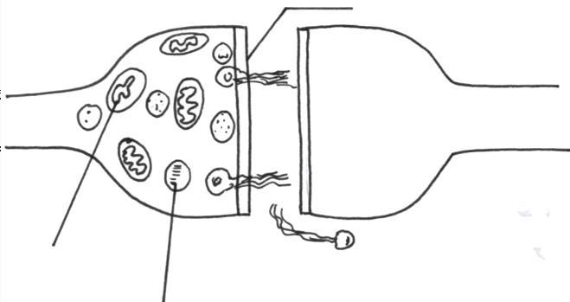
C

B

A

- a) Name the parts labelled A and C. (2 marks )

b) using an arrow ,indicate the direction of impulse transmission on the diagram.
(1 mark)

- a) Give TWO examples of ball and socket joint. (2 marks)

b) Name two types of strengthening tissues in plants. (2 marks)

- The diagram below represents the anterior view of a certain vertebra shown below.
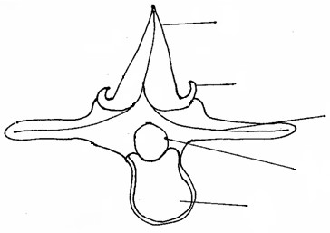

A

B

C

D

E

a) With a reason, identify the type of vertebra shown above. (2 marks)

b) Name the parts labeled A, B and D. (3 marks)

c) State the function of part E. (1 mark)

d) Which type of muscle cells is found in the gut? (1 mark)

