MARKING SCHEME

231/1
BIOLOGY
Paper 1
JULY/AUGUST 2025
Time: 2 HOURS

NYAGA SECONDARY SCHOOL
MOCK EXAMINATION 2025
Kenya Certificate of Secondary Education

- Name the tisues that carry out the following functions in mammals.
a) Binds and supports the various organs in the body 1mark
connective tissue
b) Is responsible for movement 1mark
muscular tissue
- How do plant cell walls differ from cell membranes 1mark
cell wall is made up of cellulose
- Name the cell organelle involved in formation of lysosomes 1 mark
Gogi bodies
- Give two advantages of using cover slip when preparing a specimen for observation under a light microscope 2 marks
Holds specimen in position during viewing
Prevents objective lens from staining
- Explain why deficiency of vitamin K leads to excessive bleeding even in small cuts (2 marks)
Vitamin k is required for synthesis of prothrombin ; prothrombin is converted to thrombin that activates fibrinogen to fibrin;

- Distinguish between plasmolysis and haemolysis 2marks
Plasmolysis; shrinking of vacuole and pulling away of cytoplasm from cell membrane when plant cell is place in hypertonic solution.
Haemolysis; bursting of red blood cells when placed in hypotonic solution.

- a) In land plants water logging slows down the uptake of certain minerals.suggest a reason for this 2marks
uptake of minerals involve active transport;that require energy from the aerobic respiration process;water logged soils have limited oxygen
b) Name four processes in living organism that depend on active transport 4 marks
Absorption of mineral salts by root hairs
Excretion of metabillic wastes
Reuptake of sugars and salts at the renal tubule
Transmission of nerve impulses
Absorption of digested food substances from alimentary canal.
- The equation below shows a chemical reaction that takes place in green plants under certain conditions .
Carbon (IV) oxide + water glucose + X
a) Name the process represented by the equation above 1mark
photosynthesis
b) Name two types of cells in which this process occurs 2 marks
guard cells; palisade mesophyll;spongy mesophyll.
- Explain two advantages of closed circulatory system over open circulatory system. 2marks
oxygenated and deoxygenated blood are completely separated / do not mix;
Blood flow to organs is well regulated based on demand;
Animals tend to be more active due to efficient transport of gases and nutrients
Blood circulates over longer distances at faster rate due to high blood presence;

- Describe how the following parts of the mammalian ear are adapted to their functions
3marks
a) Pinna. funnel shaped to collect and direct sound waves to ear canal
b) cochlea. Highly coiled to offer a large surface area for attachment of sensory cells
c) ossicles. Forms a system of lever which amplifies and transmits vibrations from ear drum to oval window.
- A flower was observed to be scented.
a) Identify the phylum of living organisms that transfer pollen grains within the species of plants having the flower. 1 mark
Arthropoda
b) Name a physiological process that aids the organisms in (a) above effect the transfer of pollen grains while giving a reason. 2 marks
Diffusion; scent diffuses from flower-region of high concentration to region of low concentration;
- Explain why the presence of air bubble in a xylem vessel would cause drying up of a plant.
2 marks
Breaks the cohesion force between water molecules; interrupting the continuous column of water;
- (a) Identify a useful excretory plant product obtained from raw paw paw fruits. 1 mark
Papain;
(b) Give the use of the plant excretory product named in (a) above. 1 mark
Tenderize meat;
- Name the method by which the following excretory products are removed from plants.
a) Excess water. 1 mark
Transpiration;
b) Carbon (IV) oxide from cellular respiration. 1 mark
Diffusion;
- a) State the functions of pseudopodia in amoeba species. 2 marks
For locomotion;
For feeding/engulfing food;
b)Name one type of specialized cells in human body which shows a similar mode of feeding as amoeba species. 1 mark

White blood cells/ leucocytes;
- The figure below shows a model which was used by a group of Form 2 students to show the effect of or action of intercostal muscles on the movement of ribs.

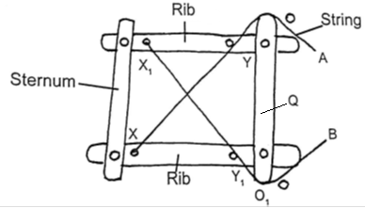

a) How does the sternum move when; 2 marks

i) String A is pulled tight.
Moves upwards and inwards (towards Q);
ii) String B is pulled tight.
Moves downwards and (away from Q);
b) Between string A and B, which one represents; 2 marks

i) External intercostal muscles?
String B;
ii) Internal intercostal muscles?
String A;
- Explain how malpighian layer of the skin is adapted to perform its function.
2 marks
Has actively dividing cells giving rise to the granular layer
contains melanocyte cells that produce melanin that gives the skin its colour/protects skin against ultra violet rays.
- Explain what happens to excess amino- acids in the liver of humans 3 marks
The amino acids are broken into amino group (NH₂) and carboxyl
group (COOH). The amino group combines with hydrogen forming highly toxic ammonia
It immediately combines with carbon (IV) oxide forming urea that is less toxic.
The carboxyl group converted to carbohydrates and then oxidized or converted into neutral fats and deposited on the parts of the human
- a) What is peristalsis? 1 mark
Involuntary movement of food along the alimentary canal

b) Explain how the process above is brought about.
2marks
Occurs when the Circular and longitudinal muscles on the wall of oesophagus and intestines contract and relax alternately;

c) The table below shows three enzymes A, B and C and their respective optimum pH.
Enzyme | Optimum pH
A | 6.8
B | 2.0
C | 8.0
i) Name the most likely region of the alimentary canal of a mammal where enzyme
B would be found. 1 mark
Stomach

ii) Give a reason for your answer in (a) (i) above 2marks

Presence of hydrochloric acid in the stomach to provide acid conditions

- Explain why maize stalks do not undergo secondary growth yet they increase in girth.
3 marks
Maize are monocots, no vascular cambium; responsible for secondary growth; increase
in girth is due to enlargement of primary cells;
- Potato cylinders were weighed and kept in distilled water overnight. They were then
reweighed.

2.5 g 2.4g 2.7g 3.0 g 3.1 g 3.2g
At the beginning of the Experiment. At the end of the experiment
a) Calculate the average mass of a potato cylinders after reweighing. Show your working.
a) 3.0 + 3.1 + 3.2 = 9.3 g; 2 marks
Average = 9.3 = 3.1g;
3

b) Explain why mass of the cylinders had increased. 2 marks)
The cell sap had a higher concentration of solutes than distilled water, water therefore
moves from the environment to the cell by osmosis
- Differentiate between sperm and ovum 3marks
Sperm | Ovum
- Spear shaped.  - Posses a tail.  - Has acrosome .  No vitelline membrane. | - Spherical shaped  - No tail  - No acrosome  - Has vitelline membrane.

- Name the type of responses exhibited by:- 2marks
a) Marine crabs burrowing into the sand to avoid dilution of their body fluids
Negative osmotaxis
b) Chlamydomonas plant moving towards a region of high light intensity
Positive phototaxis
- Define the term “Gene mutation.”
Change in base sequence of the DNA; 1 mark
- What is the role of seed dormancy in plant lifecycle 2marks

- Seed dormancy allows the plant to escape harsh conditions of the environment
- It also allows time for the seed to disperse

- Seed dormancy allow time for the seed to fully mature (after ripening period);

- Examine the diagram of a synapse shown below and answer the questions that follow.

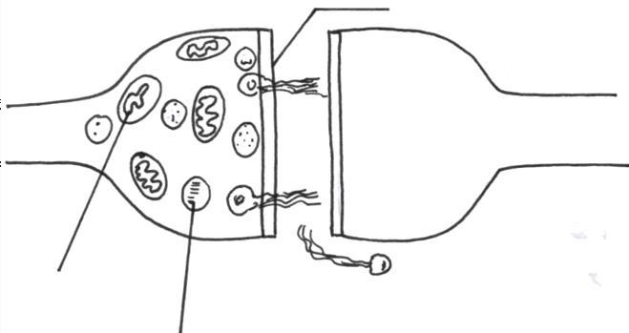
C

B

A
- a) Name the parts labelled A and C. 2 marks
A; synaptic vessicle
C; pre synaptic membrane
b) using an arrow ,indicate the direction of impulse transmission on the diagram.
1 mark
- a) Give TWO examples of ball and socket joint. 2 marks
Shoulder ; hip joint
b) Name two types of strengthening tissues in plants. 2 marks
Sclerenchyma; collenchyma; xylem; parenchyma
- The diagram below represents the anterior view of a certain vertebra shown below.
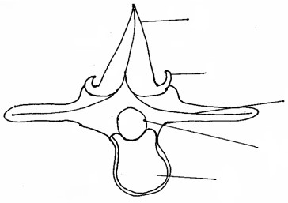

A

B

C

D

E

a) With a reason, identify the type of vertebra shown above. 2 marks
lumbar; Prominent Centrum to provide support; Prominent transverse processes.
Prominent facets.
b) Name the parts labeled A,B and D. 3 marks
A – Neural spine;
B- metapophysis
D – Neural canal;

c) State the function of part E. 1mark
provide support to the vertebra
d) Which type of muscle cells is found in the gut? 1 mark
Smooth muscle cells

