NAME: __________________________________ADM NO: ___________CLASS: _____
CANDIDATE’S SIGNATURE: __________________ DATE: ____________________

443/2
AGRICULTURE
PAPER 2
JULY/AUGUST 2025
Time: 2 HOURS

NYAGA SECONDARY SCHOOL
MOCK EXAMINATION 2025
Kenya Certificate of Secondary Education

Instructions to Candidates
a) Write your name and index number in the spaces provided above.
b) Sign and write the date of examination in the spaces provided above.
c) This paper consists of three sections: A, B and C.
d) Answer all questions in section A and B and only two questions from section C.
For Examiner’s Use Only
SECTION | QUESTION | MAXIMUM SCORE | CANDIDATE’S SCORE
A | 1-19 | 30
B | 20-22 | 20
C | 23 | 20
C | 24 | 20
C | 25 | 20
TOTAL SCORE |  | 90

Candidates should check the question paper to ascertain that all the questions are printed as indicated and that no questions are missing.

SECTION A 30 MARKS
1. Give one function of each of the following tool/equipment. (1¹/₂ mks)
b) Pruning saw

c) Cold Chisel

d) Tin snip

2. State the differences between large white and landrace breeds of pigs. (2mks)

5.i) State the components of the power transmission system. (2mks)

ii)State the maintenance practices of an ox-cart. (2mks)

7. State four maintenance practices of a plunge dip. (2 mks)

8. List four disadvantages of artificial insemination. (2mks)

9. Give four factors that necessitate culling of birds. 2mks

10. Outline four factors that influence the amount of water taken by a farm animal. (2 mks)

11. state measures that can be put in place to control tsetse flies. (2mks)

12. Name four activities in livestock health that necessitates handling of animals. (2mks)

13. State four general uses of solar energy (2mk)

14. Give two reasons for seasoning timber. (1mk)

15. What is the purpose of giving feed additives to livestock? (1^{1/}₂mks)

16. Give three reasons for docking. (1¹/₂mk)

17. State the reasons for feeding bees? (1¹/_{2mks})

18.Give two advantages of natural method of calf rearing. (1)

19.Outline the advantages of the fold system. (2 mks)

SECTION B (20 MARKS)
20.Study the illustration below showing a method of grazing
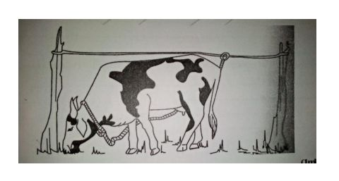
i. Identify the method of grazing illustrated above (1mk)

ii. Give Three Advantages of the method named (i) above (3mks)

iii. State two other rotational grazing systems commonly used (2mks).

21. Study the diagram below and answer the questions that follow.
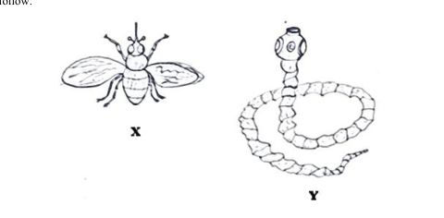
a) Identify the parasites X and Y above. (2mks)

b) State two effects that are caused by the parasite labeled X on the animal’s body. (2mks)

c) Name one disease transmitted by parasite labeled X above. (1mk)

d) State three measures taken to control the parasite labeled Y above. (3mks)

22. The diagram below shows a system of rearing poultry
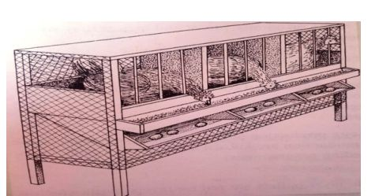
- Identify the system (1mk)

- Give four advantages of the above system (2mks)

c) Mention factors that should be considered when sorting and grading eggs for marketing. (3 marks)

SECTION C (40 MARKS)
Answer any TWO questions in this section
23.(a) Describe Newcastle disease under the following sub – headings
(i) Animals affected. (1mk)
(ii) Causal Organism. (1 mk)
iii) Symptoms of attack. (5mks)
iv)Control and Treatment. (3mks)
(b) State five differences between a petrol and a diesel engine (10mks)

24. a) Explain five factors that affect milk composition in dairy farming. (10mks)
b.) State six signs that are likely to be observed when a cow is on heat (6mks)
c) State four Short-Term Tractor Servicing (4mks)

25.a) Describe any six livestock rearing practices. (12 marks)
b) State four differences between ruminant and a non-ruminant animal. (8marks)

This is the last printed page

