Name: _____________________________________________ Adm No: ____________Class:_____
Candidate’s Signature: ________________________ Date: __________________________

443/1
AGRICULTURE
PAPER 1
JULY/AUGUST 2025
Time: 2 HOURS

NYAGA SECONDARY SCHOOL
MOCK EXAMINATION 2025
Kenya Certificate of Secondary Education

Instructions to Candidates
- Answer all questions in section A and B in the spaces provided in each question
- Answer any two questions in section C in the answer sheet attached

For examiner’s use only
SECTION | Question | Maximum Score | Candidate’ Score
A | 1-17 | 30
B | 18-21 | 20
C |  | 20
C |  | 20
TOTAL SCORE |  | 90

SECTION A (30 MARKS)
- Name four biotic factors that influence agriculture negatively. (2marks)

- State four activities that may be undertaken in organic farming. (2marks)

- Give four reasons for early preparation of a seedbed in crop production. (2marks)

- State two causes of forking in carrots (1mark)

- Name four books of account kept by a farmer (2 marks)

- Give four causes of poor drainage on farmland. (2marks)

- State four advantages of a mixed grass legume pasture over a pure grass pasture. (2marks)

- Give a solution for each of the following properties of nitrogenous fertilizer when applying to crops.
- Easily leached to lower horizons. $(\frac{1}{2}mark)$

- Are highly volatile. $(\frac{1}{2}mark)$

- Are hygroscopic. $(\frac{1}{2}mark)$

- Define the term “Economic Injury Level” of a crop. (1mark)

- State four benefits of land consolidation. (2marks)

- State four ways in which humus is beneficial to a growing crop. (2marks)

- State four disadvantages of chemical pest control. (2marks)

- Define the term ‘’integrated pest management’’ $(\frac{1}{2}mark)$

- State four factors considered when selecting planting material for forage crops. (2marks)

- State four disadvantages of broadcasting seeds during planting. (2marks)

- Name any two diseases that affect bean production in the field. (1 mark)

- State four factors that would determine the number of secondary cultivations to be carried out on a seedbed before planting. (2marks)

- State two characteristics of a good vegetable seedling. (1mark)

SECTION B (20 MARKS)
- A member of the young farmers’ club was advised to apply a complete compound fertilizer 30-20-10 in a tomato plot measuring 10m by 5m at the rate of 300kg per hectare.
- Give the percentage of nitrogen (N) and phosphorus pentoxide ${(P}_{2}O_{5})$ in the fertilizer.
(2marks)

- Calculate the amount of fertilizer the member would require for the plot. (3marks)

- Study the methods of crop propagation illustrated below and answer the questions that follow
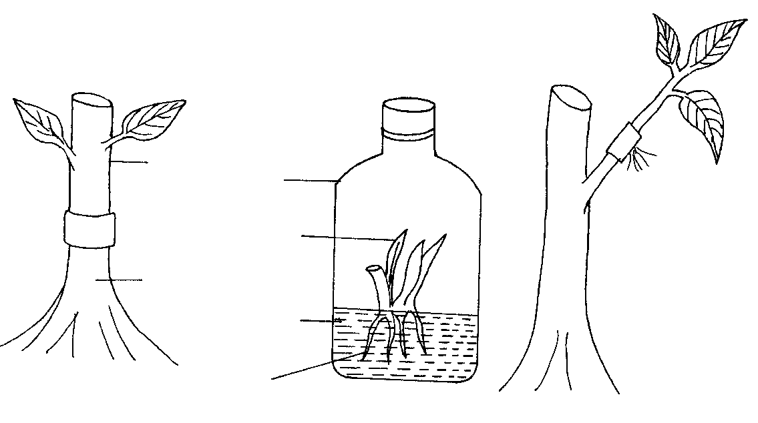
Developing roots
Culture medium
Root stock
Banana plantlet
scion
Glass container
3
1
2
roots
- Identify the methods of crop propagation illustrated above.
1- (1 mark)
2 - (1 mark)
3- (1 mark)
b) Give one condition under which method (1) above is carried out. (1 mark)
c) State two disadvantages of using stem cuttings for planting. (2marks)

- Study the diagram on silage making shown below and answer the questions that follow.

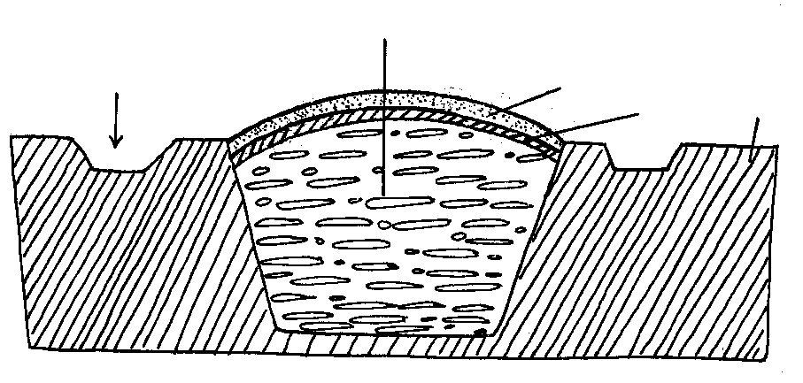
Ground level
Polythene sheet
Soil layer
Silage material
Drainage
a) Identify the silage preparation method shown above. (1mark)

b) Give two precautions taken when ensiling to ensure high quality silage. (2marks)

c) State two advantages of this method of forage conservation over other methods. (2marks)

- The diagram below is of a tea cutting. Study it and answer the questions that follow.
- Which part of the branch is most appropriate for raising a new seedling. (1mark)

- Give a reason for your answer in (a) above. (1mark)

- Give a reason why farmers are advised to raise tea cuttings in polythene sleeves. (1 mark)

- State two factors that affect the rooting of the cutting above. (1 mark)

SECTION C (40 Marks)
23. a) Outline five factors that determine the quality of hay (5mks)
b) Explain five objectives of land tenure reform in Kenya (5mks)
c) Describe ten factors that can influence soil erosion (10mks)
24. The following information was extracted from the farm records of Victory Farm as at 31/12/2017.
Sale of poultry……………………………………5000
Sale of milk……………………………………….6000
Telephone bill……………………………………..1000
Feed purchase…………………………………….. 2500
Purchase of calves ……………………………….3000
Purchase of lambs………………………………….2800
Sale of goats ………………………………………5000
Closing Valuation ………………………………….150, 000
Rent ……………………………………………….. 2000
Casual labour……………………………………… 2500
Sale of Cereal……………………………………… 12000
Opening Valuation…………………………………140,000
Depreciation of machinery……………………………500
Interest on loan……………………………………….. 400
Sale of sukuma Wiki……………………………………500
Purchase of chicks……………………………………….800
- Prepare profit and loss account for victory farm using the above information (8mks)
- Distinguish between closing and opening valuation (2mks)
- State five functions of a farm manager (5mks)
d) Give ways in which labour efficiency can be increased in the farm (5mks)
25. a) Describe the advantages of using seeds as planting materials 5mks) b) Describe the production of tomatoes under the following subheadings
- Land preparation (4mks)
- Transplanting (6mks)
c)State five advantages of using herbicides (5mks)

