MARKING SCHEME

443/1
AGRICULTURE
PAPER 1
JULY/AUGUST 2025
Time: 2 HOURS

NYAGA SECONDARY SCHOOL
MOCK EXAMINATION 2025
Kenya Certificate of Secondary Education

SECTION A (30 MARKS)
- Name four biotic factors that influence agriculture negatively. (2marks)
-Pests
-Parasites
-Predators
-Pathogens
- State four activities that may be undertaken in organic farming. (2marks)
-Use of organic manure
-Timely planting
-Practicing crop rotation.
-Mulching
-Use of medicinal plant products to control diseases and parasites e.g. hot pepper solution.
-Livestock being reared by feeding them on natural feedstuffs without artificial additives.
-Physical/cultural pest, weed, parasite and disease control.

- Give four reasons for early preparation of a seedbed in crop production. (2marks)
-To kill weeds
-To incorporate manure and other organic matter into the soil.
-To destroy different stages of crop pests such as eggs larvae, pupae or adults by burying them, exposing them to the heat of the sun and predators and starving them.
-To aerate the soil.
-To encourage the penetration of roots in the soil.
-To make subsequent operations possible e.g. planting, fertilizer application, rolling and ridging.
-To encourage water infiltration into the soil.

- State two causes of forking in carrots 2x ½= 1mark
-Conditions of heavy soils
-A lot of undecomposed organic matter /manure in the soil
5. Name four books of account kept by a farmer (4x ½ =2 mark)
-Journal
-Cash books
-Inventory
-Ledger
- Give four causes of poor drainage on farmland. (2marks)
-Too much rainfall on low lying areas.
-High amounts of clay particles in the soil.
-Presence of impermeable rock near the soil surface.
-Formation of hard pans in the soil.
-High water table.
- State four advantages of a mixed grass legume pasture over a pure grass pasture. (2marks)
-It is more palatable than pure grass.
-A farmer has security against total loss in case of pest and disease attack or bad weather.
-Yields are higher per unit area of land than in pure grass pasture.
-It is more nutritious/has a higher nutritive value than pure grass pasture.
-It makes maximum use of soil nutrients because of different nutrient requirement.
-It has better weed control effect.
-It reduces soil erosion because of good soil cover.
-It increases soil fertility because of nitrogen fixation.
-There is economy in use of fertilizers in mixed pastures.
-There is better growth in a mixture of late and early maturing species.
- Give a solution for each of the following properties of nitrogenous fertilizer when applying to crops.
- Easily leached to lower horizons. $(\frac{1}{2}mark)$
-They should be applied to an already established crop.
- Are highly volatile. $(\frac{1}{2}mark)$
-They should be applied to moist soils.
- Are hygroscopic. $(\frac{1}{2}mark)$
-They should be stored under dry conditions.
- Define the term “Economic Injury Level” of a crop. (1 x1=1mark)
When pest population has caused damage beyond tolerance.

- State four benefits of land consolidation. (2marks)
-Proper supervision of land
-Economic use of time and saving of transportation costs.
-Easy provision of agricultural advice by extension officers.
-Ensures sound farm planning and adoption of crop rotation programs.
-Facilitates soil conservation and land improvement.
-Promotes construction of permanent structures e.g. buildings and fences.
-Registered land gives the farmer legal ownership and the title deed which can be used to obtain loans.
-Weed, pest and disease control is enhanced.
-Facilitates mechanization especially because of large holdings.

- State four ways in which humus is beneficial to a growing crop. (2marks)
- It increases the water holding capacity of the soil. It also increases the infiltration rate due to its colloidal nature.
-It improves soil fertility by releasing a wide range of nutrients into the soil.
-It provides food and shelter for soil micro-organisms responsible for the decomposition of organic matter.
-It improves soil structure. Humus binds soil particles together thus improving soil structure.as a result of this drainage and aeration of soil improves.
-It buffers soil P_{H} i.e. moderates soil P_{H} by avoiding rapid chemical changes due to the addition of acidic fertilizers and liming materials.
-It reduces the toxicity of plant poisons that may have built up in the soil as a result of continuous use of pesticides and fungicides.
Humus gives soil its dark colour which absorbs heat helping to moderate soil temperature.

- State four disadvantages of chemical pest control. (2marks)
-Expensive.
-Most are not environmental friendly since they are toxic to man and livestock
-They require care and skill when handling and applying them.
-Most are non-selective and therefore they kill useful insects such as pollinators and pest predators.
-Pests establish resistance to pesticides if they are used continuously against them. E.g. DDT.

- Define the term ‘’integrated pest management’’ $(\frac{1}{2}mark)$
-This is a combination of chemical physical, biological and pest control methods.
- State four factors considered when selecting planting material for forage crops. (2marks)
-Adaptable to the local ecological conditions.
-Fast growth
-High herbage yield/high leaf: stem ratio
-High germination percentage/viable
-High nutritive value
-Pure/true to type
-Certified seed
-Healthy/free from pests and diseases.
- State four disadvantages of broadcasting seeds during planting. (2marks)
-It uses more seed than row planting.
-Seeds are spread unevenly leading to crowding of plants in some places.
-Lack of uniformity in seed placement causes lack of uniformity in establishment.
-There is uneven germination due to uneven depth of seed placement.
-Mechanization is hard e.g. weeding.
- Name any two diseases that affect bean production in the field. (2 x ½ =1 mark)
-Bacterial (Hallo) blight.
-Bean Anthracnose.
- State four factors that would determine the number of secondary cultivations to be carried out on a seedbed before planting. (2marks)
-Size of planting materials.
-Slope of the land.
-The moisture content of the soil.
-Condition of the soil after primary cultivation.
-The type of weeds to be controlled
-Soil texture

- State two characteristics of a good vegetable seedling. (1mark)
-Healthy/free from diseases and pests.
-Free from physical deformities.
-High yielding.
-Correct stage of growth/height 10-15cm, 4-6 true leaves, 4-6 weeks old.

SECTION B (20 MARKS)
- A member of the young farmers’ club was advised to apply a complete compound fertilizer 30-20-10 in a tomato plot measuring 10m by 5m at the rate of 300kg per hectare.
- Give the percentage of nitrogen (N) and phosphorus pentoxide ${(P}_{2}O_{5})$ in the fertilizer.
(2marks)
Nitrogen (N) -30%
Phosphorus pentoxide ${(P}_{2}O_{5})$- 20%
- Calculate the amount of fertilizer the member would require for the plot. (3marks)
Area of land 10x5=50msq;
1ha = 10000msq
If 300kg =10000msq;
? =50msq
300x50
10000
=1.5kg;
- Study the methods of crop propagation illustrated below and answer the questions that follow
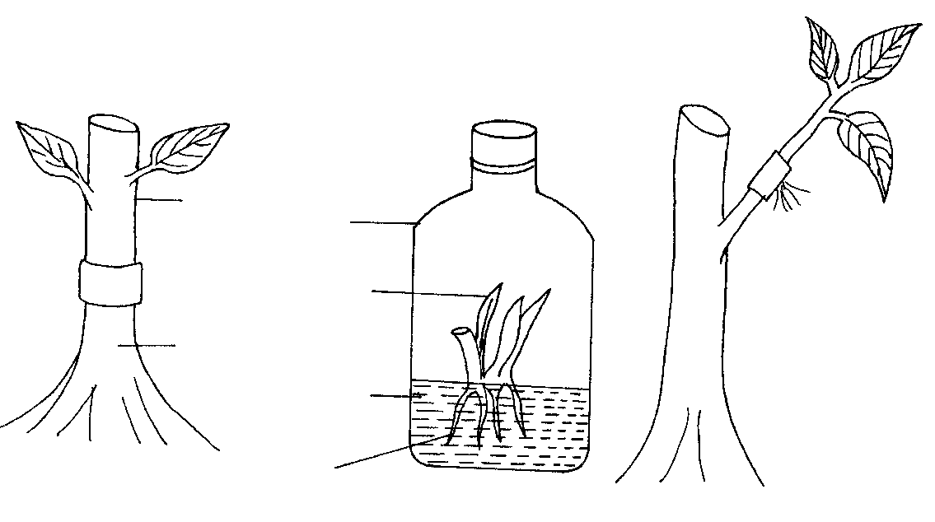
3
1
2
Banana plantlet
Root stock
Glass container
scion
Culture medium
roots
Developing roots
- Identify the methods of crop propagation illustrated above.

1- Whip / tongue grafting (1 mark)

2 - Tissue culture / banana tissue culture (1 mark)

3- Aerial layering / marcotting (1 mark)

b) Give one condition under which method (1) above is carried out. (1 mark)
When the root stock have the same diameter as a scion
c) State two disadvantages of using stem cuttings for planting. (2marks)
-Stem cuttings does not results in new crop varieties
-Stem cuttings cannot be stored for long
- It is difficult to keep stem cuttings tree from diseases
i-Stem cuttings are bulky to transport
- Study the diagram on silage making shown below and answer the questions that follow.

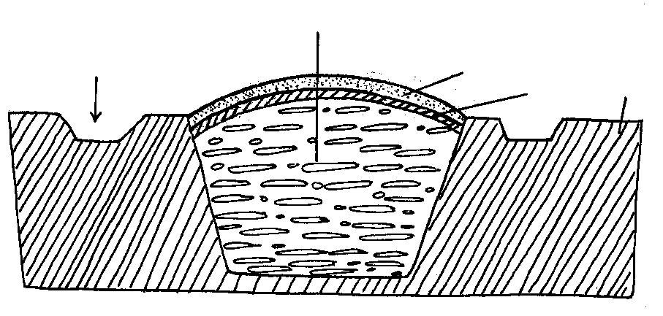
Ground level
Polythene sheet
Soil layer
Silage material
Drainage
a) Identify the silage preparation method shown above. (1mark)
- Trench silo
b) Give two precautions taken when ensiling to ensure high quality silage. (2marks)
-Fast filling of the material into the silo
-compacting/pressing
- The last layer covered with polythene sheet to prevent air and water
- Drainage channel should be made to ensure run off water is kept away

c) State two advantages of this method of forage conservation over other methods. (2marks)
- Few field losses
- More nutrients are preserved
- Can be preserved for a long period of time
- No storage problem
- Does not depend much on weather conditions
- Does not entirely require liquid additives
- The diagram below is of a tea cutting. Study it and answer the questions that follow.

- Which part of the branch is most appropriate for raising a new seedling. (1mark)
-Part B
- Give a reason for your answer in (a) above. (1mark)
-The top part tends to rot when planted and the bottom part takes long to root.
- Give a reason why farmers are advised to raise tea cuttings in polythene sleeves. (1 mark)
-The rooting system is not disturbed during transplanting.
-Seedlings can be stored further if transplanting is delayed after the seedlings have been collected from the nursery.
-Sleeved seedlings grow very fast and take a shorter time in the nursery.
- State two factors that affect the rooting of the cutting above. (2 marks)
-Temperature
-Relative humidity
-Light intensity
-Oxygen supply
-Chemical treatment
-Leaf area.

SECTION C (40marks)
Choose any two questions from this question
23. a) Outline five factors that determine the quality of hay (5mks)
-forage species used
-stage of harvesting
-length of the drying period
-weather condition during the drying process
-condition of the storage structure
b) Explain five objectives of land tenure reform in Kenya (5mks)
-to encourage conservation measures on the land
-to achieve increasing productivity of both land and labor
-to encourage commercial instead of subsistence production in order to create employment
-to encourage farmers to invest more through offering tenure security
-to achieve flexibility in farming pattern, to meet changing national market demands
-to achieve effective utilization of land resources

c) Describe ten factors that can influence soil erosion (10mks)
-amount and intensity of rainfall
-type of soil
-slope of land
-soil depth
-vegetation cover
-overstocking
-deforestation
-planting of annual crops on steep slopes
-clean weeding
-Ploughing up and down the slope
-indiscriminate burning of vegetation before cultivation

24. The following information was extracted from the farm records of Victory Farm as at 31/12/2017.
Sale of poultry……………………………………5000
Sale of milk……………………………………….6000
Telephone bill……………………………………..1000
Feed purchase…………………………………….. 2500
Purchase of calves ……………………………….3000
Purchase of lambs………………………………….2800
Sale of goats ………………………………………5000
Closing Valuation ………………………………….150, 000
Rent ……………………………………………….. 2000
Casual labour……………………………………… 2500
Sale of Cereal……………………………………… 12000
Opening Valuation…………………………………140,000
Depreciation of machinery……………………………500
Interest on loan……………………………………….. 400
Sale of sukuma Wiki……………………………………500
Purchase of chicks……………………………………….800

- Prepare profit and loss account for victory farm using the above information (8mks)
PROFIT AND LOSS ACCOUNT FOR VICTORY FARM FOR THE YEAR ENDING 31 STR DECEMBER 2017
Purchase and expenses Sales and receipts

Open Valuation | 140,000 |  | Sale of poultry | 5000
Bought feeds | 2500 |  | Sale of rice | 6000
Bought lambs | 2800 |  | Sale of cereals | 12000
Bought calves | 3000 |  |  | 500
Rent | 2000 |  | Sale of sukuma wiki | 5000
Casual labour | 2500 |  | Sale of goat | 150,000
Purchase chicks | 800 |  | Closing valuation
Telephone bill | 1000
Depreciation machines | 500
Interest on loan | 400
Total | 155,500
Profit | 2300
 | 178,500 |  |  | 178,500

- Distinguish between closing and opening valuation (2mks)
O. V is the total value of all assets in the firm at the beginning of the financial year while
C.V is the total value of assets in a firm at the end of the financial year
- State five functions of a farm manager (5mks)
Short term planning
Long term planning
Information gathering
Comparing the standards of one’s enterprises with set standards
Detecting weaknesses and constraints
Keeping farm records up to date
Implementing farm decisions and taking responsibility
d) Give ways in which labour efficiency can be increased in the farm (5marks)
- Provision of good & competitive salaries to employees.
- Educating and training the laborers
- Provision of proper tools & equipment to the labour force.
- Provision of god working conditions e.g. healthy environment & proper protective clothing.
- Providing incentives to the workers
- Proper supervision of farm labour
- Mechanization of farm operations
- Assignment of specific duties to the farm workers.
- Giving reasonable lengths of working period
- Promoting individual qualities of farm workers
- Promoting good human relation between management and farm workers
25. a) Describe the advantages of using seeds as planting materials (5mks)
Planting can be mechanized
Less bulky
Seeds can be mixed with fertilizers easily
Easily available hence are cheaper planting materials
Easy to treat against soil borne pests and diseases
Possible to develop new crop varieties
Seeds can be stored easily awaiting better conditions
Easy to handle
b) Describe the production of tomatoes under the following subheadings
- Land preparation (4mks)
Prepare the land early
Clear bush and plough the land
Harrow to medium tilt
Eradicate all perennial weeds
Incorporate well rotten manure
Avoid portions of land with previously solanacea family
- Transplanting (6mks)
Transplant at onset of rains when they have 2-3 true leaves
Make holes 15cm deep at spacing of mostly (90*60 (Fresh market variety)
Apply 2 tablespoonful of DSP fertilizer
Water thaw nursery hours before uprooting using a garden trowel with a lump of soil
Put into planting holes and then fill with the holes with soil
Firm soil at the base
Water if necessary and apply mulch
- State five advantages of using herbicides (5mks)
No root disturbance
Can destroy weeds with rhizomes
Less laborious
No interference with soil structure
Effective in closely spaced crops e.g. wheat
Can be used under wet conditions

