Candidate’s Name |  | Assessment Number
School Name |  | School Code
Candidate’s Signature |  | Date
KENYA JUNIOR SCHOOL EDUCATION ASSESSMENT (KJSEA)
GRADE 8:

SOCIAL - STUDIES.
CODE: 009 YEAR: 2025
TIME: 1 hour 40 minutes
INSTRUCTIONS TO CANDIDATES
- Write your name and class in the spaces provided above.
- This paper consists of two sections: A and B.
- Answer ALL questions in Section A.
- Answer ALL questions in Section B.
- All answers must be written in the spaces provided.
- Marks for each question are indicated in brackets.
For official use only

SECTION A: MULTIPLE CHOICE QUESTIONS (20 Marks)
Question No. | 1 | 2 |  | 3 | 4 |  | 5 | 6 | 7 |  | 8 | 9 | 10
Max Score | 1 | 1 |  | 1 | 1 |  | 1 | 1 | 1 |  | 1 | 1 | 1
Candidate’s Score
Question No. | 11 |  | 12 |  |  | 13 |  | 14 |  | 15 |  | 16 | 17 | 18 | 19 | 20 | TOTAL
Max Score | 1 |  | 1 |  |  | 1 |  | 1 |  | 1 |  | 1 | 1 | 1 | 1 | 1 | 20
Candidate’s Score

SECTION B: STRUCTURED QUESTIONS. (60 Marks)
Task | Qn Nos. | Max Marks | Candidate's Score
TASK 1: Mapwork | Q21 a–e | 5
TASK 2: Citizenship | Q22 a–c | 5
TASK 3: History | Q23–27 | 30
TASK 4: Geography | Q28–32 | 30
TASK 5: Life Skills | Q33–14 | 10
TOTAL STRUCTURED SCORE | — | 80
STANDARDIZED TO (60 Marks) | — | 60
This paper consists of 10 printed pages. Candidates should check the question paper to ascertain that all the pages are printed as indicated and that no questions are missing.

© 2025 The Kenya Junior School Examination and Assessment Series. Turn over

SECTION A: (20 MARKS)
Answer all questions

- While visiting the community chief's office, Amina saw a poster listing the importance of being a responsible citizen. According to the poster, which of the following is a role of a responsible citizen?
A) Destroying public property
B) Voting during elections
C) Avoiding community meetings
D) Ignoring national symbols
- During a class tour to Lake Victoria, the learners noticed water plants along the edges. Their teacher explained that these plants are part of the natural environment. This is a study under:
A) Citizenship B) Geography
C) Entrepreneurship D) Religion
- Alex found an old coin used in trade in ancient Kongo Kingdom during a family trip. This discovery helps him learn about:
A) Future technology
B) History and money origin
C) Fashion design
D) Human rights
- After reading a book on the Swahili civilization, Julie learned that towns like Lamu and Mombasa had coral stone buildings. This civilization flourished along:
A) West Africa B) East Coast of Africa
C) Sahara Desert D) South Africa
- While watching a wildlife documentary, Juma learned that forests grow well in areas with heavy rainfall. Which climatic region was being shown?
A) Desert
B) Equatorial
C) Semi-arid
D) Mediterranean
- During a social studies lesson, pupils created a skit showing people being captured and sold in markets. The skit represented:
A) Modern farming
B) Slave trade
C) Political campaigns
D) Cultural celebrations
- On her school trip to Fort Jesus, Malkia noticed tourists taking pictures and asking about the monument’s history. This shows that historical sites help in:
A) Destroying heritage
B) Promoting tourism and education
C) Hiding ancient stories
D) Discouraging development
- While cleaning the school compound, the prefect reminded the team to use kind words and respect each other’s views. This practice reflects:
A) Peer pressure
B) Peaceful conflict resolution
C) Violation of rights
D) Economic growth
- During the Constitution Day celebration, a learner recited a poem about freedom of speech. This is an example of:
A) Cultural diversity
B) Human rights
C) Political instability
D) Historical fiction
- While watching a film on ancient human life, Daniel saw people using stones to cook and hunt.
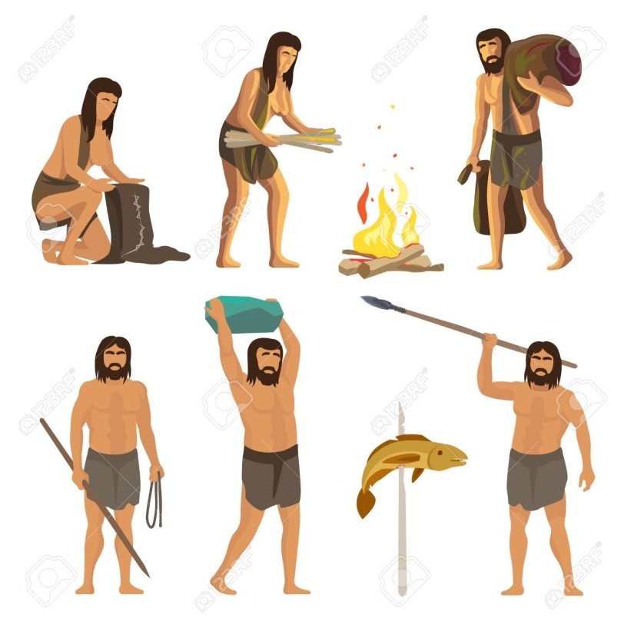
This represents:
A) The Bronze Age
B) The Stone Age
C) The Industrial Age
D) The Age of Empires
- A team of learners mapped out their school using symbols and keys. They were learning about:
A) Personal development
B) Mapwork and marginal information
C) Population growth
D) Business opportunities
- A family moved from Kisii to Nairobi due to the father's job transfer. This type of migration is known as:
A) International migration
B) Urban migration
C) Internal migration
D) Nomadic movement
- After attending a career talk, Shiro began growing sukuma wiki to sell and save money. This shows:
A) Exploration
B) Agricultural heritage
C) Entrepreneurship
D) Human evolution
- Mercy read an article about young people being forced to work in mines without pay. This is an example of:
A) Empowerment
B) Volunteering
C) Servitude
D) Peer mentoring
- While helping her cousin in schoolwork, Achieng explained that highland areas are cooler than coastal regions. The difference in temperature is caused by:
A) Soil type
B) Altitude
C) Humidity
D) Rotation
- During club activities, a peer insulted James. Instead of reacting with anger, James spoke calmly and reported to the teacher. This is a good example of:
A) Revenge
B) Violent conflict
C) Non-violent communication
D) Isolation
- A documentary on the Zulu community showed warriors defending their territory and strict laws being enforced. This shows that the Zulu had:
A) Weak leadership
B) Scientific technology
C) Strong political systems
D) Poor governance
- Students at Rafiki Junior School drew timelines showing historical development of farming in Africa. They found that agriculture first began:
A) In towns
B) Along trade routes
C) Near river valleys
D) Inside forests
- At a children’s rights club, pupils listed their rights and responsibilities. One right they mentioned was:
A) To hurt others
B) To play only
C) To access education
D) To steal food
- During a school trip, learners saw the following weather instrument.
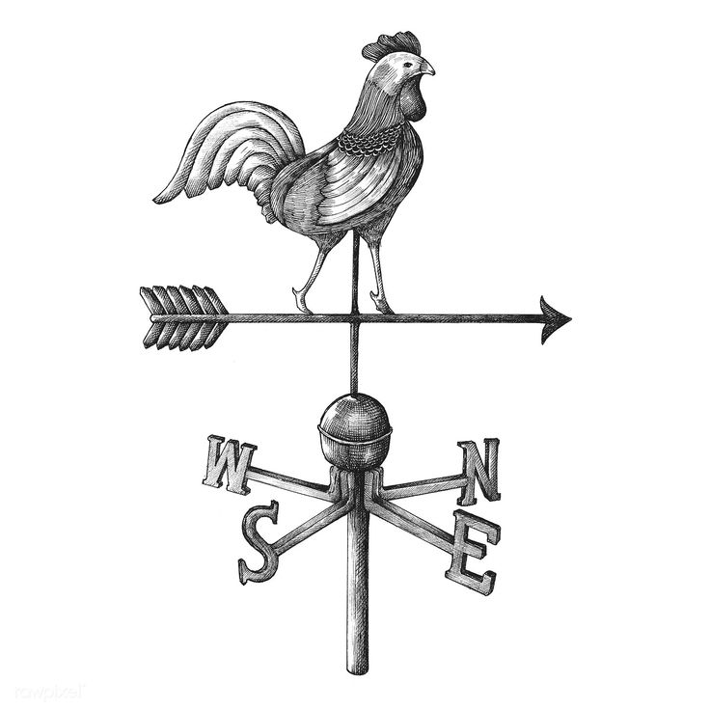
What is the name of the weather instrument?
A) Anemometer
B) Rain-gauge
C) Windsock
D) Wind-vane.

SECTION B: STRUCTURED QUESTIONS (80 MARKS)

Answer all questions in the spaces provided.

TASK 1: MAPWORK (5 MARKS)
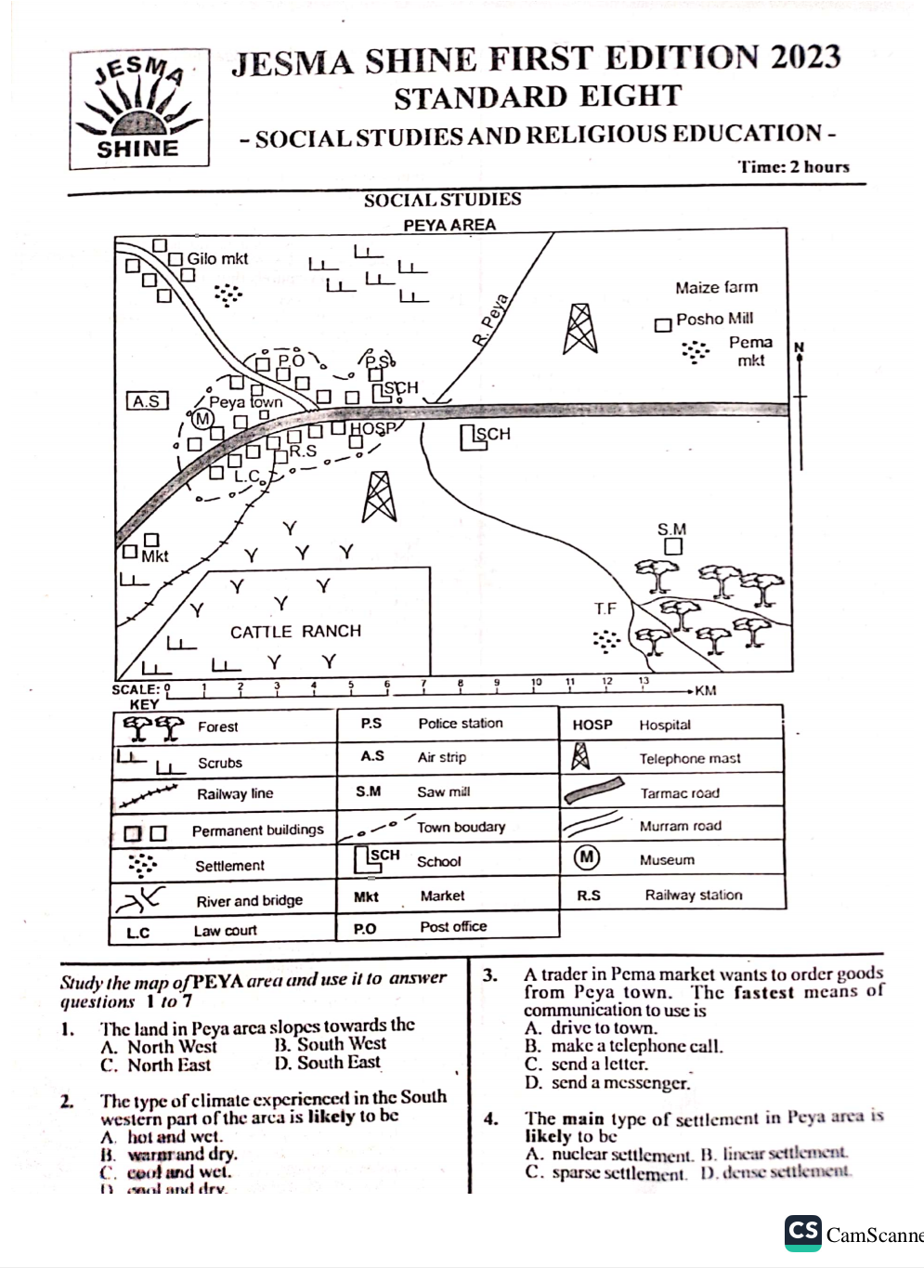
- During a class field trip, learners were given the sketch map below.

a) What type of settlement is found in Peya Area? (1 mark)
……………………………………………………………………………….………………………………..…………
b) State one method used to show vegetation on a map. (1 mark)
…………………………………………………………………………………………………………………………..
c) What is the approximate area of the cattle ranch in Peya Area in km²? (1 mark)

d) Identify one natural feature on the map. (1 mark)
………………………………………………………………………………………………………………………
e) Identify the type of scale used in the map. (1 mark)
……………………………………………………………………………………………………………………….

TASK 2: CITIZENSHIP (5 MARKS)
- A group of learners at Pamoja School created a constitution for their environmental club.
a) What is a constitution? (1 mark)
……………………………………………………………………………………………………………………
……………………………………………………………………………………………………………………
b) Name two components of the Constitution of Kenya. (2 marks)
- …………………....………………………………………………………………………………………
- ……………………………………………………………………………………………………………
c) State two qualities of a good citizen shown by the club. (2 marks)
- …………………....………………………………………………………………………………………
- …………………………………………………………………………………………………………….

TASK 3: HISTORY (30 MARKS)
- Little Leaders School drama club is preparing a play on the Trans-Saharan slave trade.
a) Name two factors that led to the development of the Trans-Saharan slave trade. (2 marks)
- …………………....………………………………………………………………………………………
- …………………………………………………………………………………………………………….
b) State two ways in which the trade was organized. (2 marks)
- …………………....………………………………………………………………………………………
- …………………………………………………………………………………………………………….
c) Identify two effects of the trade on African societies. (2 marks)
- …………………....………………………………………………………………………………………
- …………………………………………………………………………………………………………….
- During a digital heritage project, learners studied early humans in Africa.
a) State the scientific theory that explains the origin of humans. (1 mark)
…………………....………………………………………………………………………………………
b) Name two changes that occurred in humans due to evolution. (2 marks)
- …………………....………………………………………………………………………………………
- …………………………………………………………………………………………………………….
c) Explain how the discovery of fire helped early humans. (2 marks)
- …………………....………………………………………………………………………………………
- …………………………………………………………………………………………………………….
- A class presentation focused on early African civilizations such as Egypt and Great Zimbabwe.
a) State two features of early civilizations. (2 marks)
- …………………....………………………………………………………………………………………
- …………………………………………………………………………………………………………….
b) Name one best practice from ancient Egypt still used today. (1 mark)
…………………………………………………………………………………………………………………..
c) Why was the Nile River important to the Egyptian civilization? (2 marks)
- …………………....………………………………………………………………………………………
- …………………………………………………………………………………………………………….
- A group of pupils visited Fort Jesus in Mombasa.
a) Name two other historical monuments found in Africa. (2 marks)
- …………………....………………………………………………………………………………………
- …………………………………………………………………………………………………………….
b) Suggest two ways of protecting historical sites. (2 marks)
- …………………....………………………………………………………………………………………
- …………………………………………………………………………………………………………….
- After learning about the Ogiek and Asante communities, learners made posters on African heritage.
a) State one economic activity practiced by the Ogiek. (1 mark)
………………………………………………………………………………………………………….……….
b) Describe one social organization of the Asante community. (2 marks)
…………………………………………………………………………………………………….…………….
c) Mention one political system used by the Zulu. (1 mark)
……………………………………………………………………………………………………………………

TASK 4: GEOGRAPHY (30 MARKS)
- After watching a documentary on global warming, a class discussed climate in Africa.
a) Name three factors influencing climate in Africa. (3 marks)
- …………………....………………………………………………………………………………………
- …………………………………………………………………………………………………………….
- …………………………………………………………………………………………………………….
b) State two characteristics of the desert climate. (2 marks)
- …………………....………………………………………………………………………………………
- …………………………………………………………………………………………………………….
- The map below shows the location of some vegetation regions of Africa. Use it to answer
the questions that follow:
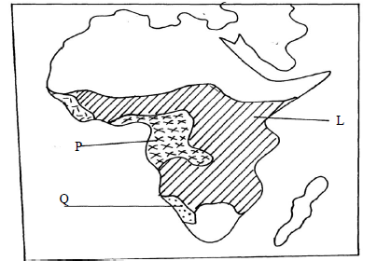
(a)i) Name the grassland region marked L
…………………………………………………………………………………………..…………
ii) Describe the characteristics of the natural vegetation found in the shaded area P
…………………………………………………………………………………………………………..
b)Explain two ways in which the vegetation found in the area marked Q adapts to the
environmental conditions of the region
……………………………………………………………………………………………………………
……………………………………………………………………………………………………………
- A Grade 8 class studied maps showing land use and rainfall distribution.
a) Explain the meaning of relief. (1 mark)
………………………………………………………………………………………………………………………
………………………………………………………………………………………………………………………
b) Describe one method of showing relief on a map. (2 marks)
……………………………………………………………………………………………………………………..
…………………………………………………………………………………………………………………….
c) State two reasons why relief is important to human activities. (2 marks)
  - …………………………………………………………………………………….………………
  - …………………………………………………………………………………………………….

- Pupils used different types of map scales in their assignment.
a) Name two types of map scales. (2 marks)
    - ……………………………………………………………………………………………….
    - ………………………………………………………………………………………………..
b) Convert a representative scale of 1:100,000 into a statement scale. (1 mark)

- During weather week, the school installed a rain gauge.
a) Name two elements of weather that can be recorded in a school. (2 marks)
    - …………………………………………………………………………………………………….
    - …………………………………………………………………………………………………….
b) Give one reason for studying weather. (1 mark)
…………………………………………………………………………………………………………………..
c) State two ways weather affects human activity. (2 marks)
  - …………………………………………………………………………………….………………
  - …………………………………………………………………………………………………….

TASK 5: LIFE SKILLS AND PERSONAL DEVELOPMENT (10 MARKS)
- During a mentorship session, learners were taught how to manage peer pressure.
a) Define peer pressure. (1 mark)
………………………………………….……………………………………………………………………….
…………………………………………………………………………………………………………………...
b) State two effects of negative peer pressure. (2 marks)
  - …………………………………………………………………………………….………………
  - …………………………………………………………………………………………………….
c) Give one way learners can build confidence to resist peer pressure. (1 mark)
……………………………………………………………………………………………………………………
- A pupil at Tumaini School felt sad after being bullied but did not report it.
a) Suggest two ways of managing emotions after a conflict. (2 marks)
  - …………………………………………………………………………………….………………
  - …………………………………………………………………………………………………….
b) Define empathy. (1 mark)
…………………………………………………………………………………………………………………..
…………………………………………………………………………………………………………………..
c) Give one reason why it is important to show empathy to others. (1 mark)
………………………………………………………………………………………………………………….
…………………………………………………………………………………………………………………..
d) Mention one way learners can build healthy self-esteem. (1 mark)
…………………………………………………………………………………………………………………
…………………………………………………………………………………………………………………..

THIS IS THE LAST PRINTED PAGE.

