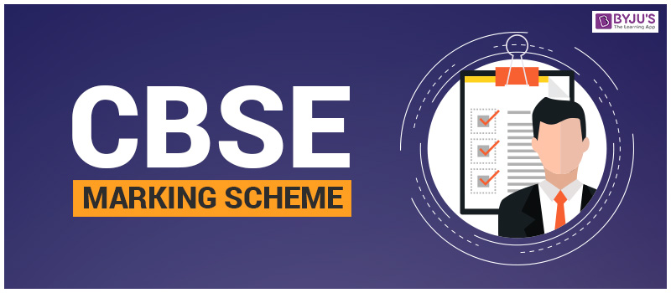
COMPETENCE BASED EDUCATION
GRADE 8
CODE: 009/2025
MATHEMATICS



SECTION A: MULTIPLE CHOICE QUESTIONS

Question No. | Answer
1 | D
2 | B
3 | D
4 | B
5 | A
6 | D
7 | C
8 | A
9 | D
10 | A
11 | D
12 | B
13 | A
14 | A
15 | C
16 | A
17 | C
18 | C
19 | A
20 | B
21 | C
22 | B
23 | D
24 | D
25 | A
26 | C
27 | D
28 | C
29 | B
30 | C

SECTION B: STRUCTURED QUESTIONS

  - Second quarter = 1,250,500 + 150,000 = 1,400,500 bags (2 marks)
- Total = 1,250,500 + 1,400,500 + 875,750 = 3,526,750 bags (2 marks)
- Remaining to target = 5,000,000 - 3,526,750 = 1,473,250 bags (2 marks)

  - Rectangle perimeter: 2(20 + 14) = 68 m. Semicircle perimeter = (1/2) x 2πr = πr = 22/7 x 7 = 22 m Total = 68 + 22 = 90 m (3 marks)
- Posts: 90/2 = 45 posts (3 marks)
- Area = Rectangle + semicircle = 20x14 + ($\frac{1}{2}$)πr² = 280 + ($\frac{1}{2}x\frac{22}{7}x 7 x 7$) = 280 + 77 = 357 m² (2 marks)

  - 3p + 2b = 130 p + 2b = 90 (2 marks)
- Subtract: (3p + 2b) - (p + 2b) = 130 - 90 2p = 40 → p = 20 From p + 2b = 90 → 20 + 2b = 90 → 2b = 70 → b = 35 Pen = 20, Book = 35 (2 marks)

  - Mode = 2 and 4 (both appear twice) (2 marks)
- Mean = (4+2+5+2+7)/5 = 20/5 = 4 (2 marks)
- [Bar graph to be drawn on grid: Mon - 4, Tue - 2, Wed - 5, Thu - 2, Fri - 7] (2 marks)

  - Use compass and ruler to construct triangle ABC (AB=6cm, BC=7cm, ∠ABC=60°)
Steps of construction :
  - Draw a line BC = 6 cm.
  - At B, draw a ray BX making an angle of 120° with BC. With B as center and radius 3.5 cm, cut off AB = 3.5 cm.
  - Join AC. ABC is the required triangle.
  - Draw perpendicular bisector of BC which cuts BC at point O. With O as center and radius = OB, draw a circle.
  - Draw angle bisector of ∠ABC which meets the circle at point P. Thus, point P is equidistant from AB and BC.
  - c. Measure ∠BCP.
  - Hence, ∠BCP = 30°.

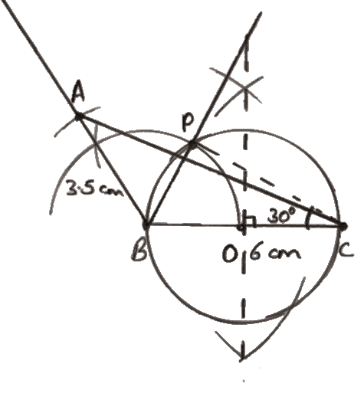

  - Hire purchase = Deposit + (12 x 2500) = 6000 + 30000 = 36,000 (2 marks)
- Extra cost = 36,000 - 30,000 = 6,000 (2 marks)

  - Triangle isosceles (JG = GH). Angle GFJ = 56°. So, angle JGH = 180 - 56 = 124° Since rhombus: angle HEF = 180 - 124 = 56° (2 marks)

  - Volume = πr²h = $\frac{22}{7}$ x (1.4)² x 3 = $\frac{22}{7}$ x 1.96 x 3 = 18.48 m³ (2 marks)
- Time = 18.48 / 1.54 = 12 minutes (2 marks)
- Surface in contact = base + sides = πr² + 2πrh = 6.16 + 26.4 = 32.56 m² (2 marks)

  - 120m → 6 cm, 80m → 4 cm (2 marks)
- Draw rectangle 6 cm by 4 cm (2 marks)
- Diagonal = √(120^2 + 80^2) = √(14400 + 6400) = √20800 ≈ 144.2 m (2 marks)

  - 360/45 = 8 sides (1 mark)
- Name: Octagon (1 mark)
- Interior angle = 180(n - 2) = 180(6) = 1080° (1 mark)

  - Year 1: 500,000 x 1.1 = 550,000; Year 2: 550,000 x 1.1 = 605,000 (2 marks)
- Year 1: 1,200,000 x 0.85 = 1,020,000; Year 2: x 0.90 = 918,000 (2 marks)

  - Plot A (-2,1), B (0,3), C (4,7)
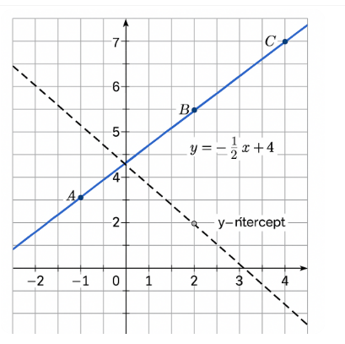
- Slope AB = (3-1)/(0+2) = $\frac{2}{2}$= 1 Slope BC = (7-3)/(4-0) = 4/4 = 1 Equal slope → Collinear (2 marks)

- Draw straight line through A, B, C (1 mark)
- Equation: y = x + 3 (from B: 3 = 0 + c) (1 mark)
- Line L2: y = -2x + 4 → y-intercept = (0,4) (1 mark)

THIS IS THE LAST PRINTED PAGE.

