Candidate’s Name |  | Assessment Number
School Name |  | School Code
Candidate’s Signature |  |   Date
KENYA JUNIOR SCHOOL EDUCATION ASSESSMENT (KJSEA)
GRADE 8: MATHEMATICS
CODE: 009 YEAR: 2025
TIME: 2 HOURS
INSTRUCTIONS TO LEARNERS
- Write your name and Assessment number in the spaces provided above.
- Sign and write the date of the assessment in the spaces provided above.
- This question paper consists of TWO sections: A and B.
- Answer ALL the questions in Section A on the separate ANSWER SHEET provided.
- Show all the workings in Section B in the spaces provided.
- Non-programmable calculators may be used, except where stated otherwise.
- Answer ALL the questions in Section B in the spaces provided in this QUESTION PAPER.
- For π, use either the calculator value or 3.142.
- Give non-exact numerical answers, correct to 3 significant figures and one decimal place for angles in degrees, unless a different level of accuracy is specified in the question.
- Do NOT remove any page from this question paper.
- Answer ALL the questions in English.
For Official Use Only
Qn No. | 1 | 2 | 3 | 4 | 5 | 6 | 7 | 8 | 9 | 10 | 11 | 12 | 13 | 14 | 15 | 16 | 17 | 18 | 19 | 20 | Total
Score | 1 | 1 | 1 | 1 | 1 | 1 | 1 | 1 | 1 | 1 | 1 | 1 | 1 | 1 | 1 | 1 | 1 | 1 | 1 | 1 | 20
Candidate’s score

Section B: Structured Questions (50 Marks)
Qn No. | 21a | 21b | 21c | 22a | 22b | 22c | 22d | 23a | 23b | 23c | 24a | 24b | 24c | 25a | 25b | 25c | 25d | 26a | 26b | 26c | 27a | 27b | 27c | Total
Marks | 2 | 2 | 3 | 1 | 3 | 2 | 4 | 3 | 3 | 2 | 4 | 1 | 2 | 2 | 3 | 2 | 1 | 1 | 2 | 4 | 2 | 1 | 2 | 50
Score

This paper consists of 18 printed pages. Candidates should check the question paper to ascertain that all the pages are printed as indicated and that no questions are missing.
© 2025 The Kenya Junior School Examination and Assessment Series. Turn over

SECTION A: (30 Marks)
Answer all questions in this section.

- What is the total value of the digit 7 in the number 47,863,591? A. Seven million B. Seventy thousand C. Seven hundred thousand D. Seventy million
- What is 89.956 rounded off to the nearest tenth? A. 89.9 B. 90.0 C. 89.96 D. 89.0
- What is the Greatest Common Divisor (GCD) of 24, 36, and 48? A. 6 B. 72 C. 144 D. 12
- Express $\frac{3}{5}$​ as a percentage. A. 35% B. 60% C. 0.6% D. 75%
- What is the next number in the sequence: 3, 6, 10, 15, 21, ___? A. 28 B. 25 C. 30 D. 27
- Which of the following numbers is a prime number? A. 51 B. 87 C. 91 D. 97
- A square piece of land has the same area as a rectangular plot measuring 45 metres by 36 metres.
What is the length of one side of the square land?
A. 240 m B. 81 m
C. 90 m D. 108 m
- A meeting started at 9:50 a.m. and ended at 12:15 p.m. How long did the meeting last? A. 2 hours 25 minutes B. 3 hours 35 minutes C. 1 hour 25 minutes D. 2 hours 35 minutes

- In the figure shown below, line EF is parallel to line GH. Line MN is a transversal. Which one of the following statements is correct?
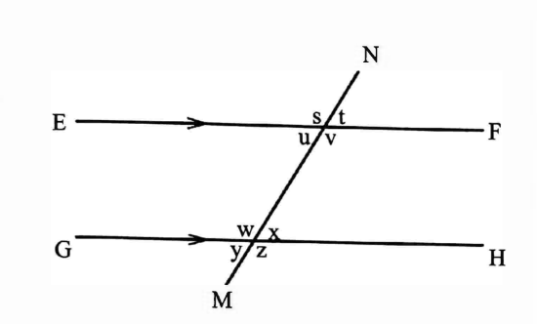
A. Angle (t + u) - 180°
B. Angle (u + x) = 180°
C. Angle (s + w) = 180°
D. Angle (u + w) = 180°
- What is the value of n in the equation
5n + 3 (n-4) = 36?
A. 8
B. 6
C. 5
D. 3
- In a ranch the ratio of goats to sheep is 4:3, sheep to cows 5:2 and cows to donkeys is 3:2. What is the ratio of goats to donkeys?
A. 1:2
B. 1:1
C. 2:1
D. 5:1
- A pupil left home for school at a speed of 5 km/h and returned at a speed of 4 km/h. The whole journey took 5 h 24 min. How far is the school from home, in kilometres?
A. 9
B. 12
C. 24
D. 27

- The volume of a cuboid is 120 cm³. If its length is 8 cm and width is 5 cm, what is its height? A. 3 cm B. 4 cm C. 15 cm D. 30 cm
- A family uses $\frac{3}{4}$​ of a litre of milk for breakfast and $½​$ of a litre for dinner. How much more milk is used for breakfast than for dinner? A. $\frac{1}{4}$​ L B. $\frac{1}{2}$​ L C. $1\frac{1}{4}$​ L D. $\frac{2​}{3}$ L
- A farmer buys 2 bags of fertilizer and 3 bags of seed for Ksh 1,050.
Another farmer buys 3 bags of fertilizer and 2 bags of seed for Ksh 1,100.
What is the cost of one bag of fertilizer?
A. Ksh 150
B. Ksh 200
C. Ksh 250
D. Ksh 300
- Solve the inequality: 3x−5<10 A. x<5 B. x>5 C. x<15 D. x>3
- What is the sum of the interior angles of a hexagon? A. 360° B. 540° C. 720° D. 180°
- A bag contains 5 red balls and 3 blue balls. What is the probability of picking a blue ball at random? A. $\frac{3}{5}$​ B. $\frac{5}{8}$​ C. $\frac{3}{8}$​ D. $½​$
- A student's scores in five subjects were 65, 70, 85, 80, and 75. What is the mean score? A. 75 B. 80 C. 70 D. 77

- The price of an article was decreased from Ksh 250 to Ksh 200. What was the percentage decrease? A. 80% B. 25% C. 50% D. 20%
- The angles of a triangle are in the ratio 1:2:3. What is the size of the largest angle? A. 30° B. 60° C. 90° D. 120°
- A conference room measures 24m by 12m. Square carpets of 4 metres long, each costing sh 12000 were used to completely cover the floor. How much did it cost to cover the floor?
A.sh 48000 B. sh 72000
C. sh 216000 D. sh 864000
- A train timetable for station J to 0 is given below
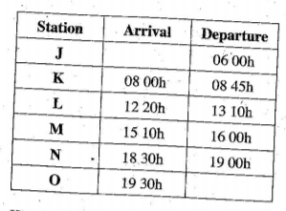
How long does the train take from station L to N?
A. 6h 40min B. 6h 10min
C.5h 50min D. 5h 20mins

- What is the sum of the vertices and faces in a triangular pyramid?
A. 11 B. 10 C.8 D. 7
- The pie chart below shows how DCalll spends his monthly salary on food, clothing, fees, transport and savings.
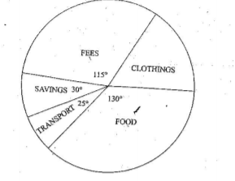
If he spends sh 6000 on clothing, how much more money does he spend on food than fees?
A. sh 1500 B. sh 11500
C. sh 13000 D. sh 36000
- The perimeter of the figure below is 1120 metres.
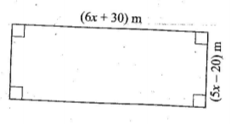
What is the area of the figure in acres?
A. 7.59
B. 75.9
C. 759
D. 75900

- The marked price of a wheelbarrow is sh 8600.Abachwas given 81% discount while Asha was given 7% discount for a similar wheelbarrow. How much money was received as discount by Abach and Asha all together?
A. sh 129
B. sh 602
C. sh 1333
D. sh 2064
- Wakesho collects Y50 eggs daily from her poultry. She sells the eggs at sh 9 each. How much money did she make in the month of February, 2008?
A. sh 405.00 B. sh 39150
C. sh 37800 D. sh 1350

- Construct a circle touching the sides of triangle JKL drawn below.
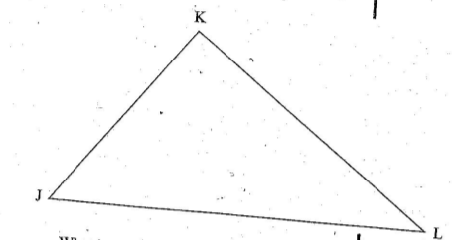
What is the length of the diameter of the circle
A.2cm B.4cm
C.5cm D.10cm

- Bestee spent his salary as shown in the figure below
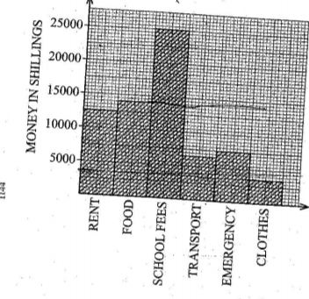
How much money does he spend on food than clothes?
A. 17500
B. 14000
C.10500
D.3500

SECTION B: (70 Marks)
Answer all questions in this section. Show your workings.
31. A factory produced 1,250,500 bags of cement in the first quarter of the year. In the second quarter, production increased by 150,000 bags. Due to a machine breakdown, the production in the third quarter was 875,750 bags.
a) How many bags were produced in the second quarter? (2 marks)

b) What was the total production for the first three quarters? (2 marks)

c) If the target for the year was 5,000,000 bags, how many more bags are needed to meet the target? (2 marks)

32. A farmer has a piece of land with the shape shown below, consisting of a rectangle and a semicircle. (Image: A rectangle with length 20m and width 14m. A semicircle is attached to one of the 14m sides.)
a) Calculate the perimeter of the entire piece of land. (Use π=$\frac{22}{7}$ (3 marks)

b) The farmer wants to fence the land. If fencing posts are placed 2 meters apart, how many posts will be required? (3 marks)

c) What is the total area of the land in square meters? (2 marks)

33. Amina bought 3 pens and 2 exercise books for Ksh 130. Juma bought 1 pen and 2 exercise books for Ksh 90 from the same shop. Let 'p' be the price of a pen and 'b' be the price of a book.
a) Form two simultaneous equations from the information above. (2 marks)

b) Solve the equations to find the cost of one pen and one exercise book. (2 marks)

34. The table below shows the number of students who were absent from a class in a particular week.
Day | Mon | Tue | Wed | Thu | Fri
Absentees | 4 | 2 | 5 | 2 | 7
a) What is the modal number of absentees? (2 marks)

b) Calculate the mean number of absentees for the week. (2 marks)

c) On the grid provided, draw a bar graph to represent this information. (2 marks)

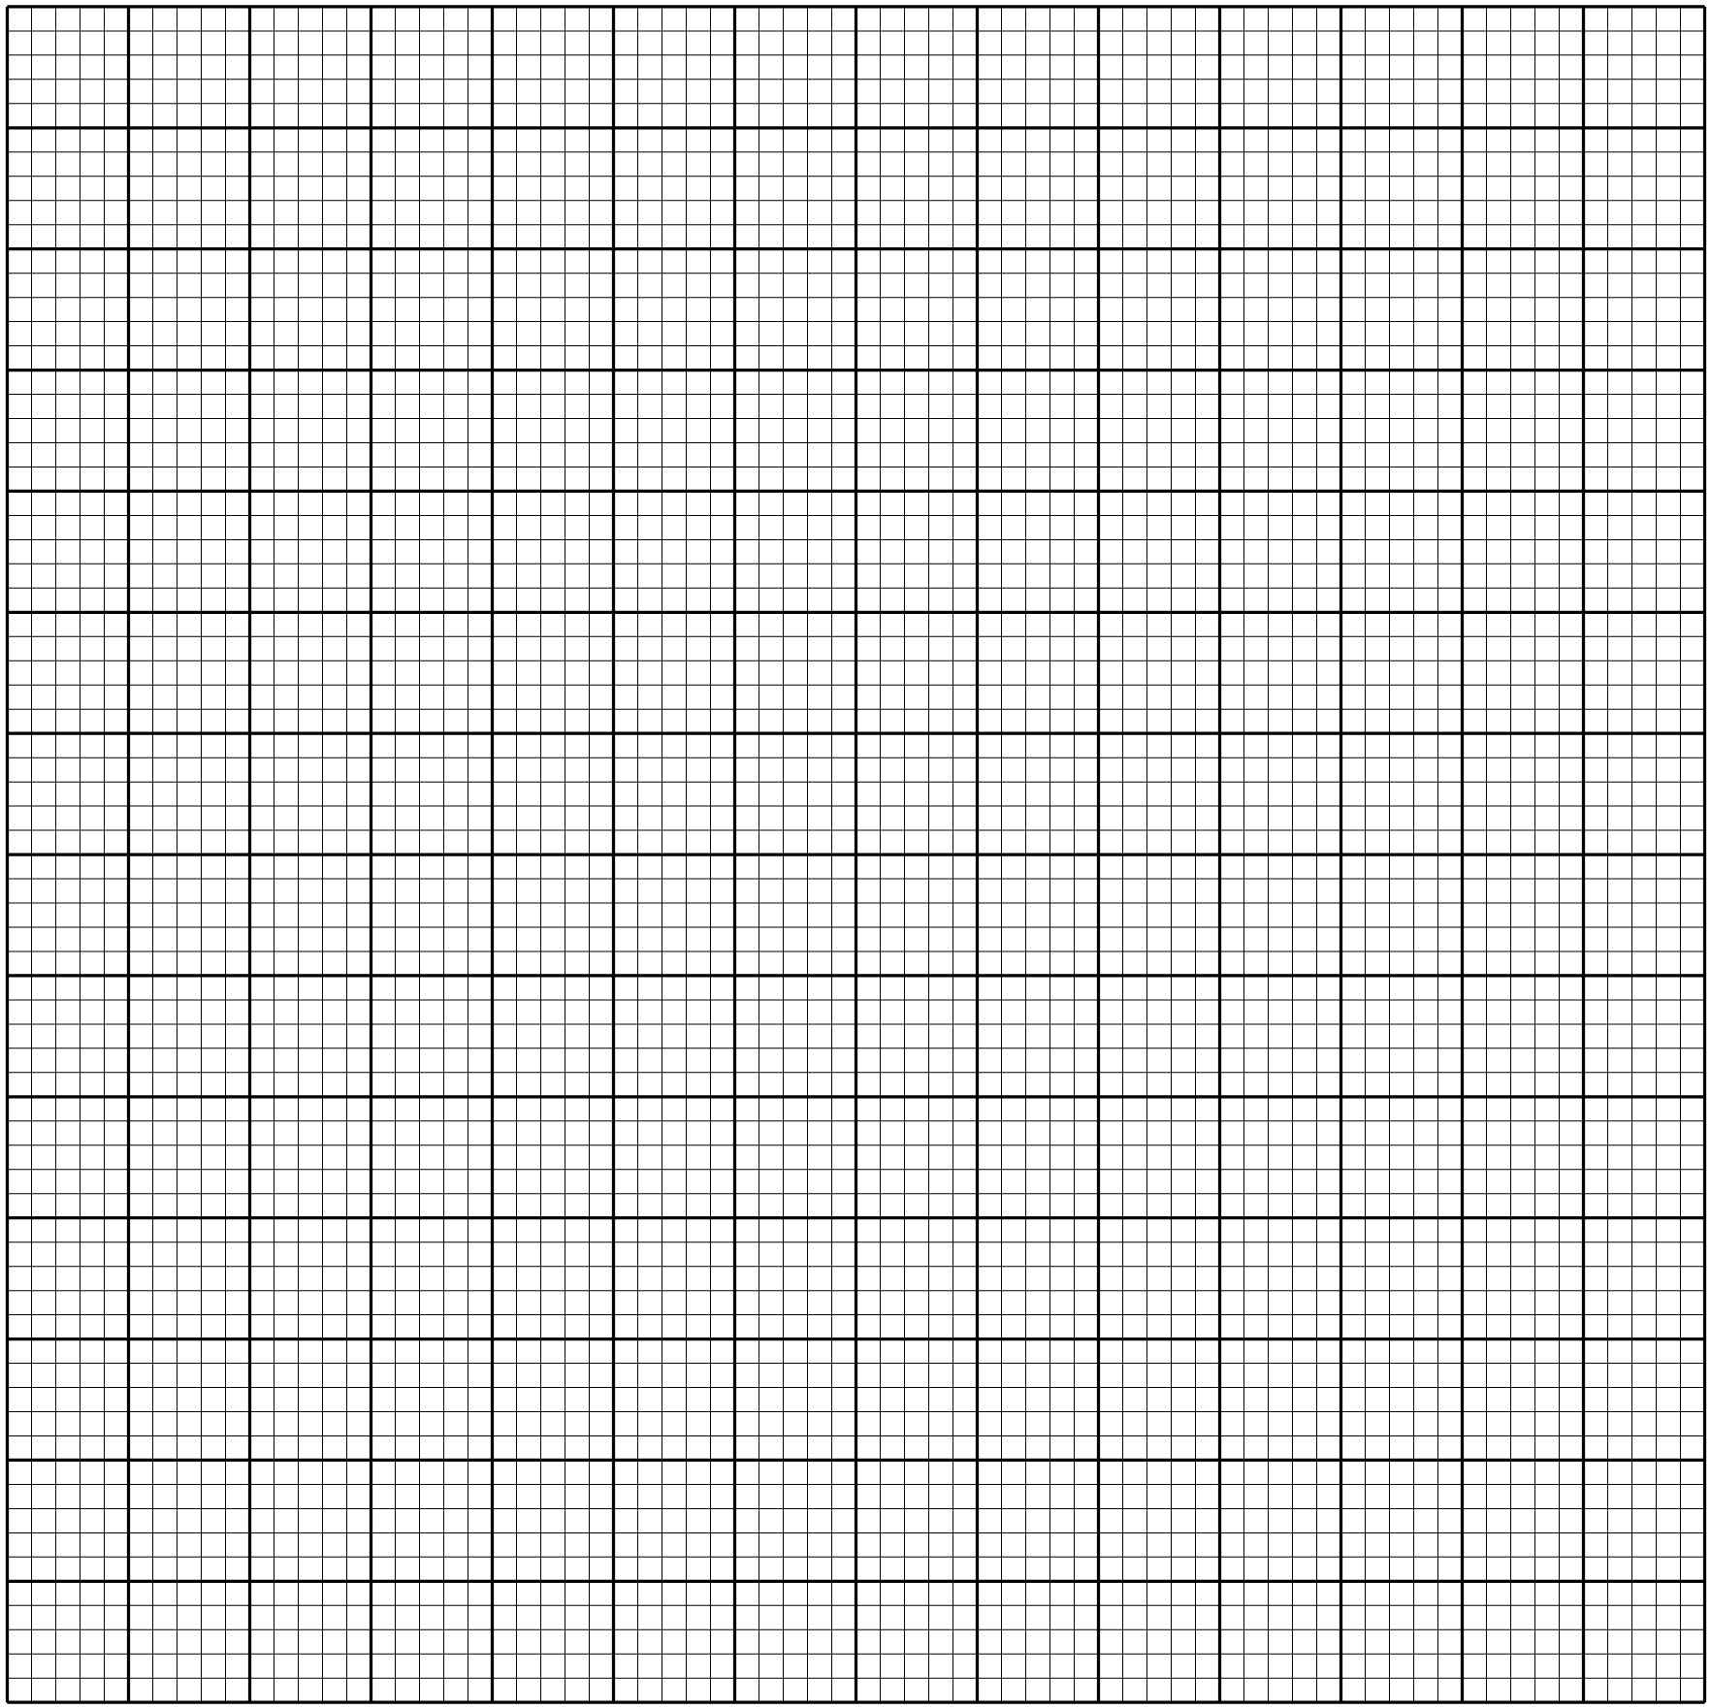

35. Using a ruler and a pair of compasses only:
(i) Construct a triangle ABC with the following data. (2 marks)
AB = 3.5 cm, BC = 6 cm and ∠ABC = 120°.

(ii) In same diagram, draw a circle with BC as diameter. Find a point P on the circumference of the circle which is equidistant from AB and BC. (2 marks)

(iii) Measure ∠BCP. (1 mark)

36. The cash price of a television is Ksh 30,000. It can also be bought on hire purchase terms by paying a deposit of Ksh 6,000 followed by 12 monthly installments of Ksh 2,500 each.
a) Calculate the total amount paid on hire purchase. (2 marks)

b) How much more does one pay on hire purchase than for cash? (2 marks)

37. In the figure below EFGFI is a rhombus and FG..1 is a triangle. Angle GFJ = 56° and JGH is a straight line. Line JG = line GH.
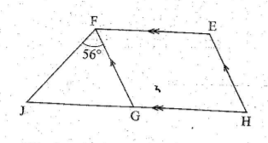
What is the size of angle HEF?( 2 marks)

38. A cylindrical water tank has a diameter of 2.8 meters and a height of 3 meters. (Use π=$\frac{22}{7}$​)
a) Calculate the volume of the tank in cubic meters. (2 marks)

b) If water flows into the tank at a rate of 1.54 cubic meters per minute, how long will it take to fill the tank? Give your answer in minutes. (2 marks)

c) Find the surface area of the tank that is in contact with water when it is full . (2 marks)

39. A rectangular field measures 120m long by 80m wide.
a) Using a scale of 1 cm represents 20 m; calculate the dimensions of the field on the drawing. (2 marks)

b) Draw the scale diagram of the field. (2 marks)

c) From the drawing, find the length of the diagonal of the field in meters. (2 marks)

40.The exterior angle of a regular polygon is 45°.
a) How many sides does the polygon have? (1 mark)

b) What is the name of the polygon? (1 mark)

c) Calculate the sum of its interior angles. (1 mark)

41. a) A piece of land was bought for Ksh 500,000. Its value appreciated by 10% each year for two years. What was its value after two years? (2 marks)

b) A car was bought for Ksh 1,200,000 and its value depreciated by 15% in the first year and 10% in the second year. Find the value of the car after the two years. (2 marks)

42. a) On the grid provided, plot the points A (-2, 1), B (0, 3), and C (4, 7).
b) Show that the points A, B, and C are collinear (lie on the same straight line).

c) Draw the line passing through A, B, and C.

d) Determine the equation of the line.

e) Another line, L2​, has the equation y=−$\frac{1}{2}$​x+4. Find the coordinates of the y-intercept of L2​ and draw it on the same grid.

THIS IS THE LAST PRINTED PAGE.

