Candidate’s Name |  | Assessment Number
School Name |  | School Code
Candidate’s Signature |  | Date

KENYA JUNIOR SCHOOL EDUCATION ASSESSMENT (KJSEA)
GRADE 7: INTEGRATED SCIENCE
PAPER 2 (Practical)
CODE: 008 YEAR: 2025
TIME: 2 HOURS
INSTRUCTIONS TO CANDIDATES:
- Write the name and code of your school in the spaces provided above.

- Sign and write the date of the assessment in the spaces provided above.

- This paper consists of 2 questions.

- Answer BOTH questions in the spaces provided on this QUESTION PAPER.

- Do NOT remove any page from this question paper.

- Answer the questions in English.

FOR OFFICIAL USE ONLY.

For Official Use Only
Task | Task 1 | Task 2 | TOTAL
Question | 1 | 2 | 3QUESTIONS
Maximum Score | 20 | 10 | 30 MARKS
Candidate’s Score

This paper consists of 6 printed pages. Candidates should check the question paper to ascertain that all the pages are printed as indicated and that no questions are missing.
© 2025 The Kenya Junior School Examination and Assessment Series. Turn over

QUESTION ONE (20 marks)
You are provided with a mixture of sand and salt in a beaker, a glass rod, a filter funnel, filter paper, a glass beaker, and distilled water.
a) Describe the steps you would take to separate the sand from salt in the mixture. (List in the correct order)
(6 marks)
- …………………………………………………………………………………………………………………
- …………………………………………………………………………………………………………………
- ………………………………………………………………………………………………………………….
- ………………………………………………………………………………………………………………….
- ………………………………………………………………………………………………………………….
- ………………………………………………………………………………………………………………….
b) State the method used to separate:
(i) Sand from the mixture…………………………………………………………………….. (1 mark)
(ii) Salt from the solution: …………………………………………………………………….. (1 mark)
c) Identify three basic laboratory instruments used in this activity.
(3 marks)
- ………………………………………………………………………………………………………………….
- …………………………………………………………………………………………………………………..
- ………………………………………………………………………………………………………………….
d) State two reasons why it is important to observe laboratory safety when handling mixtures.
(2 marks)
- …………………………………………………………………………………………………………………
- …………………………………………………………………………………………………………………
e) Give two examples of mixtures used in everyday life and state how they can be separated.
(4 marks)
Mixture | Method of Separation
f) Draw and label a filtering set-up used in this activity. (3 marks)

QUESTION TWO (10 marks)
You are provided with:
- A tape measure
- A human torso model or diagram
- Labels: Kidney, Ureter, Bladder, Urethra

a) Use the torso or diagram to:
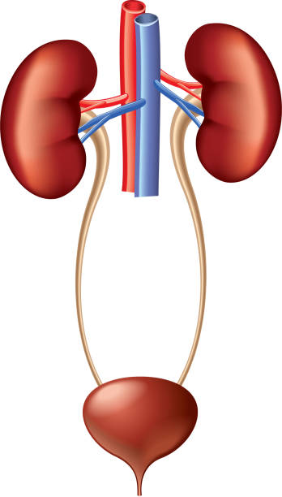
(i) Identify and label the four main parts of the human excretory system using the labels provided.(4 marks)

b) Match each excretory organ below with its function correctly :( 3 marks)
Organ | Function
Kidney | Stores urine temporarily before it is excreted from the body.
Bladder | Carries urine from the bladder to the outside of the body during urination.
Urethra | Filters waste products and excess water from the blood to form urine.

c) Identify the kidney disorders below. (1 mark)
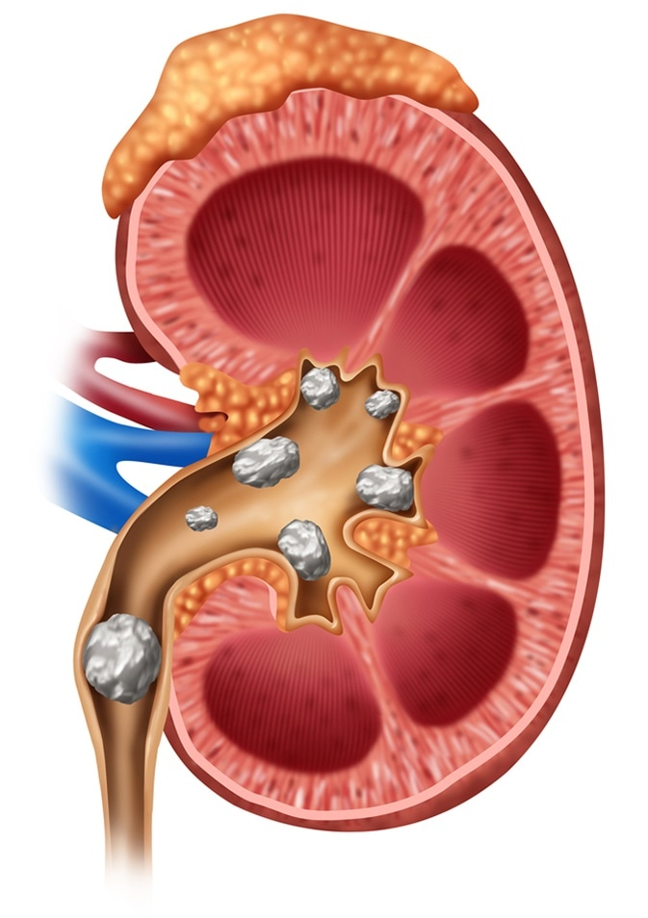
…………………………………………………………………

d) Apart from the disease you have identified in © above, mention one more kidney disease.(1mark)

…………………………………………………………………………

e) The teacher has provided the picture below of a tool used to measure length.



State the SI unit used to measure length. (1 mark)
………………………………………………………………………………………………………………………….
………………………………………………………………………………………………………………………….

THIS IS THE LAST PRINTED PAGE.

