Candidate’s Name |  | Assessment Number
School Name |  | School Code
Candidate’s Signature |  | Date

MONITORING JUNIOR SCHOOL LEARNER PROGRESS
GRADE 7: 705/1: INTEGRATED SCIENCE
PAPER 1 (Theory) CODE: 009 YEAR: 2025 TIME: 2 HOURS
INSTRUCTIONS TO CANDIDATES:
1. Write your name and assessment number in the spaces provided.
2. Answer ALL questions.
3. Section A: 30 multiple-choice questions (30 marks).
4. Section B: 20 structured questions (40 marks).
5. Use diagrams, images, and symbols to answer questions where necessary.
6. Draw clear, neat, and labeled diagrams where required.

For Official Use Only

SECTION B
Task | Question | Score per question | Maximum score | Candidate’s score
Task 1 | 31 |  | 03
 | 32 |  | 02
Task 2 | 33(a) |  | 02
 | 33(b) |  | 01
 | 34 |  | 03
 | 35 |  | 03
Task 3 | 36 |  | 03
 | 37 |  | 03
 | 38 |  | 03
 | 39(a) |  | 01
 | 39(b) |  | 01
Task 4 | 40(a) |  | 02
 | 40(b) |  | 02
 | 41 |  | 02
 | 42 |  | 02
 | 43 |  | 02
 | 44 |  | 03
 | 45 |  | 02
 | 46 |  | 02
 | 47 |  | 01
 | 48 |  | 02
 | 49 |  | 02
 | 50 |  | 03
Total Section B |  | Overall Total | 40
This paper consists of 9 printed pages. Candidates should check the question paper to ascertain that all the pages are printed as indicated and that no questions are missing.
© 2025 The Kenya Junior School Examination and Assessment Series. Turn over
SECTION A: 30 MARKS
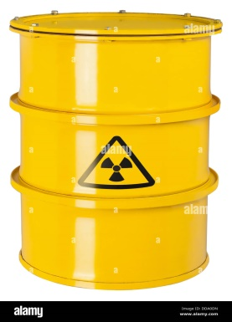
- Wanjiku saw this sign on a certain container:

What does this laboratory symbol mean? A. Corrosive
B. Flammable
C. Toxic
D. Radioactive
- A mixture of sand and iron filings was given to students. Mary suggested using a magnet to separate them. Why is this method effective? A. Sand is heavier
B. Iron is magnetic
C. Sand dissolves in water
D. Filings float
- The image below shows types of circuits:
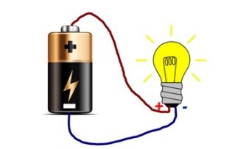
Which one represents a short circuit?

A

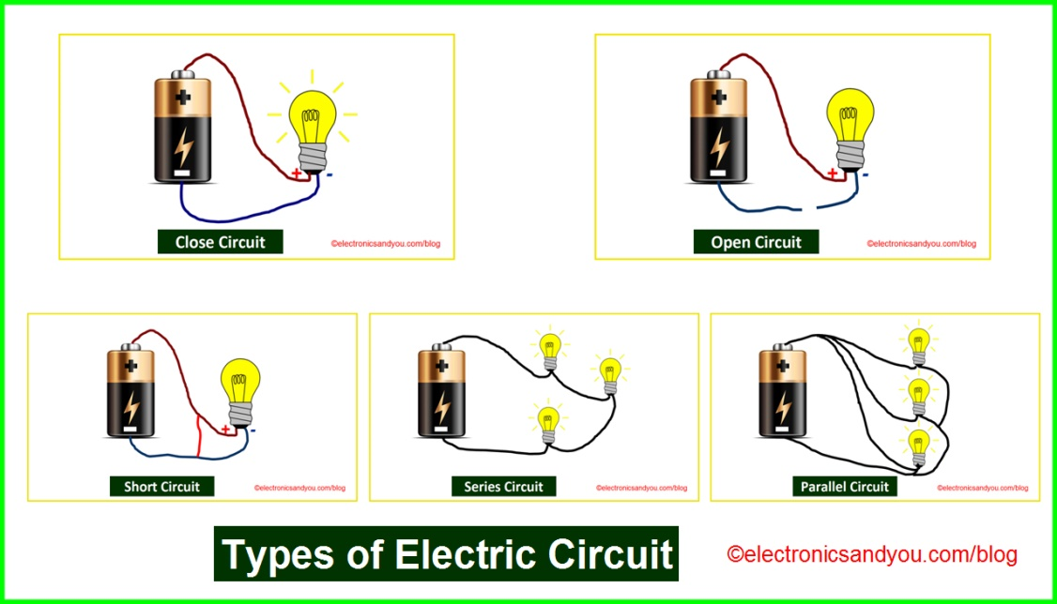

B

C

D

- In a science lesson, Diana poured oil into water and saw that the two liquids did not mix. What kind of mixture is this? A. Solution
B. Suspension
C. Emulsion
D. Colloid
- The diagram below shows the human male reproductive system:
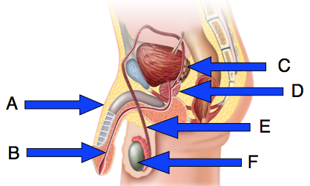
Which part produces sperm cells?
A. B
B. C
C. E
D. F
- Salim suffered a minor burn on his arm during an experiment. What is the first aid procedure? A. Rub with lotion
B. Put in cold running water
C. Apply butter
D. Cover with cloth
- The instrument below was used by a student in the lab:
What is reading of Vernier calipers as shown in figure below?
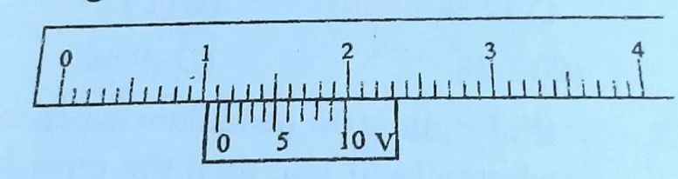1MSD=1 mm
- 1.15 cm
- 1.055 cm
- 1.05 mm
- 1.55 mm
- Grade 7 learners visited a certain Hospital and the doctor displayed the parts of a heart and asked them a question.
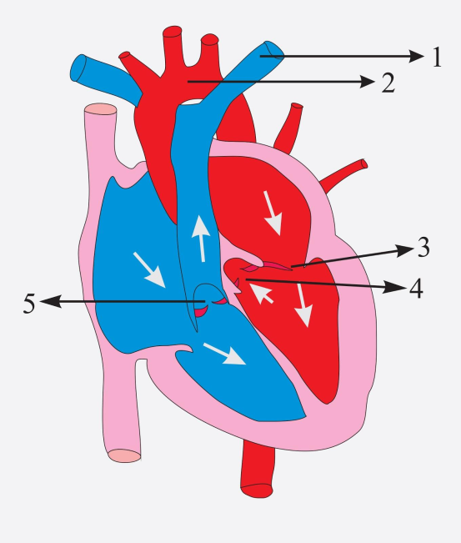
The blood vessel labelled 1 is called A. Vena cava
B. Pulmonary vein
C. Aorta
D. Pulmonary artery
- A student used red and blue litmus paper to test a solution. Both papers stayed the same. What is the solution? A. Neutral
B. Acidic
C. Basic
D. Weak acid
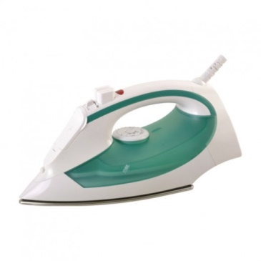
- A kidney removes excess salts and water from the body. Which process is this? A. Circulation
B. Excretion
C. Digestion
D. Absorption
- Identify the appliance below.

A. Water heater
B. Flat iron
C. Kettle
D. Blender
- The SI unit of temperature is: A. Degree
B. Celsius
C. Fahrenheit
D. Kelvin
- Identify the method suitable for separating chalk from water: A. Sieving
B. Decanting
C. Filtration
D. Evaporation
- The diagram shows two bar magnets:
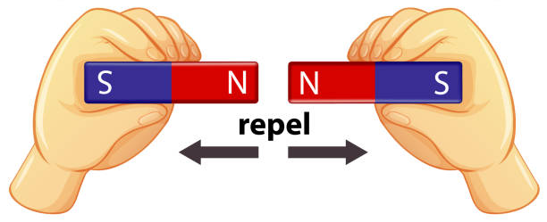

What poles are facing each other?
A. North and South
B. North and North
C. North and North
D. South and North
- Jane was asked to record the time taken for water to boil. Which SI unit should she use?
A. Celsius
B. Seconds
C. Minutes
D. Litres
- Which component of Integrated Science deals with acids and indicators? A. Life science
B. Physical science
C. Earth science
D. Social science
- Ali observed that a bar magnet attracts pins but a plastic rod does not. What can we conclude?
A. Plastic is magnetic
B. Pins are non-magnetic
C. Only metals are useful
D. Magnets attract magnetic materials only
- Ali observed that a bar magnet attracts pins but a plastic rod does not. What can we conclude?
A. Plastic is magnetic
B. Pins are non-magnetic
C. Only metals are useful
D. Magnets attract magnetic materials only
- During a separation of mixtures lesson, learners were presented with the following setup.:
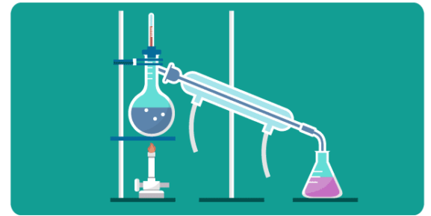
What method will best separate this mixture?
A. Filtration B. Evaporation
C. Distillation D. Decanting
- The image shows a broken beaker with spilled acid:
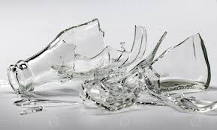
What is the first step you should take?
A. Wipe it with cloth
B. Call the teacher
C. Ignore it
D. Add water
- Which of the following is a characteristic property of acids?
A. They turn red litmus paper blue.
B. They have a pH greater than 7.
C. They react with metals to produce hydrogen gas.
D. They feel slippery to the touch.
- During a demonstration, the teacher mixed iron filings and sulphur and heated them. What type of change took place?
A. Physical B. Magnetic
C. Chemical D. Reversible
- Which instrument is used to measure mass? A. Stopwatch B. Thermometer
C. Beam balance D. Ruler
- Which of the following is a component of the human reproductive system in females?
A. Penis B. Urethra
C. Ovary D. Scrotum
- What is the first aid response to a simple fracture?
A. Massage the area
B. Bandage tightly
C. Support and keep still
D. Soak in warm water
- Which material is magnetic?
A. Wood B. Glass
C. Plastic D. Steel
- Which property of magnets is correct?
A. They repel all metals
B. They attract non-metals
C. Like poles attract
D. Opposite poles attract
- The device below converts electrical energy into light energy:
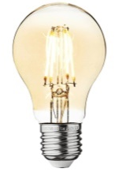
What is the name of this device?
A. Iron B. Bulb C. Kettle D. Fuse
- What is the function of the ureter in the excretory system?
A. Filters blood
B. Stores urine
C. Carries urine to bladder
D. Produces urine
- Adolescents often experience emotional changes. Which is an appropriate way to manage them? A. Fighting
B. Talking to a trusted adult
C. Isolating oneself
D. Ignoring emotions

SECTION B: STRUCTURED QUESTIONS (40 MARKS)
Answer all questions in the spaces provided below.
- The diagram below shows some laboratory equipment. Identify each item and state its use. (3 marks)
Item | Name | Use
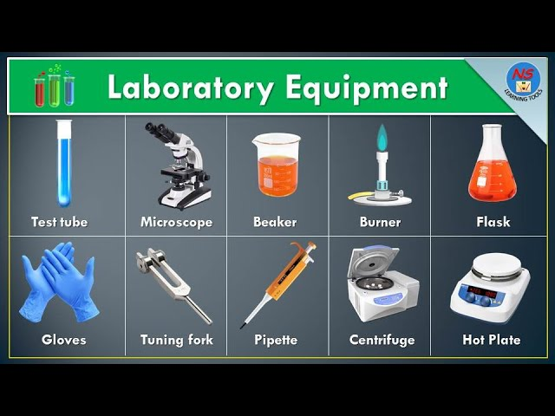

- A class conducted an experiment where they mixed water and salt. Describe how they would recover pure salt from the mixture. (2 marks)
……………………………………………………………………………………………………………………….
………………………………………………………………………………………………………………………..
……………………………………………………………………………………………………………………….
- Use the diagram below to answer:
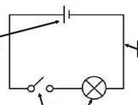

A

B

C D
- Name each component. (2 marks)
C:………………………………………………………………
D: ……………………………………………………………..
- What will happen when the switch is closed? (1 mark)
…………………………………………………………………………………………………………….
……………………………………………………………………………………………………………..
- Explain three differences between acids and bases. (3 marks)
……………………………………………………………………………………………………………….
……………………………………………………………………………………………………………….
………………………………………………………………………………………………………………..
……………………………………………………………………………………………………………….
- Jane got a small cut on her hand while using a scalpel. State three first aid steps she should take. (3 marks)
………………………………………………………………………………………………………………
………………………………………………………………………………………………………………
………………………………………………………………………………………………………………
- The table below shows changes in adolescents:
Change | Physical or Emotional?
Growth of beards
Mood swings
Breast development
- Fill in the correct category for each. (3 marks)
- Study the diagram below and answer the question that follow.. (3 marks)
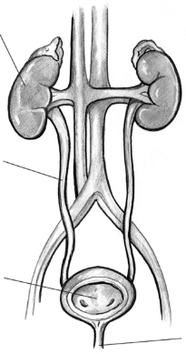
A

B

C

D

Identify the labelled parts:
B: ……………………………………………..
C: …………………………………………….
D: …………………………………………….
- Name two common kidney disorders and one way to prevent them. (3 marks)
- ……………………………………………………….
- ……………………………………………………….
- The diagram shows separation of a mixture:
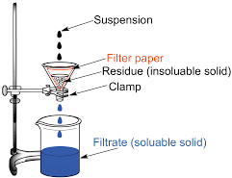
- Name the method shown. (1 mark)
…………………………………………………………………………………………………………
- Name one mixture that can be separated using this method. (1 mark)
…………………………………………………………………………………………………………
- Mention two applications of magnets in everyday life. (2 marks)
- …………………………………………………………………………………………………….
- …………………………………………………………………………………………………….
- State two properties of magnetic materials. (2 marks)
- ……………………………………………………………………………………………………..
- …………………………………………………………………………………………………….
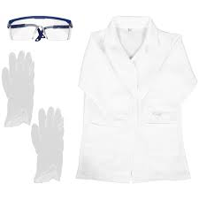
- The image shows various safety gears in a laboratory.

List two reasons why this gear is important. (2 marks)
- ……………………………………………………………………………………………………….
- ……………………………………………………………………………………………………….
- The table shows different instruments and their functions:
Complete the missing functions. (2 marks)

Instrument | Function
Thermometer
Beam balance
- Identify the components of Integrated Science. (3 marks)
- …………………………………………………………………………………….
- …………………………………………………………………………………….
- …………………………………………………………………………………….
- State two reasons why we study Integrated Science. (2 marks)
- …………………………………………………………………………………………………………….
- ……………………………………………………………………………………………………………
- Name two magnetic and two non-magnetic materials. (2 marks)
Magnetic materials | Nonmagnetic materials
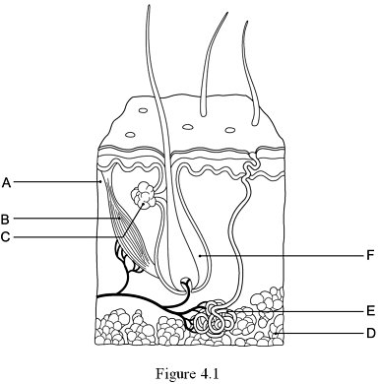
- The diagram shows parts of the human skin.

Identify parts F, E, and D. (3 marks)
F: ……………………………………………………..
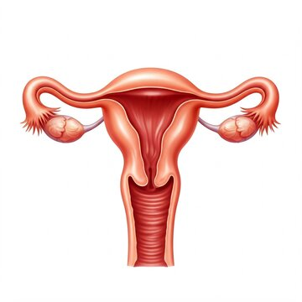
E: ……………………………………………………..
D: ……………………………………………………..
- Study the diagram below.
M

What is the function of the part labelled M? ( 1 mark)
……………………………………………………………………………………………………………..
- Give two examples of common electrical appliances found at home and the energy they convert. (2 marks)
- ……………………………………………………………………………..
- ……………………………………………………………………………..
- Differentiate between a solution and a suspension. Give one example of each. (2 marks)
…………………………………………………………………………………………..……………………
…………………………………………………………………………………………..……………………
………………………………………………………………………………………………………………..
- The diagram shows an SI unit table: Fill in the missing SI units. (3 marks)
Quantity | SI Unit
Time
Length
Mass

THIS IS THE LAST PRINTED PAGE.

