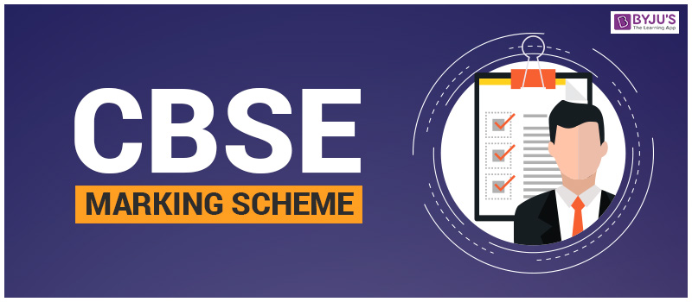
COMPETENCE BASED EDUCATION
GRADE 7
CODE: 009/2025
ENGLISH PP1



Qn | Ans | Qn | Ans | Qn | Ans | Qn | Ans | Qn | Ans
1 | C | 11 | B | 21 | B | 31 | A | 41 | C
2 | C | 12 | C | 22 | B | 32 | B | 42 | C
3 | B | 13 | C | 23 | B | 33 | B | 43 | A
4 | C | 14 | C | 24 | B | 34 | A | 44 | B
5 | C | 15 | C | 25 | C | 35 | A | 45 | A
6 | C | 16 | B | 26 | B | 36 | A | 46 | C
7 | B | 17 | C | 27 | B | 37 | B | 47 | C
8 | C | 18 | B | 28 | C | 38 | C | 48 | B
9 | B | 19 | A | 29 | C | 39 | A | 49 | A
10 | C | 20 | D | 30 | A | 40 | C | 50 | A

THIS IS THE LAST PRINTED PAGE.

