Candidate’s Name |  | Assessment Number
School Name |  | School Code
Candidate’s Signature |  |   Date
KENYA JUNIOR SCHOOL EDUCATION ASSESSMENT (KJSEA)
GRADE 7: CREATIVE ARTS AND SPORTS
PAPER 2 (Theory) CODE: 009 YEAR: 2025
TIME: 2 HOURS
CREATIVE ARTS AND SPORTS

INSTRUCTIONS TO CANDIDATES:
- Write your name and assessment number in the spaces provided.
- Read each question carefully before answering.
- Attempt all questions.
- Do not open this paper until you are told to do so.

For Official Use Only:

SECTION B: (50 Marks)
PART | Task No. | Questions | Max Marks per Question | Total per Task | Candidate’s Score
Part I: Performing Arts | Task 1 | 1(a), 1(b) | 2, 4 | 6
 | Task 2 | 2(a), 2(b) | 2, 2 | 4
 | Task 3 | 3(a), 3(b), 3(c) | 2, 3, 1 | 6
 | Task 4 | 4 | 4 | 4
 | Task 5 | 5(a), 5(b) | 2, 2 | 4
Part I Subtotal |  |  |  | 20
Part II: Sports | Task 6 | 6(a), 6(b) | 3, 1 | 4
 | Task 7 | 7(a), 7(b) | 4, 2 | 6
 | Task 8 | 8(a), 8(b) | 3, 2 | 5
 | Task 9 | 9(a), 9(b), 9(c) | 2, 2, 1 | 5
Part II Subtotal |  |  |  | 20
Part III: Visual Arts | Task 10 | 10(a), 10(b) | 2, 3 | 5
 | Task 11 | 11(a), 11(b) | 2, 3 | 5
 | Task 12 | 12(a), 12(b) | 2, 2 | 4
 | Task 13 | 13(a), 13(b) | 3, 2 | 5
Part III Subtotal |  |  |  | 20
SECTION B TOTAL |  |  |  | 60
This paper consists of 12 printed pages. Candidates should check the question paper to ascertain that all the pages are printed as indicated and that no questions are missing.
© 2025 The Kenya Junior School Examination and Assessment Series. Turn over

SECTION A: (40 MARKS)
Answer all questions.

- Which of the following is NOT considered a component of Creative Arts and Sports? A) Music B) Dance C) Mathematics D) Athletics
- Rhythm in music is primarily concerned with: A) The loudness of a sound. B) The organization of sounds in time. C) The highness or lowness of a sound. D) The speed of a song.
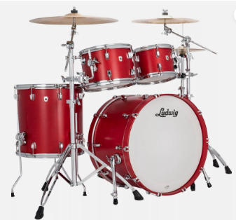
- Which of these is a solo Western musical instrument?

A

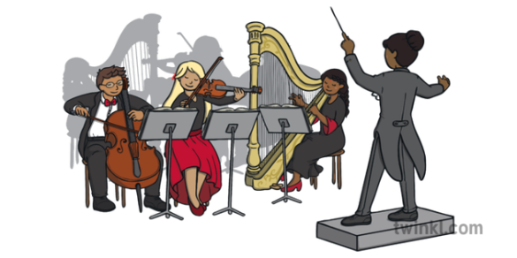

B

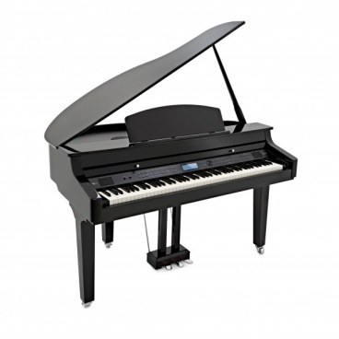

C



D

- In football, a long pass played along the ground to a teammate is often called a: A) Through ball B) Chip C) Tackle D) Cross
- Munene was telling his friends a story at home.

Storytelling is important because it helps to: A) Only entertain children. B) Preserve culture and history. C) Make people sleepy. D) Avoid communication.
- Which of the following is an example of a Kenyan folk song? A) Jingle Bells B) Baby Shark C) Kamba Dancers' Chant D) Twinkle Twinkle Little Star
- The art of creating visual messages or designs is known as: A) Music B) Dance C) Graphic design D) Athletics
- Which principle of visual arts refers to the arrangement of elements to create stability in a composition? A) Contrast B) Rhythm C) Balance D) Emphasis
- Agility in physical fitness refers to the ability to: A) Run long distances without tiring. B) Change direction quickly and accurately. C) Lift heavy objects. D) Stand still for a long time.
- The 2/4 time signature indicates: A) Two beats per measure, and a quarter note gets one beat. B) Four beats per measure, and a half note gets one beat. C) Two measures per four beats. D) Four beats per two measures.
- A musical note that receives two beats is called a: A) Whole note B) Half note C) Quarter note D) Eighth note
- Yego plays the game shown below.
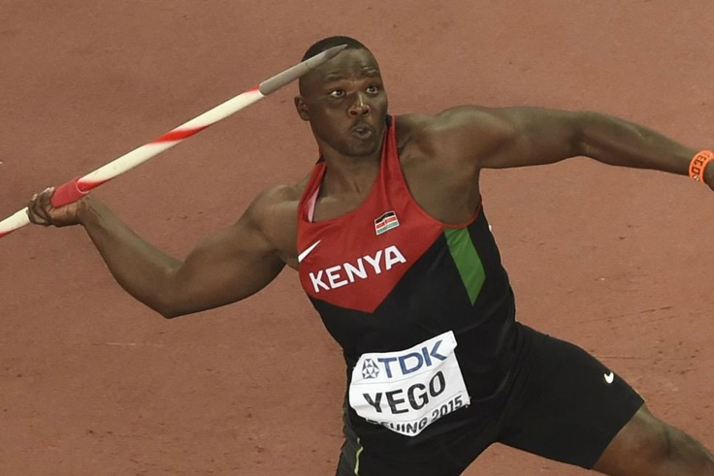
Which of these is NOT an item used in Javelin? A) Measuring tape B) Javelin spear C) Starting blocks D) Throwing sector
- A good melody should ideally be: A) Very complex and hard to remember. B) Simple, memorable, and pleasing to the ear. C) Always played very fast. D) Without any clear pitch.
- When creating card designs, which element would you consider for the overall feel and emotion? A) Shape B) Texture C) Color D) Line
- In handball, a pass where the ball is thrown with one hand over the shoulder is a: A) Chest pass B) Bounce pass C) Overhead pass D) Underhand pass
- Which technique is crucial for a goalkeeper in handball to prevent goals? A) Dribbling B) Shooting C) Blocking shots D) Weaving
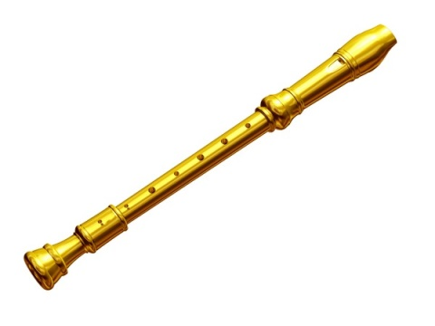
- Nimrod likes to play a descant recorder.

A descant recorder is a type of: A) Percussion instrument B) Brass instrument C) Woodwind instrument D) String instrument
- When performing on a descant recorder, tuning ensures that: A) The instrument looks shiny. B) The instrument is played in harmony with others. C) The player holds the instrument correctly. D) The notes are played loudly.
- In football, a "throw-in" is awarded when: a) The ball goes out of bounds over the goal line. b) The ball goes out of bounds over the touchline. c) A foul is committed inside the penalty area. d) The game starts.
- Maimuna made a flipbook below.
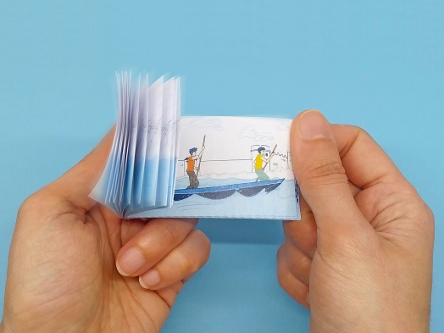
What is a flipbook primarily used for in storytelling? A) To write long novels. B) To create simple animations. C) To store old photographs. D) To record audio stories.
- Which swimming stroke involves moving both arms together over the head while kicking with the legs? A) Freestyle B) Backstroke C) Breaststroke D) Butterfly
- Before swimming, it is important to: A) Eat a heavy meal. B) Do warm-up exercises. C) Run a marathon. D) Sleep for an hour.
- Adornments are often used in Kenyan folk dances to: A) Make the dancers uncomfortable. B) Enhance the visual appeal and express cultural identity. C) Hide the dancers' faces. D) Slow down the dance movements.
- Which of the following is a role of Creative Arts and Sports in society? A) Only to provide entertainment. B) To foster creativity, physical health, and cultural preservation. C) To encourage competition only. D) To make people work harder.
- A storyboard is a sequence of drawings that visually tells a story. It is most useful for: A) Writing a song. B) Planning a visual presentation or animation. C) Playing a sport. D) Cooking a meal.
- Which of the following is an element of music? A) Texture B) Movement C) Melody D) Balance
- The ability to control your body's position while performing a task is known as: A) Strength B) Agility C) Stability D) Coordination
- Which of these is a part of the long jump event in athletics? A) Throwing a spear B) Running up and jumping into a sandpit C) Swimming laps D) Cycling around a track

- In netball, what is the maximum number of steps a player with the ball can take before passing or shooting? A) One B) Two C) Three D) Unlimited
- The "verse" in a song refers to: A) The main catchy part of the song. B) A section that tells a part of the story or develops the theme. C) The instrumental break. D) The ending of the song.
- Which of the following is a fundamental element of visual arts? A) Tempo B) Pitch C) Line D) Rhythm
- The term "French Rhythms" in music often refers to: A) Very slow and quiet rhythms. B) Complex and intricate rhythmic patterns. C) Simple and repetitive rhythms. D) Rhythms played only on French instruments.
- Which action is NOT a common pass in football? A) Push pass B) Inside of the foot pass C) Overhead throw D) Outside of the foot pass
- A key rule in netball is that players cannot: A) Bounce the ball once. B) Stand still with the ball. C) Run with the ball. D) Pass the ball to a teammate.
- Which element of a story introduces the characters and setting? A) Climax B) Resolution C) Exposition D) Falling action
- Which of the following is a characteristic of a well-composed melody? A) It uses only one note repeatedly. B) It has a clear direction and often a climax. C) It is always played very loudly. D) It is impossible to sing.

- Learners from Ilmeshuki Junior School wore decorative costumes during a music competition.
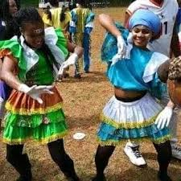
The main purpose of decorating costumes in traditional Kenyan performances is to: A) Make them uncomfortable to wear. B) Add to the aesthetic appeal and cultural significance. C) Hide the performers' identities. D) Reduce the cost of the performance.
- When considering the "repetition of notes" in music, it can be used to: A) Make a melody boring. B) Create a sense of emphasis or pattern. C) Make the music sound random. D) Ensure the music is always loud.
- Leshan likes playing volleyball.
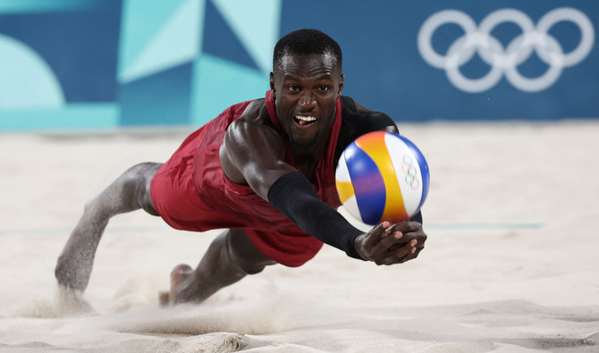
In volleyball, what is the maximum number of touches a team can make on the ball before it must go over the net? A) One B) Two C) Three D) Four
- The skill of "dribbling" in sports like football or handball involves: A) Kicking or bouncing the ball repeatedly while moving. B) Throwing the ball as far as possible. C) Standing still and passing the ball. D) Jumping high to catch the ball.

SECTION B: STRUCTURED QUESTIONS (60 MARKS)
Answer all questions in the spaces provided.
PART 1: PERFORMING ARTS (20 Marks)
- A group of Grade 7 students are gathered around their music teacher to learn about a descant recorder. The teacher is holding a descant recorder and pointing to music score on a stand. The score shows a simple melody with a 2/4 time signature.
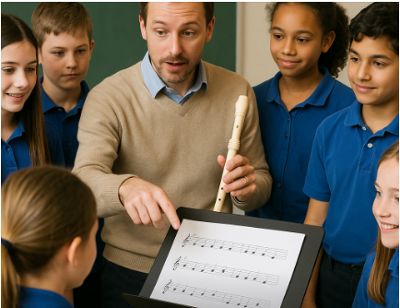
a) Identify two techniques a student would use to produce clear notes on a descant recorder. (2 Marks)
……………………………………………………………………………………………………….
………………………………………………………………………………………………………..
b) Explain why it is important to "tune" a descant recorder before playing with others. (2 Marks)
………………………………………………………………………………………………………………
………………………………………………………………………………………………………………..
c) Looking at the music score with the 2/4 time signature,
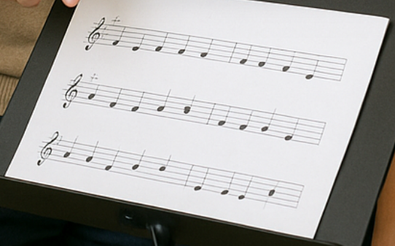
Explain what this time signature tells the students about how to count the beats in the music. (2 Marks)
………………………………………………………………………………………………………………..
………………………………………………………………………………………………………………..
- Kenyan dancers in traditional attire were seen performing a folk dance.

a) Identify two traditional adornments shown in the picture that are used to decorate costumes in Kenyan folk dances. (2 Marks)
………………………………………………………………………………………………………………..
…………………………………………………………………………………………………………………
b) Besides entertainment, state two other roles that Creative Arts, such as this folk dance, play in the community. (2 Marks)
……………………………………………………………………………………………………………….
……………………………………………………………………………………………………………….
c) Briefly describe one element of dance that is clearly visible in the picture. (2 Marks)
………………………………………………………………………………………………………….……
……………………………………………………………………………………………………………….
- A child is flipping through a small book with simple stick-figure drawings that show a progression of movement from one page to the next.
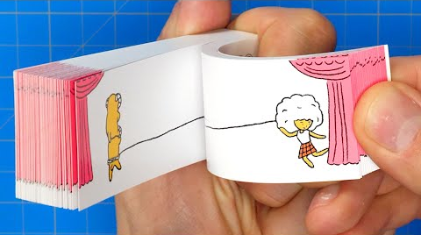
a) What is the main purpose of a flipbook in storytelling and animation? (2 Marks)
………………………………………………………………………………………………………………
………………………………………………………………………………………………………………
b) If the child wanted to present a more elaborate story, what visual planning tool, often used in film and animation, could they create? (1 Mark)
……………………………………………………………………………………………………………..
……………………………………………………………………………………………………………..
c) List three elements that make up a good story. (3 Marks)
……………………………………………………………………………………………………………..
……………………………………………………………………………………………………………..
……………………………………………………………………………………………………………..

PART 2: SPORTS (20 Marks)
- Observe the activities of the football players in the picture.

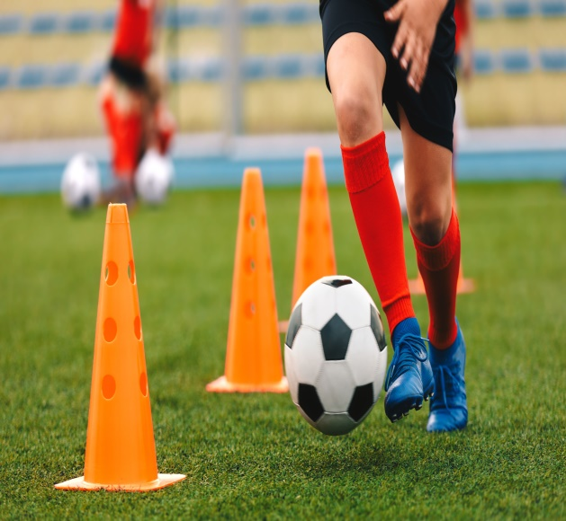

A B
a) Describe the technique of "dribbling" as demonstrated by the player around the cones. (2 Marks)
…………………………………………………………………………………………………………….
…………………………………………………………………………………………………………….
b) Identify two key items or equipment essential for playing a game of football. (2 Marks)
…………………………………………………………………………………………………………….
…………………………………………………………………………………………………………….
c) Explain the importance of "goalkeeping" in a football match and state one technique a good goalkeeper should possess. (2 Marks)
……………………………………………………………………………………………………………
……………………………………………………………………………………………………………

- Hope Junior School learners were asked to prepare for different games for the upcoming games competition
a) For the long jump athlete, what physical fitness component is most crucial during the take-off phase of the jump? Explain your answer. (2 Marks)
…………………………………………………………………………………………………………….
…………………………………………………………………………………………………………….
b) Name two items that are specifically used in the sport of Javelin. (2 Marks)
…………………………………………………………………………………………………………….
…………………………………………………………………………………………………………….
c) In netball, a player is not allowed to run with the ball. What skill must they master to move the ball effectively around the court? (1 Mark)
…………………………………………………………………………………………………………….
……………………………………………………………………………………………………………..
d) State one specific rule of netball related to a player holding the ball. (1 Mark)
…………………………………………………………………………………………………………….
- Grade 7 learners are learning various aspects of swimming.
a) Before entering the pool, what is one important preparation a swimmer should undertake? (1 Mark)
………………………………………………………………………………………………………………..
………………………………………………………………………………………………………………..
b) Name two essential items a swimmer needs for safety and comfort in the water. (2 Marks)
………………………………………………………………………………………………………………..
………………………………………………………………………………………………………………..
c) Briefly describe the technique of "diving" from a starting block into the pool. (2 Marks)
………………………………………………………………………………………………………………..
………………………………………………………………………………………………………………..
……………………………………………………………………………………………………………….

PART 3: VISUAL ARTS (20 Marks)
- Use the picture below to answer the following question.
Analyze the greeting card in the picture

a) Identify two elements of visual arts that are clearly present in the design of this card. (2 Marks)
…………………………………………………………………………………………………………….
…………………………………………………………………………………………………………….
b) Explain how the principle of "balance" has been applied in the card's design. (2 Marks)
…………………………………………………………………………………………………………….
…………………………………………………………………………………………………………….
c) If you were to create a similar card design for a special occasion, what kind of "variation of notes" could you use to make the design more interesting? (2 Marks)
………………………………………………………………………………………………………………
……………………………………………………………………………………………………………….
……………………………………………………………………………………………………………….

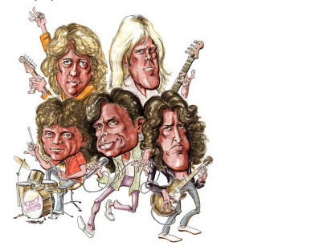
- Observe the drawings and paintings.
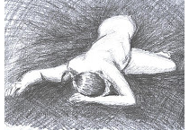

A B
a) Looking at the two drawings ,identify the principle of art demonstrated in picture? (2 Marks)
A: ………………………………………………………….
B: …………………………………………………………….
b) Shade using appropriate technique to show balance. (2 Marks)
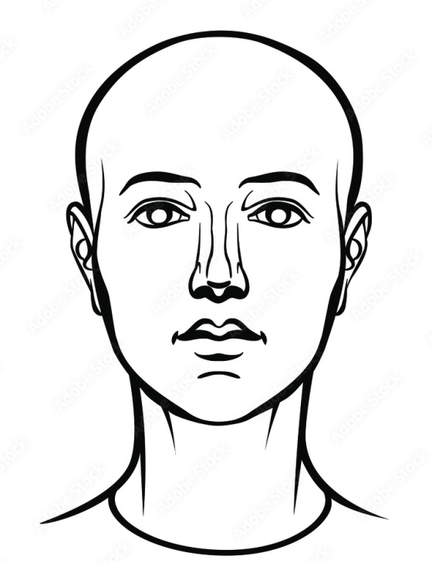
c) Briefly describe the process of "creating card designs" from the initial idea to the final product. (2 Marks)
……………………………………………………………………………………………………………….
………………………………………………………………………………………………………………...
…………………………………………………………………………………………………………………
- The image illustrates aspects of music notation.
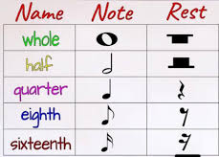
a) What is the purpose of a "rest" in music? (1 Mark)
…………………………………………………………………………………………………………
b) Using the information provided, explain the difference in duration between a "quarter rest" and a "half rest." (2 Marks)
…………………………………………………………………………………………………………….
…………………………………………………………………………………………………………….
…………………………………………………………………………………………………………….
c) Why might a composer choose to use "repetition of notes" within a melody? (2 Marks)
…………………………………………………………………………………………………………..
…………………………………………………………………………………………………………
…………………………………………………………………………………………………………

THIS IS THE LAST PRINTED PAGE.

