**BUTEREGIRLS'NATIONALSCHOOL**



**MOCK EXAMS 2025**

**Kenya Certificate of Secondary Education**

**NAME________________________________ ADM NO___________ CLASS__________**

**121/2**

**MATHEMATICS**

**PAPER 2**

**TIME: 2 HOURS 30 MINUTES**

**INSTRUCTIONS TO CANDIDATES:**

* Write your **name**, **class** and **admission** **numbe**r in the spaces provided.
* The paper contains **two** sections. Section I and Section II.
* Answer **ALL** the questions in section I and any **five** questions in section II.
* Answers and working **must** be written on the question paper in the spaces provided below each question.
* Show all steps in your calculations below each question.
* Marks may be given for correct working even if the answer is wrong.
* Non programmable silent electronic calculators and KNEC mathematical table may be used, except where stated otherwise.

**FOR EXAMINERS USE ONLY**

**SECTION I**

|  |  |  |  |  |  |  |  |  |  |  |  |  |  |  |  |  |  |
| --- | --- | --- | --- | --- | --- | --- | --- | --- | --- | --- | --- | --- | --- | --- | --- | --- | --- |
| **Question** | 1 | 2 | 3 | 4 | 5 | 6 | 7 | 8 | 9 | 10 | 11 | 12 | 13 | 14 | 15 | 16 | **TOTAL** |
| **Marks** |  |  |  |  |  |  |  |  |  |  |  |  |  |  |  |  |  |

**SECTION II**

**GRAND TOTAL**

|  |  |  |  |  |  |  |  |  |  |
| --- | --- | --- | --- | --- | --- | --- | --- | --- | --- |
| **Question** | 17 | 18 | 19 | 20 | 21 | 22 | 23 | 24 | **TOTAL** |
| **Marks** |  |  |  |  |  |  |  |  |  |

**SECTION 1 50 MKS**

**Answer all questions in this section**

1. Use logarithms to evaluate. (4 marks)

1/3

415.3 × 0.0152

sin 75º

1. The base and perpendicular height of a triangle measured to the nearest centimeter are 12cm and 8cm respectively. Find the absolute error in calculating area of the triangle (3 marks)
2. a) Expand ( 3+2/x )5 up to the x4 (1 mark)

b) Hence estimate the value of (3.5)5 to 4 s.f (2 marks)

4. Find the radius and centre of the circle whose equation is 3x2 + 3y2 – 12x +18y = 9 (3 marks)

1. An aero plane leaves town A (40º N , 155ºW) for town B ( 40º N, 25º E) using the shortest route at a speed of 300 knots. Calculate the time it takes to travel from A to B (3 marks)

6. The third term and the sixth term of a geometric series are31/3 and 11 ¼ respectively.

Calculate the:

a) Common ratio (2 marks)

b) First term (1 mark)

1. Two taps A and B ca n fill a water bath in 8 minutes and 10 minutes respectively. Tap A is opened

for 2 minutes then closed. Tap B is later opened for one minute then closed. How long will the two taps take running together to fill the remaining part of the water bath? (3 marks)

1. After t seconds, a particle moving along a straight line has a velocity of the v m/s and an acceleration of (5- 2t) m/s2. If the initial velocity was 2m/s, determine the velocity of the particle at the beginning of the third second (3 marks)
2. A quantity P is partly constant and partly varies inversely as square of t. P = 6 when t = 6 and

P = 18 when t = 3. Find t when P = 11. (3 marks)

1. A mobile phone can be purchased in cash ksh. 30,000 or by paying ksh. 1,750 for 24 months. Calculate the rate of interest charged on instalment buying. Giving your answer correct to 2 decimal places (3 marks)

11. Solve for x in 3log3 x + 4 = 24 (3 marks)

12. Solve for x in the equation (3 marks)

6 sin 2x – cos x – 5 = 0 for 0º ≤ x ≤ 360

13. Two brands of tea costing sh. 160 and 140 per kilogram respectively are mixed in the ration 2:3

by mass. The mixture is sold at sh. 240 per kilogram. Find the percentage profit made. (3 marks)

14. Triangle A'B'C' is the image of triangle ABC under transformation represented by the matrix 3 1

5 4

If the area of triangle A'B'C' is 140cm2, find the area of triangle ABC (3 marks)

15. Given that PR = 2cm, PN = 12cm and PM = 3cm. Find the length of:

N

R

S M

Q

i) PS (2 marks)

ii) PQ (1 mark)

16. Given that tan x = 1 find the value of tan x + cos x (3 marks)

3

**SECTION II 50MARKS**

**Answer any five questions only in this section**

17. In a science class 2/3 of the class are boys and the rest are girls. 80% of the boys and 90% of the

girls are right handed. The probability that the right handed student will break a test tube in any

session is 1/10 and that for the left handed student is 3/10 regardless of whether boy or girl.

a) Draw a tree diagram to represent this information (2 marks)

b) Using the tree diagram drawn, find the probability that:

i) A student chosen at random from the class is left handed (2 marks)

ii) A test tube is broken by a left handed student (2 marks)

iii) A test tube is broken by a right handed student (2 marks)

iv) A test tube is not broken in any session (2 marks)

18. In a triangle ABC, E is the midpoint of BC, D is a point on AC such that AD: DC = 3:2 and F is

the point of intersection of AE and BD. Vectors AB = b⃗ and AC = c⃗

B

F

E

A D C

a) Express the following vectors in terms of b⃗ and c⃗ only.

i) AE (2 marks)

ii) BD (1 mark)

b) By expressing vectors BF in two ways, find the ratio BF:FD given that BF = hBD and AF = Tae

where h and t are constants (5 marks)

c) Hence find vector BF in terms of b and c only (2 marks)

19. A plane S flies from a point P (40ºN, 45ºW) to a point Q ( 35º N, 45ºW) and then to another point

T (35ºN, 135ºE).

a) Given that the radius of the earth is 6370km find the distance from P to Q in km. Take  = 22/7 (2 marks)

b) Find in nm

i) The shortest distance between Q and T (2 marks)

ii) The longest distance between Q and T ( to the nearest tens) (2 marks)

c) Find the difference in time taken when S flies along the shortest and longest routes if its speed is

420 knots (4 marks)

20. The marks obtained by 50 students in an examination were recorded in the table below

|  |  |  |  |  |  |  |  |  |
| --- | --- | --- | --- | --- | --- | --- | --- | --- |
| Marks | 0-9 | 10-19 | 20-29 | 30-39 | 40-49 | 50-59 | 60-69 | 70-79 |
| Number of student | 3 | 6 | 10 | 12 | 9 | 5 | 3 | 2 |

Using 44.5 as the assumed mean, calculate

i) The actual mean mark (4 marks)

ii) The standard deviation to 2 decimal place (3 marks)

iii) The quartile deviation (3 marks)

21. Given that y = 2 sin 2x and y = 3 cos (x+45º)

a) Complete the table below (2 marks)

|  |  |  |  |  |  |  |  |  |  |  |
| --- | --- | --- | --- | --- | --- | --- | --- | --- | --- | --- |
| X | 0 º | 20 º | 40 º | 60 º | 80 º | 100 º | 120 º | 140 º | 160 º | 180 º |
| 2sin 2x | 0 |  | 1.97 |  | 0.68 | -0.68 | -1.73 |  | -1.28 | 0 |
| 3 cos (x+ 45 º) | 2.12 | 1.27 |  | -0.78 |  | -2.46 |  |  | -2.72 | -2.12 |

b) Use the data to draw the graph of y = 2 sin 2x and y = 3 cos (x+45 º) for 0 º ≤ x ≤ 180 º on the

same axis on the grid provided below (5 marks)

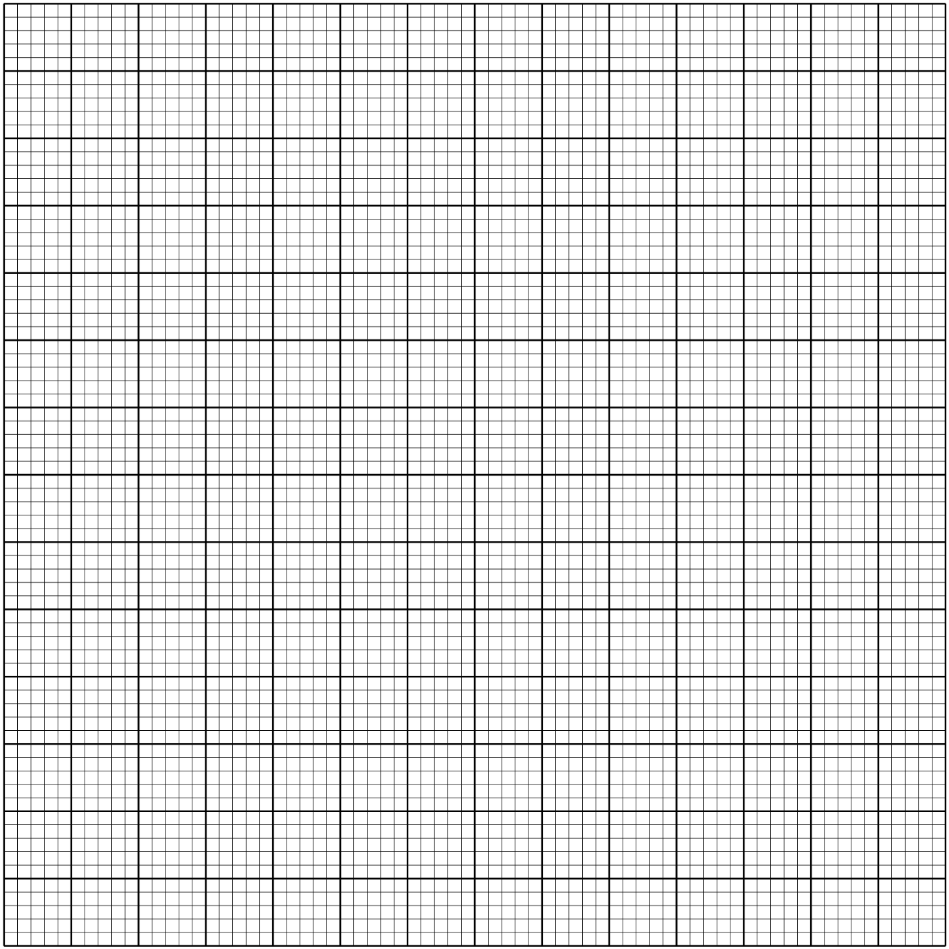

c) State the amplitude and period of each curve (2 marks)

d) Use the graph to solve the equation 2 sin 2x – 3 cos (x+45 º) = 0 for 0 º ≤ x ≤ 180 º (1 mark)

22. VABC is a pyramid standing on an equilateral triangular base ABC whose sides are 6cm.

VO is the perpendicular height. VA = VB = VC = 15cm.

V

B

A C

Calculate to 2 d.p

a) Height VO (3 marks)

b) The inclination of VAB to ABC (2 marks)

c) The inclination of VB to ABC (3 marks)

d) The volume of the pyramid (2 marks)

23. A small scale farmer wishes to buy some sheep and goat for rearing. Sheep cost sh 400 and goat cost

sh. 300. The farmer has enough space for only 20 animals and may spend at most sh 6,800.

The number of goats should not exceed twice the number of sheep.

1. By letting x and y to represent the number of sheep and goats he can buy respectively, write

down all inequalities from the above information (4 marks)

b) Represent the inequalities on the grid provided (4 marks)



c) From your graph, find the maximum number of animals he can buy at the lowest cost (2 marks)

24. The following table shows the rate at which income tax was charged during a certain year.

|  |  |
| --- | --- |
| Monthly taxable income in Ksh. | Tax rate % |
| 0 – 9860 | 10 |
| 9861 – 19720 | 15 |
| 19721 – 29580 | 20 |
| 29581 – 39440 | 25 |
| 39441 – 49300 | 30 |
| 49301 – 59160 | 35 |
| Over 59160 | 40 |

A civil servant earns a basic salary of ksh. 35750 and a monthly house allowance of sh.12,500. The civil servant is entitled to a person relif of sh. 1,062 per month. Calculate:

a) Taxable income (2 marks)

b) Calculate his net monthly tax (5 marks)

c) Apart from the salary the following deduction are also made from his monthly income.

WCPS at 2% of the basic salary

Loan repayment Ksh. 1,325

NHIF Ksh. 480

Calculate his net monthly earning (3 marks)