Candidate’s Name |  | Assessment Number
School Name |  | School Code
Candidate’s Signature |  | Date

KENYA JUNIOR SCHOOL EDUCATION ASSESSMENT (KJSEA)
GRADE 8: INTEGRATED SCIENCE
PAPER 2 (Practical)
CODE: 009 YEAR: 2025
TIME: 2 HOURS
INSTRUCTIONS TO CANDIDATES:
INSTRUCTIONS TO CANDIDATES:
- Write your name and assessment number in the spaces provided above.

- Write the name and code of your school in the spaces provided above.

- Sign and write the date of the assessment in the spaces provided above.

- This paper consists of 2 questions.

- Answer BOTH questions in the spaces provided on this QUESTION PAPER.

- Do NOT remove any page from this question paper.

- Answer the questions in English.

FOR OFFICIAL USE ONLY.

For Official Use Only
Task | Task 1 | Task 2 | TOTAL
Question | 1 | 2 | 3QUESTIONS
Maximum Score | 20 | 10 | 30 MARKS
Candidate’s Score

This paper consists of 5 printed pages. Candidates should check the question paper to ascertain that all the pages are printed as indicated and that no questions are missing.
© 2025 The Kenya Junior School Examination and Assessment Series. Turn over

QUESTION ONE (20 Marks)
You are required to observe the provided setup and answer the questions that follow.
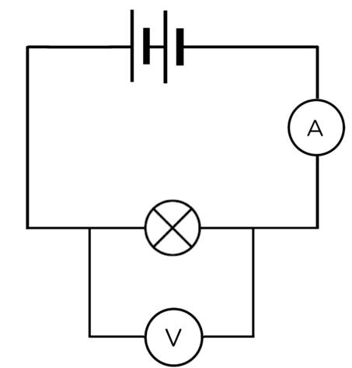
A

B E

C

D

a) Identify the components labelled in the circuit diagram provided:
i) Component C: ……………………………………………….. (1 Mark)
ii) Component D: ………………………………………………. (1 Mark)
iii) Component E: ………………………………………………(1 Mark)
b) Describe what would happen to the light bulb if the Component B is closed. (1 Mark)
………………………………………………………………………………………………..……………………..
……………………………………………………………………………………………………………………….
c) Name the form of energy that flows through the wires in this circuit. (1 Mark)
………………………………………………………………………………………………………………………
d) Give two safety precautions one must observe when dealing with electrical appliances at home. (2 Marks)
i) ……………………………………………………………………………………………………………………
ii) …………………………………………………………………………………………………………………..
e) Observe the appliance shown below:

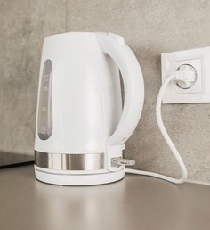

i) Identify the common electrical appliance shown above. (1 Mark)

……………………………………………………………………………….

ii) What is the main energy transformation that occurs in this appliance when it is in use? (2 Marks)

……………………………………………………………………………………………………………………..

……………………………………………………………………………………………………………………..
f) You are provided with:
- A small piece of wood,
- A copper wire, and
- An iron nail.
i) Which of these materials is a magnetic material? (1 Mark)
………………………………………………………………………….……………………………………….
ii) State one property of a magnet. (1 Mark)
……………………………………………………………………………………………………………………
g) Explain briefly how magnetism is applied in a common device like a refrigerator door. (2 Marks)
……………………………………………………………………………………………………………………….
………………………………………………………………………………………………………………………..
h) Draw the 'Fire Triangle' and label its three components. (3 Marks)

i) Give two common causes of fire in a domestic setting. (2 Marks)
i) ……………………………………………………………………………………………………………………..
ii) ……………………………………………………………………………………………………………………
QUESTION TWO (10 Marks)
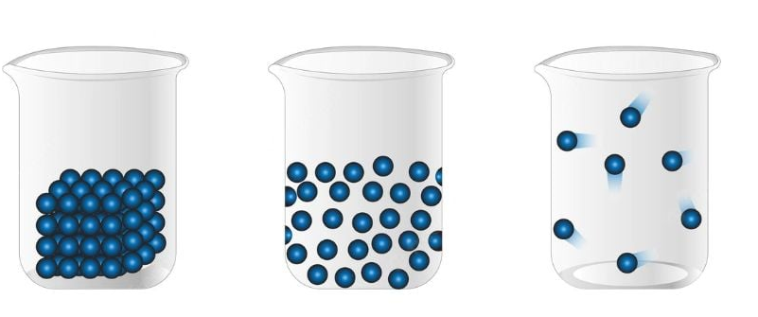
You are provided with diagrams representing different states of matter.

A B C
a) Identify the state of matter represented by:
i) Diagram A: ………………………………. (1 Mark)
ii) Diagram C: ……………………………… (1 Mark)
b) Describe the characteristic arrangement of particles in the state of matter shown in Diagram B. (2 Marks)
……………………………………………………………………………………………………………………….
……………………………………………………………………………………………………………………….
c) Name the process by which matter changes from:
i) Liquid to gas (at boiling point): ………………………………………….. (1 Mark)
ii) Gas to liquid: ……………………………………………………………..(1 Mark)
d) Explain the term diffusion using an example of air freshener sprayed in a room. (3 Marks)
……………………………………………………………………………………………………………………….
……………………………………………………………………………………………………………………….
………………………………………………………………………………………………………………………..
e) What is the SI unit for pressure? (1 Mark)
………………………………………………………………………………..

THIS IS THE LAST PRINTED PAGE.

