Candidate’s Name |  | Assessment Number
School Name |  | School Code
Candidate’s Signature |  |   Date
KENYA JUNIOR SCHOOL EDUCATION ASSESSMENT (KJSEA)
GRADE 8: INTEGRATED SCIENCE
PAPER 1 (Theory)
CODE: 009 YEAR: 2025
TIME: 2 HOURS
INSTRUCTIONS TO CANDIDATES
- Write your name and assessment number in the spaces provided above.
- Sign and write the date of the assessment in the spaces provided above.
- This paper consists of two sections: A and B.
- Section A comprises Multiple Choice Questions numbered 1 to 30.
- Section B comprises short, structured questions number 31 to 40.
- Answer ALL the questions in section A on the separate ANSWER SHEET provided.
- Answer ALL the questions in section B in the spaces provided in this QUESTION PAPER.
- Do NOT remove any page from this question paper.
- Answer ALL the questions in English.

For Official Use Only

SECTION A: (30 MARKS)
Question Number | 1 | 2 | 3 | 4 | 5 | 6 | 7 | 8 | 9 | 10 | 11 | 12 | 13 | 14 | 15 | 16 | 17 | 18 | 19 | 20
Maximum Score | 1 | 1 | 1 | 1 | 1 | 1 | 1 | 1 | 1 | 1 | 1 | 1 | 1 | 1 | 1 | 1 | 1 | 1 | 1 | 1
Candidate’s Score

Question Number | 21 | 22 | 23 | 24 | 25 | 26 | 27 | 28 | 29 | 30
Maximum Score | 1 | 1 | 1 | 1 | 1 | 1 | 1 | 1 | 1 | 1
Candidate’s Score

SECTION B: (40 MARKS)
Task | Task 1 |  | Task 2 |  |  | Task 3 |  |  | Task 4 |  | GRAND TOTAL
Question No. | 31 | 32 | 33 | 34 | 35 | 36 | 37 | 38 | 39 | 40
Score/Question
Max Score | 4 | 4 | 4 | 4 | 4 | 4 | 4 | 4 | 4 | 4 | 70
Candidate’s Score
This paper consists of 9 printed pages. Candidates should check the question paper to ascertain that all the pages are printed as indicated and that no questions are missing.
© 2025 The Kenya Junior School Examination and Assessment Series. Turn over

SECTION A: (30 MARKS)
Choose the best answer for each of the following questions.

- During a field trip to a local factory, students observe engineers applying principles from chemistry, physics, and biology to design a new water purification system. This scenario best illustrates the concept of: A. Specialization in science B. The historical development of science C. The integrated nature of science D. The theoretical aspects of science
- Your science teacher always emphasizes that studying integrated science helps you understand the natural world holistically, from how your body works to how technology impacts the environment. This highlights the primary _________ of studying integrated science. A. Cost B. Benefit C. Challenge D. History
- A student is about to start an experiment involving heating a chemical in a test tube. Before starting, they ensure they are wearing safety goggles and tie back their long hair. These actions are directly related to: A. First aid measures B. Laboratory safety C. Chemical disposal D. Data collection
- While running in the schoolyard, a student falls and sustains a deep cut on their knee. The school nurse is called to administer first aid. What should be the nurse's immediate priority after ensuring the student's safety? A. Apply a cold compress B. Stop the bleeding C. Give pain medication D. Perform CPR

- You are handed a bottle with a label showing:

This symbol indicates that the substance is: A. Corrosive B. Biohazard C. Flammable D. Oxidizing
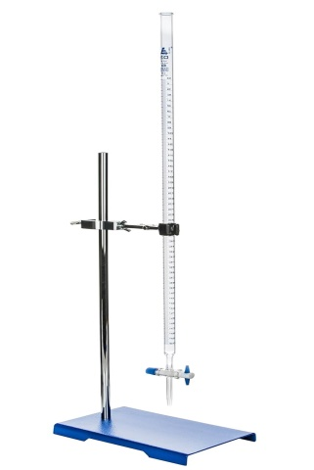
- Your teacher asks you to place the apparatus marked X onto a stand.

M

What is the name of the instrument? A. Test tube B. Burette C. Pipette D. Watch glass
- A technician is measuring:
- The electric current in amperes (A),
- The voltage in volts (V), and
- The resistance in ohms (Ω).
These are all standard units in the: A. CGS system B. FPS system C. SI system D. Imperial system
- You have a mixture of salt dissolved in water. You want to obtain the salt back as a solid. Which method of separation would be most suitable? A. Filtration B. Decantation C. Distillation D. Evaporation
- You are given a solution that feels slippery to the touch and turns red litmus paper blue. This solution is most likely a(n): A. Acid B. Base C. Neutral solution D. Indicator

- The following diagram represents a setup that can be used to demonstrate a certain aspect of light.
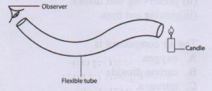
The aspect investigated is
- refraction of light
- dispersion of light
- reflection of light
- how light ttravels
- A 15-year-old girl expresses concerns about acne, mood swings, and the start of her menstrual periods. These are common characteristics and challenges associated with: A. Infancy B. Childhood C. Adolescence D. Early adulthood
- Grade 8 learners were discussing about chemical equations. What is the correct product of:
CuSO₄ + Fe → ?
A. Cu + FeSO₄
B. FeSO₄ + CuSO₄
C. Fe + Cu
D. CuSO₄ + Fe₂O₃
- A battery-powered toy car moves across the floor. The primary energy transformation occurring is from: A. Kinetic energy to potential energy B. Electrical energy to mechanical energy C. Light energy to chemical energy D. Heat energy to sound energy
- You connect a light bulb, a switch, and a battery in a closed loop, and the bulb lights up.
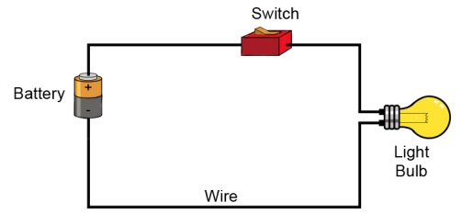
This arrangement forms a: A. Parallel circuit B. Series circuit C. Simple circuit D. Complex circuit
- A hair comb was brought near pieces of papers, and the pieces of papers were attracted to the comb.

This type of electricity is known as: A. Current electricity B. Electric force C. Magnetic force D. Static electricity
- You are given a collection of items:
- A wooden pencil,
- An iron nail,
- A plastic comb,
- And a copper wire.
Which of these items is a magnetic material? A. Wooden pencil B. Iron nail C. Plastic comb D. Copper wire
- Your science textbook defines a substance that is made up of only one type of atom and cannot be broken down into simpler substances by chemical means. This definition refers to a(n): A. Compound B. Mixture C. Element D. Solution

- The teacher displayed various cards showing chemical symbols: which symbol represents Sodium?

A B C D
- The smallest particle of an element that still has the properties of that element is called a(n): A. Molecule B. Compound C. Ion D. Atom
- You mix sugar into hot tea, and the sugar completely disappears, forming a uniform sweet liquid. This combination of sugar and tea is an example of a: A. Heterogeneous mixture B. Compound C. Homogeneous mixture D. Element
- Your teacher explains that the particles in a gas are far apart and move randomly and rapidly.
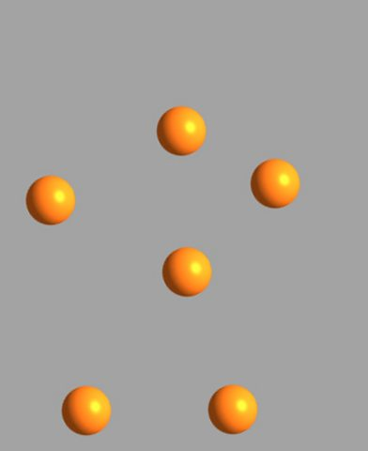
This description aligns with the principles of the: A. Law of conservation of energy B. Kinetic theory of matter C. Law of multiple proportions D. Theory of relativity
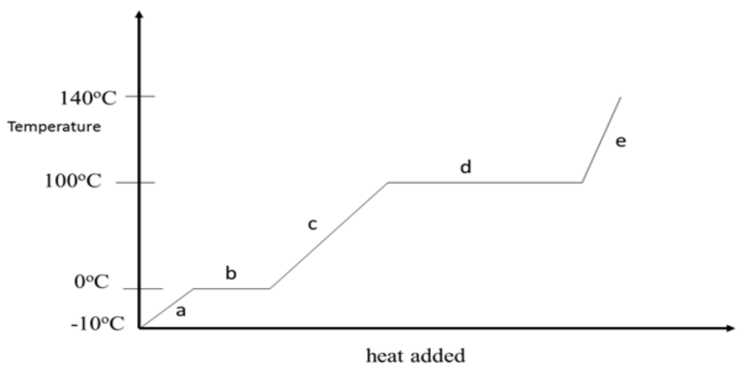
- You are observing the process of water boiling at 100°C. Even though heat is continuously supplied, the temperature of the water remains constant until all the water has turned into steam.

This indicates that the supplied heat energy is being used for: A. Increasing the kinetic energy of water molecules B. Breaking the bonds between water molecules to change state C. Increasing the potential energy of water molecules D. Decreasing the density of water
- From the diagram above, the process marked d is called? A. Boiling point B. Melting point C. Evaporation rate D. Condensation point
- You observe a block of ice melting into water. If you cool the water, it will turn back into ice. This change is an example of a: A. Chemical change B. Permanent change C. Physical change D. Irreversible change
- A fire breaks out in a car during an accident. The firefighter immediately covers the pot with a wet cover.
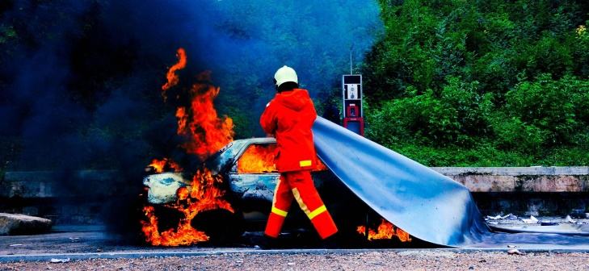
Which component of the fire triangle is your mother trying to remove or limit? A. Fuel B. Heat C. Oxygen D. Ignition source
- In a biology class, the teacher display the image below:
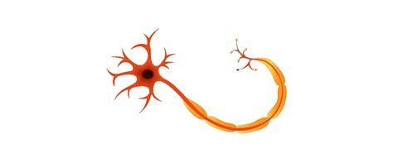
In which class do we place the illustration above?
A. Tissue B. Organ C. Cell D. Organism
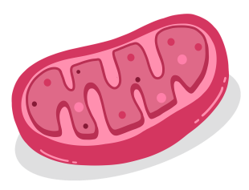
- A student is drawing a component of an animal cell below.

What is its name?
A. Ribosome B. Endoplasmic Reticulum C. Mitochondrion D. Golgi apparatus
- Plant roots absorb water from the soil, where there is a higher concentration of water, into the root cells, where there is a lower concentration of water, through a partially permeable membrane. This process is known as: A. Diffusion B. Active transport C. Transpiration D. Osmosis

- During a public health campaign, a nurse explains that consistent and correct use of condoms is an effective way to prevent the transmission of certain infections during sexual activity. The nurse is referring to the prevention of: A. Respiratory infections B. Food poisoning C. Sexually Transmitted Infections (STIs) D. Waterborne diseases

- The diagram below represents a demonstration of a certain property of light.
The diagram shows that light
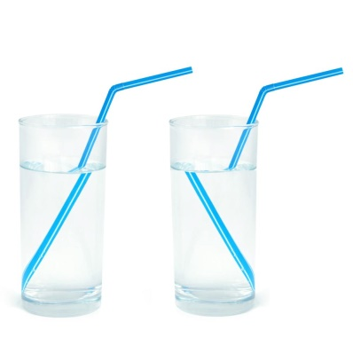

A. Travels in a straight line
B. Bounces back
C. Can be split
D. Apparently bends.

SECTION B: STRUCTURED QUESTIONS (40 MARKS)
Answer all questions in the spaces provided.
- During a chemistry experiment involving corrosive acids, a student accidentally gets a splash of the acid on their clothing. The teacher immediately directs them to the emergency shower.
a) Why is it crucial to immediately use the emergency shower in this scenario? (2 Marks)
  - ……………………………………………………………………………………………………….
  - ………………………………………………………………………………………………………..
b) After rinsing, what should be the next first aid step for the affected skin if a burn is observed? (2 Marks)
  - ………………………………………………………………………………………………………
  - ………………………………………………………………………………………………………..

- A scientist is investigating the effect of temperature on the rate of a chemical reaction. They need to accurately measure the temperature of the reactants and the volume of gas produced.
a) Name two laboratory instruments the scientist would use to measure temperature and volume of gas produced (by displacement of water). (2 Marks)
  - ……………………………………………………………………………………………………….
  - ………………………………………………………………………………………………………..
b) State the SI unit for: (2 Marks)
i) Temperature: ……………………………………….
ii) Amount of substance: …………………………….
- You are given a mixture of water and insoluble chalk powder. You want to obtain clear water from this mixture.
a) Is this mixture homogeneous or heterogeneous? Explain your answer. (2 Marks)
……………………………………………………….……………………………………………………….
…………………………………………………………………………………………………………………
b) Describe a simple laboratory method you could use to separate the chalk powder from the water. (2 Marks)
  - ……………………………………………………………………………………………………….
  - ………………………………………………………………………………………………………..
  - ……………………………………………………………………………………………………….
- Your teacher gives you a red cabbage indicator and three unknown solutions (X, Y, and Z). When you add the indicator to solution X, it turns bright red. When added to solution Y, it turns green. Solution Z causes no significant color change.
a) Classify solutions X, Y, and Z based on their likely pH properties (acidic, basic, or neutral). (3 Marks) Solution X: Solution Y: Solution Z:
X: ……………………………………………..
Y: ……………………………………………..
Z: …………………………………………….
b) Name one common household substance that is a base. (1 Mark)
…………………………………………………………………………………………………………………..
- A school counselor is addressing Grade 8 students about the changes they are experiencing and will experience during puberty, emphasizing that these are normal developmental stages.
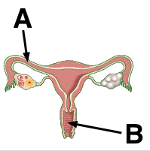
a) Name the female reproductive parts marked A and B. (2 Marks)
A: …………………………………………………..
B: ………………………………………………….
b) List two emotional or social challenges that adolescents might face during puberty. (2 Marks)
  - ……………………………………………………………………………………………………….
  - ………………………………………………………………………………………………………..
- A friend complains of frequent, painful urination and back pain. Their doctor suspects a common kidney-related issue often caused by mineral buildup.
a) What is the primary role of the human excretory system? (1 Mark)
……………………………………………………………………………………………………………….
b) Name the common kidney disorder described in the scenario. (1 Mark)
………………………………………………………………………………………………………………
c) Suggest two ways to maintain healthy kidneys. (2 Marks)
  - ……………………………………………………………………………………………………….
  - ………………………………………………………………………………………………………..
- You are studying the composition of matter. Your teacher explains that water is made of hydrogen and oxygen, but sugar is also made of carbon, hydrogen, and oxygen.
a) Using chemical symbols, write the symbol for oxygen and hydrogen. (2 Marks)
  - ……………………………………………………………………………………………………….
  - ………………………………………………………………………………………………………..
b) Explain why water and sugar, despite both containing hydrogen and oxygen, are considered different compounds. (2 Marks)
  - ………………………….………………………………………………………………………….
  - ……………………………………………………………………………………………………..
- You are preparing a temporary slide of a plant cell. After adding a drop of water and placing the coverslip, you observe the cells under the microscope. Later, you add a drop of concentrated salt solution to the edge of the coverslip and observe changes in the cell.
a) Name two main parts of a microscope that help in focusing the image. (2 Marks)
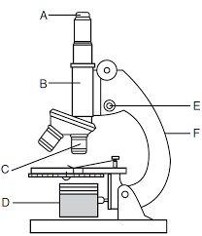
E……………………………………………………………………………………………………….
F………………………………………………………………………………………………………..
b) Describe what you would observe happening to the plant cells when a concentrated salt solution is added, explaining why this occurs in terms of diffusion or osmosis. (1 Mark)
……………………………………………………………………………………………………………………………
……………………………………………………………………………………………………………………………
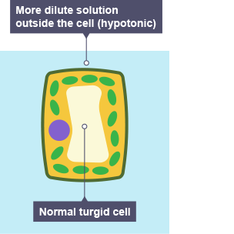
c) Identify the part labeled T. (1 Mark)

T
………………………………….

- You observe water in three different states: solid ice, liquid water, and gaseous steam. Your teacher explains that the arrangement and movement of particles differ significantly in each state.
a) According to the kinetic theory of matter, describe the arrangement and movement of particles in solid ice. (2 Marks)
………………………………………………………………………………………………………………
………………………………………………………………………………………………………………
b) Name the process by which liquid water turns into steam upon heating. (1 Mark)
…………………………………………………………….
c) Identify one characteristic property of liquids. (1 Mark)
………………………………………………………………………………………………………………
- Your younger sibling is fascinated by how a simple flashlight works and also how some toys have magnets that attract metal objects.

a) Name the energy transformation that takes place when a flashlight is switched on . (2 Marks)
………………………………………………………………………………………………………………
………………………………………………………………………………………………………………
b) List two common applications of magnets in everyday life. (2 Marks)
  - …………………………………………………………………………………………………….
  - ……………………………………………………………………………………………………..

THIS IS THE LAST PRINTED PAGE.

