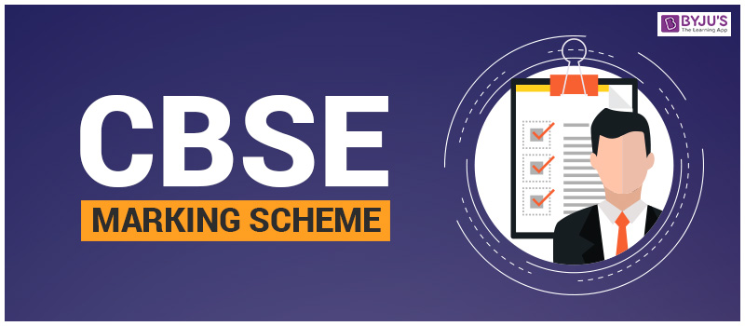
COMPETENCE BASED EDUCATION
GRADE 8
CODE: 009/2025
INTEGRATED SCIENCE PP1



Section A: Answers

Question No. | Answer
1 | C
2 | B
3 | B
4 | B
5 | B
6 | B
7 | C
8 | D
9 | B
10 | D
11 | C
12 | A
13 | B
14 | C
15 | D
16 | B
17 | C
18 | C
19 | D
20 | C
21 | B
22 | B
23 | A
24 | C
25 | C
26 | C
27 | C
28 | D
29 | C
30 | D

SECTION B ANSWERS
Question 31:
a) Why is it crucial to immediately use the emergency shower in this scenario? (2 Marks)
i. To immediately dilute and wash off the corrosive acid from the skin and clothing.
ii. To prevent or minimize chemical burns and further damage to the skin and underlying tissues.
b) After rinsing, what should be the next first aid step for the affected skin if a burn is observed? (2 Marks)
i. Cover the burn with a clean, sterile dressing (e.g., non-stick bandage or clean cloth).
ii. Seek immediate medical attention to assess the severity of the burn and receive appropriate treatment.
Question 32:
a) Name two laboratory instruments the scientist would use to measure temperature and volume of gas produced (by displacement of water). (2 Marks)
i. To measure temperature: Thermometer
ii. To measure volume of gas produced: Measuring cylinder (or Gas syringe/Burette if more precise)
b) State the SI unit for: (2 Marks)
i) Temperature: Kelvin (K) (or degrees Celsius, °C, is also commonly used in practice, but Kelvin is the official SI unit)
ii) Amount of substance: Mole (mol)
Question 33:
a) Is this mixture homogeneous or heterogeneous? Explain your answer. (2 Marks)
This mixture is heterogeneous.
Explanation: You can still see the separate components (chalk powder and water), and the chalk powder does not dissolve uniformly but rather settles or remains suspended.
b) Describe a simple laboratory method you could use to separate the chalk powder from the water. (2 Marks)
i. Filtration: Pour the mixture through a filter paper placed in a funnel.
ii. The chalk powder (residue) will be trapped on the filter paper.
iii. The clear water (filtrate) will pass through the filter paper and be collected in a beaker or flask.
Question 34:
a) Classify solutions X, Y, and Z based on their likely pH properties (acidic, basic, or neutral). (3 Marks)
X: Acidic (Red cabbage indicator turns bright red in acidic solutions)
Y: Basic (Red cabbage indicator turns green in basic/alkaline solutions)
Z: Neutral (No significant color change with red cabbage indicator)
b) Name one common household substance that is a base. (1 Mark)
Baking soda (Sodium bicarbonate) or Ammonia-based cleaner or Soap or Drain cleaner.
Question 35:
a) Name the female reproductive parts marked A and B. (2 Marks)
A: Oviduct/fallopian tube.
B: Vagina/birth canal
b) List two emotional or social challenges that adolescents might face during puberty. (2 Marks)
i. Mood swings and increased emotional sensitivity due to hormonal changes.
ii. Body image concerns and self-consciousness as their bodies change.
iii. Peer pressure and the desire for social acceptance.
iv. Increased independence conflicting with parental guidance.
v. Developing identity and exploring personal values.
Question 36:
a) What is the primary role of the human excretory system? (1 Mark)
The primary role is to remove metabolic waste products and excess substances from the body to maintain homeostasis.
b) Name the common kidney disorder described in the scenario. (1 Mark)
Kidney stones (or Renal calculi).
c) Suggest two ways to maintain healthy kidneys. (2 Marks)
i. Drink adequate amounts of water daily to help flush out toxins and prevent stone formation.
ii. Maintain a healthy diet, low in sodium, processed foods, and excessive protein.
iii. Control blood pressure and blood sugar levels, as high levels can damage kidneys.
iv. Avoid overuse of pain relievers (NSAIDs) and other nephrotoxic medications.
Question 37:
a) Using chemical symbols, write the symbol for oxygen and hydrogen. (2 Marks)
i. Oxygen: O
ii. Hydrogen: H
b) Explain why water and sugar, despite both containing hydrogen and oxygen, are considered different compounds. (2 Marks)
i. Water and sugar are different compounds because they have different ratios of constituent atoms and often include different types of atoms (sugar contains carbon, water does not).
ii. This difference in atomic composition and arrangement results in distinct chemical structures and unique physical and chemical properties for each compound.
Question 38:
a) Name two main parts of a microscope that help in focusing the image. (2 Marks)
E: Fine adjustment knob/KAK
F: Arm.
b) Describe what you would observe happening to the plant cells when a concentrated salt solution is added, explaining why this occurs in terms of diffusion or osmosis. (1 Mark)
You would observe the plant cells undergoing plasmolysis, where the cell membrane shrinks and pulls away from the cell wall. This occurs due to osmosis: the concentrated salt solution has a lower water potential than the cell sap, causing water to move out of the plant cells and into the surrounding solution.
c) Identify the part labeled T. (1 Mark)
T: SapVacuole /Cell vacuole
Question 39:
a) According to the kinetic theory of matter, describe the arrangement and movement of particles in solid ice. (2 Marks)
In solid ice, particles are closely packed in fixed positions (arranged in a regular, crystalline lattice). Their movement is limited to vibrating about their fixed positions.
b) Name the process by which liquid water turns into steam upon heating. (1 Mark)
Boiling (or Vaporization/Evaporation, but boiling is most specific when heating to 100°C).
c) Identify one characteristic property of liquids. (1 Mark)
Liquids have a definite volume but no definite shape (they take the shape of their container).
Other properties: Particles are closely packed but can slide past each other; they are generally incompressible.
Question 40:
a) Name the energy transformation that takes place when a flashlight is switched on. (2 Marks)
Chemical energy (stored in the battery) is converted into electrical energy, which is then transformed into light energy and heat energy by the bulb.
b) List two common applications of magnets in everyday life. (2 Marks)
i. Refrigerator doors (to keep them sealed)
ii. Credit cards/Debit cards (magnetic strip for data storage)
iii. Speakers and headphones (to produce sound)
iv. Compas (for navigation)
v. Electric motors and generators (converting electrical to mechanical energy and vice versa)
vi. Magnetic clasps on bags or jewelry
vii. Scrap metal sorting

THIS IS THE LAST PRINTED PAGE.

