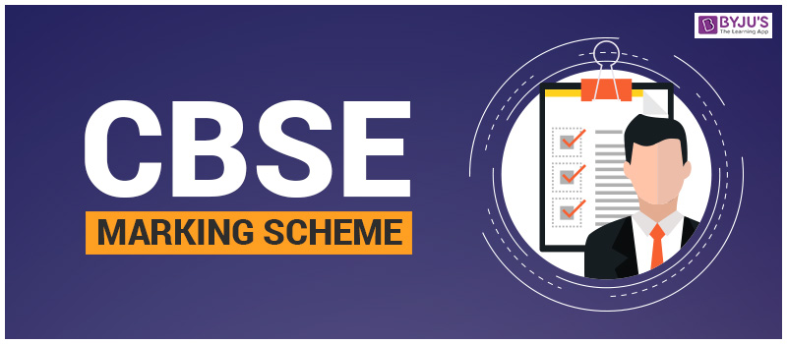
COMPETENCE BASED EDUCATION
GRADE 8
CODE: 009/2025
ENGLISH PP1



Answers:
Question No. | Answer
1 | B
2 | C
3 | C
4 | C
5 | A
6 | B
7 | C
8 | D
9 | C
10 | B
11 | C
12 | B
13 | D
14 | C
15 | C
16 | C
17 | C
18 | C
19 | C
20 | C
21 | B
22 | D
23 | B
24 | C
25 | B
26 | B
27 | C
28 | B
29 | B
30 | D
31 | C
32 | B
33 | C
34 | B
35 | C
36 | A
37 | C
38 | C
39 | B
40 | C
41 | B
42 | B
43 | C
44 | B
45 | A
46 | B
47 | C
48 | B
49 | A
50 | B

THIS IS THE LAST PRINTED PAGE.

