Candidate’s Name |  | Assessment Number
School Name |  | School Code
Candidate’s Signature |  | Date
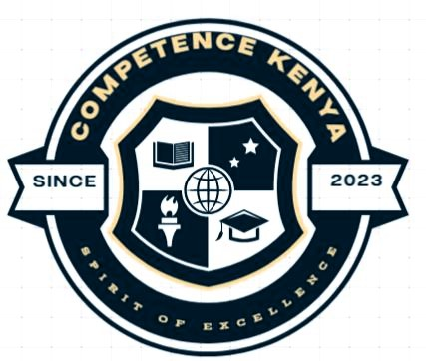
KENYA JUNIOR SCHOOL EDUCATION ASSESSMENT (KJSEA)
GR ADE 7: CREATIVE ARTS AND SPORTS
PAPER 1 (Project)
CODE: 009 YEAR: 2025
DURATION: 3 weeks

INSTRUCTIONS TO SCHOOLS
- This is a project paper to be done over a 3-weeks period.
- Teachers will assess each task based on the provided scoring rubrics.
- Each milestone should be marked and recorded for every learner as they progress.

This paper consists of 4 printed pages. Candidates should check the question paper to ascertain that all the pages are printed as indicated and that no questions are missing.
© 2025 The Kenya Junior School Examination and Assessment Series. Turn over

1. INTRODUCTION
This is a practical, learner-centered project combining Visual Arts, Performing Arts (Music and Theatre), and Sports. It allows learners to explore their talents and creativity around a unifying theme.

2. PROJECT THEME: “Unity in Diversity”
Kenya is rich in culture, languages, and lifestyles. This term, your class will organize a school showcase titled "Unity in Diversity" to celebrate the beauty of differences and promote harmony.

TASK 1: VISUAL ARTS – CULTURE IDENTITY ARTWORK
Individually:
a) Create a piece of artwork (drawing, painting, collage or sculpture) that represents your ethnic or cultural identity.
b) Use available materials like paper, leaves, fabrics, bottle tops, sand, etc.
c) The artwork should highlight an important symbol, tradition, attire, or celebration from your culture.
d) Write a short paragraph (5–7 lines) explaining the meaning of your artwork.
e) Display your artwork during the Unity in Diversity showcase.

TASK 2: MUSIC AND DANCE – CULTURAL MEDLEY PERFORMANCE
In groups of 6–10 learners:
a) Select two cultural folk songs or dances from two different Kenyan communities.
b) Create a medley performance by blending parts of both songs/dances into a single presentation.
c) Use appropriate costumes and improvised instruments.
d) Record a practice video and the final performance.
e) Each group must submit:
- A short write-up about the songs/dances (origin, meaning, message)
- A list of materials used for costumes/instruments
- Reflection notes from at least three members
Perform your medley during the school’s Unity in Diversity Showcase.

TASK 3: THEATRE – MINI PLAY ON HARMONY
In groups of 4–6 learners:
a) Write and present a short play (3–5 minutes) promoting peace, respect, and friendship across different communities.
b) The play should include:
- Dialogue in at least two different local languages or dialects (with translations)
- A short poem or chant
- Use of costumes, facial expressions, and body movement
c) Submit:
- Script of the play
- Costume ideas with sketches or photos
- Group reflection on how theatre can promote national unity

TASK 4: SPORTS – INTER-CULTURAL TEAM GAMES
In teams of 4–5:
a) Research and select a traditional game or sport played by any Kenyan community (e.g., wrestling, bao, tag, tug of war, sack race).
b) Practice the game and create a short guide describing:
- How the game is played
- The community it comes from
- Values or lessons learned through the game
c) Organize a demo match of the traditional game with classmates.
d) Reflect on:
- What you enjoyed most
- How teamwork was applied
- Any new cultural lesson you learned

THIS IS THE LAST PRINTED PAGE.

