Candidate’s Name |  | Assessment Number
School Name |  | School Code
Candidate’s Signature |  | Date

KENYA JUNIOR SCHOOL EDUCATION ASSESSMENT (KJSEA)
GRADE 7: SOCIAL STUDIES.
CODE: 009 YEAR: 2025
TIME: 1 hour 40 minutes
INSTRUCTIONS TO CANDIDATES
- Write your name and class in the spaces provided above.
- This paper consists of two sections: A and B.
- Answer ALL questions in Section A.
- Answer ALL questions in Section B.
- All answers must be written in the spaces provided.
- Marks for each question are indicated in brackets.
For official use only

SECTION A: MULTIPLE CHOICE QUESTIONS (20 Marks)
Question No. | 1 | 2 |  | 3 | 4 |  | 5 | 6 | 7 |  | 8 | 9 | 10
Max Score | 1 | 1 |  | 1 | 1 |  | 1 | 1 | 1 |  | 1 | 1 | 1
Candidate’s Score
Question No. | 11 |  | 12 |  |  | 13 |  | 14 |  | 15 |  | 16 | 17 | 18 | 19 | 20 | TOTAL
Max Score | 1 |  | 1 |  |  | 1 |  | 1 |  | 1 |  | 1 | 1 | 1 | 1 | 1 | 20
Candidate’s Score

SECTION B: STRUCTURED QUESTIONS. (60 Marks)
Task | Qn Nos. | Max Marks | Candidate's Score
TASK 1: MAPWORK | Q1 a–c | 5
TASK 2: CITIZENSHIP | Q1 a–c | 5
TASK 3: HISTORY | Q1–12 | 30
TASK 4: GEOGRAPHY | Q1–8 | 30
TASK 5: LIFE SKILLS | Q1–3 | 10
TOTAL SCORE (Standardized to 60 Marks) | — | 60

This paper consists of 10 printed pages. Candidates should check the question paper to ascertain that all the pages are printed as indicated and that no questions are missing.

© 2025 The Kenya Junior School Examination and Assessment Series. Turn over

SECTION A: (20 Marks)
Answer all questions in this section.

- Which of the following is NOT a core component of Social Studies? A) History B) Chemistry C) Geography D) Citizenship
- A young person who actively participates in protecting the environment and promoting peace globally is an example of a: A) National citizen B) Global citizen C) Local resident D) Tourist
- The theory that suggests human beings were created by a divine being is known as the: A) Scientific theory B) Mythical theory C) Religious theory D) Evolutionary theory
- Which of these is a major source of historical information? A) Future predictions B) Oral traditions C) Science fiction novels D) Weather forecasts
- The time in Mogadishu 45° East is 9.00 p.m. What will be the time in El Aaiun 15° West? (v)
  - 5.00 a.m.
  - 5.00 p.m.
  - 7.00 a.m.
  - 7:00 p.m
- Use the diagram below to answer question 11
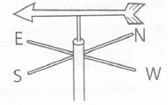
The instrument shown above is used to measure
  - direction of wind
  - speed of wind
  - atmospheric pressure
  - humidity.
Use the map below to answer question 7 and 8.
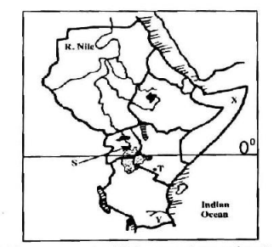
- The country marked X is called?
    - Kenya
    - Libya
    - South Africa
    - Somalia

- What is the name of the latitude 0⁰
A) Tropic of Capricorn B) tropic of cancer C) equator D) prime meridian
- The main reason for the Scramble and Partition of Africa by European powers was to: A) Promote African development B) Share African cultures C) Access raw materials and new markets D) End slavery
- The concept of "Harambee" in Kenya is an example of which national value? A) Patriotism B) Rule of law C) Human dignity D) Social justice
- Which arm of the Kenyan government is responsible for interpreting laws? A) Legislature B) Executive C) Judiciary D) Police force
- A characteristic of human rights is that they are: A) Granted by the government B) Earned through hard work C) Inherent to all human beings D) Dependent on one's wealth
- The buying and selling of enslaved people across the Indian Ocean is known as the: A) Trans-Atlantic Slave Trade B) Indian Ocean Slave Trade C) Internal Slave Trade D) European Slave Trade
- Which of these is a benefit of self-exploration for a learner? A) It makes you popular in school B) Helps in identifying personal abilities and interests C) Leads to immediate wealth D) Reduces the need for studying
- Which of the following is a key step in resolving a conflict peacefully? A) Blaming one party B) Attacking the other person C) Communicating openly and listening D) Ignoring the problem
- Which of these is a contribution of the Nile River to the growth of ancient Egyptian civilization? A) Providing sand for desert formation B) Facilitating trade and transport C) Causing frequent earthquakes D) Freezing water for ice storage
- What is the capital city of Ethiopia? A) Cairo B) Nairobi C) Addis Ababa D) Abuja
- An example of a career opportunity directly related to Social Studies is a: A) Doctor B) Pilot C) Museum curator D) Mechanic
- The formal act of putting a new constitution or law into effect is called: A) Amendment B) Repealing C) Promulgation D) Debating
- The practice of respecting and valuing the unique characteristics of every individual falls under the concept of: A) Discrimination B) Non-discrimination C) Conflict D) Segregation

SECTION B: STRUCTURED QUESTIONS (60 Marks)
Answer all questions in this section in the spaces provided.
TASK 1: MAPWORK (5 Marks)
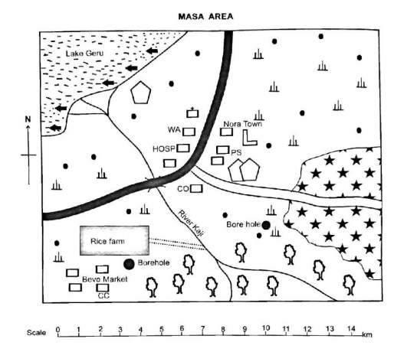
- Study the map of Masa area and use it to answer the questions that follow.

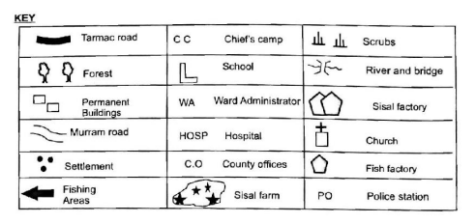

a) State two components of this map that help you understand what features are represented. (2 Marks)
i) …………………………………………………………………………………………………………..
ii) …………………………………………………………………………………………………………
b) Identify the main direction of flow of the river Kaji(1 Mark)
…………………………………………………………………………………………………………….
c) Explain the difference between topographical map and a sketch map. (2 Marks)
……………………………………………………………………………………………………………..
……………………………………………………………………………………………………………..
TASK 2: CITIZENSHIP (5 Marks)
- Your class has decided to initiate a "Peace Club" to promote harmony and understanding among students, reflecting the national values.
- a) Name two national values of Kenya that the Peace Club would promote. (2 Marks)
i) ………………………………………………………………………………………………………..
ii) ……………………………………………………………………………………………………........
b) Explain the concept of non-discrimination as a human right. (1 Mark)
…………………………………………………………………………………..………………………..
c) Give two reasons why it is important to promote global citizenship among young people. (2 Marks)
i) …………………………………………………………………………………………………………..
ii) ………………………………………………………………………………………………………….
TASK 3: HISTORY (30 Marks)
- A teacher presented the following photographs on a projector.
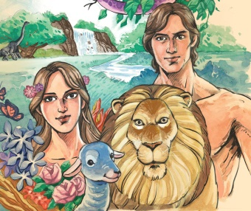 |  | 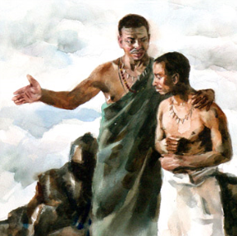
Panel 1 | Panel 2 | Panel 3
a) Identify the three theories on the origin of man illustrated above. (3 Marks)
i) Panel 1: ………………………………………………………………………………………….
ii) Panel 2: ………………………………………………………………………………………….
iii) Panel 3: ………………………………………………………………………………………..
b) Briefly explain one key idea from the scientific theory of human origin. (1 Mark)
……………………………………………………………………………………………………..
……………………………………………………………………………………………………
- a) Name two major early kingdoms in Africa, other than Egypt, you have studied. (2 Marks)
i) …………………………………………………………………………………………………………
ii) ………………………………………………………………………………………………………..
b) State two factors that led to the growth and prosperity of these early African kingdoms. (2 Marks)
i) ……………………………………………………………………………………………………....
ii) ……………………………………………………………………………………………………..
c) Give one contribution of the Egyptian Kingdom to the modern world. (1 Mark)
…………………………………………………………………………………………………………
- a) Identify two places along the East African coast where the Indian Ocean Slave Trade took place. (2 Marks)
i) …………………………………………………………………………………………………………
ii) …………………………………………………………………………………………………………
b) Describe two significant changes that Arab traders brought to the East Coast of Africa. (2 Marks)
i) ………………………………………………………………………………………………………..
ii) ……………………………………………………………………………………………………….
      - Explain how the Indian Ocean Slave Trade violated key human rights. (2 Marks)
……………………………………………………………………………………………………………………
……………………………………………………………………………………………………………………

- a) Name two methods of irrigation used by ancient Egyptians. (2 Marks)
i) ……………………………………………………………………………………………………………
ii) …………………………………………………………………………………………………………..
b) State two ways of collecting historical data for a research project. (2 Marks)
i) ……………………………………………………………………………………………………………
ii) ………………………………………………………………………………………………………….
- a) Identify two reasons for the Scramble and Partition of Africa by European powers. (2 Marks)

i) ………………………………………………………………………………………………………………

ii) ……………………………………………………………………………………………………………..
b) Which major conference formally laid down the rules for the partition of Africa? (1 Mark)
……………………………………………………………………………………………………………..
c) Name two African countries that were taken up by the British during the partition. (2 Marks)
i) …………………………………………………………………………………………………………….
ii) …………………………………………………………………………………………………………….
d) State two terms or conditions agreed upon at the conference mentioned in 6 (b). (2 Marks)
i) ……………………………………………………………………………………………………………
ii) …………………………………………………………………………………………………………..
TASK 4: GEOGRAPHY (30 Marks)
- a) Name the capital city of Nigeria. (1 Mark)
………………………………………………………………………………………………………..
b) Identify two major physical features found in Africa. (2 Marks)
i) ……………………………………………………………………………………………………….
ii) ……………………………………………………………………………………………………..

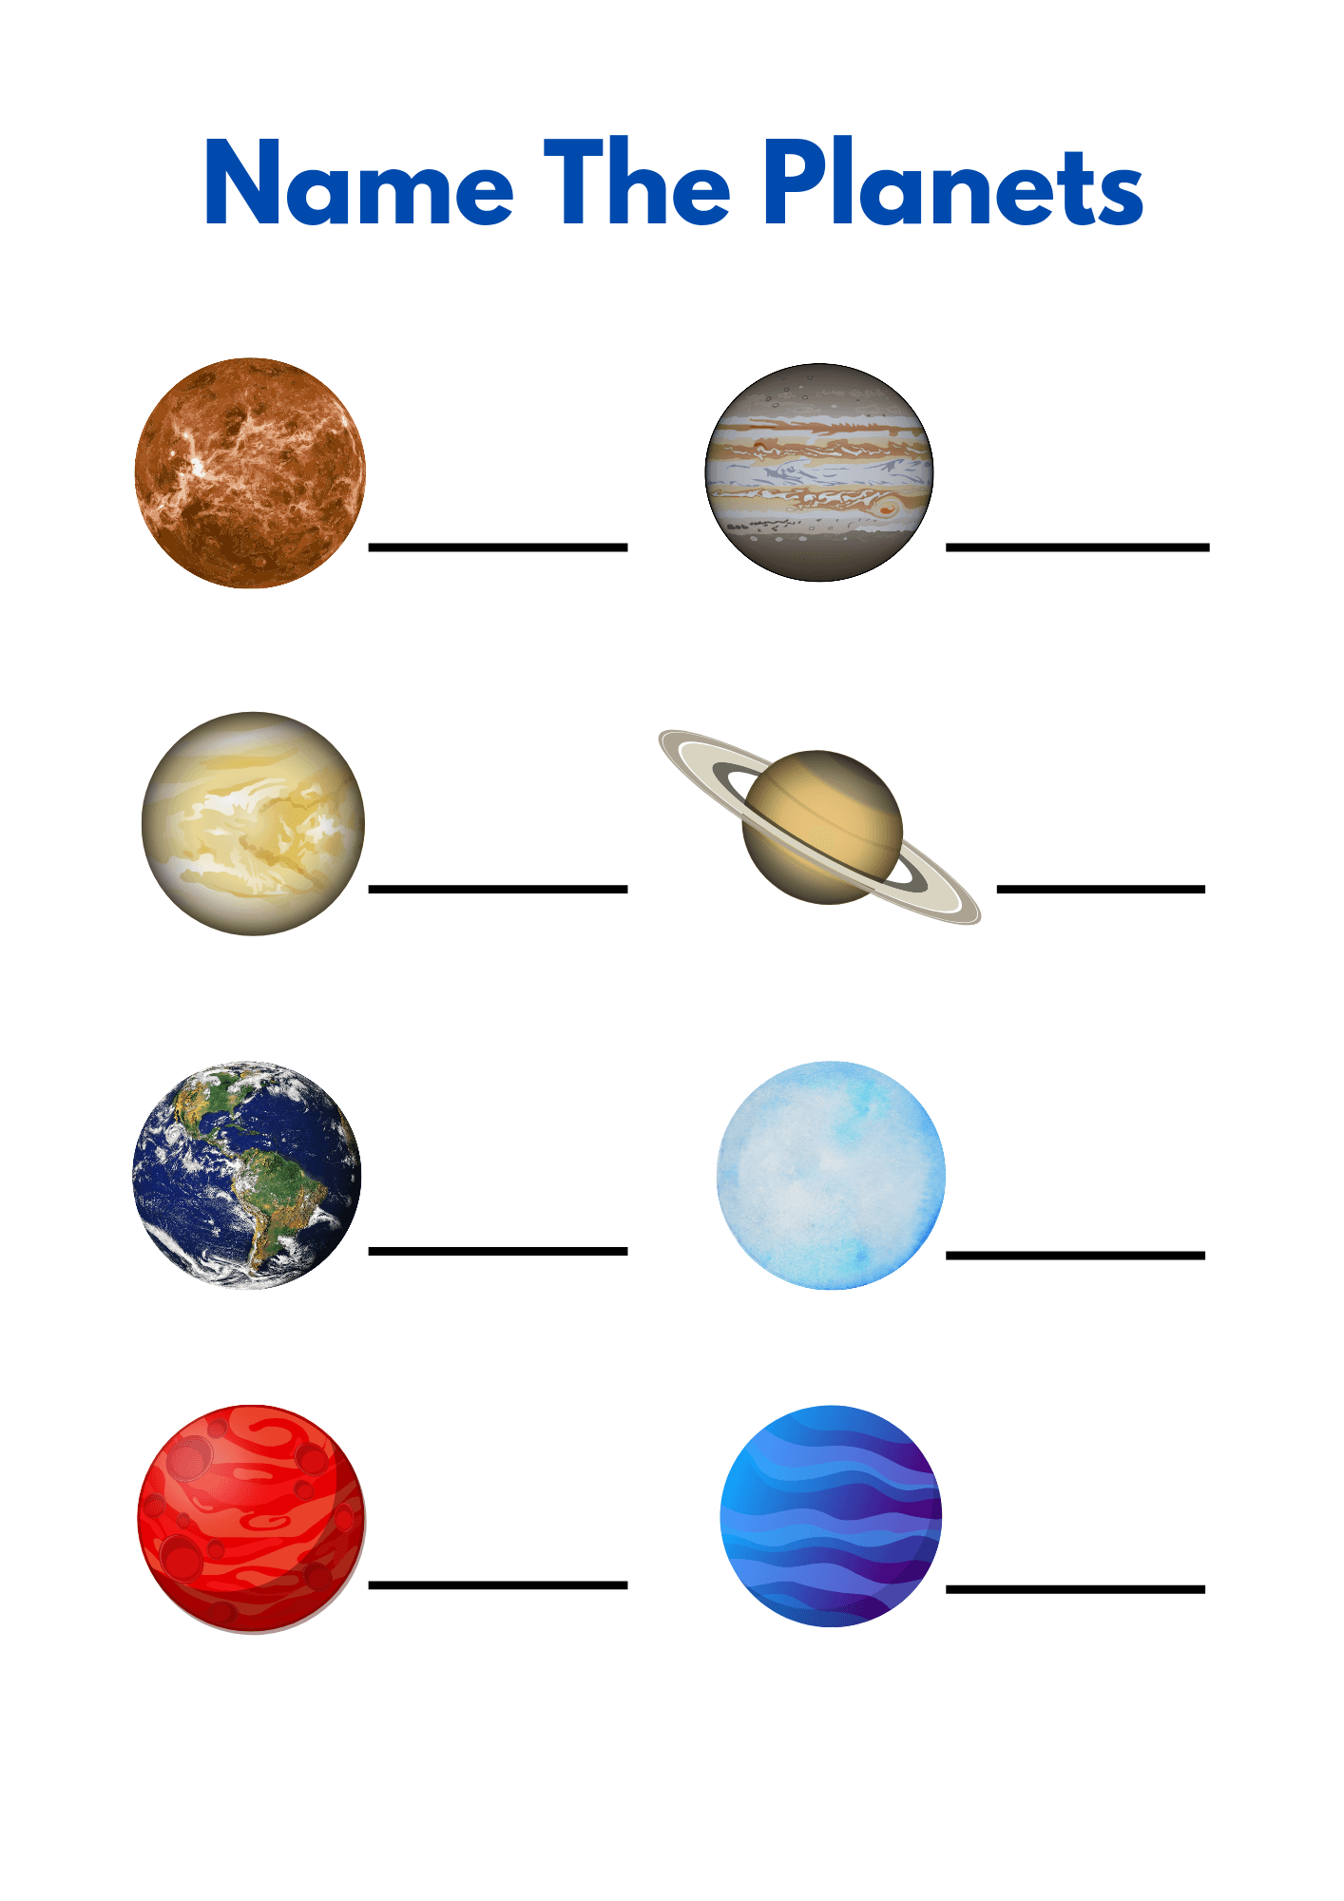
c) Name the following planets. (2 Marks)
- Grade 7 learners of Watuha Junior School visited a weather station for a practical lesson. They interacted with various weather instruments.
a) State two characteristics of the Stevenson Screen that make it suitable for its function. (2 Marks)
i) ………………………………………………………………………………………………….………..
ii) ……………………………………………………………………………………………………….…..
b) Give two factors considered when siting a weather station. (2 Marks)
i) …………………………………………………………………………………………………………..
ii) …………………………………………………………………………………………………………
c) Oscar wants to become a pilot. He was told that pilots also rely on whether to fly planes.

Explain the significance of knowing weather patterns to a pilot. (1 Mark)
………………………………………………………………………………………………………….
- a) Describe two factors that contribute to individual differences among people. (2 Marks)

i) …………………………………………………………………………………………………………….

ii) ……………………………………………………………………………………………………………
b) Explain the importance of promoting solidarity in a community. (1 Mark)
…………………………………………………………………………………………………………
- As a Grade 7 student, suggest two ways you can appreciate human identities in your school. (2 Marks)
i) …………………………………………………………………………………………………………….
ii) …………………………………………………..………………………………………………………..
- a) State two reasons why fieldwork is carried out in Social Studies. (2 Marks)

i) ………………………………………………………………………………..………………………..……

ii) …………………………………………………………………………………..…………………………..
b) Identify two challenges that learners might face during a fieldwork exercise. (2 Marks)
i) ………………………………………………………………………………………………………….
ii) …………………………………………………………………………………………………………..
- Your class is planning a community service learning project to address a local issue.
a) Give one reason why community service learning is important for learners. (1 Mark)
………………………………………………………………………………………………………………..
b) List two steps involved in planning a successful community service learning project. (2 Marks)
i) ……………………………………………………………………………………………………………..
ii) …………………………………………………………………………………………………………..
TASK 5: LIFE SKILLS (10 Marks)
- a) Based on the lesson you learnt about career opportunities, identify two career opportunities related to Social Studies. (2 Marks)
i) ………………………………………………………………………………………………………..
ii) _...............................................................................................................................................................
b) Explain how knowing your personal abilities and interests can guide you in choosing a suitable career. (2 Marks)
…………………………………………………………………………………………………………………….
…………………………………………………………………………………………………………………….
Study the diagram below to answer question 35

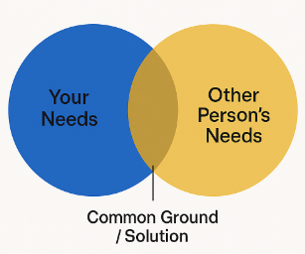

- a) Based on the diagram, identify one important principle for effective conflict resolution. (1 Mark)
…………………………………………………………………………………………………………..
b) Name two causes of conflict that can arise in your peer group. (2 Marks)
i) _______________________________________________________________________________
ii) ______________________________________________________________________________
c) Describe two ways you can prevent conflicts from escalating in your school. (2 Marks)
i) _______________________________________________________________________________
ii) ______________________________________________________________________________
- Explain why resolving conflicts peacefully are crucial for maintaining healthy interpersonal relationships. (1 Mark)
…………………………………………………………………………………………………………………..
…………………………………………………………………………………………………………………..

THIS IS THE LAST PRINTED PAGE.

