Candidates Name |  | Assessment Number
School Name |  | School Code
Candidates Signature |  | Date

MONITORING JUNIOR SCHOOL LEARNER PROGRESS
GRADE 7: PRETECHNICAL STUDIES. PAPER 1. (Theory)
CODE: 009 YEAR: 2025
TIME: 1 hour 40 minutes
INSTRUCTIONS TO CANDIDATES
- Write your name and assessment number in the spaces provided above.
- Sign and write the date of the assessment in the spaces provided above.
- This paper consists of two sections: A and B.
- Answer ALL the questions in section A on the separate ANSWER SHEET provided.
- Answer ALL the questions in section B in the spaces provided in this question paper.
- Do not remove any page from this question paper.
- Answer all questions in English.
For official use only

SECTION A: MULTIPLE CHOICE QUESTIONS (30 Marks)
Question Number | 1 | 2 |  | 3 | 4 |  | 5 | 6 | 7 |  | 8 | 9 | 10 | 11 | 12 | 13 | 14 | 15
Maximum Score | 1 | 1 |  | 1 | 1 |  | 1 | 1 | 1 |  | 1 | 1 | 1 | 1 | 1 | 1 | 1 | 1
Candidates Score
Question Number | 16 |  | 17 |  |  | 18 |  | 19 |  | 20 |  | 21 | 22 | 23 | 24 | 25 | 26 | 27 | 28 | 29 | 30 | Total score
Maximum Score | 1 |  | 1 |  |  | 1 |  | 1 |  | 1 |  | 1 | 1 | 1 | 1 | 1 | 1 | 1 | 1 | 1 | 1 | 30
Candidates Score

SECTION B: STRUCTURED QUESTIONS. (50 Marks)
Task | Question | 31 | 32 | 33 | 34 | 35 | 36 | 37 | 38 | 39 | 40 | 41 | 42 | 43 | 44 | 45 | 46 | 47 | 48 | 49 | 50
Task 1
Task 2
Task 3
Question
Max Score |  |  |  |  | 25 |  |  |  | 12 |  |  |  |  |  |  |  | 13
Candidates Score per Question
Candidates Score per Task
This paper consists of 12 printed pages. Candidates should check the question paper to ascertain that all the pages are printed as indicated and that no questions are missing.
© 2025 The Kenya Junior School Examination and Assessment Series. Turn over
SECTION A (30 marks)
Answer All questions in this section on the answer sheets provided.

- Which of the following best describes the Role of Pre-Technical Studies in Junior School education?
A. To specialize learners in one technical skill.
B. To provide a broad foundation for technical and practical skills.
C. To prepare learners only for university studies.
D. To replace traditional academic subjects.
- In a workshop, a student sees a :-
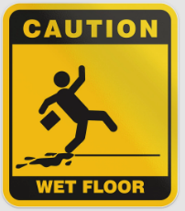
This sign is primarily placed to address which type of threat?
A. Online safety threat.
B. Economic threat.
C. Physical threat.
D. Communication threat.
- A computers ability to process vast amounts of data without getting tired or losing accuracy is known as:
A. Speed. B. Versatility.
C. Diligence. D. Accuracy.
- Which of the following is an example of an ICT tool used for communication?
A. A hammer.
B. A newspaper.
C. A mobile phone.
D. A ruler.
- When dimensioning a technical drawing, which type of dimensioning is used to indicate the length of a straight line segment?
A. Radial dimensioning.
B. Angular dimensioning.
C. Linear dimensioning.
D. Arc dimensioning.
- Which of the following is a 2D shape?
A. Pyramid. B. Cube.
C. Square. D. Cylinder.
- Grade 7 learners tested magnetic conductivity of various metals they brought to class:
Which material below is non-magnetic?
A. iron B. nickel.
C. cobalt D. copper
- Which of the following is considered a Need?
A. A luxury car.
B. Basic food.
C. A designer watch.
D. A vacation to a foreign country.
- Mr. Omondi, a carpenter, ensures his tape measure is always clean and stored properly after use. This practice falls under the Care of measuring tools to ensure its:
A. Aesthetic appeal.
B. Durability and accuracy.
C. Ease of transportation.
D. Colour preservation.
- Which of the following is a characteristic of Land as a factor of production?
A. It can be easily moved.
B. It includes natural resources provided by nature.
C. It is created by human effort.
D. It includes money used to start a business.
- Which of the following is a characteristic of Money?
A. It is only accepted in one country.
B. It must always be in physical form.
C. It is divisible into smaller units.
D. It has no value of its own.
- Sarah is drawing a line shown below.
Which type of line should she use?
A. Hidden line.
B. Centre line.
C. Cutting plane
D. Dimension line.
- A student is learning about Computer Concepts. Which of the following best describes the Central Processing Unit (CPU)?
A. A device for printing documents.
B. The brain of the computer, performing calculations.
C. A storage device for large files.
D. A tool for Browse the internet.
- Which of the following is an example of a physical threat in the workplace?
A. Cyberbullying on social media.
B. Loud noise causing hearing damage.
C. Phishing scams via email.
D. Identity theft online.
- Which type of metallic material is commonly used for electrical wiring due to its excellent conductivity?
A. Iron.
B. Steel.
C. Copper.
D. Aluminum.
- What is the primary purpose of Setting Financial Goals?
A. To spend money without planning.
B. To avoid saving money.
C. To provide a clear direction for managing money.
D. To make money instantly.

- A company decides to use child labour in its production process to cut costs. This is an example of what type of practice?
A. Ethical practice.
B. Unethical practice.
C. Sustainable practice.
D. Legal practice.
- Which of the following types of artistic drawings involves creating exaggerated drawings of people for humorous effect?
A. Portrait. B. Illustration.
C. Graffiti. D. Caricature.
- Which classification of computers is typically found in large organizations like banks and airlines, handling massive amounts of data and transactions?
A. Microcomputer. B. Minicomputer.
C. Mainframe computer. D. Supercomputer.
- Why is communication considered important in a professional setting?
A. It makes tasks more complicated.
B. It hinders teamwork.
C. It facilitates understanding, coordination, and problem-solving.
D. It reduces productivity.
- Which of the following is a source of Business Ideas?
A. Avoiding customer feedback.
B. Identifying market gaps or unmet needs.
C. Copying competitors exactly.
D. Ignoring personal interests.
- Which of the following is a key security feature of Kenyan currency to prevent counterfeiting?
A. Its plain white colour.
B. A hidden watermark visible when held to light.
C. Its thin, easily torn paper.
D. The absence of any unique symbols.
- When drawing an object freehand, which principle focuses on representing the objects features relative to each other, maintaining their visual relationship?
A. Proportion. B. Texture.
C. Shading. D. Colour.
- Dorcas was using Microsoft word application for his project work? X
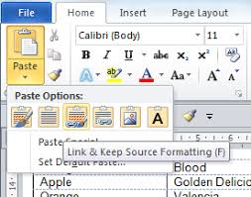
The part labeled X is known as?
A. Title bar
B. Status bar.
C. Tool bar
D. File tab.

- What is the primary reason for wearing safety gloves when handling rough materials in a workshop?
A. To improve grip on tools.
B. To protect hands from cuts and abrasions.
C. To keep hands warm.
D. To make the work look professional.
- You are dimensioning a wheel. Which method would you use to indicate the size of its circular part?
A. Linear dimensioning.
B. Angular dimensioning.
C. Radial dimensioning.
D. Combined dimensioning.
- Which of the following is a reward for the factor of production Capital?
A. Wages.
B. Rent.
C. Interest.
D. Profit.
- Which of the following is an example of Goods?
A. A teachers lesson.
B. A medical diagnosis.
C. A pair of shoes.
D. A car repair service.
- A break line in technical drawing is used to:
A. Show the exact dimensions of an object.
B. Indicate a continuous surface.
C. Show that a part of the object has been cut away or shortened.
D. Mark the centre of a circle.
- The ability of a computer to perform tasks without human intervention is known as:
A. Automation.
B. Intelligence.
C. Creativity.
D. Emotion.

SECTION B (50 marks)
Answer ALL the questions in this section in the spaces provided.
- Explain two benefits of studying Pre-Technical Studies for a Grade 7 learner. (4 marks)
  - …………………………………………………………………………………………………………..
  - ………………………………………………………………………………………………………….

- Mary is working in a science laboratory. She notices a fellow student mixing chemicals without wearing a lab coat and safety glasses.
a) Identify two safety rules being violated by the student. (2 marks)
  - …………………………………………………………………………………………………………..
  - ……………………………………………….………………………………………………………….
b) State one potential physical threat that the student faces by not adhering to these safety rules. (1 mark)
…………………………………………………………………………………………………………………
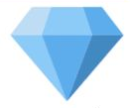
- The image below shows a basic 3D geometric shape.

a) Name the 3D shape shown above. (1 mark)
……………………………………………………………………………………………………………….
b) Draw two different types of lines used in dimensioning this shape, clearly labelling each line. (4 marks)

- Consider a scenario where a student is using a tablet computer.
a) Name two characteristics of the tablet computer that make it suitable for learning on the go. (2 marks)
  - ………………………………………………………………………………………………………….
  - ………………………………………………………………………………………………………….
b) Differentiate between hardware and software in computer concepts, providing one example for each. (4 marks)
Hardware | Software
Example: | Example:
- John is developing a new mobile application for local businesses. State two factors that would enhance the success of his business. (2 marks)
  - ………………………………………………………………………………………………………….
  - ………………………………………………………………………………………………………….
- Alex receives an email from an unknown sender claiming his social media account has been hacked and asking him to click a link to verify his identity.
a) What online safety threat is Alex likely facing? (1 mark)
………………………………………………………………………………………………………………….
b) State two best practices for Alex to protect himself from such online threats. (2 marks)
  - …………………………………………………………………………………………………………..
  - ………………………………………………………………………………………………………….
- Differentiate between Metallic and Non-metallic materials, providing one example of each. (4 marks)
Metallic Materials | Non-metallic Materials
Example: | Example:
- Identify two common uses of Brass. (2 marks)
  - ……………………………….………………………………………………………………………….
  - …………………………………………………………………………………………………………..
- Outline three reasons why Freehand Sketching is important in technical and artistic drawing. (3 marks)
  - ………………………………………………………………………………………………………….
  - ………………………………………………………………………………………………………….
  - ………………………………………………………………………………………………………….

- A student is asked to measure the length of a curved line on a map.
a) Which type of dimensioning would be most appropriate for this task? (1 mark)
…………………………………………………………………………………………………………………
b) State two common uses of measuring tools in everyday life. (2 marks)
  - ………………………………………………………………………………………………………….
  - ………………………………………………………………………………………………………….
- An entrepreneur is starting a small baking business.
a) Name one economic resource that represents Capital in her baking business. (1 mark)
…………………………………………………………………………………………………………………
b) State two importance of Entrepreneurship to the economy. (2 marks)
  - ………………………………………………………………………………………………………….
  - ………………………………………………………………………………………………………….
- Consider a combined shape consisting of a rectangle and a triangle. The rectangle has a length of 8 cm and a width of 5 cm. The triangle has a base equal to the rectangles width (5 cm) and a height of 4 cm.
a) Calculate the area of the rectangle. (1 mark)

b) Calculate the area of the triangle. (2 marks)

- Kevin wants to save Ksh 10,000 to buy a new tablet computer by the end of the year.
a) Identify two factors to consider when setting this financial goal. (2 marks)
  - ………………………………………………………………………………………………………….
  - …………………………………………………………………………………………………………..
b) Name one source of money Kevin could use to achieve his financial goal. (1 mark)
………………………………………………………………………………………………………………….
- Kenyan currency notes feature various themes and symbols. Describe two such themes or symbols and their significance. (4 marks)
  - ……………………………………………………………………………………………………………………………………………………………………………………………………………………
  - ……………………………………………………………………………………………………………………………………………………………………………………………………………………
- In a busy office, poor communication often leads to misunderstandings and errors. State two ways to improve fundamentals of communication in this office. (2 marks)
  - ………………………………………………………………………………………………………
  - …………………………………………………………..…………………………………………..
- Name the rewards for factors of production. (4 marks)
Factor of Production | Reward
Land
Labour
Capital
Entrepreneurship
- What is the main importance of communication in fostering teamwork and collaboration? (1 mark)
………………………………………………………………………………………………………………
- Mary is asked to sketch a cylindrical object without using any tools. Which method of freehand sketching involves drawing light construction lines to define the basic form before adding details? (1 mark)
………………………………………………………………………………………………………………
- A small business needs a computer system primarily for word processing, Browse the internet, and managing customer contacts. Which classification of computer would be most appropriate and cost-effective for them? (1 mark)
…………………………………………………………………………………………………………….
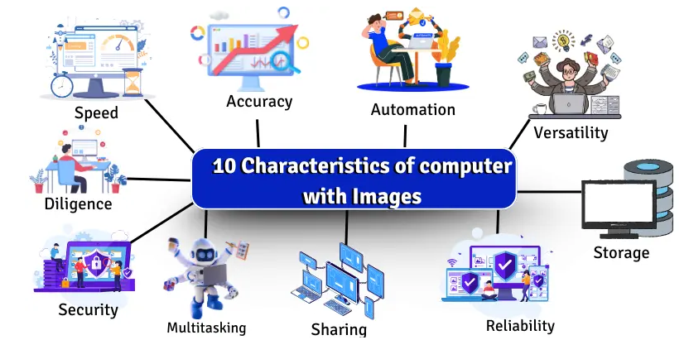
- A computer engineer displayed a chart showing the characteristics of a computer:

Which of these characteristics implies that a computer can perform the same task repeatedly without getting tired or making errors? (1 mark)
……………………………………………………………………………………………………………..
THIS IS THE LAST PRINTED PAGE.

