Candidate’s Name |  | Assessment Number
School Name |  | School Code
Candidate’s Signature |  | Date

KENYA JUNIOR SCHOOL EDUCATION ASSESSMENT (KJSEA)
GRADE 7: MATHEMATICS
CODE: 009 YEAR: 2025 TERM 3 2025
TIME: 2 HOURS
INSTRUCTIONS TO CANDIDATES:
- Write your name and class in the spaces provided above.
- The paper consists of two sections: Section A and Section B.
- Answer ALL questions in Section A and Section B.
- Show all your working in the spaces provided.
- All questions carry marks as indicated.
- Mathematical tables and electronic calculators may be used.
.

FOR OFFICIAL USE ONLY.

For Official Use Only
Task | Task 1 | Task 2 | TOTAL
Question | 1 | 2 | 3QUESTIONS
Maximum Score | 20 | 10 | 30 MARKS
Candidate’s Score

This paper consists of 17 printed pages. Candidates should check the question paper to ascertain that all the pages are printed as indicated and that no questions are missing.
© 2025 The Kenya Junior School Examination and Assessment Series. Turn over

SECTION A: (20 Marks)
Answer all questions.

- A farmer harvested 23,456 kilograms of maize. What is the place value of the digit '3' in this number? A. Thousands B. Ten Thousands C. Hundreds D. Tens
- A tailor had 15.5 meters of fabric. He used 7.8 meters to make a dress and 3.2 meters to make a shirt. How much fabric is left? A. 4.5 m B. 5.5 m C. 4.8 m D. 5.2 m
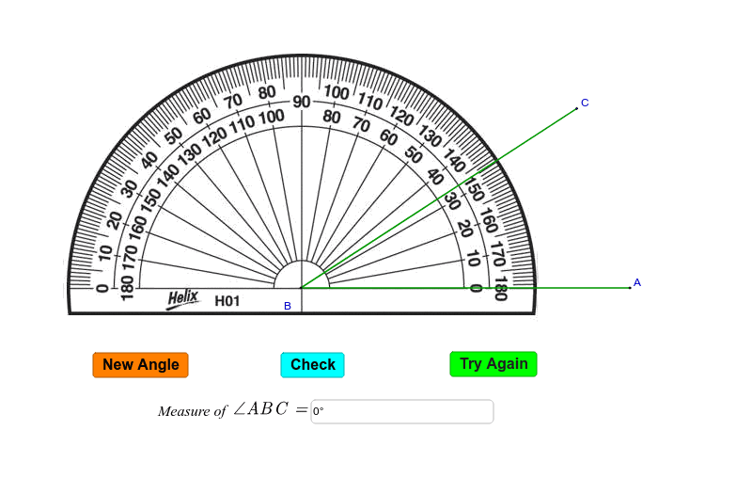
- Mwangi measured an angle using a protractor.

What is the measure of angle ABC? A. 22⁰ B. 40⁰ C. 150⁰ D. 33⁰
- Which of the following shapes has all its sides equal and all its angles equal? A. Rectangle B. Rhombus C. Square D. Parallelogram

Working space.

- During a school survey, 200 students counted the number of pets they own as represented by the pie-chart below.
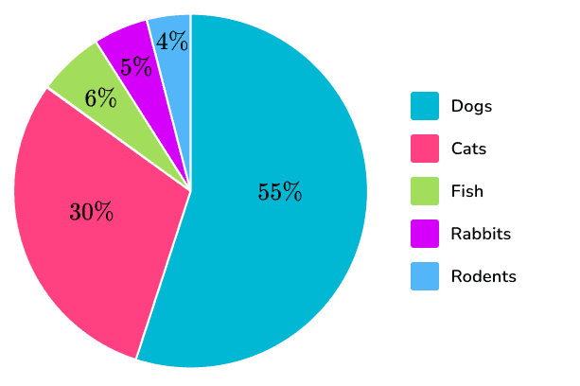
How many students own cats? A. 60 B. 12 C. 110 D. 8
- Mwangi spent $\frac{1}{3}$ ​of his money on food and $¼ ​$ on transport. What fraction of his money did he spend in total? A. $\frac{1}{7​}$ B. $\frac{2}{7​}$ C. $\frac{7}{12}$ D. $\frac{5}{12}$​
- A bus left Nairobi at 8:30 AM and arrived in Mombasa at 3:15 PM. How long did the journey take? A. 6 hours 45 minutes B. 7 hours 15 minutes C. 6 hours 15 minutes D. 7 hours 45 minutes [ ]
- Look at the butterfly below.

How many lines of symmetry does the object shown in the image above approximately have? A. 0 B. 1 C. 2 D. 4
- Convert 0.75 into a fraction in its simplest form. A. $\frac{3​}{4}$ B. $\frac{75}{100}$​ C. $¼​$ D. $½​$

Working space.

- The table shows bus fare for adult passengers in shillings between different towns.
Town K
300 | Town L
500 | 300 | Town M
600 | 300 | 200 | Town N
700 | 400 | 300 | 200 | Town P
Amina and her two children travelled by bus from town K to P via N. The bus fare for children was half that of adults. How much money did Amina and her children spend as fare for the whole journey altogether
  - sh 1400
  - sh 1600
  - sh2000
  - sh2400

- A sack of potatoes weighs 50 kg. If a customer buys 2.5 kg, how many kilograms of potatoes are left in the sack? A. 47.5 kg B. 48.5 kg C. 49.5 kg D. 52.5 kg
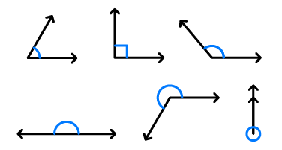
- What type of angle is exactly 90 degrees?
A B

C D

- In a class, the ratio of boys to girls is 3:5. If there are 15 boys, how many more girls than boys are there? A. 9 B. 20 C. 10 D. 30
- A rectangular garden is 10 meters long and 6 meters wide. What is its area? A. 16 m² B. 32 m² C. 60 m² D. 100 m²

Working space.

- Nicholas paid sh 4000 for a carpet after getting a discount of 20%. What would have been the percentage discount had he bought the carpet for sh 3 800?
  - 4%
  - 24%
  - 30%
  - 76%
- Patel bought the following items from a shop:
  - 3½ kg of maize flour @sh 90 per kg
  - 2 loaves of bread for sh 110
  - 5 packets of milk @sh 52
  - 4 kg of rice @sh 69 per kg
He paid for all the items using a sh 1 000 note. How much more money should Patel give the shopkeeper so as to be given a balance of a sh 100 note?
    - sh961
    - sh 161
    - sh61
    - sh 39
- The marked price of a radio was sh3 200. The hire purchase price was 115% of the marked price. Mutai bought the radio on hire purchase terms. He paid a deposit of sh 1680 and 4 equal monthly instalments. How much money was each monthly instalment?
  - sh 500
  - sh920
  - sh 2000
  - sh 3680
- The sitting capacity of a matatu was decreased from 14 passengers to 11 passengers. What was the percentage decrease in the sitting capacity?
  - 21 3/7%
  - 27 3/11%
  - 72 8/11%
  - 78 4/7%

Working space.

- The figure shows an incomplete stack of cubes
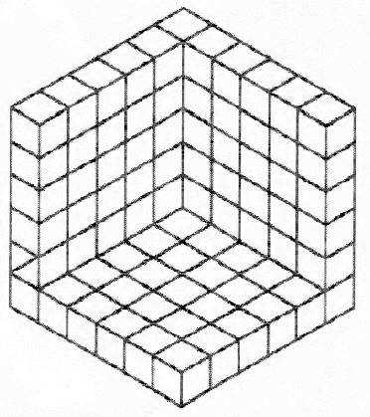
How many cubes are in the stack?
  - 216
  - 125
  - 108
  - 91
- Which one of the following nets will form a triangular prism?
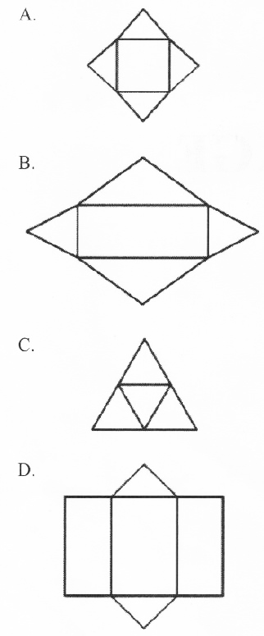

Working space.

SECTION B: STRUCTURED QUESTIONS (80 Marks)
Answer all questions in the spaces provided. Show all your working clearly.
- A charitable organization planned to distribute 15,000 bags of maize to needy families. They managed to distribute 8,765 bags in the first week and 4,980 bags in the second week.
a) How many bags of maize were distributed in total during the two weeks?

b) How many bags of maize are yet to be distributed? (4 Marks)

- Sarah bought 3 kg of sugar at Ksh 150 per kg, 2 liters of cooking oil at Ksh 220 per liter, and a loaf of bread for Ksh 60. (4 Marks)
a) Calculate her total expenditure.

b) If she paid with a Ksh 1000 note, how much change did she receive?

- Study the diagram below. (4 Marks)
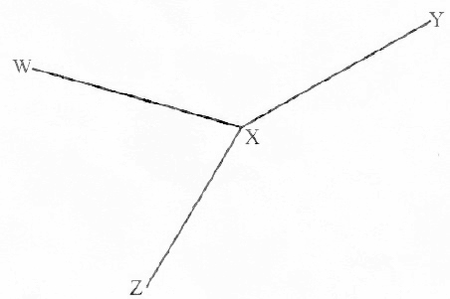
    - What is the measure of angle WXZ? (1 mk)

    - Draw a line touching points ZY. Find the length of line ZY.( 1 mk)

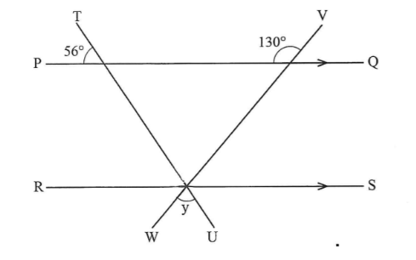
    - In the figure below, lines PQ and RS are parallel. Lines TU and VW are transversals.

What is the size of angle y? (2 mks)

- The figure shows a semicircle of radius 3.5 cm enclosed in a rectangle.
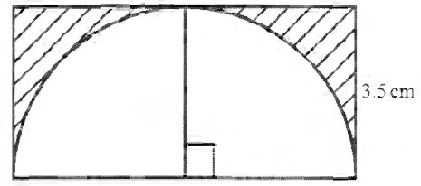
What is the area of the shaded part?
(Take π = $\frac{22}{7}$)

- Mercy has 5 bags of maize and Peter has 3 bags of maize. The mass of 1 bag of maize is represented by (x + 10) kg. Which one of the following expressions will show the total mass of maize that they have? (2 marks)
- What is $\frac{1}{4}$(32g+ 16f) + $\frac{1}{3}$(15g + 9f) in the simplest form?(1 mark)

- What is the value of (2 marks)
x² + y²
x - y
given that x =8 and y = 6

- a) The bar graph below shows the amount of milk, in litres, a farmer got from his farm in one week.
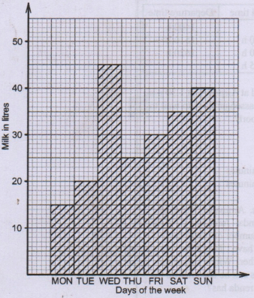
Which two days following each other in the week had the highest total production of milk?(1 mark)
………………………………………………………………………………….

    - The table below shows the number of students who scored an EE in different subjects in a Grade 7 class.
- Maths 15
- English 12
- Kiswahili 10
- Integrated Science 8
- Social Studies 5
On the grid provided below, draw a bar graph to represent this data. (4 Marks)


b) Which subject had the highest number of EE's? (1 Mark)

- (6 Marks) Three friends, Alex, Brian, and Carol, shared a profit of Ksh 7,200 in the ratio 2:3:4 respectively.
a) How much did Brian receive?

b) If Carol used 25% of her share to buy a book, how much money did she have left?

- A rectangular water tank has the dimensions shown in the image above
Length = 300cm,
Width = 200m,
Height = 150m.
a) Calculate the volume of the tank in cubic meters. (2 Marks)

b) How many liters of water can the tank hold when full? (3 Marks)

- What is three million forty eight thousand two hundred and fifty seven written in numerals? (2 marks)

- What is the place value of 7 in the number 9843.071? (2 marks)

- What is the next number in the pattern shown below? (1 mark)
³/₄, 1¹/₄, 1³/₄, 2¹/₄, _______.

- What is ³/₈ as a percentage? (1 mark)

- Charity cycled from home to school a distance of 12 kilometres. She started the journey at 7.20 a.m and arrived at 8.00 a.m. What was her speed in metres per second?(2 marks)

- The figure below shows a trapezium UWXY. Line YX is parallel to line UW. The perpendicular distance between the parallel lines is 12 cm and line YX = 18 cm.
      - The area of the trapezium is 252 cm².(3 marks)
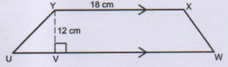

      - What is the length of line UW? (2 marks)

- The temperature in a town was 15∘C in the morning. It dropped by 7∘C in the afternoon and then rose by 3∘C in the evening. What was the temperature in the evening? (4 Marks)

- A car travels at an average speed of 60 km/h.
a) How long will it take to cover a distance of 210 km?

b) If the car started its journey at 9:45 AM, what time would it arrive at its destination? (6 Marks)

- Two bells ring at intervals of 12 minutes and 18 minutes respectively. If they both ring together at 10:00 AM, at what time will they next ring together? (5 Marks)

- Simplify the expression: 5x+3y−2x+7y. (2 Marks)

- What is the value of x in (2 marks)
3(x+8)=4(x+4)?

- The boiling point of water is 100∘C. The freezing point of water is 0∘C. (4 Marks)
a) What is the difference between the boiling and freezing points of water?

b) If the temperature of a liquid is 25∘C and it drops by 15∘C, what is the new temperature?

- Using a ruler and a pair of compasses only, construct an equilateral triangle ABC with sides 6 cm. (4 Marks)

- A farmer plants trees in a pattern. In the first row, he plants 3 trees, in the second row, 6 trees, and in the third row, 9 trees. (5 Marks)
a) How many trees will be in the 5th row if the pattern continues?

b) How many trees will be in total in the first 5 rows?

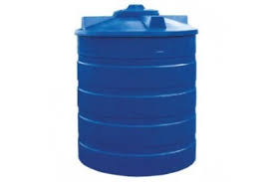
- A cylindrical water tank has a radius of 0.7 meters and a height of 2 meters. (6 Marks)
0.7M

2M

a) Calculate the volume of the tank in cubic meters (use π=722​).

b) If 500 liters of water are drawn from the full tank, how many liters of water remain in the tank?

0716035408

COMPETENCE KENYA
THIS IS THE LAST PRINTED PAGE.

