**KENYA JUNIOR SCHOOL EDUCATION ASSESSMENT (KJSEA)**

**GRADE 9: MATHEMATICS**  
**CODE: 011 YEAR: 2025 TIME: 2 HOURS**

**Candidate’s Name: ___________________________________. Assessment Number: _____________________.**

**School Name: ________________________________________. School Code: _______________________________.**

**Candidate’s Signature: ______________________________. Date: ________________________________________.**

**INSTRUCTIONS TO CANDIDATES:**

**INSTRUCTIONS TO CANDIDATES:**

1. Write your name and class in the spaces provided above.
2. The paper consists of two sections: Section A and Section B.
3. Answer ALL questions in Section A and Section B.
4. Show all your working in the spaces provided.
5. All questions carry marks as indicated.
6. Mathematical tables and electronic calculators may be used.

.

|  |  |  |  |
| --- | --- | --- | --- |
| **For Official Use Only** |  |  |  |
| **Task** | **Task 1** | **Task 2** | **TOTAL** |
| **Question** | 1 | 2 | 3QUESTIONS |
| **Maximum Score** | 20 | 10 | 30 MARKS |
| **Candidate’s Score** |  |  |  |

**FOR OFFICIAL USE ONLY.**

This paper consists of **17 printed pages**. Candidates should check the question paper to ascertain that all the pages are printed as indicated and that no questions are missing.

**© 2025 COMPETENCE KENYA ASSESSMENT COUNCIL *Turn over***

**SECTION A: MULTIPLE CHOICE QUESTIONS (20 MARKS)**

1. 1. The cube root of 3375 is:  
   A. 12 B. 13 C. 15 D. 18
2. 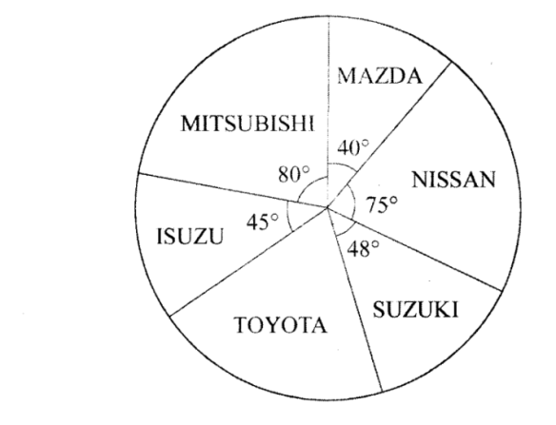The pie chart below represents the types of vehicles imported in Kenya in a certain year.

If l6, 000 Mazdas were imported, how many more Toyotas than Suzukis were imported?

A. 48 000 B. 28 800 C. 19 200 D. 9 600

1. Triangle XYZ shown below, has been Working Space drawn accurately.

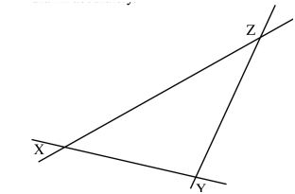

What is the measure of angle ZXY?

A.36 B.42 C.108 D.136

**WORKING SPACE**

1. The following are properties of a certain quadrilateral 1

(1) opposite sides are parallel

(ii) all sides are equal

(m) apposite angles are equal

(iv) diagonals are unequal and bisect each other at right angles

What is the name of the quadrilateral?

A. Rectangle B. Trapezium C. Rhombus D. Square

1. Construct a circle centre O using line ROS, given below, as diameter.

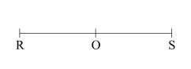

Construct angle QRS I 30°. Mark point Q on the circumference and draw line QO. What is the size of angle QOS?

A. 150° B. 120° C. 90° D. 60°

**WORKING SPACE**

1. Below are four different types of triangles.

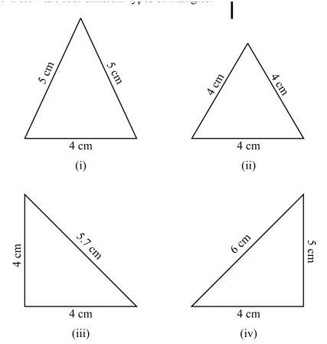

Which one of the following pairs of triangles correctly describes the types of triangles above?

A. (i) and (m) are isosceles triangles

B. (ii) and (iv) are scalene triangles

C. (ii) and (m) are right angled triangles

D. (i) and (ii) are equilateral triangles

**WORKING SPACE**

1. A road measuring 5 cm on a map has an actual distance of 15 kilometres. What is the scale used in drawing the map?

A. 1 :3 B. 1:300 C. 1:3 000 D :3 00 000

1. An open cylindrical tank has an internal diameter of 5.6 cm and an internal height of4 cm. The inside ofthe tank was painted. What area of the tank, in square centimetres, was painted? (Take Tc I 27-2)

A. 119.68

B. 98.56

C. 95.04

D. 70.04

**WORKING SPACE**

1. In the ﬁgure below, lines PQ and TS are parallel. Lines RQ and RS are equal. Angle QPR = 36° and angle STR = 50°. P. What is the size of angle PQS?

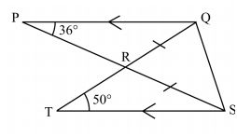

A. 47°C B. 86 ° C C. 94° D. 97°

1. 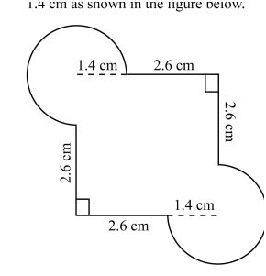A design was made up of straight edges of length 2.6 cm and arcs of circles of radii 1.4 cm as shown in the ﬁgure below 2.6 cm

What is the area of the design?

A. 16.00 cm B. 22.16 cm C. 25.24 cm D. 28.32 cm

**WORKING SPACE**

1. Simplify: 3⁵ ÷ 3²  
   A. 3³ B. 3⁷ C. 3² D. 9
2. Solve for x: 7x – 4 = 24  
   A. 3 B. 4 C. 6 D. 8
3. Evaluate log₁₀ 0.01  
   A. -2 B. -1 C. 0.1 D. 2
4. Which of the following is a Pythagorean triple?  
   A. (8, 15, 17) B. (10, 12, 15) C. (6, 8, 11) D. (7, 10, 14)
5. Find the compound interest on Ksh 20,000 at 10% per annum for 2 years.  
   A. 2,000 B. 4,200 C. 4,000 D. 2,100
6. A fair die is rolled once. The probability of getting an even number is:  
   A. 1/2 B. 1/3 C. 1/6 D. 2/3

**WORKING SPACE**

1. Expand:

**(x+2)(x–5)**

A. x2–3x–10  
B. x2–3x+10x  
C. x2+7x–10  
D. x2–10x–10

1. Find the determinant of matrix   
   |1 2|  
   |3 5|  
   A. 1 B. -1 C. 2 D. -2
2. If cos θ = 12/13, find sin θ (θ acute).  
   A. 5/13 B. 12/13 C. 13/5 D. 1/13
3. A trader bought goods worth Ksh 25,000. He sold them at a loss of 10%. The selling price was:  
   A. 22,500 B. 25,000 C. 27,500 D. 30,000

**WORKING SPACE**

**SECTION B: STRUCTURED QUESTIONS (80 MARKS)**

21. (a) Find the cube of 21.

(b) Using mathematical tables, find the cube root of 5832.

22. Simplify using indices: (5³ × 5²) ÷ 5⁴.

23. Bakari and Ouma travelled to different destinations. Both started at 7.00 am; Bakari started from town J to town K While Ouma started from K to J

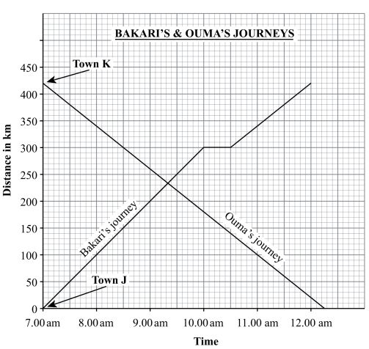

a)How far from town J was Bakari at 30 minutes of his journey?

(b) Find its average speed of Ouma.

(c) whose speed was higher?

24. Two towns P (37°E) and Q (49°E) lie along the equator.  
(a) Find the distance between them in km.

(b) Find the difference in local time between the two towns.

25. The matrix B = 4 3 c 2 1

(a) Find det (B).

(b) Find B⁻¹.

(c) Use B⁻¹ to solve the simultaneous equations: 4x + 3y = 11, 2x + y = 5.

26. Solve graphically the simultaneous equations:  
y = 2x + 1 and y = -x + 4.

27. A cone has radius 7 cm and height 24 cm.  
(a) Find its slant height.

(b) Find its curved surface area.

(c) Find its volume.

28. A sector of a circle has radius 10 cm and angle 120°.  
(a) Find the area of the sector.

(b) Find the length of the arc.

29. A trader imported goods worth £15,000. The exchange rate is £1 = Ksh 150. Import duty is 25% of the value.  
(a) Find the duty paid in Ksh.

(b) Find the total cost in Ksh.

30. The marks of 50 students are recorded as follows:

|  |  |  |  |  |  |
| --- | --- | --- | --- | --- | --- |
| Marks: | 0–10, | 10–20, | 20–30, | 30–40, | 40–50 |
| Frequency: | 6 | 10 | 14 | 12 | 8 |

(a) Draw a histogram.

(b) Estimate the mean from the histogram.

1. A cylindrical container has radius 7 cm and height 10 cm.  
   a) Draw a neat sketch of its net. (1mk)

b) Find its volume. (Use π = 3.142). (3mks)

1. Find the equation of the line through points (1, 2) and (3, 6). (3mks)
2. A bag contains 5 red, 4 green, and 3 blue balls. A ball is picked at random. Find the probability it is:  
   a) Red (1mk)

b) Not green (1mk)

1. Draw a triangle ABC with AB = AC = 6 cm and ∠BAC = 100°. Construct the bisector of angle B. (3mks)
2. Triangle DEF has vertices D(1,1), E(3,1), F(2,3).  
   It is enlarged by scale factor 2 about the origin.  
   (a) Plot both triangles on the same Cartesian plane. *(Include grid in Word)* (3 marks)



(b) Write down the coordinates of D’, E’, F’. (3 marks)

**This is the last printed page.**