**KENYA JUNIOR SCHOOL EDUCATION ASSESSMENT (KJSEA)**

**GRADE 8: INTEGRATED SCIENCE PP1**   
**CODE: 010 YEAR: 2025**  
**MARKING SCHEMES**

**SECTION A: MULTIPLE CHOICE QUESTIONS (30 MARKS)**

|  |  |  |
| --- | --- | --- |
| **No.** | **Answer** | **Explanation** |
| 1 | A | Sand can be removed by filtration, and salt can be obtained by evaporating the water. |
| 2 | B | Sodium chloride (NaCl) is a compound made from sodium and chlorine. |
| 3 | B | Ink spreads due to diffusion, the movement of particles from high to low concentration. |
| 4 | C | Loss of green colour in vegetables is permanent because chlorophyll breaks down. |
| 5 | C | Neutrons = Mass number − Atomic number = 23 − 11 = 12. |
| 6 | C | Iron is represented by Fe in the periodic table. |
| 7 | C | Metals are good conductors of electricity and heat. |
| 8 | B | Oxygen is obtained by heating potassium permanganate. |
| 9 | C | Foam extinguishers are effective on oil fires. |
| 10 | D | Cell membrane controls the movement of materials in and out of the cell. |
| 11 | C | The mirror reflects light onto the specimen in a microscope. |
| 12 | B | Osmosis is the diffusion of water into plant root hairs. |
| 13 | D | Type of microscope does not affect diffusion rate. |
| 14 | B | Chemical energy from fuel is converted to kinetic energy in a car engine. |
| 15 | A | Pressure = Force / Area = 10 / 0.5 = 20 N/m². |
| 16 | D | Sulphur is an element, not an alloy. |
| 17 | C | Rusting requires water and oxygen. |
| 18 | B | Soft water lathers more with soap than hard water. |
| 19 | D | Nitrogen is not required for photosynthesis. |
| 20 | C | The liver produces bile. |
| 21 | B | Insect-pollinated flowers have large, brightly coloured petals to attract insects. |
| 22 | A | Seed dispersal prevents overcrowding and competition. |
| 23 | B | A food chain begins with a producer (plant). |
| 24 | B | Industrial effluents discharge pollutes water. |
| 25 | C | Dentists use concave mirrors to focus light on teeth. |
| 26 | C | Focal length is the distance between mirror and its focal point. |
| 27 | A | Wavelength is the distance between two successive crests. |
| 28 | C | Sound waves are longitudinal, not transverse. |
| 29 | C | Remote sensing satellites collect information about Earth. |
| 30 | B | Torch transforms chemical energy → electrical → light. |

**SECTION B: STRUCTURED QUESTIONS (40 MARKS)**

**Part 1: Biology (14 Marks)**

**1(a) Plant cell diagram (4 marks)**

* Draw a plant cell with labeled parts: Cell wall, cell membrane, nucleus, cytoplasm, chloroplast, vacuole, mitochondria.

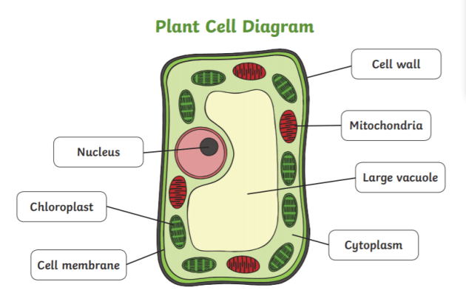

**1(b) Differences between plant and animal cells (3 marks)**

I. Plant cells have a **cell wall**; animal cells do not.  
II. Plant cells contain **chloroplasts**; animal cells do not.  
III. Plant cells have a **large central vacuole**; animal cells have small vacuoles.  
IV. Plant cells are usually rectangular; animal cells are round.  
V. Plant cells produce their own food via photosynthesis; animal cells do not.  
VI. Plant cells have plasmodesmata; animal cells lack them.  
VII. Plant cells store starch; animal cells store glycogen.  
VIII. Plant cells are autotrophic; animal cells are heterotrophic.  
IX. Plant cells have rigid structure; animal cells are flexible.  
X. Plant cells lack centrioles in most cases; animal cells have centrioles.

**2(a) Function of stomata (2 marks)**

I. Allow exchange of gases (O₂ and CO₂).  
II. Control transpiration.  
III. Allow water vapor to escape.  
IV. Aid in cooling the plant.  
V. Maintain water balance.

**2(b) Adaptations of a leaf for photosynthesis (2 marks)**

I. Broad surface area to capture sunlight.  
II. Thin structure to allow gas exchange.  
III. Chlorophyll in chloroplasts to absorb light.  
IV. Veins for transport of water and food.  
V. Stomata for gas exchange.  
VI. Cuticle to reduce water loss.  
VII. Transparent epidermis to let light pass.  
VIII. Palisade cells packed with chloroplasts.

**3. Food chain (3 marks)**  
Grass → Goat → Human

**Part 2: Chemistry (13 Marks)**

**4(a) Physical test for hard water (1 mark)**

I. Add soap to water; observe lather formation.  
II. Boil the water; observe scale formation.

**4(b) Advantage and disadvantage of hard water (2 marks)**

Advantage:  
I. Improves taste of water.  
II. Provides essential minerals (Ca²⁺, Mg²⁺).  
III. Strengthens bones.

Disadvantage:  
I. Forms scum with soap.  
II. Clogs pipes.  
III. Reduces efficiency of soap.  
IV. Forms scale in boilers.

**5(a) Electron arrangement of magnesium (2 marks)**

I. 2, 8, 2

**5(b) Uses of magnesium (2 marks)**

I. Manufacturing aircraft and rockets.  
II. Making alloys like magnalium.  
III. Fireworks (bright white flame).  
IV. Medicine (antacids).  
V. Batteries.  
VI. Making lightweight materials.  
VII. Reducing agent in chemical reactions.  
VIII. As a dietary supplement.  
IX. Photography chemicals.  
X. Deoxidizing agent in steel.

**6(a) Methods of preventing rusting (2 marks)**

I. Painting iron.  
II. Oiling or greasing.  
III. Galvanizing (coating with zinc).  
IV. Alloying with chromium (stainless steel).  
V. Coating with plastic.  
VI. Sacrificial protection (attaching a more reactive metal).  
VII. Electroplating.

**6(b) Chemical symbols (2 marks)**

i. Sodium → Na  
ii. Copper → Cu

**7. Oxygen supports combustion (2 marks)**

I. Oxygen reacts with fuel to release energy.  
II. Example: A candle burns brightly in oxygen.  
III. Wood burns faster in pure oxygen.  
IV. Combustion requires oxygen to produce heat and light.

**Part 3: Physics (13 Marks)**

**8(a) Pressure calculation (2 marks)**

Pressure

=

=400 N/m2

**8(b) Application of pressure in liquids (2 marks)**

I. Hydraulic brakes.  
II. Water supply in dams.  
III. Syringes.  
IV. Lifting heavy objects using liquid pressure.  
V. Water fountains.

**9(a) Focal length of a mirror (2 marks)**

I. Distance between the mirror and its focal point.  
II. Point where parallel rays converge.

**9(b) Use of concave mirrors (1 mark)**

I. Dentists use concave mirrors to see teeth.  
II. Car headlights.  
III. Solar concentrators.  
IV. Shaving mirrors.

**10(a) Transverse wave diagram (4 marks)**

* Label crest, trough, wavelength, amplitude.

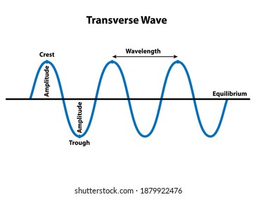

**10(b) Difference between transverse and longitudinal waves (2 marks)**

I. Transverse waves: particles vibrate perpendicular to wave direction.  
II. Longitudinal waves: particles vibrate parallel to wave direction.  
III. Transverse waves include light and water waves.  
IV. Longitudinal waves include sound waves.

**THIS IS THE LAST PRINTED PAGE.**