KENYA JUNIOR SCHOOL EDUCATION ASSESSMENT (KJSEA)
GRADE 8: SOCIAL STUDIES
CODE: 010 YEAR: 2025 TIME: 1 Hour 40 Minutes
Candidate’s Name: ___________________________________. Assessment Number: _____________________.
School Name: ________________________________________. School Code: _______________________________.

Candidate’s Signature: ______________________________. Date: ________________________________________.
INSTRUCTIONS TO CANDIDATES
- Write the required details in the spaces provided above.
- This paper consists of two sections: A and B.
- Answer ALL questions in Section A and in Section B.
- All answers must be written in the spaces provided.
For official use only
SECTION A: MULTIPLE CHOICE QUESTIONS (20 Marks)
Question No. | 1 | 2 |  | 3 | 4 |  | 5 | 6 | 7 |  | 8 | 9 | 10
Max Score | 1 | 1 |  | 1 | 1 |  | 1 | 1 | 1 |  | 1 | 1 | 1
Candidate’s Score
Question No. | 11 |  | 12 |  |  | 13 |  | 14 |  | 15 |  | 16 | 17 | 18 | 19 | 20 | TOTAL
Max Score | 1 |  | 1 |  |  | 1 |  | 1 |  | 1 |  | 1 | 1 | 1 | 1 | 1 | 20
Candidate’s Score
SECTION B: STRUCTURED QUESTIONS (60 Marks)
Task | Qn Nos. | Max Marks | Candidate's Score
TASK 1: MAPWORK | Q1 a–c | 5
TASK 2: CITIZENSHIP | Q1 a–c | 5
TASK 3: HISTORY | Q1–12 | 30
TASK 4: GEOGRAPHY | Q1–8 | 30
TASK 5: LIFE SKILLS | Q1–3 | 10
TOTAL SCORE (Standardized to 60 Marks) | — | 60
2025 THE COMPETENCE KENYA ASSESSMENT COUNCIL. Turn over
SECTION A: MULTIPLE CHOICE QUESTIONS (20 MARKS)

Answer all questions.
- Mr. Mwangi displayed pictures which show different skulls representing stages of human evolution. Use it to answer question.
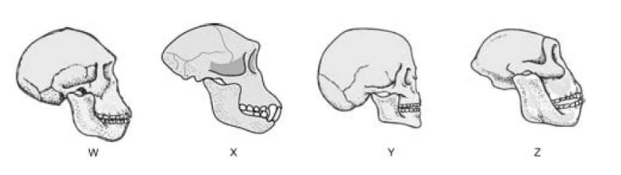
The skull most likely to be that of a homo sapien sapien is A. W B. X C. Y D. Z

- A learner observed a community member cleaning a riverbank to prevent pollution. This demonstrates:
A) Community service
B) Avoiding civic duties
C) Breaking laws
D) Entrepreneurship
- During a geography lesson, learners discussed factors that affect vegetation growth. Which of the following is a factor?
A) Soil type
B) Clothing style
C) Religion
D) Entertainment
- A school project required learners to identify the first humans in Africa. This is a study of:
A) Human origin B) Modern technology
C) Political systems D) Map-work
- The Great Zimbabwe Kingdom was known for:
A) Stone walls and trade
B) Coastal dhows
C) Mining in Europe
D) Industrial machines
- A documentary showed deserts, savannahs, and forests in Africa. This lesson is about:
A) Climate and vegetation
B) History of wars
C) Citizenship rights
D) Business opportunities
- Look at the map outline below, which represents Africa.
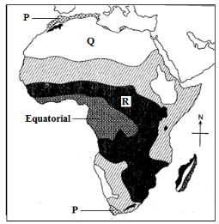
Identify the climatic region marked P
A. Tropical climate. B. Mediterranean climate. C. Desert climate. D. Mountain climate.

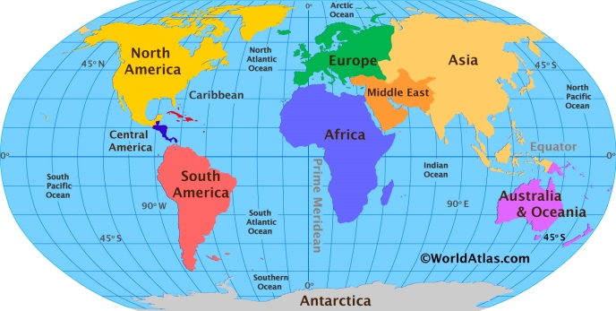
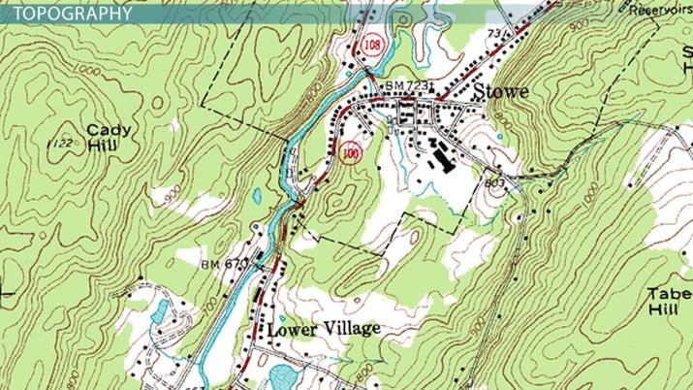
- Which of the maps below is a topographical map?
A B

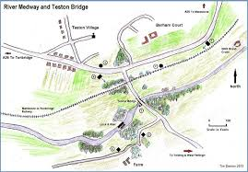
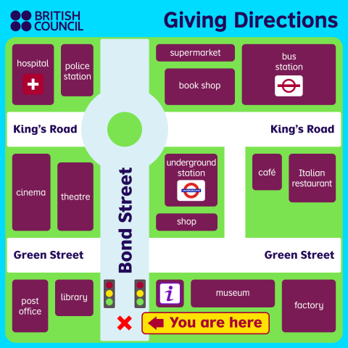

C D

- During a field trip to Fort Jesus, learners learned about the Portuguese influence. This is an example of:
A) Historical monuments in Africa
B) Physical geography
C) Climate zones
D) Entrepreneurship
- A learner recorded rainfall, wind direction, and temperature in the school yard. These are examples of:
A) Weather elements
B) Population data
C) Map symbols
D) Currency exchange
- Which one is not part of marginal information on a map?
A. Scale
B. Grid references
C. Relief features
D. Title
Look at the map outline below, which represents Africa to answer question 16.
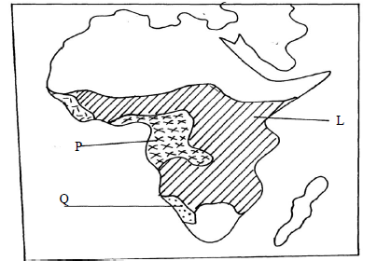
- Identify the vegetation region marked P A. Equatorial Rainforest. B. Desert Vegetation. C. Savanna Grasslands. D. Mountain Vegetation.

- In a group activity, learners were identifying stone tools and their likely uses. Which one of the following is correctly matched?
Option | Tool Type | Use
A | Chopper | Hunting with arrows
B | Hand axe | Cutting meat and digging roots
C | Spearhead | Grinding grains
D | Scraper | Used to build huts
- A learner noticed that some crops grow better on highlands than lowlands. This is influenced by:
A) Altitude
B) Longitude
C) Latitude
D) Currency
- The teaching of non-violent ways of solving conflicts in school reflects:
A) Peace education
B) Military training
C) Political campaigns
D) Slavery history
- A news report described children being forced to work on farms without pay. This is an example of:
A) Servitude
B) Entrepreneurship
C) Civic responsibility
D) Career guidance
- When a learner mapped their school, they used lines to show roads. These lines are called:
A) Symbols
B) Scale
C) Keys
D) Longitude
- A family moved from Mombasa to Kisumu seeking better job opportunities. This is:
A) Rural-urban migration
B) Seasonal migration
C) International migration
D) Nomadic lifestyle
- During a lesson, learners discussed entrepreneurship. Starting a small vegetable garden to sell produce shows:
A) Community service
B) Entrepreneurial opportunity
C) Human evolution
D) Migration
- Learners studied the Trans-Saharan trade. Which of the following was a main commodity traded?
A) Gold and salt
B) Electronics
C) Textbooks
D) Plastic
- A class compared climate across Africa. Areas with high temperatures and low rainfall are classified as:
A) Desert climate
B) Equatorial climate
C) Highland climate
D) Mediterranean climate
- Learners learned that global citizenship involves:
A) Respecting human rights worldwide
B) Ignoring other cultures
C) Focusing only on local issues
D) Violating international laws
- A timeline showed the stages of human evolution from Australopithecus to Homo sapiens. This is a study of:
A) Early humans
B) Modern transportation
C) Global trade
D) Weather patterns
- A learner listed factors that contributed to European colonization of Africa. Which of the following is one factor?
A) Industrial revolution
B) Mount Everest
C) Maasai cultural practices
D) Local food recipes
- A map showed Kenya and neighboring countries. Longitude lines help determine:
A) East-west position
B) North-south position
C) Vegetation type
D) Currency
- A cultural festival highlighted the Zulu, Asante, and Ogiek communities. This is an example of:
A) Cultural diversity
B) Weather observation
C) Population growth
D) Entrepreneurship
- A village has 1,000 people living in an area of 2 square kilometers. What is the population density?
A. 500 people/km² B. 2,000 people/km² C. 200 people/km² D. 1,000 people/km²

- Which of the following is correctly matched?
City-State | Main Feature
A. Sofala | Known for selling gold
B. Kilwa | Located in Uganda
C. Lamu | Center of farming activities only
D. Mombasa | Lacked any trade connections
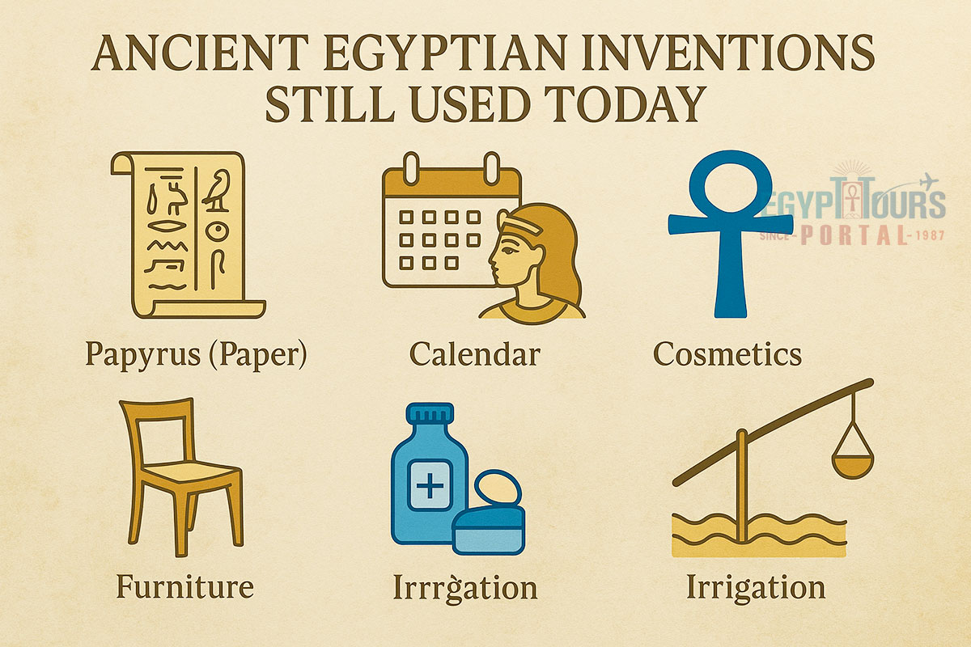
- Which one of the following ancient Egypt innovation is incorrectly named.

A

B

C

D

SECTION B: STRUCTURED QUESTIONS (80 MARKS)
TASK 1: MAPWORK (5 MARKS)
- A Social Studies teacher used the sketch map provided to facilitate a lesson on map reading and interpretation.

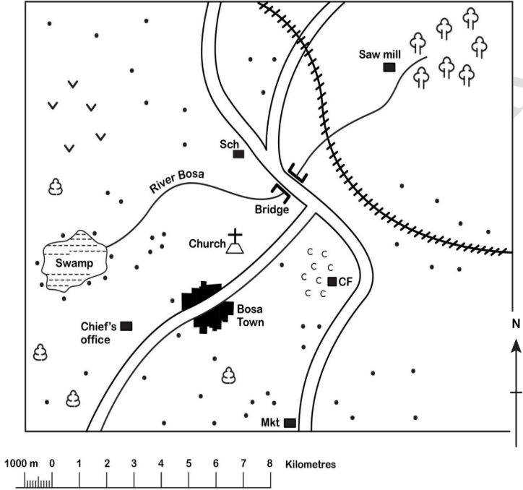
BOSA AREA

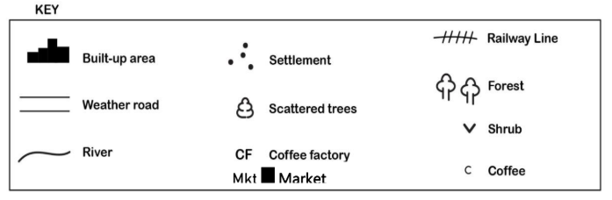

a) The teacher asked the learners to give the direction one would take when walking from the sawmill to Bosa town along the weather road. The direction is (1 mark)

___________________________________________________________________________________________________

b) During the lesson, the teacher asked that learners to measure the distance along the weather road from the bridge to the market. Give the distance in kilometres. (1 marks)

______________________________________________________________________________________________________________________

______________________________________________________________________________________________________________________

c) The learners studied some economic activities carried out in the area. Name four of these activities. (2 marks)

______________________________________________________________________________________________________________________

______________________________________________________________________________________________________________________

______________________________________________________________________________________________________________________

______________________________________________________________________________________________________________________

d) The learners were asked to discuss the types of vegetation found in the area. Identify two types of vegetation that they discussed. (2 marks)

______________________________________________________________________________________________________________________

______________________________________________________________________________________________________________________

______________________________________________________________________________________________________________________

e) Identify the type of map scale used. (1 mark)

______________________________________________________________________________________________________________________
TASK 2: CITIZENSHIP AND PERSONAL DEVELOPMENT (5 MARKS)
- Learners formed a school leadership club.
a) Define citizenship. (1 mark)
_______________________________________________________________________________________________________________________
_______________________________________________________________________________________________________________________
b) Mention two rights protected by the Constitution of Kenya. (2 marks)
i. _____________________________________________________________________________________________________________________
ii. ____________________________________________________________________________________________________________________
c) State two qualities of a responsible leader. (2 marks)
i. _____________________________________________________________________________________________________________________
ii. _____________________________________________________________________________________________________________________
TASK 3: HISTORY (30 MARKS)
- Learners studied African kingdoms and trade.
a) Name two features of the Kongo Kingdom. (2 marks)
i. ____________________________________________________________________________________________________________________
ii. ____________________________________________________________________________________________________________________
b) Identify one practice from the Egyptian Kingdom still in use today. (1 mark)
______________________________________________________________________________________________________________________
c) Explain two ways the Great Zimbabwe Kingdom contributed to trade. (2 marks)
i. ____________________________________________________________________________________________________________________
ii. ____________________________________________________________________________________________________________________
- Learners studied slavery and servitude in Africa.
a) Name one factor that contributed to the Indian Ocean slave trade. (1 mark)
____________________________________________________________________________________________________________________
b) State two effects of the Trans-Saharan slave trade on African societies. (2 marks)
i. ____________________________________________________________________________________________________________________
ii. ___________________________________________________________________________________________________________________
c) Suggest two ways Africans resisted slavery. (2 marks)
i. ___________________________________________________________________________________________________________________
ii. ___________________________________________________________________________________________________________________
- Learners studied the origin of money and types of trade.
a) Name two functions of money. (2 marks)
i. __________________________________________________________________________________________________________________
ii. _________________________________________________________________________________________________________________
b) Mention two types of trade practiced in Africa before colonization. (2 marks)
i. __________________________________________________________________________________________________________________
ii. __________________________________________________________________________________________________________________
- Learners researched African diasporas and migrations.
a) Define African diaspora. (1 mark)
______________________________________________________________________________________________________________________________________________________________________________________________________________________________________________
b) State two causes of migration in Africa. (2 marks)
i. _____________________________________________________________________________________________________________________
ii. ____________________________________________________________________________________________________________________
c) Identify one challenge of migration. (1 mark)
_______________________________________________________________________________________________________________________
- Learners studied the Ogiek, Zulu, and Asante communities.
a) Mention one economic activity of the Ogiek. (1 mark)
______________________________________________________________________________________________________________________
b) Describe one social organization of the Zulu. (2 marks)
______________________________________________________________________________________________________________________
c) State one political system of the Asante. (1 mark)
____________________________________________________________________________________________________________________
TASK 4: GEOGRAPHY AND CLIMATE (30 MARKS)
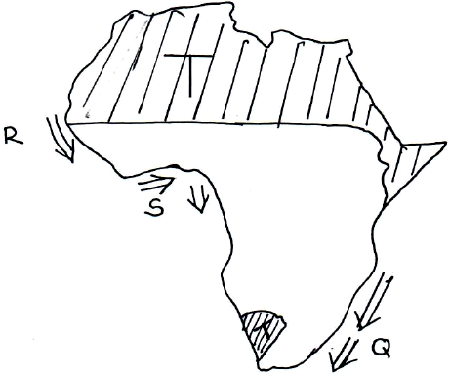
- Use the map of Africa below to answer the questions that follow.

U

(i) Name the climatic region marked U and T. (2 marks)
Q……………………………………………………………………………..
T……………………………………………………………………………
a) Name one factors that influence climate. (1 marks)
i. __________________________________________________________________________________________________________________
b) State two characteristics of Mediterranean climate. (2 marks)
i. ___________________________________________________________________________________________________________________
ii. __________________________________________________________________________________________________________________
- The diagram below represents zones of natural vegetation on a mountain in Africa.
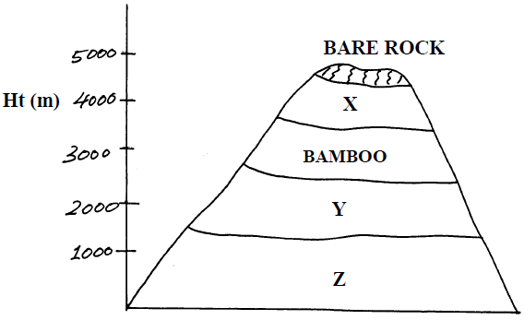
a) Name the vegetation zones marked X and Y.(2 marks)
X,…………………………………………………………………………………………………….
Y ……………………………………………………………………………………………………..
b) Describe vegetation in the region marked Z. (2 marks)
____________________________________________________________________________________________________________________
____________________________________________________________________________________________________________________
c) Explain two ways vegetation in deserts adapts to the environment. (2 marks)
____________________________________________________________________________________________________________________
____________________________________________________________________________________________________________________
- Learners studied maps, latitudes, longitudes, and time calculation.
a) Define latitude. (1 mark)
______________________________________________________________________________________________________________________________________________________________________________________________________________________________________________
b) Name two countries crossed by the equator in Africa. (2 marks)
i. ________________________________________________________
ii. _______________________________________________________
c) Calculate the time difference between Nairobi 36⁰East and London (0º). (1 mark)

- Learners studied population and human evolution.
a) Identify two stages in human evolution. (2 marks)
i. ___________________________________________________________________
ii. __________________________________________________________________
b) Name two factors contributing to population growth in Africa. (2 marks)
i. ___________________________________________________________________________________________________________________
ii. ____________________________________________________________________________________________________________________
c) State one challenge of high population growth. (1 mark)
______________________________________________________________________________________________________________________
______________________________________________________________________________________________________________________
- Learners studied weather elements and effects on human activity.
a) Name two elements of weather that can be recorded. (2 marks)
i. _____________________________________________________________________________________________________________________
ii. ____________________________________________________________________________________________________________________
b) State one way weather affects farming. (1 mark)
______________________________________________________________________________________________________________________
c) Name the weather instrument used to measure. (2 marks)
i)speed of wind: ________________________________________________
ii)Amount of rainfall: ____________________________________________
TASK 5: LIFE SKILLS, PEACE AND ENTREPRENEURSHIP (10 MARKS)
- Learners discussed interpersonal skills and conflict resolution.
a) Define non-violent conflict resolution. (1 mark)
____________________________________________________________________________________________________________________
_____________________________________________________________________________________________________________________
b) Suggest two ways learners can solve disagreements peacefully. (2 marks)
i. __________________________________________________________________________________________________________________
ii. __________________________________________________________________________________________________________________
c) State one interpersonal skill useful for teamwork. (1 mark)
_____________________________________________________________________________________________________________________
- Learners studied entrepreneurship and career opportunities.
a) Define entrepreneurship. (1 mark)
_____________________________________________________________________________________________________________________
b) State two entrepreneurial opportunities in Social Studies. (2 marks)
i. _______________________________________________________________________________________________________________
ii. _______________________________________________________________________________________________________________
c) Name one career related to Social Studies. (1 mark)
___________________________________________________________________________________________________________________
d) Suggest one way learners can prepare for a career in Social Studies. (1 mark)
____________________________________________________________________________________________________________________
(c) Look at the image below, which illustrates different facial expressions.

A B

I) Identify emotions displayed in persons:
A_____________________________________________________________________________
B_____________________________________________________________________________

This is the last printed page.

