KENYA JUNIOR SCHOOL EDUCATION ASSESSMENT (KJSEA)
GRADE 7: PRETECHNICAL STUDIES (THEORY)
CODE: 010 YEAR: 2025 TIME: 2 HOURS
Candidate’s Name: ___________________________________. Assessment Number: _____________________.
School Name: ________________________________________. School Code: _______________________________.

Candidate’s Signature: ______________________________. Date: ________________________________________.
INSTRUCTIONS TO CANDIDATES
- Write your name and assessment number in the spaces provided above.
- Write the name and code of your school in the spaces provided above.
- Sign and write the date of the assessment in the spaces provided above.
- This paper consists of two sections: A and B.
- Section A comprises Multiple Choice Questions.
- Section B comprises Short Structured questions.
- Answer ALL the questions in section A on the separate ANSWER SHEET provided.
- Answer ALL the questions in section B in the spaces provided in this question paper.
- Do not remove any page from this question paper.
- Answer all questions in English.
For official use only

SECTION A: MULTIPLE CHOICE QUESTIONS (30 Marks)
Question Number | 1 | 2 |  | 3 | 4 |  | 5 | 6 | 7 |  | 8 | 9 | 10 | 11 | 12 | 13 | 14 | 15
Maximum Score | 1 | 1 |  | 1 | 1 |  | 1 | 1 | 1 |  | 1 | 1 | 1 | 1 | 1 | 1 | 1 | 1
Candidate’s Score
Question Number | 16 |  | 17 |  |  | 18 |  | 19 |  | 20 |  | 21 | 22 | 23 | 24 | 25 | 26 | 27 | 28 | 29 | 30 | Total score
Maximum Score | 1 |  | 1 |  |  | 1 |  | 1 |  | 1 |  | 1 | 1 | 1 | 1 | 1 | 1 | 1 | 1 | 1 | 1 | 30
Candidate’s Score

SECTION B: STRUCTURED QUESTIONS. (50 Marks)
Section | Question | Candidate's Score | Max Score
A | 1-30 |  | 30
B | Task 1 |  | 25
 | Task 2 |  | 12
 | Task 3 |  | 13
TOTAL |  |  | 80
This paper consists of 7 printed pages. Candidates should check the question paper to ascertain that all the pages are printed as indicated and that no questions are missing.
© 2025 COMPETENCE KENYA ASSESSMENT COUNCIL Turn over

SECTION A: MULTIPLE CHOICE QUESTIONS (30 MARKS)
Answer all questions provided.
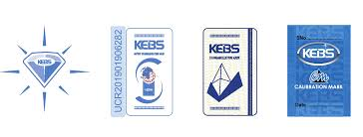
- Which one of the following KEBS symbols means that the product is quality, voluntary and meets high standards

A B C D
- A Grade 8 learner created the following instructions using a visual programming
application.
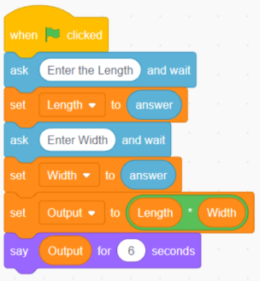
The instructions were meant for calculating the
A. perimeter of a rectangle. B. area of a square.
C. perimeter of a square. D. area of a rectangle.
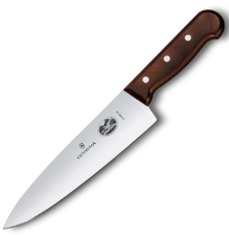
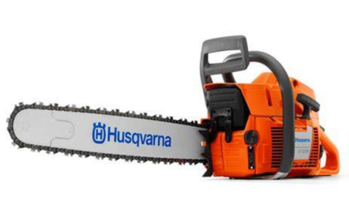
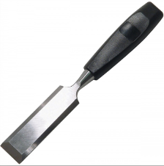
- Which cutting tool is typically used to pare away wood to form joints or create precise shapes, often by striking it with a mallet?
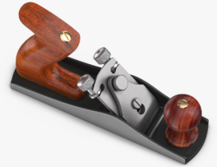

A B C D
- A business buys goods for KES 2,000 and sells them for KES 3,500. What is the gross profit on these goods? A) KES 1,500 B) KES 2,000 C) KES 3,500 D) KES 5,500

- Amina started a salon business. In the month of June, her records showed the following:
Item | Amount (Ksh)
Revenue from services | 85,000
Wages paid | 25,000
Rent | 15,000
Electricity bill | 5,000
Hair products used | 10,000
What was Amina’s profit or loss for the month of June?
A. Ksh 30,000 B. Ksh 45,000 C. Ksh 20,000 D. Ksh 50,000

- A learner is operating a machine in the workshop that produces a lot of noise. Which personal protective equipment should they wear to protect their hearing? A. Safety goggles B. A face shield C. A dust mask D. Ear defenders
- Which of the following is an example of an input device? A. A printer B. A speaker C. A keyboard D. A monitor
- You are told to make an isometric drawing of a box. What is the key feature of this type of drawing? A. It shows only two dimensions. B. It uses different scales for different axes. C. All lines are drawn at a 30° angle to the horizontal. D. It uses a vanishing point to create depth.
- Which property of a material refers to its ability to resist scratching or indentation? A. Ductility B. Hardness C. Malleability D. Strength
- When a person uses a fake identity online to deceive others, they are engaging in: A. Phishing B. Hacking C. Cyberbullying D. Identity theft
- What is the main characteristic of a WANT in business studies? A. It is necessary for survival. B. It is essential for health. C. It is a desire that can be satisfied by a product or service. D. It is a public service provided by the government.
- A learner is sketching a new product design. What type of line should they use for the main outlines of the object? A. Continuous thin line B. Dashed line C. Continuous thick line D. Centre line
- Which of the following is a physical threat to a computer system? A. A computer virus B. A power surge C. Hacking D. A software bug

- In financial literacy, what does the term budgeting mean? A. Spending all your money at once. B. Keeping records of past income only. C. Planning how to spend your money in the future. D. Borrowing money from a bank.
- A worker in a factory is shaping a metal sheet by hammering it into a flat surface. This process is possible because of which property of the material? A. Brittleness B. Malleability C. Brittleness D. Ductility
- What is the main purpose of a dimension in a technical drawing? A. To add color to the drawing. B. To indicate the size and location of features. C. To make the drawing look artistic. D. To show the internal structure of the object.
- Which of these is an example of a non-metallic material? A. Copper B. Iron C. Wood D. Brass
- What is the primary role of an entrepreneur in the economy? A. To consume goods and services. B. To provide labor for businesses. C. To create and manage a new business. D. To regulate financial institutions.

- During Pre-Technical studies lesson in grade 7, the teacher came with the following devices into the classroom. Identify the keying device.
A 

B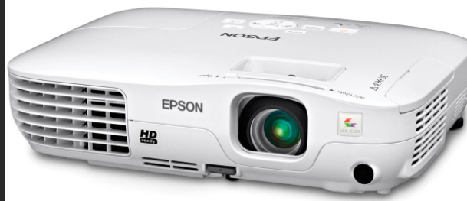

C.

D.

- A user receives an email promising a large sum of money if they click on a link. This is most likely a: A. Spam email B. Phishing attempt C. Legitimate offer D. A computer virus
- What is the purpose of a centre line in technical drawing? A. To indicate the edge of a hidden object. B. To show the center of a symmetrical object or circle. C. To represent the cutting plane. D. To show the end of a dimension line.
- Timothy drew a certain type of artistic drawing as shown below.
The type of artistic drawing shown is called?.
A. Caricuture B. Potrait C. Illustration D. Graffiti
- The ability of a material to conduct electricity is known as: A. Resistance B. Insulation C. Conductivity D. Magnetism
- Which of these is an example of a Need? A. A smartphone B. A car C. Food D. A video game console
- Which part of the computer is responsible for storing data and programs on a long-term basis? A. Random Access Memory (RAM) B. Central Processing Unit (CPU) C. Hard Disk Drive (HDD) D. Motherboard
- A businessman offers services to his customers. Which one of the following is not a service? A. Car repair B. hairdressing C. Teaching D. Sofa set.
- A line used to represent an object's outline that is not visible from the current view is called a: A. Centre line B. Phantom line C. Hidden line D. Cutting plane line
- Which of the following is a key characteristic of money? A. It is always a physical coin or note. B. It must be made of a precious metal. C. It serves as a medium of exchange. D. It can only be used in one country.
- Which tool is used to measure and draw angles in technical drawing? A. A ruler B. A set square C. A protractor D. A compass
- A learner is using a visual programming tool. Which of these terms is directly related to this type of programming? A. Syntax B. Blocks C. Compiler D. Variables

SECTION B: STRUCTURED QUESTIONS (50 MARKS)
Answer all questions in this section. Write your answers in the space provided.
Part I: Pre-Technical Studies (25 marks)
- A Grade 8 learner was asked to prepare a wooden frame in the school workshop.
a) State two safety rules the learner should observe when handling sharp tools. (2 marks)

i)___________________________________________________________________________________________________________.
ii)___________________________________________________________________________________________________________.
b) Name the following tools that the learner is likely to use. (4 marks)
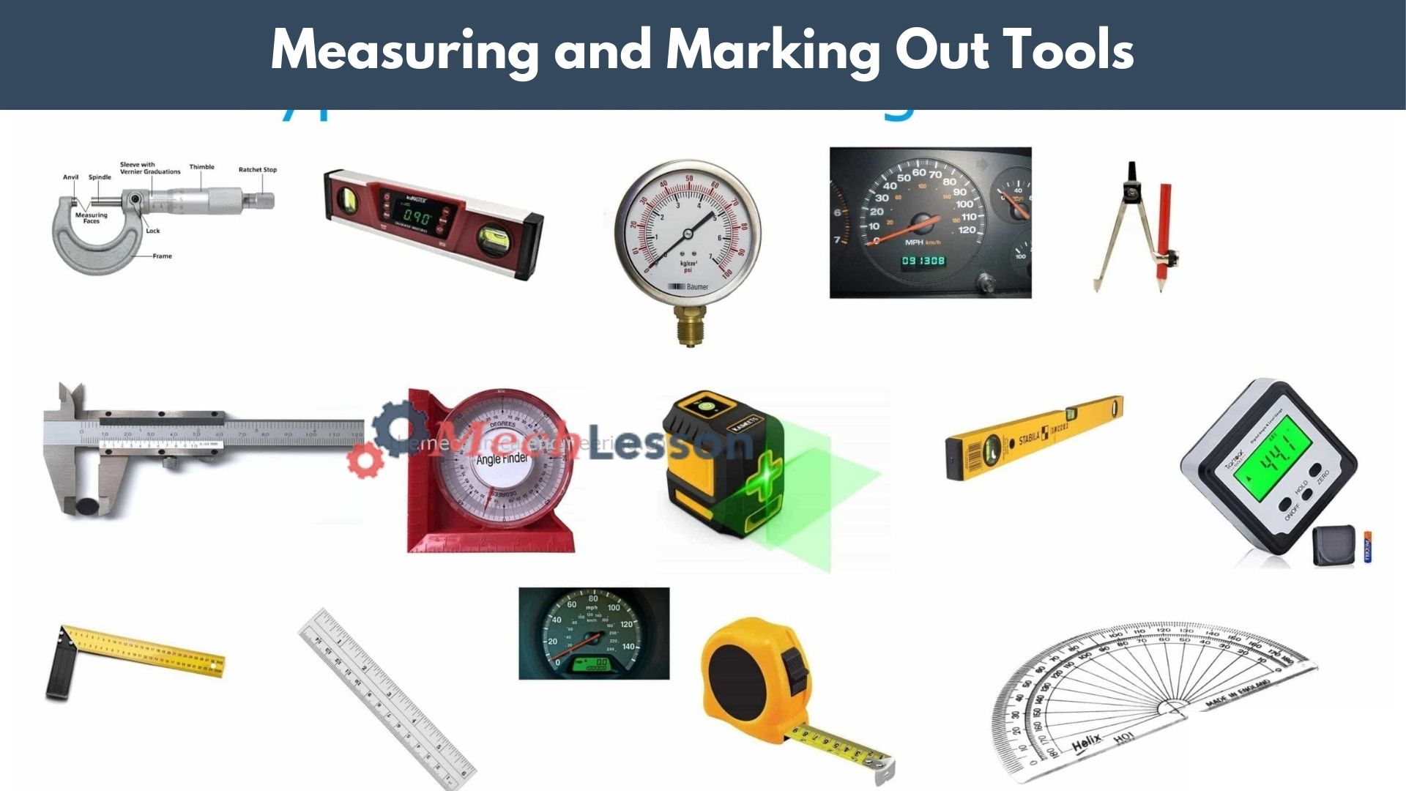
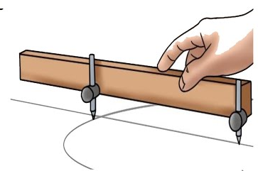

- ii)

i)___________________________________________________________________________________________________________.

ii)___________________________________________________________________________________________________________.
- A farmer in your village wants to choose between metallic and non-metallic materials for making a simple water trough.
a) Give two advantages of using metallic materials. (2 marks)
i)___________________________________________________________________________________________________________.

ii)___________________________________________________________________________________________________________.
b) Mention two examples of natural non-metallic materials that could be used. (2 marks)

i)___________________________________________________________________________________________________________.

ii)___________________________________________________________________________________________________________.

- Your class has been tasked with designing a flowerbed for the school compound.
a) Explain two importance of technical drawings in this activity. (2 marks)
i)___________________________________________________________________________________________________________.

ii)___________________________________________________________________________________________________________.
b) Differentiate between artistic drawing and technical drawing. (2 marks)
___________________________________________________________________________________________________________.

___________________________________________________________________________________________________________.

___________________________________________________________________________________________________________.

___________________________________________________________________________________________________________.
- The science teacher used a combined shape of a rectangle and a semicircle to make a diagram of a flower garden.
a) Sketch the combined shape. (1 mark)

b) State two methods of dimensioning in drawing. (2 marks)

i)___________________________________________________________________________________________________________.

ii)___________________________________________________________________________________________________________.
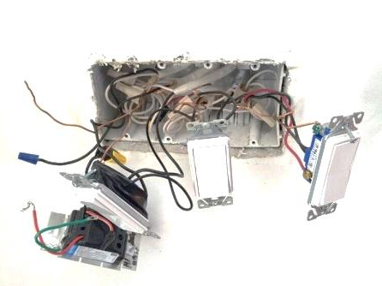
- During an inspection at the school, computer laboratory, learners came across the site as shown below

Identify one safety defect shown in the incorrectly wired plug diagram. (1 Mark)
_________________________________________________________________________________________
iv) If a learner accidentally touches an exposed live wire and receives an electrical shock, what is the immediate safest action for someone else nearby to take? (1 Mark)
____________________________________________________________________________________________________________
……………………………………………………………………………………………………………………….…….
v) The teacher emphasizes the importance of avoiding water near electrical equipment. Explain why water and electricity are a dangerous combination. (1 Mark)
_______________________________________________________________________________________________________________
_______________________________________________________________________________________________________________
vii) Digital devices like tablets and computers are often used in modern workshops for accessing instructions or designs. State one physical threat that these digital devices might face in a practical work environment. (1 Mark)
_______________________________________________________________________________________________________________
______________________________________________________________________________________________________________
Part II: Business Studies (12 marks)
- A shopkeeper in your local market sells sugar at a profit.
a) Define the term profit. (2 marks)
i)___________________________________________________________________________________________________________.

ii)___________________________________________________________________________________________________________.
b) If the shopkeeper bought 10 kg of sugar at Ksh 1,200 and sold at Ksh 1,500, calculate the profit made. (2 marks)

- Your school is planning to open a small canteen.
a) State two factors to consider when selecting the business site. (2 marks)
i)___________________________________________________________________________________________________________.

ii)___________________________________________________________________________________________________________.
b) Mention two ethical business practices the canteen should observe. (2 marks)
i)___________________________________________________________________________________________________________.

ii)___________________________________________________________________________________________________________.
- Kenyan currency has both notes and coins.
a) Identify two security features found in Kenyan banknotes. (2 marks)
i)___________________________________________________________________________________________________________.
ii)___________________________________________________________________________________________________________.
b) Give two uses of money in daily life. (2 marks)
i)___________________________________________________________________________________________________________.

ii)___________________________________________________________________________________________________________.
Part III: Computer Studies (13 marks)
- A Grade 8 learner was using a desktop computer in the ICT room.
a) Name two hardware components of a computer. (2 marks)
i)___________________________________________________________________________________________________________.

ii)___________________________________________________________________________________________________________.
b) Identify two storage devices used to save learner’s work. (2 marks)
i)___________________________________________________________________________________________________________.

ii)___________________________________________________________________________________________________________.
- During a computer lesson, the teacher warned learners about online threats.
a) State two common online threats learners may face. (2 marks)
i)___________________________________________________________________________________________________________.

ii)___________________________________________________________________________________________________________.
b) Give two ways of securing computer data from harm. (2 marks)
i)___________________________________________________________________________________________________________.

ii)___________________________________________________________________________________________________________.
- Your class is learning visual programming using Scratch.
a) State two features of visual programming. (2 marks)
i)___________________________________________________________________________________________________________.

ii)___________________________________________________________________________________________________________.
b) Give one importance of visual programming in learning ICT. (1 mark)
i)___________________________________________________________________________________________________________.

This is the last printed page.

