KENYA JUNIOR SCHOOL EDUCATION ASSESSMENT (KJSEA)
GRADE 8: MATHEMATICS
CODE: 010 YEAR: 2025 TIME: 2 HOURS
Candidate’s Name: ___________________________________. Assessment Number: _____________________.
School Name: ________________________________________. School Code: _______________________________.

Candidate’s Signature: ______________________________. Date: ________________________________________.
INSTRUCTIONS TO CANDIDATES:
INSTRUCTIONS TO CANDIDATES:
- Write your name and class in the spaces provided above.
- The paper consists of two sections: Section A and Section B.
- Answer ALL questions in Section A and Section B.
- Show all your working in the spaces provided.
- All questions carry marks as indicated.
- Mathematical tables and electronic calculators may be used.
.

For Official Use Only
Task | Task 1 | Task 2 | TOTAL
Question | 1 | 2 | 3QUESTIONS
Maximum Score | 20 | 10 | 30 MARKS
Candidate’s Score
FOR OFFICIAL USE ONLY.

This paper consists of 17 printed pages. Candidates should check the question paper to ascertain that all the pages are printed as indicated and that no questions are missing.

© 2025 COMPETENCE KENYA ASSESSMENT COUNCIL Turn over

SECTION A: (20 Marks)

Answer all questions
- What is the value of:
−15+24–(–12)?
A. 21
B. –3
C. 27
D. 51
- Write 0.375 as a fraction in its simplest form.
A. 3/8
B. 37/100
C. 75/200
D. 15/40
- Which one of the following is the square root of 1,296?
A. 34
B. 36
C. 32
D. 38
- The mean of the numbers 8, 10, 12, 14, and x is 12. Find the value of x.
A. 14
B. 16
C. 18
D. 20
- A car travels 180 km in 3 hours. What is its average speed?
A. 30 km/h
B. 60 km/h
C. 90 km/h
D. 120 km/h
- Express 420 as a product of its prime factors.
A. 2²×3×5×7
B. 2×3×5×7
C. 2×3²×5×7
D. 2×3×5²×7

WORKING SPACE.

- A trader sells a radio for Ksh 4,800 making a profit of 20%. What was the cost price?
A. Ksh 3,600
B. Ksh 4,000
C. Ksh 3,800
D. Ksh 4,200
- Solve for x:
5x–7=18
A. 3 B. 4 C. 5 D. 6
- Factorise:
x²–7x+10
A. (x – 2)(x – 5)
B. (x – 1)(x – 10)
C. (x + 2)(x – 5)
D. (x – 10)(x + 1)
- The circumference of a circle is 44 cm. Find its diameter. (Take π = $\frac{22}{7}$).
A. 7 cm B. 14 cm C. 21 cm D. 28 cm
- The diagram below shows a sector of a circle of radius 14 cm and angle 90°.
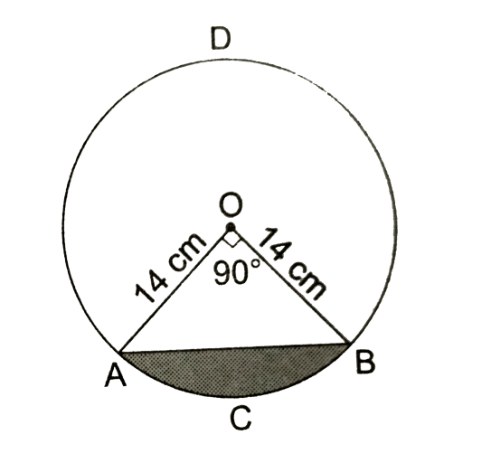
Find the area of the sector.
A. 49 cm²
B. 77 cm²
C. 154 cm²
D. 308 cm²

WORKING SPACE.

- The sum of the interior angles of a polygon is 1,260°. How many sides does the polygon have?
A. 7
B. 9
C. 11
D. 12
- The marked price of a television is Ksh 24,000. A customer is allowed a discount of 10%. How much does he pay?
A. Ksh 21,600
B. Ksh 22,000
C. Ksh 23,000
D. Ksh 21,000
- A salesman earns a commission of 7.5% on sales. If he sells goods worth Ksh 80,000, his commission is:
A. Ksh 6,000 B. Ksh 6,200
C. Ksh 6,400 D. Ksh 6,600
- Which line is parallel to the y-axis?
A. x = 3 B. y = 3
C. y = x + 3 D. y = –x
- A cuboid has dimensions 6 cm × 4 cm × 3 cm. Its total surface area is:
A. 72 cm² B. 108 cm² C. 94 cm² D. 132 cm²
- The coordinates of A are (–4, 2). In which quadrant is point A?
A. I B. II C. III D. IV
- Cylinder has a radius of 7 cm and a height of 15 cm. Find its volume. (Take π = 22/7).
A. 1,540 cm³ B. 2,310 cm³
C. 3,300 cm³ D. 2,3100 cm³
- The table below shows the number of pens sold by a shopkeeper in one week.
Day | Mon | Tue | Wed | Thu | Fri | Sat
Pens | 10 | 14 | 8 | 16 | 12 | 20
What is the mean number of pens sold per day?
A. 12
B. 13.3
C. 14
D. 15
- A map is drawn to a scale of 1:200,000. If the distance between two towns on the map is 7.5 cm, what is the actual distance in km?
A. 7.5 km
B. 15 km
C. 120 km
D. 150 km

SECTION B: Structured Questions (80 marks)
21. Simplify: (6 marks)
$$\frac{3}{4}÷\frac{5}{8}$$
Hence, evaluate:
$$\frac{3​}{4}÷\frac{5}{8​}×\frac{2}{3​}.$$

22. Solve for x and y: (6 marks)
2x+y=13
3x– y = 11


23. A rectangular hall is 25 m long and 15 m wide. Tiles measuring 0.5 m by 0.25 m are used to cover the floor. (7 marks)
a) Find the area of the hall.

b) Find the area of one tile.

c) Calculate the number of tiles required.

24. A piece of land in the shape of a trapezium has parallel sides of 60 m and 40 m and height 30 m. (7 marks)
a) Find the area of the land.

b) If 1 hectare of land costs Ksh 800,000, calculate the cost of this land.

25. A tank is in the form of a cylinder of radius 3.5 m and height 4.2 m. (7 marks)
a) Find its volume in cubic metres.

b) If 1 m³ = 1,000 litres, how many litres can the tank hold?

c) If water costs Ksh 50 per 1,000 litres, find the cost of filling the tank.

26. The table below shows the marks scored by 40 learners in a test. (7 marks)
Marks | 0–9 | 10–19 | 20–29 | 30–39 | 40–49 | 50–59
Learners | 4 | 6 | 10 | 8 | 7 | 5

a) Draw a histogram to represent the data.

b) Find the modal class.

27. A man borrowed Ksh 60,000 from a bank at 12% p.a. simple interest for 3 years. (7 marks)
a) Calculate the interest.

b) Find the total amount he paid at the end of the period.

28. The interior angle of a regular polygon is 165°.(2 marks)
a) Find the number of sides of the polygon.

b) Name the polygon.

c)Construct a circle touching the sides of triangle JKL drawn below.(3 marks)
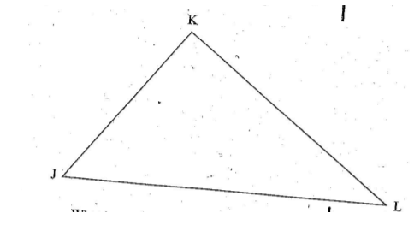

b) What is the length of the diameter of the circle.(1 mark)

29. The diagram below shows a sector of a circle of radius 21 cm and angle 120°.(6 marks)
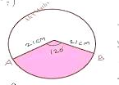
a) Find the length of the arc.

b) Find the area of the sector.

c) In the figure be:ow EFGFI is a rhombus and FG..1 is a triangle. Angle GFJ = 56° and JGH is a straight line. Line JG = line GH.
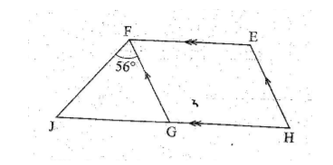
What is the size of angle HEF?

30. A car travelled from town A to B, a distance of 150 km, at 75 km/h. It then travelled from B to C, a distance of 120 km, at 60 km/h. (6 marks)
a) Calculate the total time taken.

b) Find the average speed for the whole journey.

31. On the Cartesian plane provided: (8 marks)
a) Plot points P(2, 3), Q(6, 3), and R(6, 7).
b) Join them to form triangle PQR.
c) Find the area of the triangle.
d) Find the equation of line PR.

This is the last printed page.

