KENYA JUNIOR SCHOOL EDUCATION ASSESSMENT (KJSEA)
GRADE 8: INTEGRATED SCIENCE (THEORY)
CODE: 010 YEAR: 2025 TIME: 2 HOURS
Candidate’s Name: ___________________________________. Assessment Number: _____________________.
School Name: ________________________________________. School Code: _______________________________.

Candidate’s Signature: ______________________________. Date: ________________________________________.
INSTRUCTIONS TO CANDIDATES:
- This paper consists of TWO sections: A and B.
- Answer ALL questions in Section A and B.
- All answers MUST be written in the spaces provided.
- Candidates should check the question paper to ascertain that all the pages are printed as indicated and that no questions are missing.
- Candidates should answer the questions in English.
INTEGRATED SCIENCE (THEORY)

FOR OFFICIAL USE ONLY
Task | Question | Score per question | Maximum score | Candidate’s score
Task 1 | 31 |  | 03
 | 32 |  | 02
Task 2 | 33(a) |  | 02
 | 33(b) |  | 01
 | 34 |  | 03
 | 35 |  | 03
Task 3 | 36 |  | 03
 | 37 |  | 03
 | 38 |  | 03
 | 39(a) |  | 01
 | 39(b) |  | 01
Task 4 | 40(a) |  | 02
 | 40(b) |  | 02
 | 41 |  | 02
 | 42 |  | 02
 | 43 |  | 02
 | 44 |  | 03
 | 45 |  | 02
 | 46 |  | 02
 | 47 |  | 01
 | 48 |  | 02
 | 49 |  | 02
 | 50 |  | 03
Total Section B |  |  | 40
Overall Total |  |  | 70
© 2025 COMPETENCE KENYA ASSESSMENT COUNCIL
SECTION A: 40 MARKS

Choose the best answer for each of the following questions.

- A student is observing a slide of a plant cell under a microscope. Which of the following organelles will they see that is responsible for producing food through photosynthesis? A. Nucleus B. Chloroplast C. Mitochondrion D. Vacuole
- A lab technician is measuring the amount of a substance in moles (mol), the mass in kilograms (kg), and the temperature in Kelvin (K). These are all standard units in the: A. CGS system B. FPS system C. SI system D. Imperial system
- A student notices that a copper coin turns green after being left outside for a long time. This is an example of a: A. Physical change B. Reversible change C. Chemical change D. Temporary change
- The diagram below shows the movement of water molecules from a region of high concentration to a region of low concentration across a semi-permeable membrane.
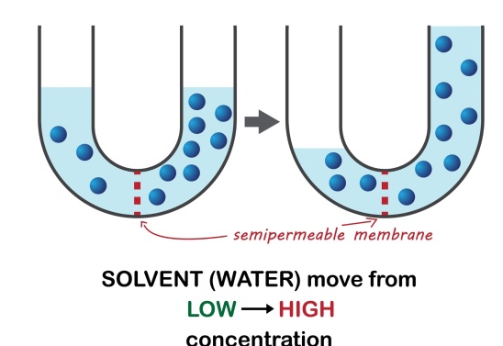
This process is known as: A. Diffusion B. Osmosis C. Active transport D. Transpiration

- A compound is a molecule that contains at least two different elements. Each of the following substances in the list are molecules. One of these is not a compound.
Which one is it?
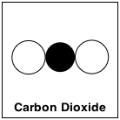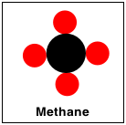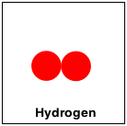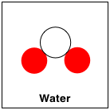
A B. C. D.

- What is the chemical symbol of the element phosphorus?
- Ph
- Fe
- P
- F
- When performing an experiment to study the conditions necessary for rusting, some water is boiled and allowed to cool. Why is this done?
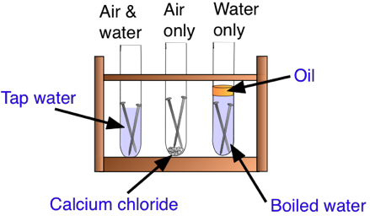
  - To wash the metal being tested
  - To sterilise the water
  - To purify the water
  - To remove oxygen that may be dissolved in the water
- A student observed that when a piece of copper metal is heated in air, it turns black, forming a new substance called copper oxide.
Which word equation best represents this reaction? A. Copper + Carbon Copper carbide B. Copper + Oxygen Copper oxide C. Copper + Water Copper hydroxide D. Copper + Nitrogen Copper nitride
- A student is designing an experiment to test if the amount of water affects plant growth. The first step is to state an educated guess that can be tested, such as "More water will make plants grow taller." This guess is known as a: A. Conclusion B. Observation C. Hypothesis D. Procedure

- The development of new medicines using knowledge from both biology and chemistry to treat diseases is a great example of the importance of integrated science in: A. Improving personal finances B. Enhancing artistic skills C. Solving global health challenges D. Developing entertainment
- A lab safety symbol shows the following symbol

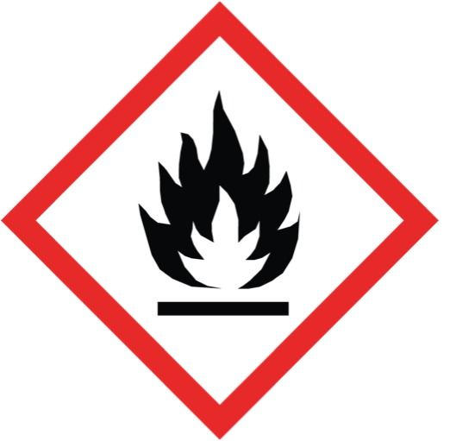

This indicates that the substance is: A. Corrosive B. Flammable C. Oxidizing D. Explosive

- If a student suffers a minor burn from a hot plate, the most appropriate immediate first aid action is to: A. Apply toothpaste to the burn B. Submerge the affected area in cold water C. Puncture any blisters that form D. Wrap the burn tightly with a bandage
- What is the name of the laboratory instrument shown below, which is used to measure the volume of a liquid?
A. Pipette
B. Burette
C. Measuring cylinder
D. Beaker
- In the SI system of measurement, what is the standard unit for time?
A. Minute B. Hour C. Second D. Day
- A scientist carefully watches a chemical reaction, noting changes in color, temperature, and the production of bubbles. This process is a key part of:
A. Data analysis B. Observation C. Drawing conclusions D. Hypothesis formulation
- Which of the following methods is most suitable for separating a mixture of water and cooking oil? A. Filtration B. Evaporation C. Using a separating funnel D. Distillation
- A universal indicator is added to a solution, and the solution turns a deep purple color. This indicates that the solution is a(n): A. Strong acid B. Weak acid C. Neutral solution D. Strong base
- A girl sees her reflection in a calm puddle of water. This phenomenon is a perfect example of: A. Refraction of light B. Absorption of light C. Reflection of light D. Dispersion of light
- Which of the following is a male secondary sexual characteristic that emerges during puberty? A. Menstruation B. Widening of the hips C. Growth of facial and body hair D. Breast development
- What is the correct balanced chemical equation for the decomposition of calcium carbonate (CaCO_3) by heat?
A. CaCO₃ CaO+CO₂
B. CaCO₃ Ca+C+O²
C. CaCO₃ CaO₂+C
D. CaCO₃ Ca₂O+CO₂
- A car engine burns fuel to make the car move. This is an example of the energy transformation from: A. Electrical energy to heat energy B. Chemical energy to kinetic energy C. Light energy to mechanical energy D. Potential energy to electrical energy
- A circuit is connected with a battery and two light bulbs connected in a parallel arrangement. If one of the bulbs burns out and is removed, what will happen to the other bulb? A. It will also go out. B. It will get brighter. C. It will become dimmer. D. It will continue to glow with the same brightness.
- A compass needle points north because: A. It is attracted to the sun's magnetic field. B. The Earth has a magnetic field. C. It is a non-magnetic material. D. The needle is made of wood.
- Which of the following materials is a good electrical insulator? A. Copper wire B. Iron nail C. Plastic ruler D. Aluminum foil
- The smallest particle of an element is called a(n) atom, while the smallest particle of a compound is a(n) molecule. The main difference is that a molecule is formed by: A. A single type of atom B. Two or more atoms chemically bonded C. Ions in a lattice structure D. Electrons moving freely
- The chemical symbol for the element Potassium is: A. P B. Po C. K D. Pt
- A solution is a special type of mixture where the components are: A. Chemically bonded together B. Visible and can be separated by filtration C. Uniformly distributed and cannot be distinguished from each other D. In different states of matter
- A mixture of sand and water where the sand settles at the bottom is known as a: A. Solution B. Compound C. Homogeneous mixture D. Suspension
- A learner was asked to identify the following laboratory apparatus.
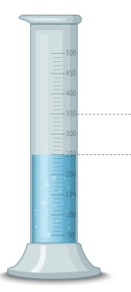
The apparatus shown above is called?
A.Ammeter
B.Liebigs Condenser
C.Volumetric Flask
C.Measuring Cylinder
- Question refers to the following heat curve for water: Which part of the graph shows the greatest amount of energy is required to change the phase?
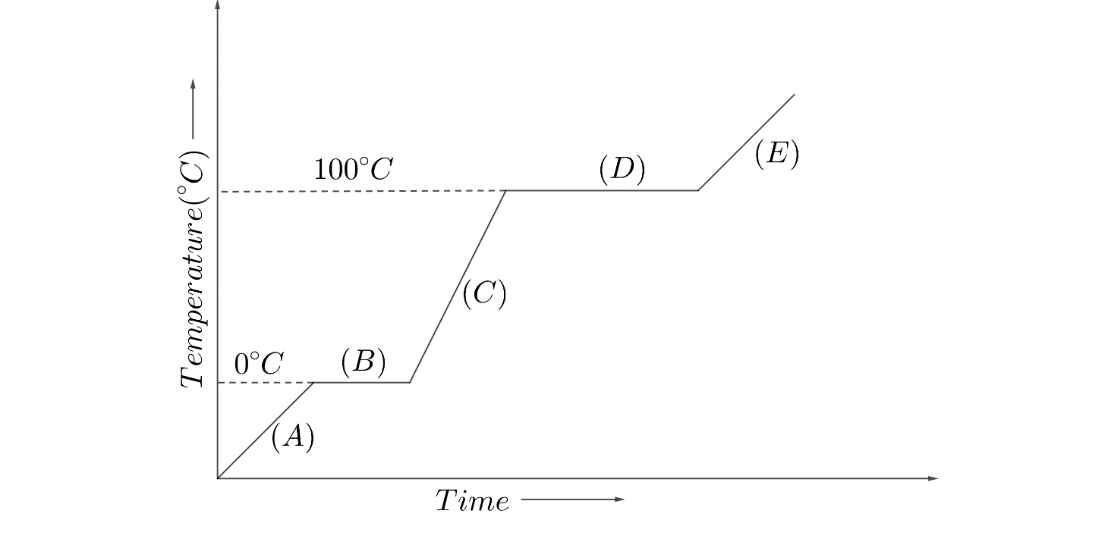

- A.
- B.
- C.
- D.

SECTION B: STRUCTURED QUESTIONS (40 MARKS)
Answer all questions in the spaces provided.
- A student is heating a liquid in a boiling tube during an experiment.
a) Name two safety precautions the student should take. (2 Marks)
____________________________________________________________________________________________________________
____________________________________________________________________________________________________________
b) What is the name of the laboratory instrument used to hold the boiling tube over the flame? (1 Mark)
____________________________________________________________________________________________________________
- A Grade 8 student is asked to prepare a solution of salt water.
a) Identify the solute and the solvent in this solution. (2 Marks)
____________________________________________________________________________________________________________
____________________________________________________________________________________________________________
b) Describe the process of making a concentrated solution. (2 Marks)
____________________________________________________________________________________________________________
____________________________________________________________________________________________________________
- A student is learning about the different states of matter.
a) Describe the arrangement and movement of particles in a solid. (2 Marks)
____________________________________________________________________________________________________________
____________________________________________________________________________________________________________
b) Name the process by which a solid changes directly into a gas without passing through the liquid state. (1 Mark)
____________________________________________________________________________________________________________
____________________________________________________________________________________________________________
- The teacher is discussing the human excretory system.

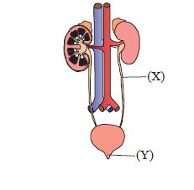
a) Name the parts labelled X and Y. (2 Marks)
X____________________________________________________________________________________________________________
Y____________________________________________________________________________________________________________
b) Explain the primary function of the kidneys. (2 Marks)
____________________________________________________________________________________________________________
____________________________________________________________________________________________________________
- A student is given a mixture of iron filings and sand.
a) Is this mixture homogeneous or heterogeneous? Explain. (2 Marks)
____________________________________________________________________________________________________________
____________________________________________________________________________________________________________
b) Describe a simple method to separate the iron filings from the sand. (2 Marks)
____________________________________________________________________________________________________________
____________________________________________________________________________________________________________
- A student is learning about puberty.
a) Name two physical changes that occur in boys during puberty. (2 Marks)
____________________________________________________________________________________________________________
____________________________________________________________________________________________________________
b) List two emotional or social challenges that adolescents might face during puberty. (2 Marks)
____________________________________________________________________________________________________________
____________________________________________________________________________________________________________
- You are given a simple circuit with a battery and a bulb.
a) Explain the energy transformation that takes place when the bulb is switched on. (2 Marks)
____________________________________________________________________________________________________________
____________________________________________________________________________________________________________
b) Describe what happens to the brightness of the bulb if you add another identical bulb in series. (2 Marks)
____________________________________________________________________________________________________________
____________________________________________________________________________________________________________
- You are learning about chemical changes.
a) State two observable signs that a chemical change has occurred. (2 Marks)
____________________________________________________________________________________________________________
____________________________________________________________________________________________________________
b) Write the chemical symbol for the element Potassium and Chlorine. (2 Marks)
____________________________________________________________________________________________________________
____________________________________________________________________________________________________________
- The diagram below shows a fire triangle.
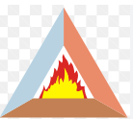
a) Name the three components needed for a fire to burn. (3 Marks)
____________________________________________________________________________________________________________
____________________________________________________________________________________________________________
____________________________________________________________________________________________________________
b) Explain one way to extinguish a fire by removing a component of the fire triangle. (1 Mark)
____________________________________________________________________________________________________________
____________________________________________________________________________________________________________
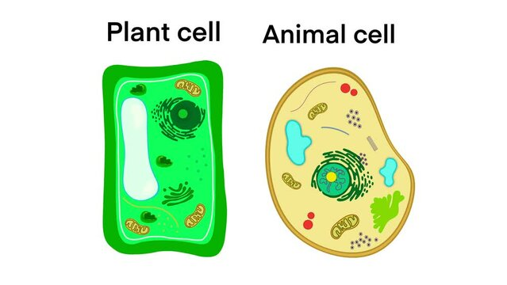
- Consider the following diagrams representing a typical plant cell and a typical animal cell as seen under a light microscope.

A B

A B
a) Identify the cells. (2 Marks)
A: ________________________________________________________________________
B: ________________________________________________________________________
b) Identify a structure, which is found in the plant cell but not the animal cell, and gives the plant cell its rigid shape. (1 mark)
___________________________________________________________________________________________________________________
c) Identify a structure, which is responsible for controlling all cell activities in both cells. (1 mark)
____________________________________________________________________________________________________________
____________________________________________________________________________________________________________
c) Identify the structure which is the jelly-like substance where most chemical reactions occur. (1 mark)
____________________________________________________________________________________________________________
____________________________________________________________________________________________________________

This is the last printed page.

