
KENYA JUNIOR SCHOOL EDUCATION ASSESSMENT (KJSEA)
GRADE 8: INTEGRATED SCIENCE PP1
CODE: 010 YEAR: 2025
MARKING SCHEME

SECTION A: MULTIPLE CHOICE (40 Marks)
No. | Correct Answer | Explanation
1 | B. Chloroplast | Chloroplasts contain chlorophyll and are responsible for photosynthesis in plants.
2 | C. SI system | Mole, kilogram, and Kelvin are SI (International System of Units).
3 | C. Chemical change | Copper reacts with oxygen, CO₂, and moisture to form green copper carbonate → chemical change.
4 | B. Osmosis | Movement of water through a semi-permeable membrane is osmosis.
5 | C. H₂ (Hydrogen) | A compound must have ≥2 different elements; H₂ is a molecule but not a compound.
6 | C. P | The chemical symbol for phosphorus is P.
7 | D. To remove oxygen dissolved in water | Boiling removes dissolved oxygen, which is needed to test rusting.
8 | B. Copper + Oxygen → Copper oxide | Heating copper in air forms black copper oxide.
9 | C. Hypothesis | An educated guess that can be tested is a hypothesis.
10 | C. Solving global health challenges | Biology + chemistry → medicine for health issues.
11 | B. Flammable | The symbol shown (flame) indicates flammable substances.
12 | B. Submerge in cold water | Cooling the burn immediately prevents tissue damage.
13 | C. Measuring cylinder | A measuring cylinder accurately measures liquid volumes.
14 | C. Second | SI unit of time is the second.
15 | B. Observation | Watching and noting changes is observation.
16 | C. Separating funnel | Oil and water are immiscible → separated with funnel.
17 | D. Strong base | Purple color of universal indicator shows strong alkali.
18 | C. Reflection of light | Reflection produces an image in water.
19 | C. Growth of facial and body hair | Male secondary sexual characteristic.
20 | A. CaCO₃ → CaO + CO₂ | Correct decomposition equation for calcium carbonate.
21 | B. Chemical → Kinetic | Burning fuel releases chemical energy converted to movement.
22 | D. Continue to glow same brightness | In parallel circuits, other bulbs remain unaffected.
23 | B. Earth has a magnetic field | Compass needle aligns with Earth’s magnetic field.
24 | C. Plastic ruler | Plastics are good insulators.
25 | B. Two or more atoms chemically bonded | Molecule = ≥2 atoms bonded (same or different elements).
26 | C. K | Symbol for potassium is K (from Latin kalium).
27 | C. Uniformly distributed | In solutions, solute is evenly dissolved.
28 | D. Suspension | Sand settles in water → suspension.
29 | C. Measuring cylinder
30 | D. D | 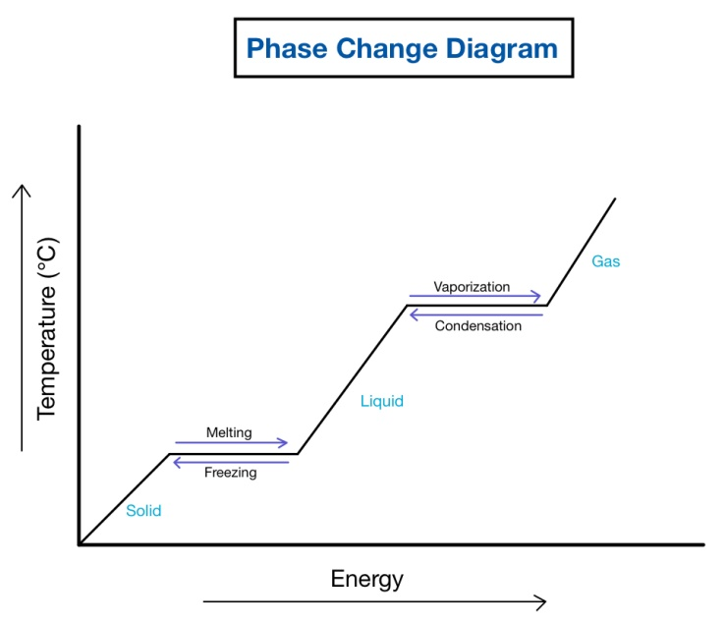Phase change (liquid ↔ gas) needs most energy (latent heat).

SECTION B: STRUCTURED QUESTIONS (40 Marks)

Q31. Heating a liquid in a boiling tube
a) Safety precautions
i. Wear goggles.
ii. Use test tube holder.
iii. Point tube mouth away from people.
iv. Do not fill tube more than half.
v. Heat gently and evenly.
vi. Tie back long hair.
vii. Avoid direct inhalation of fumes.
viii. Keep flammable items away.
ix. Do not leave unattended.
x. Allow glassware to cool before touching.
b) Instrument used
i. Test tube holder.
ii. Sometimes tripod stand with clamp.

Q32. Preparing salt solution
a) Solute and solvent
i. Solute = salt.
ii. Solvent = water.
b) Making a concentrated solution
i. Add large amount of solute.
ii. Stir until no more dissolves.
iii. Heat gently to dissolve more.
iv. Allow cooling to form supersaturated solution.
v. Reduce solvent volume by evaporation.
vi. Keep adding until saturation point reached.
vii. Use warm water to dissolve faster.

Q33. States of matter
a) Particles in a solid
i. Arranged closely, in fixed positions.
ii. Packed in regular pattern (lattice).
iii. Vibrate but do not move freely.
iv. High density and incompressible.
b) Solid → Gas directly
i. Sublimation.

Q34. Excretory system
a) Parts X and Y
i. X –Ureter.
ii. Y – Bladder.
b) Function of kidney
i. Filters blood.
ii. Removes urea, salts, excess water.
iii. Maintains osmotic balance.
iv. Regulates pH.
v. Controls water balance.
vi. Excretes metabolic waste.

Q35. Iron filings + sand
a) Homogeneous or heterogeneous?
i. Heterogeneous – components can be seen.
ii. Different physical properties remain.
b) Separation method
i. Use a magnet to attract iron.
ii. Leave sand behind.

Q36. Puberty
a) Physical changes in boys
i. Growth of facial hair.
ii. Deepening of voice.
iii. Broadening of shoulders.
iv. Growth of chest hair.
v. Enlargement of genitals.
vi. Increased height.
vii. Muscle development.
viii. Frequent erections.
b) Emotional/social challenges
i. Mood swings.
ii. Peer pressure.
iii. Low self-esteem.
iv. Curiosity about opposite sex.
v. Confusion about body changes.
vi. Struggle with identity.
vii. Pressure from school work.
viii. Conflict with parents.
ix. Anxiety or depression.
x. Bullying in school.

Q37. Simple circuit
a) Energy transformation
i. Chemical energy in battery → electrical energy → light + heat in bulb.
b) Adding bulb in series
i. Increases resistance.
ii. Current decreases.
iii. Each bulb glows dimmer.
iv. Voltage shared.

Q38. Chemical change
a) Observable signs
i. Color change.
ii. Heat/light given off.
iii. Gas produced (bubbles).
iv. Precipitate formed.
v. Irreversible change.
vi. New substance formed.
b) Symbols
i. Potassium – K.
ii. Chlorine – Cl.

Q39. Fire triangle
a) Components
i. Heat.
ii. Fuel.
iii. Oxygen.
b) Extinguishing a fire
i. Remove heat → use water/foam.
ii. Remove oxygen → cover with blanket/foam.
iii. Remove fuel → cut off supply.

Q40. Plant & animal cells
a) Identify cells
i. A – Plant cell.
ii. B – Animal cell.
b) Structure unique to plant cell
i. Cell wall.
c) Structure controlling activities
i. Nucleus.
d) Jelly-like substance
i. Cytoplasm.

