KENYA JUNIOR SCHOOL EDUCATION ASSESSMENT (KJSEA)
GRADE 8: AGRICULTURE AND NUTRITION (THEORY)
CODE: 010 YEAR: 2025 TIME: 2 HOURS
Candidate’s Name: ___________________________________. Assessment Number: _____________________.
School Name: ________________________________________. School Code: _______________________________.

Candidate’s Signature: ______________________________. Date: ________________________________________.
INSTRUCTIONS TO CANDIDATES:
AGRICULTURE AND NUTRITION

Write your name and assessment number in the spaces provided.
- Answer ALL questions in Section A and Section B.
- All answers must be written in the spaces provided in this question booklet.
- This paper consists of 12 printed pages.
Candidates should check the question paper to ascertain that all pages are printed as
indicated and that no questions are missing.
- Candidates should answer the questions in English.

For Official Use Only

SECTION A: MULTIPLE CHOICE QUESTIONS (30 Marks)
Question Number | 1 | 2 |  | 3 | 4 |  | 5 | 6 | 7 |  | 8 | 9 | 10 | 11 | 12 | 13 | 14 | 15
Maximum Score | 1 | 1 |  | 1 | 1 |  | 1 | 1 | 1 |  | 1 | 1 | 1 | 1 | 1 | 1 | 1 | 1
Candidate’s Score
Question Number | 16 |  | 17 |  |  | 18 |  | 19 |  | 20 |  | 21 | 22 | 23 | 24 | 25 | 26 | 27 | 28 | 29 | 30 | Total score
Maximum Score | 1 |  | 1 |  |  | 1 |  | 1 |  | 1 |  | 1 | 1 | 1 | 1 | 1 | 1 | 1 | 1 | 1 | 1 | 30
Candidate’s Score

SECTION B: STRUCTURED QUESTIONS. (50 Marks)
Part 1: AGRICULTURE (25 Marks) <br>
Qn No. | 31 | 32 | 33 | 34 | 35 | 36 | 37 | Total Agriculture
Max Score | 3 | 3 | 5 | 4 | 4 | 4 | 2 | 25
Cand score
Part 2: NUTRITION (25 Marks) <br>
Qn No. | 38 | 39 | 40 | 41 | 42 | 43 | 44 | Total Nutrition
Max Score | 3 | 3 | 3 | 4 | 4 | 4 | 4 | 25
Cand score

© 2025 COMPETENCE KENYA ASSESSMENT COUNCIL Turn over

SECTION A: (30 MARKS)
Choose the most appropriate answer for each question.
- Which of the following describes a soil that is sandy, drains water quickly, and does not hold nutrients well? A. Loam soil B. Clay soil C. Silt soil D. Sandy soil
- A farmer is preparing a seedbed for small seeds like sukuma wiki. Which soil tilth is most suitable for this purpose? A. Coarse tilth B. Fine tilth C. Medium tilth D. Lumpy tilth
- Which tool is best for removing weeds with deep taproots from a garden? A. Rake B. Shovel C. Fork hoe D. Trowel
- The practice of planting different types of crops on the same piece of land in a planned sequence is known as: A. Intercropping B. Mulching C. Crop rotation D. Broadcasting
- What is the primary purpose of applying mulch around growing plants? A. To increase soil erosion B. To introduce pests C. To conserve soil moisture D. To make the garden look tidy
- Which of the following is an example of a legume that helps to fix nitrogen in the soil? A. Maize B. Beans C. Cabbage D. Potatoes
- A farmer notices that their tomato plants have yellowing leaves and stunted growth. This could be a sign of: A. Too much water B. A nutrient deficiency C. A viral disease D. Pest infestation
- Why is it important to isolate a sick animal from a healthy flock in poultry farming? A. To give the sick animal special food B. To prevent the spread of diseases C. To make it easier to sell the sick animal D. To reduce the cost of medication
- Which of these is NOT a function of a poultry feeder? A. To hold food for the birds B. To prevent wastage of feed C. To keep feed clean from contamination D. To provide water to the chickens
- A pupil in a school garden is using ash to control aphids on cabbage leaves. This is an example of which pest control method? A. Chemical control B. Biological control C. Cultural control D. Mechanical control
- What is the process of removing excess seedlings from a seedbed to allow the remaining plants to grow well? A. Weeding B. Thinning C. Pruning D. Broadcasting
- A pupil wants to improve the water retention of sandy soil. Which material should they add? A. Stones and gravel B. Clay soil C. Organic matter like compost D. Pieces of plastic
- What is the main purpose of constructing a kitchen garden near the homestead? A. To provide shade for the house B. To allow for easy access and supervision C. To prevent wild animals from entering D. To store farm tools
- The practice of digging trenches along the contours of a hill to prevent soil erosion is called: A. Terracing B. Mulching C. Intercropping D. Broadcasting
- Farmers from Eldoret planted grass along a certain water way a shown below.
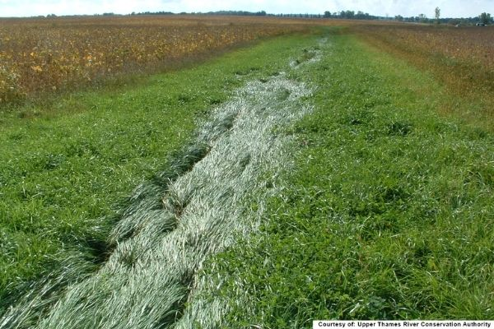
The structure shown is:
A. Grass strip B. Grassed waterway
C. Strip cropping D. Stone bund
- The diagram below shows alternating strips of maize and sweet potatoes
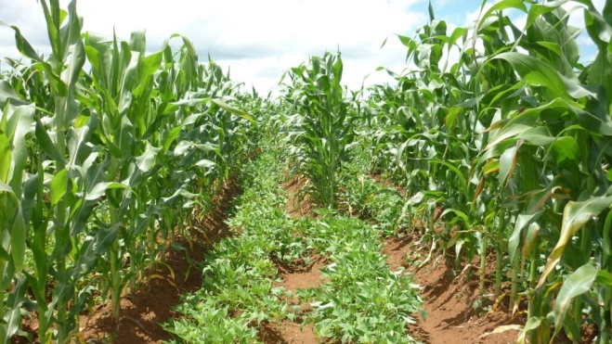
This is an example of:
A. Intercropping
B. Strip cropping
C. Crop rotation
D. Mulching

- Why is it important to wash vegetables before cooking them? A. To add flavour B. To remove dirt and germs C. To make them soft D. To make them colourful
- Which of the following cooking methods preserves most nutrients in vegetables? A. Boiling B. Frying C. Steaming D. Roasting
- What is the primary function of carbohydrates in our bodies? A. To build and repair body tissues B. To provide energy C. To protect against diseases D. To help with digestion
- Which food group is rich in protein and is essential for growth and repair? A. Fruits and vegetables B. Cereals and tubers C. Milk and meat D. Fats and oils
- Which of these is a good hygienic practice when handling food? A. Tasting food with your fingers B. Washing hands before and after cooking C. Coughing over food D. Using a dirty cloth to wipe utensils
- What is the benefit of a balanced diet? A. It makes you feel full B. It helps the body function properly C. It is easy to prepare D. It is always expensive
- Which of the following is a common method for preserving milk at home? A. Salting B. Sun-drying C. Boiling D. Freezing

- A learner finds sticky honeydew on bean leaves and tiny winged insects underneath. What pest is responsible?
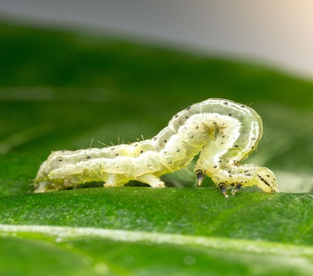

A

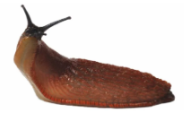
B

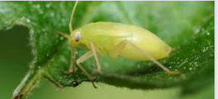

C

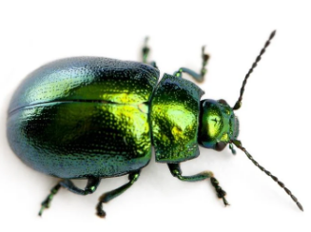

D

- What is the correct way to handle a cut or a burn in the kitchen? A. Ignore it and continue cooking B. Apply a bandage without cleaning the wound C. Clean the wound and apply first aid D. Run to the nearest hospital immediately
- A family is sitting down for a meal where a large serving dish is placed in the center of the table and everyone serves themselves. This is an example of which serving method? A. Buffet service B. Family service C. Blue plate service D. Table d’hôte service
- A pupil is mending a tear in a shirt. Which household skill is being applied? A. Cooking B. Sewing C. Cleaning D. Gardening
- A good practice for storing grains like maize is to keep them in: A. A wet, cool place B. An airtight container in a dry place C. An open sack in a damp shed D. A plastic bag left in the sun
- Which type of seam is commonly used for joining two pieces of fabric to prevent fraying at the edges? A. French seam B. Plain seam C. Flat fell seam D. Run-and-fell seam
- A student is making a pillowcase. What is the most basic seam that can be used for this project? A. French seam B. Backstitch seam C. Plain seam D. Double stitch seam

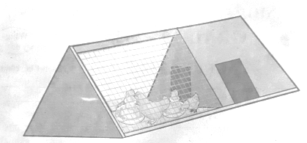
- A Grade 8 group in Narok designs a structure like that can be moved daily so birds access fresh grass. What is the best name for this structure?

A. Deep-litter house B. Poultry fold C. Brooder D. Hatchery

SECTION B: STRUCTURED QUESTIONS (50 MARKS)
Answer all questions in the spaces provided.
Part 1: Agriculture – 25 Marks
- A farmer wants to start a small-scale poultry project.
a) Name two types of poultry commonly reared in Kenya. (2 marks)
______________________________________________________________________________________________________________________
______________________________________________________________________________________________________________________
b) Give one reason why it is important to provide clean drinking water to poultry. (1 mark)
______________________________________________________________________________________________________________________
______________________________________________________________________________________________________________________
- Explain the meaning of the following terms as used in crop production: (3 marks) a) Weeding
b) Thinning
______________________________________________________________________________________________________________________
______________________________________________________________________________________________________________________
c) Mulching
______________________________________________________________________________________________________________________
______________________________________________________________________________________________________________________

- Your school is located in a dry area and the Agriculture club wants to practice water conservation.
a) State two methods of water conservation that can be applied in the farm. (2 marks)
i. ___________________________________________________________________________________________________________
ii. ___________________________________________________________________________________________________________
b) Explain how one of the methods mentioned in (a) helps in water conservation. (3 marks)
______________________________________________________________________________________________________________________
______________________________________________________________________________________________________________________
- A pupil is preparing a seedbed for planting maize.
a) What is the main purpose of primary cultivation? (2 marks)
______________________________________________________________________________________________________________________
______________________________________________________________________________________________________________________
b) Give two reasons why it is important to have a good seedbed. (2 marks)
i. __________________________________________________________________________________________________________________
ii. ________________________________________________________________________________________________________________
- The school has a small kitchen garden. a) List three tools a pupil can use to maintain the garden. (3 marks)
i. _________________________________________________________________________________________________________
ii. _________________________________________________________________________________________________________
iii. _________________________________________________________________________________________________________
b) Describe how to use one of the tools mentioned above. (2 marks)
______________________________________________________________________________________________________________________
______________________________________________________________________________________________________________________
- Study the diagram below and answer the questions that follow.

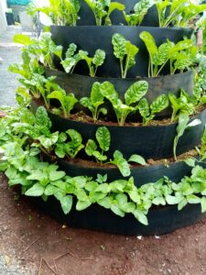
a) Identify the type of garden shown in the diagram. (1 mark)
____________________________________________________________________________________________________________________________________________________________________________________________________________________________________________
b) State three advantages of this type of garden. (3 marks)
i. ___________________________________________________________________________________________________________________
ii. ___________________________________________________________________________________________________________________
iii. __________________________________________________________________________________________________________________
- (a)What is soil erosion? (2 marks)
___________________________________________________________________________________________________________________________________________________________________________________________________________________________________________
b)Below is a diagram showing a water harvesting practice;
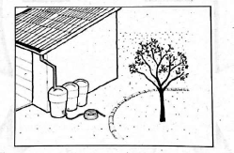
Write down two ways of storing harvested water.
i)_______________________________________________________________________________________________________________

Part 2: Nutrition – 25 Marks
- Explain the following terms as used in nutrition: (3 marks)
a) Balanced diet
____________________________________________________________________________________________________________________________________________________________________________________________________________________________________________
b) Malnutrition
____________________________________________________________________________________________________________________________________________________________________________________________________________________________________________
c) Food preservation
____________________________________________________________________________________________________________________________________________________________________________________________________________________________________________
- Name three types of nutrients found in food and give one function for each. (3 marks)
i. Nutrient: __________________________________ Function: ______________________________________________________
ii. Nutrient: __________________________________ Function: _____________________________________________________
iii. Nutrient: __________________________________ Function: ____________________________________________________
- Give three reasons why it is important to practice proper hygiene in the kitchen. (3 marks)
i. __________________________________________________________________________________________________________
ii. __________________________________________________________________________________________________________
iii. __________________________________________________________________________________________________________
- A pupil wants to cook vegetables while preserving their nutrients.
a) Name two cooking methods that achieve this. (2 marks)
i. ____________________________________________________________________________________________________________
ii. ___________________________________________________________________________________________________________
b) Why is it important to chop vegetables just before cooking? (2 marks)
_____________________________________________________________________________________________________________________
_____________________________________________________________________________________________________________________
- Describe the step-by-step procedure for making a simple household cleaning agent like soap using local materials. (4 marks)
______________________________________________________________________________________________________________________
______________________________________________________________________________________________________________________
______________________________________________________________________________________________________________________
______________________________________________________________________________________________________________________
- A pupil is sewing a work bag.
a) Name two sewing tools that would be useful for this task. (2 marks)
i. _____________________________________________________________________________________________________________
ii. ____________________________________________________________________________________________________________
b) Explain the difference between a running stitch and a backstitch. (2 marks)
______________________________________________________________________________________________________________________
______________________________________________________________________________________________________________________
- Explain two table manners that should be observed while eating a meal with family or friends. (4 marks) i. ___________________________________________________________________________________________________________
ii. ____________________________________________________________________________________________________________

This is the last printed page.

