KENYA JUNIOR SCHOOL EDUCATION ASSESSMENT (KJSEA)
GRADE 7: MATHEMATICS
CODE: 010 YEAR: 2025 TIME: 2 HOURS
Candidate’s Name: ___________________________________. Assessment Number: _____________________.
School Name: ________________________________________. School Code: _______________________________.

Candidate’s Signature: ______________________________. Date: ________________________________________.
INSTRUCTIONS TO CANDIDATES:
INSTRUCTIONS TO CANDIDATES:
- Write your name and class in the spaces provided above.
- The paper consists of two sections: Section A and Section B.
- Answer ALL questions in Section A and Section B.
- Show all your working in the spaces provided.
- All questions carry marks as indicated.
- Mathematical tables and electronic calculators may be used.
.

For Official Use Only
Task | Task 1 | Task 2 | TOTAL
Question | 1 | 2 | 3QUESTIONS
Maximum Score | 20 | 10 | 30 MARKS
Candidate’s Score
FOR OFFICIAL USE ONLY.

This paper consists of 17 printed pages. Candidates should check the question paper to ascertain that all the pages are printed as indicated and that no questions are missing.

© 2025 COMPETENCE KENYA ASSESSMENT COUNCIL Turn over

SECTION A: (20 Marks)

Answer all questions
1. What is two million six thousand four hundred and nine in numerals?
A. 2006409
B. 2600409
C. 2060409
D. 2006049
2. Which one of the following statements is correct?
A. 1/2 < 0.5 B.3/5 > 5/8
C. 0.63 < 0.36 D. 1/5 > 1/10
3. What is the difference between the total values of the digits in the thousands and hundreds position in the number 789240?
A. 200 B. 8800
C. 9000 D. 9200
4. What is the value of
(49365 — 9000 ÷ 3 + 1035) — 1250 x 4?
A. 52400 B. 42400
C. 40330 D. 52960
5.A farmer had 280 chickens.He sold 5/7 of the chicken on the first day and then sold 1/5 of the remainder the following day. How many chicken were sold?
A. 200
B. 64
C. 216
D. 16

WORKING SPACE

6. Which is the next number in the pattern?
1, 3. 3, 27, 81,
A. 135 B. 108
C. 162 D. 243
7. A trader bought 21798 bags of maize in the first week.
In the second week he bought 2476 bags less than what he had bought in the first week.
In the third week he bought 542 bags more than he bought in the first week. How many bags of maize did he buy altogether?
A. 68412
B. 3460
C. 62376
D. 24816
8. What is the value of 80.4 - (15.46 + 4.54)/0.4 A. 30.4
B. 130.4
C. 151
D. 37.21
9. In a farm, on average every 6 cows produce 108 litres of milk per week.
In five weeks the cows produced 2160 litres of milk. How many cows are in the farm?
A. 432
B. 120
C. 24
D. 18

WORKING SPACE

10. What is 759.968 rounded of to the nearest hundredth?
A. 759 96
B. 7.59.9
C. 759.97
D. 760.0
11. In a race, Korir takes 12 seconds to run round a field. Muteti takes 18 seconds while Mwenda takes 27 seconds to run round the same field.
If the three athletes start together, after how many seconds will they be together again?
A. 3 B. 57 C. 5532 D. 108
12. What is the square root of 17.64?
A. 42 B. 35.2 C. 8.82 D. 4.2
13. The area of a rectangular piece of land J is 220 square metres. Its width is 12.5 m. What is the perimeter of the piece of land?
A. 17.6 m B. 30.1 m
C. 60.2 m D. 70.4 m
14. A rectangle brick weighs 3 kg 750 g. How many such bricks can be loaded into a lorry which can carry 3 tonnes?
A. 8 B. 80 C. 800 D. 8000
15. Rono cycled from town R at an average speed of 72 km/h and took 3 hours 30 minutes to reach town S. Kepha cycled the same distance and took 4 hours. At what average speed was Kepha cycling?
A. 18 km/h
B. 33 km/h
C . 63 km/h
D. 252 km/h
WORKING SPACE

16. The figure below represents a piece of land.
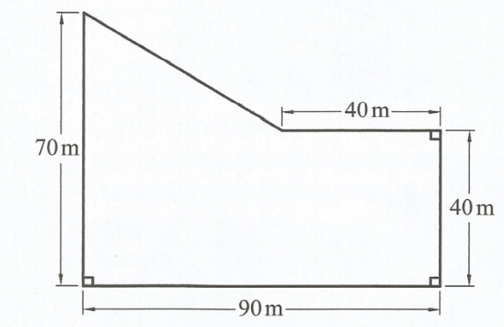
What is the area of the piece of land?
A. 6300 m² B. 4350 m² C. 3600 m² D. 6550 m²

17. Muga left town P on Wednesday at 8.30 pm.
He took 7 hours 50 minutes to reach town Q. On what day and time in 24 hours clock system did he reach town Q?
A. Thursday 0420 h
B. Wednesday 0420 h
C. Wednesday 1620 h
D. Thursday 1620 h
18. An open rectangular tank has a base measuring 2.0m by 1.5 m. It has a height of 2.5 m. The surface of the tank was painted. What was the total area painted?
A.7.5 m² B.11.75m² C.20.5 m² D. 23.5 m²
WORKING SPACE

19. A cylindrical container of diameter 8 cm has a height of 35 cm. What is the volume of the container in cubic centimetres?(Take π = 22/7)
A. 1760
B. 7040
C. 880
D. 440
20. The figure below represents a flower garden in the shape of a triangle and a semi-circle. (Take π = 22/7)
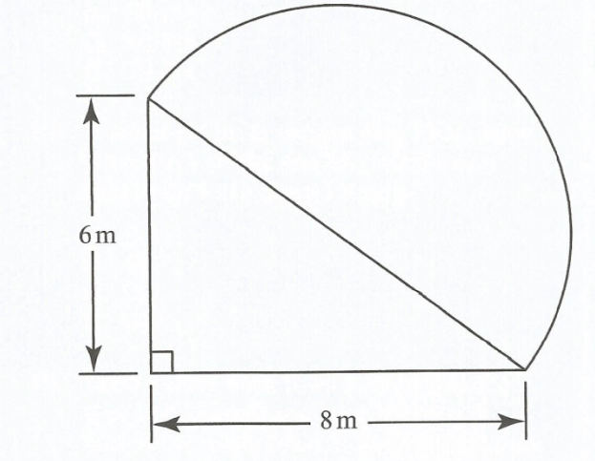
What is the area of the garden?
A. 102 4/7m²
B. 29 5/7m²
C .63 2/7m²
D. 39 2/7m²
WORKING SPACE

SECTION B
Answer all questions
21. A cylindrical tank whose diameter is 140 cm has a height of 75 cm. How many litres of water can it hold when full?(Take π = 22/7)

22. What is the value of x+ 2n — $\frac{r}{y}$ .
where x=5 , y = 2x , n = x + 9 and r = n + 6?

23. Simplify 2(3x+y)+4x/4(x+2y)-y

24. Musa bought x bananas and Maria bought 4 bananas more than Musa. Otieno bought twice as many bananas as both Musa and Maria.
The total number of bananas bought altogether was 30. Find the number of mangoes Otieno bought?

25. What is the value of x in equation 3/5 (2x + 2) — 1 = 5?

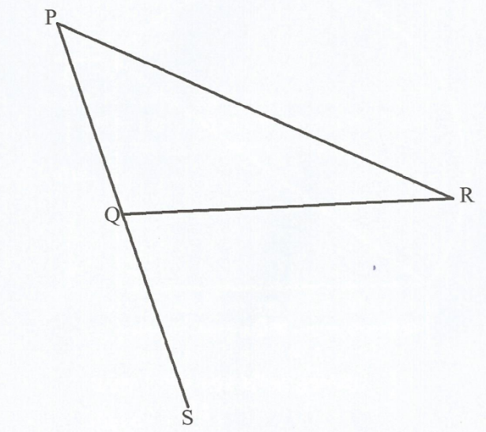
26. In the figure below construct a perpendicular bisector of line PR. Let the line intersect PR at T and meet line QS at H?

What is the measure of line HT in cm?

27. In the figure below line QP is parallel to line RS, line QS =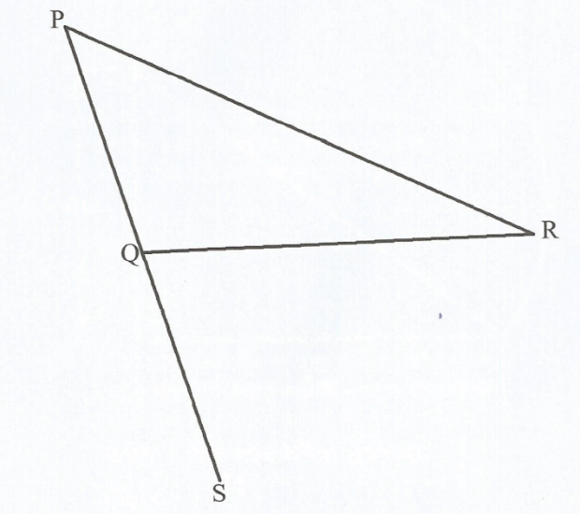
line SR and angle QSP = 32°.

What is the size of angle PQR?
28. The figure below is part of a parallelogram EFGH. Complete the parallelogram.
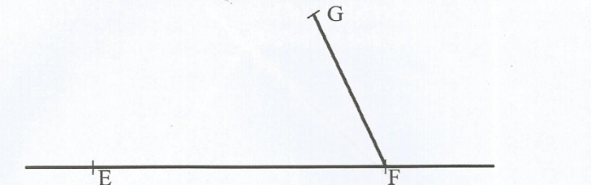
What is the length of half of the longer diagonal?
29.In a certain school the number of girls was 240 and the total number of pupils was 540.What is the ratio of boys to girls in the school?

30. What is the value of?
1½ + (2¼ x 3½ of 12 ÷ ¾)?

31. Triangle RST below is an isosceles triangle. The length RT = RS = 10 cm and ST — 12 cm.
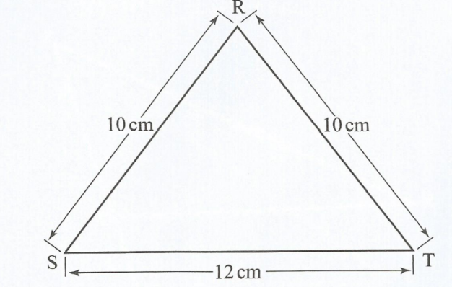
What is the area of the triangle?
32. The diagram below is a net of a solid.
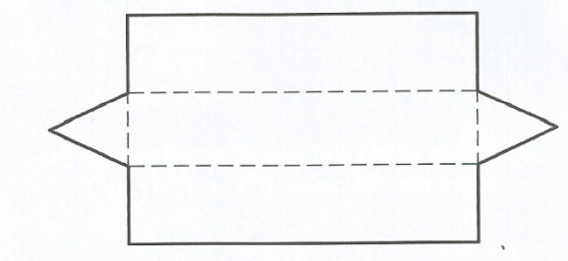
Which solid can be formed from the net above?
33. Write two similarities of both a trapezium and a rhombus?

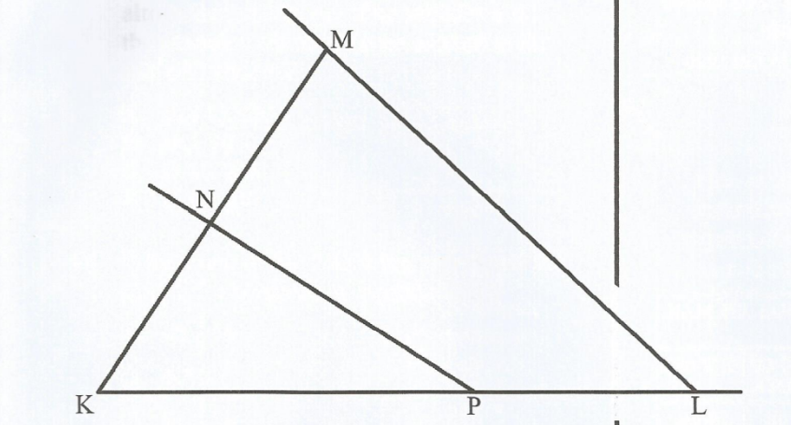

34. What is the size of the obtuse angle NPL?

35. Amina bought 4 metres of material at sh250 per metre, 6 buttons at sh 8 each, a sewing thread for sh 30 and made a dress.
A similar dress costs sh 1500 in a shop. How much money did she save by making the dress?

36. A fruit vendor bought 300 pineapples at sh2l0 for every 5 pineapples. She sold the pineapples at sh60 each. How much profit did she make?

37. Kazungu paid sh 3 200 for an item after getting a discount of 20%. What was the marked price for the item.

38. A salesman earns a basic salary of sh40 000. He is also paid a commission of 3% of the value of goods he sells above sh 100 000.
In one month he sold sh20 000 items at sh 20 each. What was his total earnings that month?
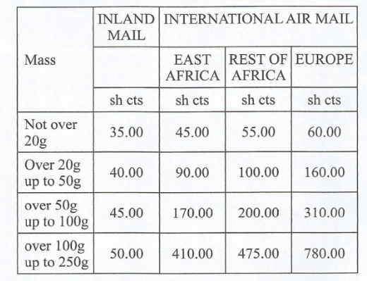
Weru posted the following letters:
- 1 letter weighing 101g to Kisumu in Kenya
- 1 letter weighing 19g to Uganda
- 2 letters weighing 80g each to Europe 1 letter weighing 50 g to Zambia
How much money did he pay for postage?

40. The hire purchase price of a sewing machine is made up of a deposit of sh4 000 and 18 equal monthly instalments of sh 1 200 each.
Wanja was allowed a 20% discount on the hire purchase price for buying the sewing machine on cash.
How much money did she pay?

41. Wanyama deposited sh 84 000 in a bank which paid simple interest at the rate of 10% per annum.
How much money altogether, did he get if he withdrew all the money with the interest earned at the end of 7 months?

42. Write the ratio 2:5 expressed as a percentage?

43. Six people working for 5 days were paid a total of sh 6 000.
How much more money could the same number of people be paid for 12 days?

44. A group of farmers harvested 10 000 kg of coffee on the first day and 8 000 kg on the second day. What was the percentage decrease in the amount of coffee harvested?

45. The table below shows sales of shoes in 5 days. The sales for Wednesday are not shown.
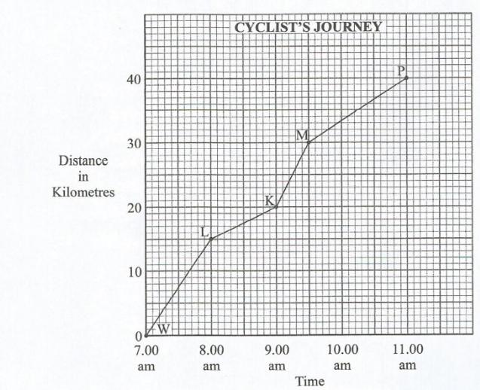
The total number of pairs of shoes sold was 180. If a pie chart was to be drawn to repreśent this information, what angle would represent the number of pairs sold on Wednesday

46. The graph below represents a journey of a cyclist travelling from town W to town P through towns L, K and M?
Between which two towns was the cyclist travelling at the highest speed?

47. The table below shows train fares from town N to town M:
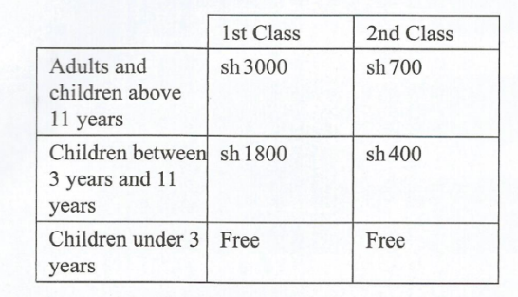
A certain school arranged for a trip by train from town N to town M. 28 pupils aged 12 years, 15 pupils aged between 7 years and 10 years, 4 teachers and the head teacher.
The passengers occupied the following classes in the train:
1st class: The head teacher and one teacher.
2nd class: 3 teachers and all the pupils.
How much money did they pay for the trip altogether?

48. The distance in kilometres between towns P, Q, R and S is shown below.
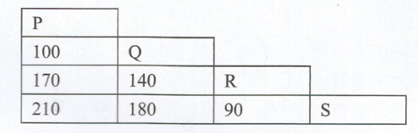
What is the distance from town S to town P via town R?

49. The scale of a building plan is l:200. What length, in cm, on the plan represents 5 metres of the building?

50. The number of pupils present in a class ] in a certain week is shown in the table below:
Days of the week | Monday | Tuesday | Wednesday | Thursday | Friday
Number of pupils | 45 | 36 | 43 | 45 | 41
What was the mean attendance for the class that week?

This is the last printed page.

