KENYA JUNIOR SCHOOL EDUCATION ASSESSMENT (KJSEA)
GRADE 7: INTEGRATED SCIENCE (THEORY)
CODE: 010 YEAR: 2025 TIME: 2 HOURS
Candidate’s Name: ___________________________________. Assessment Number: _____________________.
School Name: ________________________________________. School Code: _______________________________.

Candidate’s Signature: ______________________________. Date: ________________________________________.
INSTRUCTIONS TO CANDIDATES:
- This paper consists of TWO sections: A and B.
- Answer ALL questions in Section A and B.
- All answers MUST be written in the spaces provided.
- Candidates should check the question paper to ascertain that all the pages are printed as indicated and that no questions are missing.
- Candidates should answer the questions in English.
INTEGRATED SCIENCE (THEORY)

FOR OFFICIAL USE ONLY
Task | Question | Score per question | Maximum score | Candidate’s score
Task 1 | 31 |  | 03
 | 32 |  | 02
Task 2 | 33(a) |  | 02
 | 33(b) |  | 01
 | 34 |  | 03
 | 35 |  | 03
Task 3 | 36 |  | 03
 | 37 |  | 03
 | 38 |  | 03
 | 39(a) |  | 01
 | 39(b) |  | 01
Task 4 | 40(a) |  | 02
 | 40(b) |  | 02
 | 41 |  | 02
 | 42 |  | 02
 | 43 |  | 02
 | 44 |  | 03
 | 45 |  | 02
 | 46 |  | 02
 | 47 |  | 01
 | 48 |  | 02
 | 49 |  | 02
 | 50 |  | 03
Total Section B |  |  | 40
Overall Total |  |  | 70
© 2025 COMPETENCE KENYA ASSESSMENT COUNCIL Turn over
SECTION A: 30 MARKS
Choose the most appropriate answer from the options provided.

- A science Learner mixed sand and water in a beaker. Which of the following is the best method to separate the sand from the water? A. Evaporation B. Filtration C. Distillation D. Decantation
- Which laboratory apparatus is used for holding and mixing liquids? A. Measuring cylinder B. Conical flask C. Burette D. Test tube holder
- The diagram below shows parts of a simple electric circuit:
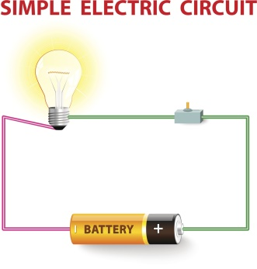
What is the purpose of the switch in the circuit? A. To produce electricity B. To measure current C. To open or close the circuit D. To resist the flow of current
- Which part of the human excretory system is responsible for filtering blood to produce urine? A. Bladder B. Urethra C. Kidney D. Ureter
- A substance with a pH of 3 is classified as: A. A strong base B. A strong acid C. A neutral substance D. A weak acid
- What is the standard SI unit for measuring the amount of substance? A. Kilogram B. Mole C. Litre D. Ampere
- The diagram below shows a magnet attracting iron pins:
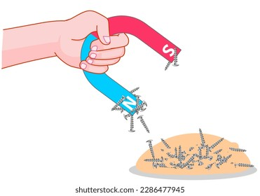
What is the region around the magnet where magnetic force is strongest called? A. The magnetic field B. The magnetic pole C. The magnetic line D. The magnetic axis
- Which of these is a physical change? A. Rusting of iron B. Burning of wood C. Melting of ice D. Digestion of food
- What is the first aid procedure for a minor cut that is bleeding? A. Apply a tight bandage B. Clean the wound with soap and water C. Apply butter to stop the bleeding D. Tie a tourniquet above the cut
- The process by which the human body maintains a constant internal temperature is known as: A. Digestion B. Respiration C. Homeostasis D. Excretion
- What is the standard SI unit for measuring the amount of substance? A. Kilogram B. Mole C. Litre D. Ampere

- The diagram shows the symbol for a toxic substance.
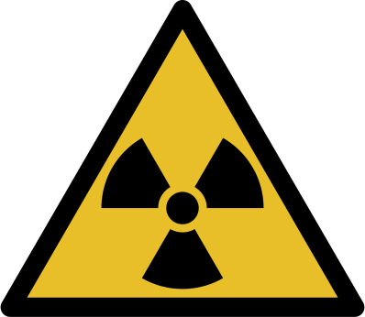

What does this symbol mean and why is it important to have such symbols in the laboratory? A. It indicates a substance that can cause harm, illness, or death if ingested or absorbed. B. It indicates a flammable substance that can easily catch fire. C. It indicates a corrosive substance that can damage other substances with which it comes into contact. D. It indicates a radioactive substance that can emit harmful radiation.

- A Learner used red and blue litmus paper to test a solution. Both papers stayed the same. What is the solution? A. Neutral B. Acidic C. Basic D. Weak acid
- The diagram below shows the human male reproductive system:
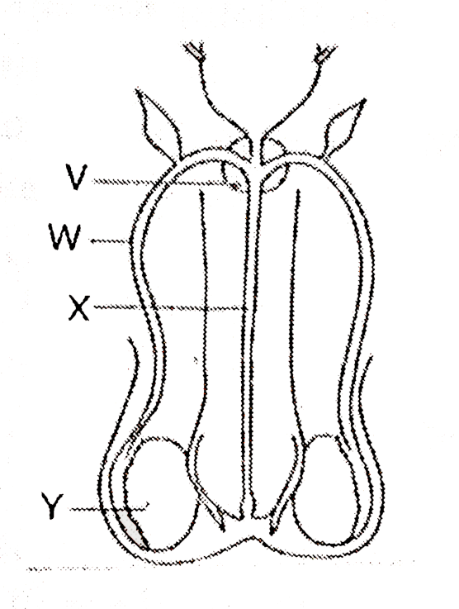
Which part produces sperm cells?
A. V
B. W
C. X
D. Y
- What is the first aid response to a simple fracture? A. Massage the area B. Bandage tightly C. Support and keep still D. Soak in warm water
- Which of the following is a characteristic property of acids? A. They turn red litmus paper blue. B. They have a pH greater than 7. C. They react with metals to produce hydrogen gas. D. They feel slippery to the touch.
- Which property of magnets is correct? A. They repel all metals B. They attract non-metals C. Like poles attract D. Opposite poles attract
- During a demonstration, the teacher mixed iron filings and sulphur and heated them. What type of change took place? A. Physical B. Magnetic C. Chemical D. Reversible

- The diagram below represents the excretory system.
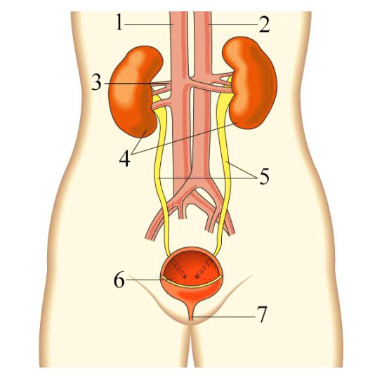
What is the function of the part marked 5 in the diagram above?
A. Filters blood B. Stores urine C. Carries urine to bladder D. Produces urine
- A mixture of sand and iron filings was given to Learners. Mary suggested using a magnet to separate them. Why is this method effective? A. Sand is heavier B. Iron is magnetic C. Sand dissolves in water D. Filings float
- Identify the method suitable for separating chalk from water: A. Sieving B. Decanting C. Filtration D. Evaporation
- Which instrument is used to measure mass? A. Stopwatch B. Thermometer C. Beam balance D. Ruler
- What is the first aid procedure for a minor burn on the arm? A. Rub with lotion B. Put in cold running water C. Apply butter D. Cover with cloth
- The diagram below shows the human digestive system:
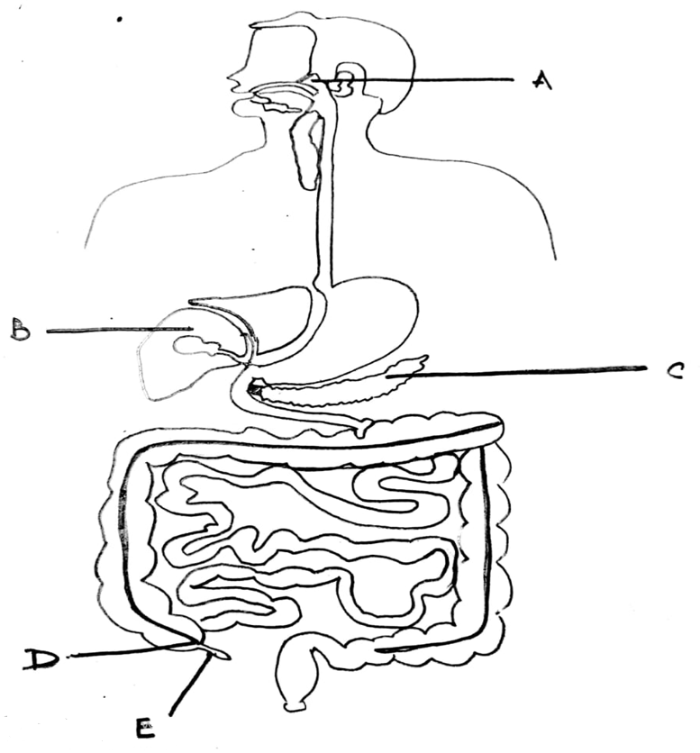
What is the function of the part labelled B?
A. To absorb water
B. To digest proteins
C. To produce bile
D. To store food
- Which of the following is a component of the human reproductive system in females? A. Penis B. Urethra C. Ovary D. Scrotum
- Adolescents often experience emotional changes. Which is an appropriate way to manage them? A. Fighting B. Talking to a trusted adult C. Isolating oneself D. Ignoring emotions
- The device below converts electrical energy into light energy: What is the name of this device? A. Iron B. Bulb C. Kettle D. Fuse
- The SI unit of temperature is: A. Degree B. Celsius C. Fahrenheit D. Kelvin

- In a science lesson, Diana poured oil into water and saw that the two liquids did not mix. What kind of mixture is this? A. Solution B. Suspension C. Emulsion D. Colloid
- Learners are gathering materials and building an electrical circuit.
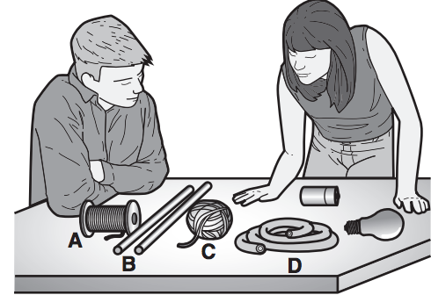

Which material will allow electricity to flow between the battery and the light bulb?
A. copper wire B. wooden rod
C. cotton string D. rubber tube

SECTION B: STRUCTURED QUESTIONS (40 MARKS)
Answer all questions in the spaces provided below.
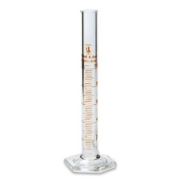
- The diagram below shows some laboratory equipment. Identify each item and state its use. (3 marks)
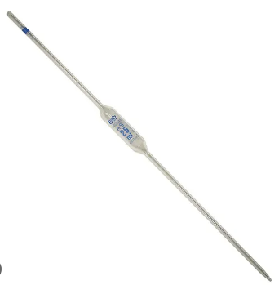
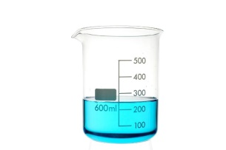
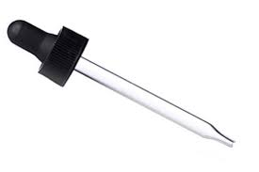

A B C D
Item | Name | Use
A
B
C
D

32. A group of learners was given a mixture of water and cooking oil. Describe how they can separate the two liquids. (2 marks)
__________________________________________________________________________________________________________________
__________________________________________________________________________________________________________________
__________________________________________________________________________________________________________________
__________________________________________________________________________________________________________________
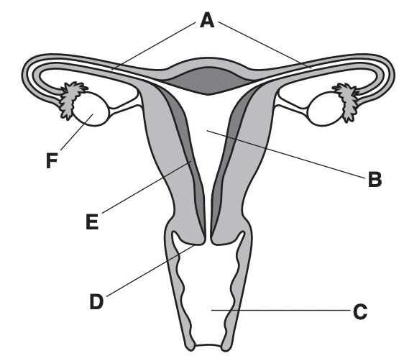
33. Use the diagram of the human female reproductive system to answer the questions.

a) Name the parts labelled A and B. (2 marks)
A: _________________________________________ F: _________________________________________
b) What is the function of the part labelled B? (1 mark)
______________________________________________________________________________________________________________________

34. Explain three differences between a series circuit and a parallel circuit. (3 marks)
______________________________________________________________________________________________________________________
______________________________________________________________________________________________________________________
______________________________________________________________________________________________________________________
35. A Learner mixed salt, sand, and iron filings. Describe a step-by-step process to separate all three components from the mixture. (3 marks)
______________________________________________________________________________________________________________________
______________________________________________________________________________________________________________________
______________________________________________________________________________________________________________________

36. The table below shows changes during adolescence. Fill in the correct category for each. (3 marks)
Change | Physical or Emotional?
Deeper voice
Feeling confused
Widening of hips
37. State three safety precautions to observe while handling a Bunsen burner in the laboratory. (3 marks)
a. _______________________________________________________________________________________________________________
b. _______________________________________________________________________________________________________________
c. _______________________________________________________________________________________________________________
38. The diagram below shows the human skin. Identify the parts labelled V, W, and X. (3 marks)
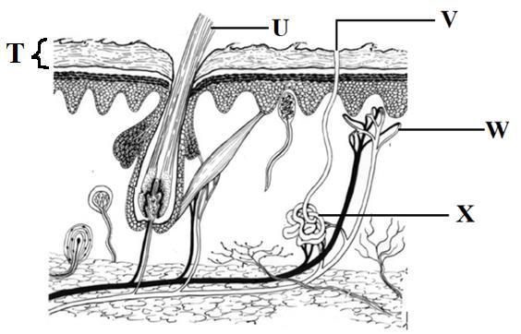

V: _________________________________________
W: _________________________________________
X: _________________________________________
39. A Learner uses a Vernier caliper to measure the length of a small object. The main scale reading is 3.5 cm and the Vernier scale reading is 0.04 cm.
a) What is the final reading of the length of the object? (1 mark)
__________________________________________________________________________________
b) Name another instrument that can be used to measure length accurately. (1 mark)
_______________________________________________________________________________________________________
40. State two properties of acids and two properties of bases. (4 marks)
Acids:
a. ______________________________________________________________________________________________________________
b. ______________________________________________________________________________________________________________
Bases:
a. ______________________________________________________________________________________________________________
b. ______________________________________________________________________________________________________________
41. What is the function of the following parts of the human heart? (2 marks)
a) Ventricle:
________________________________________________________________________________________________________________
________________________________________________________________________________________________________________
b) Atrium:
________________________________________________________________________________________________________________
______________________________________________________________________________________________________________
42. Name two common illnesses of the excretory system and suggest one way to prevent one of them. (2 marks)

a. ____________________________________________________________________________________________________

b. ____________________________________________________________________________________________________

Prevention:
_______________________________________________________________________________________________________________
________________________________________________________________________________________________________________
43. Mention two everyday life examples of materials that are magnetic and two that are non-magnetic. (2 marks)
Magnetic materials | Non-magnetic materials
44. Explain the difference between chemical and physical changes. Give one example of each. (3 marks)
____________________________________________________________________________________________________________________
____________________________________________________________________________________________________________________
____________________________________________________________________________________________________________________

45. What is the difference between a solution and a mixture? (2 marks)
____________________________________________________________________________________________________________________
____________________________________________________________________________________________________________________
46. The diagrams below show two circuits, A and B. The light bulb in circuit A is lit. The light bulb in circuit B is not lit.
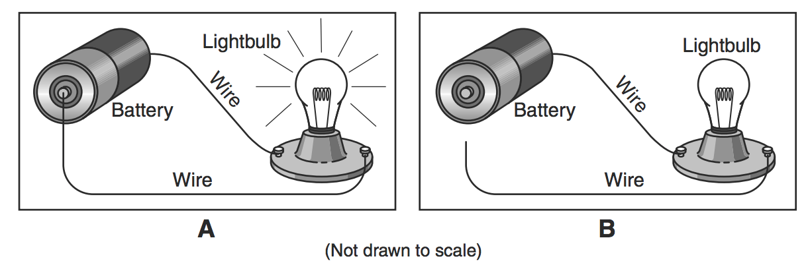

Explain why the light bulb is lit in circuit A, while the light bulb in circuit B is not lit. (2 marks)
____________________________________________________________________________________________________________________
____________________________________________________________________________________________________________________
47. The diagram shows the symbol for a substance.
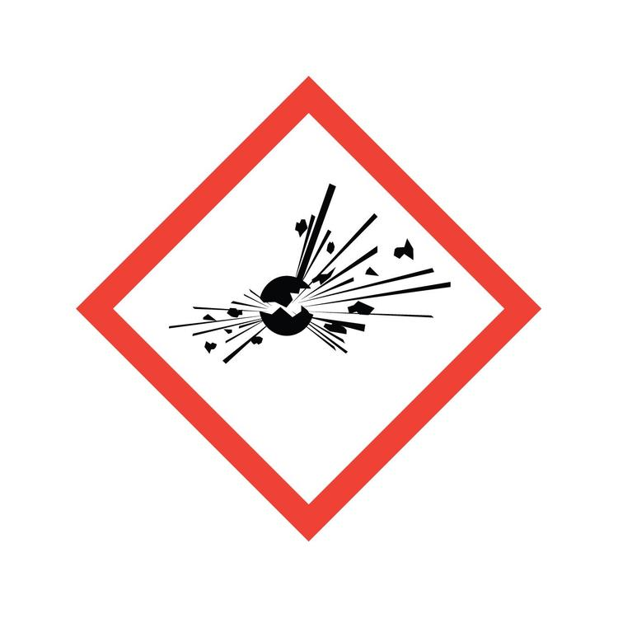

What does this symbol mean and why is it important to have such symbols in the laboratory? (2 marks)
____________________________________________________________________________________________________________________
____________________________________________________________________________________________________________________
48. State two ways to manage emotional changes during adolescence. (2 marks)
a. __________________________________________________________________________________________________________________
b. _________________________________________________________________________________________________________________
49. The diagram below shows a setup for separating a mixture of salt and water.
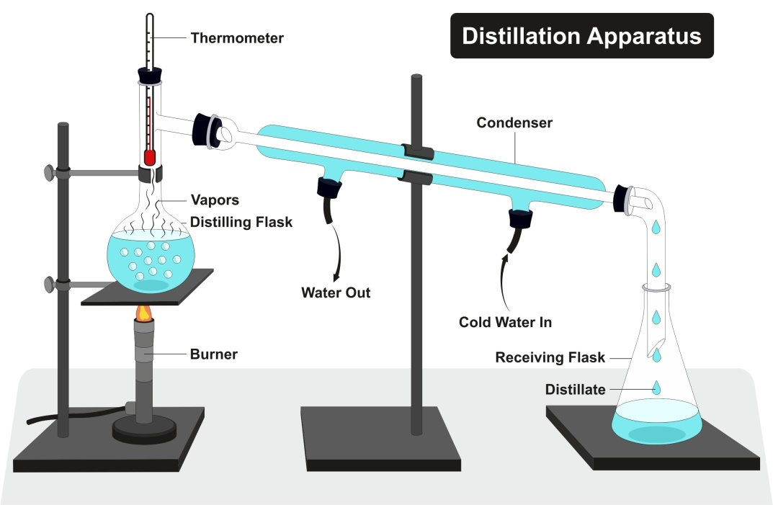
a) Name the method of separation shown in the diagram. (1 mark)
____________________________________________________________________________________________________________________
____________________________________________________________________________________________________________________
b) Name the process that occurs at the condenser. (1 mark)
____________________________________________________________________________________________________________________
____________________________________________________________________________________________________________________
50. Identify three common first aid procedures and for which situation each can be used. (3 marks)
a. _________________________________________________________________________________________________________________
b. _________________________________________________________________________________________________________________
c. _________________________________________________________________________________________________________________

This is the last printed page.

