KENYA JUNIOR SCHOOL EDUCATION ASSESSMENT (KJSEA)
GRADE 7: CREATIVE ARTS AND SPORTS (THEORY)
CODE: 011 YEAR: 2025 TIME: 2 HOURS
Candidate’s Name: ___________________________________. Assessment Number: _____________________.
School Name: ________________________________________. School Code: _______________________________.
Candidate’s Signature: ______________________________. Date: ________________________________________.

INSTRUCTIONS TO CANDIDATES
INSTRUCTIONS TO CANDIDATES:
- Write your name and assessment number in the spaces provided.
- Read each question carefully before answering.
- Attempt all questions.
- Do not open this paper until you are told to do so.

For Official Use Only:

SECTION B: (50 Marks)
PART | Task No. | Questions | Max Marks per Question | Total per Task | Candidate’s Score
Part I: Performing Arts | Task 1 | 1(a), 1(b) | 2, 4 | 6
 | Task 2 | 2(a), 2(b)  CREATIVE ARTS AND SPORTS | 2, 2 | 4
 | Task 3 | 3(a), 3(b), 3(c) | 2, 3, 1 | 6
 | Task 4 | 4 | 4 | 4
 | Task 5 | 5(a), 5(b) | 2, 2 | 4
Part I Subtotal |  |  |  | 20
Part II: Sports | Task 6 | 6(a), 6(b) | 3, 1 | 4
 | Task 7 | 7(a), 7(b) | 4, 2 | 6
 | Task 8 | 8(a), 8(b) | 3, 2 | 5
 | Task 9 | 9(a), 9(b), 9(c) | 2, 2, 1 | 5
Part II Subtotal |  |  |  | 20
Part III: Visual Arts | Task 10 | 10(a), 10(b) | 2, 3 | 5
 | Task 11 | 11(a), 11(b) | 2, 3 | 5
 | Task 12 | 12(a), 12(b) | 2, 2 | 4
 | Task 13 | 13(a), 13(b) | 3, 2 | 5
Part III Subtotal |  |  |  | 20
SECTION B TOTAL |  |  |  | 60
This paper consists of 12 printed pages. Candidates should check the question paper to ascertain that all the pages are printed as indicated and that no questions are missing.
© 2025 COMPETENCE KENYA ASSESSMENT COUNCIL Turn over

SECTION A: MULTIPLE CHOICE QUESTIONS (40 MARKS)

Choose the correct answer.
- Which of the following is a component of Creative Arts and Sports?
A. Agriculture B. Music
C. Science D. Geography
- The main purpose of Creative Arts is to:
A. Earn marks in exams
B. Encourage creativity and self-expression
C. Avoid playing games
D. Only watch others perform
- Which element of dance refers to the use of body space?
A. Time
B. Energy
C. Space
D. Rhythm
- The instrument shown below is called:
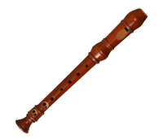
A. Trumpet
B. Recorder
C. Flute
D. Drum
- Which of the following is a Kenyan folk song?
A. Mwomboko
B. Twinkle Twinkle Little Star
C. Silent Night
D. National Anthem of France
- Rhythm in music refers to:
A. Highness and lowness of sound
B. Length of sounds and silences
C. How loud the music is
D. The meaning of words in a song
- Which is the correct grip when holding a javelin?
A. Over the shoulder grip
B. Pencil grip
C. Fork grip
D. Side grip
- The playing area for handball is called:
A. Court
B. Pitch
C. Track
D. Field
- In football, which position is responsible for preventing goals?
A. Striker
B. Midfielder
C. Goalkeeper
D. Defender
- Which of the following is NOT an indigenous Kenyan craft?
A. Beadwork
B. Pottery
C. Sculpture
D. Printing press

- The diagram below shows a craft item. Which is it?
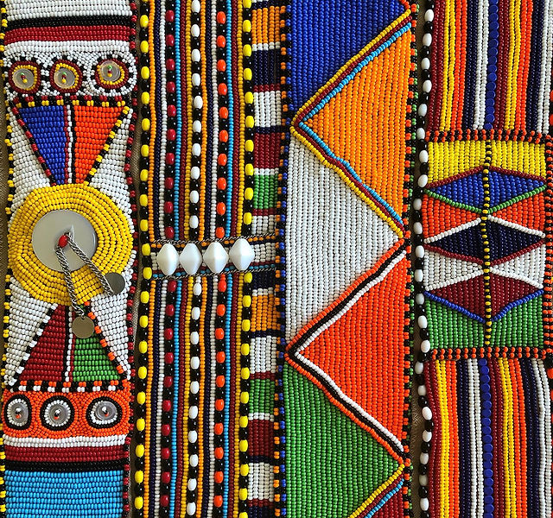
A. Basketry
B. Beadwork
C. Sculpture
D. Weaving
- Which swimming style is also called the “front crawl”?
A. Backstroke
B. Breaststroke
C. Butterfly
D. Freestyle
- The basic pass in handball is called:
A. Bounce pass
B. Overhead pass
C. Chest pass
D. Side pass
- Which of the following is a Kenyan indigenous game?
A. Chess
B. Ajua (mancala)
C. Table tennis
D. Basketball
- Sculpture is best described as:
A. Painting on paper
B. Making three-dimensional forms
C. Singing loudly
D. Drawing cartoons
- The length of a standard football pitch is about:
A. 20–40 m
B. 50–60 m
C. 90–120 m
D. 200–400 m
- Which of the following is NOT part of a melody?
A. Pitch
B. Duration
C. Timbre
D. Stone
- The rhythm notation below shows:

A. A rest only
B. Beats and rests
C. Pitch changes
D. A scale
- The arrow in the diagram below represents which sports event?
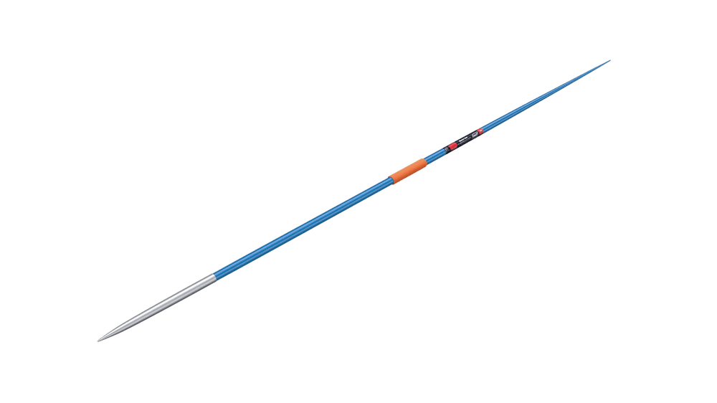
A. Shot put B. Discus throw
C. Javelin throw D. Long jump
- Which is a benefit of playing indigenous games?
A. Promotes laziness
B. Encourages teamwork and culture
C. Reduces friendship
D. Causes conflict
- Which tool is commonly used for drawing in Visual Arts?
A. Hoe B. Pencil
C. Whistle D. Football
- A storyboard in animation is used to:
A. Sing a song
B. Plan a story in pictures
C. Measure time in music
D. Kick a ball
- The football pitch is divided into two halves by:
A. Penalty box
B. Goal post
C. Center line
D. Touchline
- Which of the following is a percussion instrument?
A. Recorder
B. Drum
C. Violin
D. Guitar
- A melody that is smooth and flowing is described as:
A. Staccato
B. Legato
C. Crescendo
D. Allegro
- The person who leads singing in Kenyan folk songs is called:
A. Audience
B. Choir master
C. Soloist
D. Drummer
- Which indigenous material is often used in sculpture?
A. Plastic B. Soapstone
C. Aluminum foil D. Glass
- Which safety rule should athletes observe when throwing a javelin?
A. Run in any direction
B. Stand in front of the thrower
C. Only throw when the field is clear
D. Throw towards the crowd
- Which colour combination is common in Maasai beadwork?
A. Black, red, white, and blue
B. Pink, purple, and silver
C. Grey and brown only
D. Gold and silver
- In storytelling, the part that introduces characters is called:
A. Climax
B. Resolution
C. Introduction
D. Ending
- Which skill is used in handball to move past an opponent?
A. Dribbling
B. Passing
C. Shooting
D. Tackling
- Which Kenyan community is known for the “Isukuti” dance?
A. Kikuyu
B. Luhya
C. Luo
D. Maasai
- In swimming competitions, the official who starts the race is called:
A. Referee
B. Starter
C. Coach
D. Judge

- The diagram below shows a field marking. It is part of:
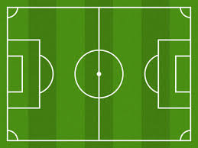
A. Netball court
B. Volleyball court
C. Football pitch
D. Tennis court
- Which artistic technique is used to make images look 3D?
A. Shading B. Colour mixing
C. Tracing D. Printing
- Which of the following is NOT a use of rhythm in music?
A. Organising beats
B. Controlling movement in dance
C. Making sound high or low
D. Giving a sense of time
- The stick used by swimmers during training for kicking is called:
A. Paddle
B. Kickboard
C. Flipper
D. Goggles
- Animation is important because it:
A. Tells stories using moving images
B. Is only for adults
C. Destroys creativity
D. Cannot be used in education
- Which Kenyan community is famous for clay pottery?
A. Turkana
B. Kamba
C. Maasai
D. Samburu
- One of the values learners gain from Creative Arts and Sports is:
A. Dishonesty B. Cooperation
C. Laziness D. Isolation

SECTION B: STRUCTURED QUESTIONS (60 MARKS)
Part I: Performing Arts (20 Marks)
- Look at the rhythm notation below:
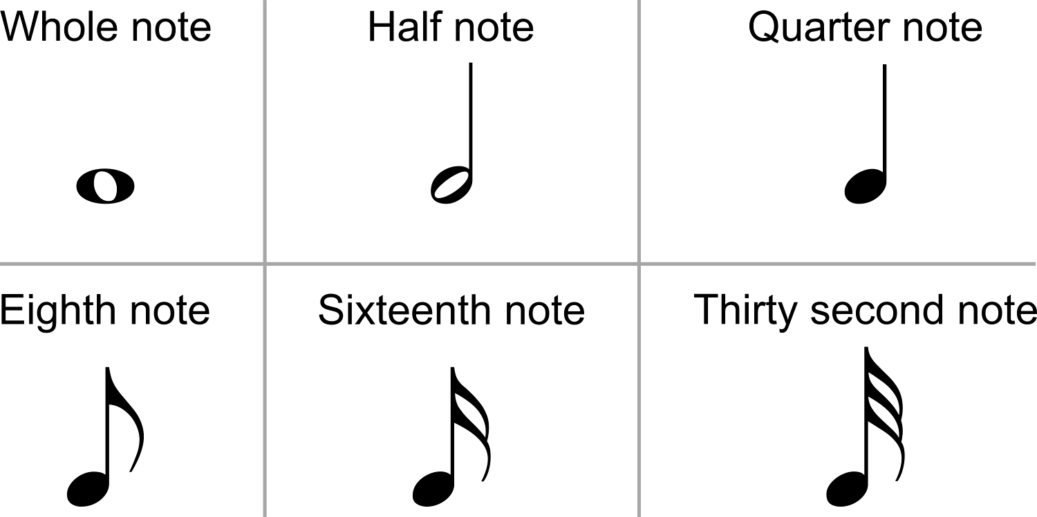
A B
a) Identify the symbols shown. (2 marks)
A: _______________________________________ B:________________________________________
b) Draw the rests of the following musical notes. (2 marks)
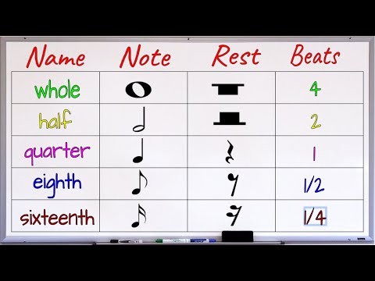
- ____________________________.

- ____________________________.
c) Explain why rhythm is important in dance. (2 marks)
_________________________________________________________________________________________________________
__________________________________________________________________________________________________________
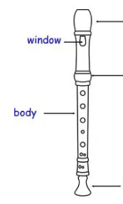
- The diagram below shows a descant recorder:
A

B

C
a) Name the parts of the recorder labelled A and B. (2 marks)
A:___________________________________________________
B:___________________________________________________
b) State two ways of caring for a recorder. (2 marks)
____________________________________________________________________________________________________________
____________________________________________________________________________________________________________
- Kenyan folk songs are often performed during ceremonies.
a) Mention one ceremony where folk songs are sung. (1 mark)
___________________________________________________________________________
b) State two characteristics of Kenyan folk songs. (2 marks)
______________________________________________________________________________________________________________.
______________________________________________________________________________________________________________.
c) Explain one way folk songs preserve culture. (2 marks)
____________________________________________________________________________________________________________.
____________________________________________________________________________________________________________.
- In storytelling:
a) State two qualities of a good storyteller. (2 marks)
___________________________________________________________________________________________________________.
___________________________________________________________________________________________________________,
b) Explain why voice projection is important. (2 marks)
___________________________________________________________________________________________________________
___________________________________________________________________________________________________________
c) Grade 7 learners performed the activity below during a function in their school. List three elements of the activity they were performing. (3 marks)
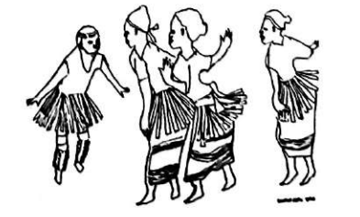
___________________________________________________________________________________________________________
___________________________________________________________________________________________________________
___________________________________________________________________________________________________________

Part II: Sports (20 Marks)
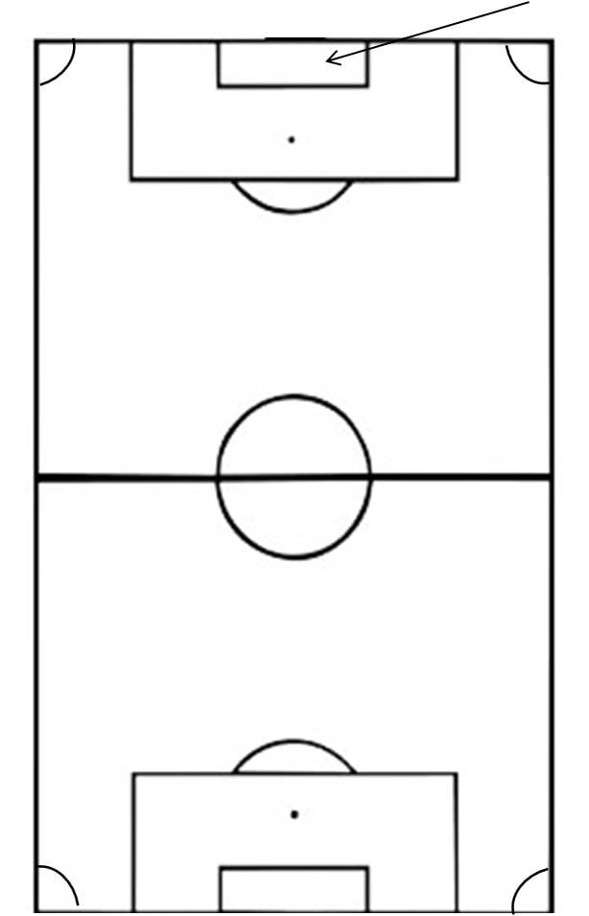
- Study the football pitch diagram below:
X

Y

- Identify the parts labelled X and Y (2 marks)
X:_________________________________________________________
Y:_________________________________________________________
b) State the main role of a defender. (2 marks)
_________________________________________________________________________________________________________
_________________________________________________________________________________________________________
c) Explain why teamwork is important in football. (1 mark)
_______________________________________________________________________________________________________
d) Which skill used in the game of football has been illustrated below.
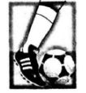

- The diagram below shows a javelin thrower.
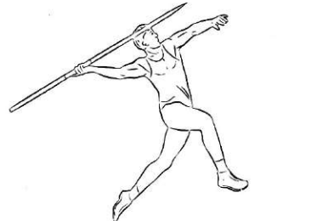
a) Identify the type of event shown. (1 mark)
_________________________________________________________________________________
b) State two safety precautions to take when throwing a javelin. (2 marks)
_________________________________________________________________________________________________________.
_________________________________________________________________________________________________________.
c) Name two skills required for successful javelin throw. (2 marks)
_________________________________________________________________________________________________________.
_________________________________________________________________________________________________________.
- Handball is a common sport in schools.
a) Mention two types of passes used in handball. (2 marks)
_________________________________________________________________________________________________________.
_________________________________________________________________________________________________________.
b) Explain one importance of speed in handball. (2 marks)
_________________________________________________________________________________________________________.
_________________________________________________________________________________________________________.
c) State one difference between handball and football. (2 marks)
_________________________________________________________________________________________________________.
_________________________________________________________________________________________________________.

- Name one indigenous Kenyan game you know. (1 mark)
a) Explain one rule of that game. (2 marks)
_________________________________________________________________________________________________________.
_________________________________________________________________________________________________________.
- State one value learners gain by playing indigenous games. (2 marks)
_________________________________________________________________________________________________________.
_________________________________________________________________________________________________________.
Part III: Visual Arts (20 Marks)
- Lipton was demonstrating how to design a necklace in beadwork as shown below.
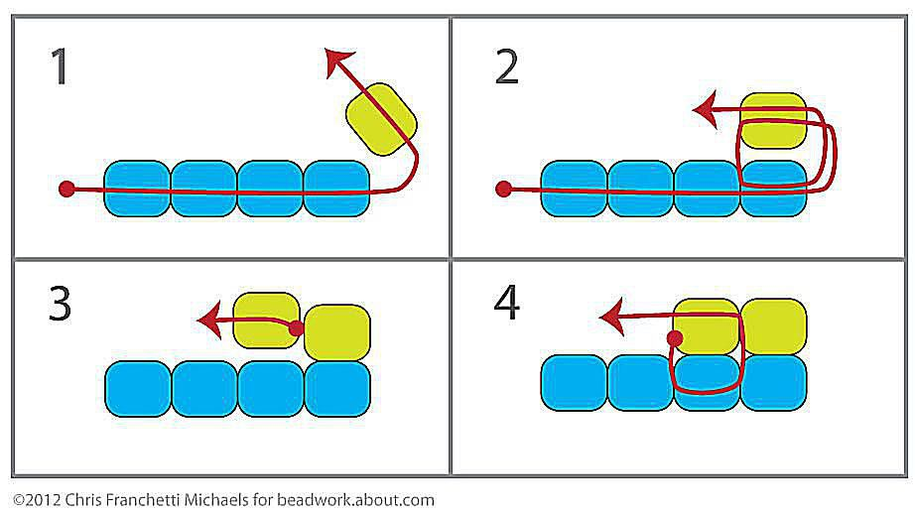
a) Name two materials used in making beadwork. (2 marks)
_________________________________________________________________________________________________________.
_________________________________________________________________________________________________________.
b) State one importance of beadwork in Kenyan culture. (2 marks)
_________________________________________________________________________________________________________.
c) Suggest one modern use of beadwork today. (2 marks)
_________________________________________________________________________________________________________.
- Sculpture is a common art in Kenya.
a) Mention two materials used in making sculptures. (2 marks)
_________________________________________________________________________________________________________.
_________________________________________________________________________________________________________.

- State one difference between sculpture and drawing. (2 marks)
_________________________________________________________________________________________________________.
_________________________________________________________________________________________________________.
c) Draw a simple sculpture of a pot. (2 marks)

- Painting is one form of visual arts.
a) Name two tools used in painting. (2 marks)
_________________________________________________________________________________________________________.
_________________________________________________________________________________________________________.
b) State one way shading improves a drawing. (2 marks)
_________________________________________________________________________________________________________.
_________________________________________________________________________________________________________.
- Explain why drawing is important in communication. (2 marks)
_________________________________________________________________________________________________________.
_________________________________________________________________________________________________________.

This is the last printed page.

