KENYA JUNIOR SCHOOL EDUCATION ASSESSMENT (KJSEA)
GRADE 7: AGRICULTURE AND NUTRITION (THEORY)
CODE: 010 YEAR: 2025 TIME: 2 HOURS
Candidate’s Name: ___________________________________. Assessment Number: _____________________.
School Name: ________________________________________. School Code: _______________________________.
Candidate’s Signature: ______________________________. Date: ________________________________________.


INSTRUCTIONS TO CANDIDATES:
Instructions to Candidates:
AGRICULTURE AND NUTRITION

- Write your name and assessment number in the spaces provided.
- Answer ALL questions in Section A and Section B.
- All answers must be written in the spaces provided in this question booklet.
- This paper consists of 12 printed pages.
Candidates should check the question paper to ascertain that all pages are printed as
indicated and that no questions are missing.
- Candidates should answer the questions in English.

For Official Use Only

SECTION A: MULTIPLE CHOICE QUESTIONS (30 Marks)
Question Number | 1 | 2 |  | 3 | 4 |  | 5 | 6 | 7 |  | 8 | 9 | 10 | 11 | 12 | 13 | 14 | 15
Maximum Score | 1 | 1 |  | 1 | 1 |  | 1 | 1 | 1 |  | 1 | 1 | 1 | 1 | 1 | 1 | 1 | 1
Candidate’s Score
Question Number | 16 |  | 17 |  |  | 18 |  | 19 |  | 20 |  | 21 | 22 | 23 | 24 | 25 | 26 | 27 | 28 | 29 | 30 | Total score
Maximum Score | 1 |  | 1 |  |  | 1 |  | 1 |  | 1 |  | 1 | 1 | 1 | 1 | 1 | 1 | 1 | 1 | 1 | 1 | 30
Candidate’s Score

SECTION B: STRUCTURED QUESTIONS. (50 Marks)
Task | Task 1: Agriculture |  |  |  | Task 2: Nutrition
Question Number | 31 | 32 | 33 | 34 | 35 | 36 | 37 | 38
Maximum Score | 2 | 4 | 3 | 5 | 9 | 3 | 4 | 3
Candidate’s Score
Maximum task score | 23 |  |  |  | 27
Candidate’s task score
© 2025 COMPETENCE KENYA ASSESSMENT COUNCIL Turn over

SECTION A: MULTIPLE CHOICE QUESTIONS (30 MARKS)

Choose the best answer for each question.
- During a school clean-up, pupils found many plastic bottles thrown in the farm. This is an example of:
A. Mulching
B. Soil pollution
C. Crop rotation
D. Manure application
- At home, Mercy noticed old plastic containers piling up in the backyard. The best way to avoid soil pollution is:
A. Burning them in the farm
B. Recycling or reusing them
C. Digging them into the soil
D. Spraying pesticides on them
- A farmer in Elgeyo Marakwet has built the structure below on his sloping land to control soil erosion.
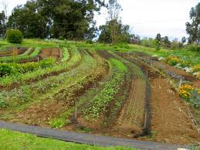
The structure is a:
A. Contour bund B. Farm pond
C. Terrace D. Dam
- A mother boiled vegetables for 30 minutes and poured away the soup water. This led to loss of:
A. Food nutrients
B. Smoke
C. Colour only
D. Taste only
- In a school compound, pupils planted trees. One major benefit of this practice is:
A. To waste land
B. To encourage soil erosion
C. To provide shade and conserve the environment
D. To block air circulation
- A farmer ploughed his land before planting maize. This activity is called:
A. Harvesting
B. Weeding
C. Land preparation
D. Storage
- John removed weeds from his bean garden as shown below.
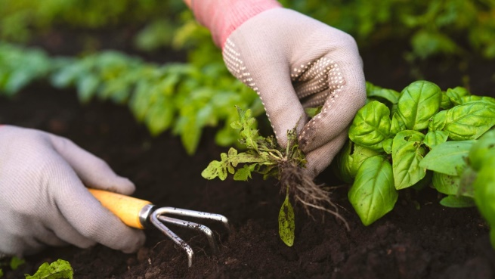
The activity is:
A. Pruning
B. Weeding
C. Harvesting
D. Thinning
- Wanjiku visited her grandfather who keeps bees. She saw him harvesting:
A. Honey
B. Milk
C. Wool
D. Eggs
- A poultry farmer wants to sell eggs to a hotel. Before selling, she should:
A. Wash them with soap
B. Store them in dusty areas
C. Grade them according to size
D. Boil them for long hours
- When preparing vegetables for supper, Peter’s mother used a lid and steamed them lightly. This method helped in:
A. Preserving nutrients B. Losing vitamins
C. Wasting fuel D. Making food tasteless
- A boy cleans the cow shed daily. This practice helps to:
A. Make animals lazy
B. Prevent spread of diseases
C. Increase weeds in the farm
D. Make water dirty
- Sarah washed her red dress together with her white blouse. The blouse changed colour because she ignored the rule of:
A. Washing coloured clothes separately
B. Mixing soap powders
C. Using bleach
D. Using soft water
- During a knitting lesson, pupils were asked to bring the tool used to form stitches. The tool is:
A. Knife
B. Hook/needles
C. Hoe
D. Spoon
- The stitch shown below is common when knitting sweaters:
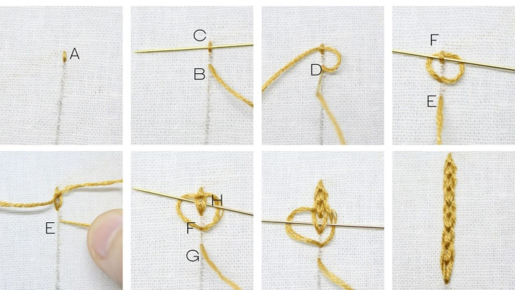
It is called:
A. Stocking stitch
B. Chain stitch
C. Garter stitch
D. Rib stitch
- A family in Nairobi with little land built the garden below to grow sukuma wiki.
This garden is useful because:
A. It wastes space
B. It improves food production in small areas
C. It increases soil pollution
D. It discourages crop production
- Jane harvested tomatoes and processed them into tomato sauce before selling. This practice helped her to:
A. Reduce market value
B. Increase shelf life and income
C. Reduce food safety
D. Attract pests
- During a home science lesson, pupils made soap. Which of the following was an ingredient?
A. Cooking oil
B. Fertilizer
C. Sawdust
D. Salt solution
- A farmer in Kitui dug a structure to collect rainwater for irrigation. The structure is a:
A. Sack garden
B. Pond
C. Animal shed
D. Charcoal burner
- After planting sukuma wiki, Achieng covered the soil with dry grass. This practice is called:
A. Mulching
B. Topdressing
C. Harvesting
D. Storage
- At home, yesterday’s ugali was kept covered in the fridge and later reheated. This is a safe way of handling:
A. Raw food
B. Leftover food
C. Waste food
D. Pet food
- A boy reared a cow, a hen, and a goat. These are examples of:
A. Domestic animals
B. Wild animals
C. Carnivores
D. Insects
- Mary had a cough. Her grandmother gave her honey. This worked because honey is used for:
A. Sweetening food
B. Suppressing cough
C. Making timber
D. Storing maize
- A cook prepared rice using only the amount of water needed and covered the sufuria. This helped to:
A. Preserve nutrients
B. Throw away nutrients
C. Waste energy
D. Spoil the food
- Which of the following animals is commonly kept for eggs in Kenya?
A. Ducks B. Bees C. Hens D. Goats
- A farmer in Murang’a built earth ridges across his land to reduce runoff. These ridges are called:
A. Contour bunds
B. Wire fence
C. Cowshed
D. Store
- During cookery, a student placed all pan handles facing inwards to avoid accidents. This is an example of:
A. Carelessness
B. Kitchen safety practice
C. Animal hygiene
D. Soil conservation
- A tailor wanted to knit a warm sweater. The most suitable fibre material was:
A. Sisal
B. Cotton
C. Wool
D. Silk
- At the market, farmers sold tea to earn money. Tea is an example of:
A. Food crop
B. Cash crop
C. Staple crop
D. Wild crop
- A teacher showed pupils a wooden structure used to grow vegetables above the ground. This is an example of:
A. Framed suspended garden
B. Soil erosion trap
C. Greenhouse
D. Store
- When washing clothes, a mother sorted them, washed, dried, and stored. This is the correct sequence of:
A. Laundry work
B. Cooking food
C. Soil conservation
D. Harvesting

SECTION B: STRUCTURED QUESTIONS (50 MARKS)
Part A: Agriculture (25 marks)
- During a class debate, pupils discussed soil pollution.
(a) List three causes of soil pollution. (3 marks)
__________________________________________________________________________________________________________
__________________________________________________________________________________________________________
__________________________________________________________________________________________________________
(b) State two methods of controlling soil pollution. (2 marks)
__________________________________________________________________________________________________________
__________________________________________________________________________________________________________
- A farmer dug the structure below to trap rainwater.

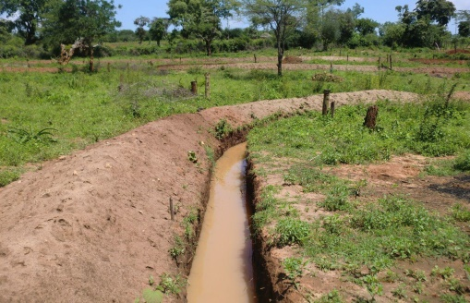
- Name the structure. (1 mark)
__________________________________________________________________________________________________________

(b) State two uses of the structure. (2 marks)
__________________________________________________________________________________________________________
__________________________________________________________________________________________________________
- In your school farm, pupils prepared a plot for planting maize.
(a) State two activities done before planting seeds. (2 marks)
__________________________________________________________________________________________________________
__________________________________________________________________________________________________________
(b) Give two crop management practices done after germination. (2 marks)
__________________________________________________________________________________________________________
__________________________________________________________________________________________________________
- A farmer covered his garden with dry grass as shown below:
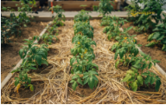
- Name the practice. (1 mark)
__________________________________________________________________________________________________________
(b) State two advantages of this practice. (2 marks)
__________________________________________________________________________________________________________
__________________________________________________________________________________________________________
- Jane’s father keeps bees. Last week, they harvested honey.
(a) Outline three steps in preparing honey for sale. (3 marks)
__________________________________________________________________________________________________________
__________________________________________________________________________________________________________
__________________________________________________________________________________________________________
- Mention two by-products of beekeeping apart from honey. (2 marks)
__________________________________________________________________________________________________________
__________________________________________________________________________________________________________
- A family rears cows, goats, and chickens.
(a) Give three hygienic practices when rearing animals. (3 marks)
__________________________________________________________________________________________________________
__________________________________________________________________________________________________________
__________________________________________________________________________________________________________
(b) Explain two reasons why hygiene is important in animal rearing. (2 marks)
__________________________________________________________________________________________________________
__________________________________________________________________________________________________________
Part B: Nutrition (25 marks)
- During supper, Susan’s family prepared vegetables.
(a) Explain two practices that conserve nutrients when cooking vegetables. (2 marks)
__________________________________________________________________________________________________________
__________________________________________________________________________________________________________
- Give two disadvantages of overcooking food. (2 marks)
__________________________________________________________________________________________________________
__________________________________________________________________________________________________________
- In your school, the environment club planted trees.
(a) Give three benefits of growing trees in schools. (3 marks)
__________________________________________________________________________________________________________
__________________________________________________________________________________________________________
(b) Mention two challenges of tree planting. (2 marks)
__________________________________________________________________________________________________________
__________________________________________________________________________________________________________
- Mary washed her new red blouse with a white handkerchief. The handkerchief turned pink.
(a) Why should loose coloured clothes be washed separately? (2 marks)
__________________________________________________________________________________________________________
__________________________________________________________________________________________________________
(b) State the correct order of laundry work. (3 marks)
__________________________________________________________________________________________________________
_____________________________________________________________________________________________________________
_____________________________________________________________________________________________________________
- During a knitting lesson, pupils practiced making sweaters.
a) name the type of stitch below
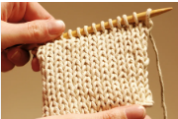
____________________________________________________

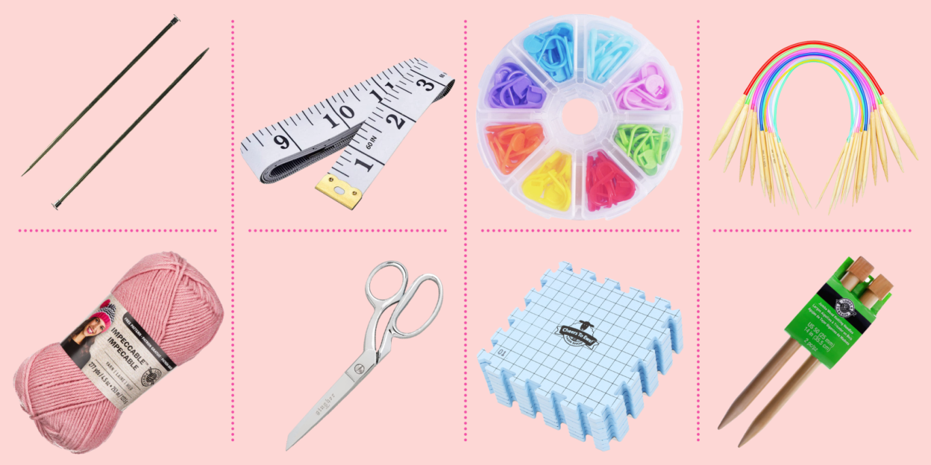
C) Identify the knitting tools below (3 marks)

A B C D
A: ________________________________________________________
B: ________________________________________________________
C:________________________________________________________
D:________________________________________________________
- Farmers are encouraged to add value to their crops.
(a) What is meant by adding value to crop produce? (2 marks)
__________________________________________________________________________________________________________
__________________________________________________________________________________________________________
- Give three examples of value addition to crops in Kenya. (3 marks)

__________________________________________________________________________________________________________
__________________________________________________________________________________________________________
__________________________________________________________________________________________________________
- During a home science club meeting, pupils made homemade soap.
(a) List three materials needed in making homemade soap. (3 marks)
__________________________________________________________________________________________________________
__________________________________________________________________________________________________________
__________________________________________________________________________________________________________
(b) State two safety precautions when making soap. (2 marks)
__________________________________________________________________________________________________________
__________________________________________________________________________________________________________
This is the last printed page.

