COMPETENCE-BASED CURRICULUM

SOCIAL STUDIES RE - GRADE 6

TERM 3 ASSESSMENTS 2025
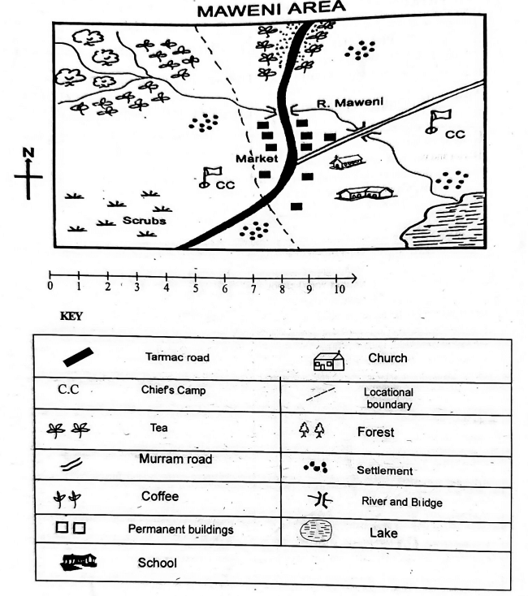

- The land in Maweni area slopes from
  - North to West
  - West to South
  - North West to South East
  - South East to North.
- Which type of climate is experienced in the Northern part of Maweni area?
  - Hot and dry.
  - Wet and cool.
  - Cool and wet.
  - Hot and wet.
- The main means of transport in Maweni area is
  - road
  - air
  - water
  - pack animals.
- The following shows that Maweni area is developed except the presence of
  - farms
  - factories
  - roads!
  - markets
- Maweni area is likely to be headed by a
  - Chief
  - Governor
  - County commissioner
  - Member of County Assembly.
- Which of the following is an indigenous beef cattle?
  - Zebu
  - Fresian
  - Jersey
  - Ayrshire.
- Which of the following is a characteristic of large-scale farming?
  - Use of simple tools.
  - Crops are grown for home use.
  - Large tracks of land are cultivated.
  - Use of family labour.
- Grade 6 learners wanted to practice fishing. Which main inland fishing ground in Kenya can they visit?
  - Lake Turkana
  - Lake Victoria
  - River Tana
- Which language group in Eastern Africa has the least number of people?
  - Bantu
  - Cushites
  - Semites
  - Nilotes
- A tourist visited our country and saw writings on a banner at the airport about a citizen. Who is a citizen? A
  - family member
  - person who owns property
  - person who runs from his/her country
  - person who belongs to a particular country.
- During a group discussion, Grade 6 pupils listed the following examples of plains. Which answer did they give wrong?
  - Lotikipi
  - Nyambene
  - Bilesha
  - Kano.
- Which of the following is not an element of weather?
  - Temperature
  - Sunshine
  - Cloud cover
  - Rain
- Kibwana school has different leaders. Grade 6 learners asked their teacher to help them identify sections of leadership in the school. Which section of leadership is top in the structure in a school?
  - Head teacher
  - Deputy head teacher
  - Board of management
  - Parents.
- The figure below shows a land forming process.
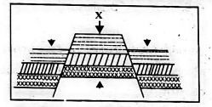
The force marked X is
  - compression force
  - upthrust force
  - tension force
  - inertia.
- Which one of the following is not a block mountain?
  - Aberdares Mountain
  - Mt. Pare
  - Mt. Ruwenzori
  - Mt. Kenya

PART C: RELIGIOUS EDUCATION
PART 1: Choose a section you have prepared for. Each section has 15 marks
CHRISTIAN RELIGIOUS EDUCATION
- Who among the following people worked for 14 years in order to get the girl he loved?
  - John
  - Job
  - David
  - Jacob.
- Jesus promised to send His disciples a helper whom he sent on the day of Pentecost. On that day, many people were filled with
  - tongues
  - fire
  - holy spirit
  - life.
- In the parable of the good Samaritan, the man who fell into the hands of robbers was going to
  - Jericho
  - Bethany
  - Jerusalem
  - Samaria.
- Which one of the following is not part of God's creation?
  - Water
  - Soil
  - Car
  - Man
- During the baptism of Jesus, the Holy Spirit came down in form of a
  - pigeon
  - dove
  - duck
  - raven.
- During break time, you find your best friend opening your bag without your permission. What is the best action to take?
  - Report to the teacher.
  - Forgive him and tell him to ask for anything he wants.
  - Discuss the act with your friends.
  - Stop your friendship.
- The following are reasons why Christians read the Bible. Which one is not? To
  - strengthen relation hip with God
  - get guidance on various issues
  - strengthen faith in God
  - pass exams.
- Sharing work and resources promotes all the following except
  - love
  - unity
  - peace
  - hatred.
- Which of the following parables reminds christians never to give up in life? The parable of
  - the friend at midnight
  - Pharisee and the tax collector
  - the three servants
  - the lost coin.
- On the way from School, Ali saw two boys fighting. What should he do?
  - Stop them.
  - Report them
  - Reconcile them
  - Run away.
- When the first humans disobeyed God, they
  - were rewarded
  - were chased from the Garden of Eden
  - reconciled with God
  - died.
- When Moses was taking care of the flock, he saw a burning bush. When he went near it,
  - he was burned
  - a voice told him to take off his shoes
  - his stick changed to a snake
  - one of the sheep disappeared.
- The Bible is divided into the Old and the New Testament. How many books does the Old Testament have?
  - 66
  - 27
  - 39
  - 47
- When Jonah was sent to Nineveh by God, he disobeyed. What did he do?
  - He was swallowed by a big fish.
  - He escaped to another place.
  - God left him alone.
  - He stayed at home and did nothing.
- Which of the following books of the Bible is a prophetic book?
  - Isaiah
  - Mathew
  - Genesis
  - 1st kings.
PART 2: ISLAMIC RELIGIOUS EDUCATION 3
- Which one of the following surahs of the holy Qur'an clearly explains the events of the day of judgement?
  - Maun
  - Nasr
  - Zilzala
  - Dhuha
- Grade 5 learners were discussing about the first revelation. Which one of the following surahs did they identify as the first to be revealed?
  - Fatiha
  - Nas
  - Falaq
  - Alaq
- When the prophet lost one of his sons, the Quraish mocked him saying that he had been cut off. Which surah did Allah reveal to console him?
  - Asr
  - Kawthar
  - Nasr
  - Tiyn.
- How old was the prophet when he lost his mother?
  - 6 years
  - 8 years
  - 10 years
  - 40 years
- Which one of the following brings love among the Muslims according to the hadith of the prophet (S.A. W)?
  - Fasting
  - Swalah
  - Hajj.
  - Greetings
- Muslims are allowed to take Tayammam when
  - water is not available
  - water is very cold
  - one has to buy water
  - there is a lot of sand and dust around.
- Which one of the following statements is true about the angels of Allah? They
  - received books
  - preached Islam
  - advice Allah
  - obeyed the command of Allah,
- Angels are created from
  - nar
  - clay
  - nur
  - water...
- When Hussein was on his way back home, he saw some Muslims who were standing throughout their prayer. Which prayer were they performing?
  - Eid
  - Jum'aa
  - Janaza
  - Dhuhr.
- The first muadhin was called by
  - Umar
  - Bilal
  - Abubakar
  - Ali.
- A prophet of Allah was thrown in fire to burn off but Allah (S.W) ordered fire, "Be cool and safe on my servant'. This was Prophet
  - Nuh (A.S)
  - Yusuf (A.S)
  - Musa (A.S)
  - Ibrahim (A.S).
- How many brothers did Prophet Yusuf (A.S) have?
  - 11
  - 10
  - 12
  - 13
- What are Hadith?
  - Stories of Prophets.
  - Sayings of Swahabas.
  - The history of Islam.
  - Sayings of the Prophet.
- In the hadith of the prophet, we learn that Allah (S.W) judges people basing on their
  - actions
  - appearance
  - wealth
  - race.
- What did Allah promise those men who wear women clothes and women who wear the male clothing according to Hadith?
  - Reward
  - Punishment
  - Curse
  - Confusion.

MARKING SCHEME
SOCIAL STUDIES
- C
- C
- A
- B
- C
- A
- C
- B
- C
- D
- B
- D
- C
- B
- D
C.R.E
- D
- C
- A
- C
- B
- B
- D
- D
- A
- C
- B
- B
- C
- B
- A
I.R.E
- C
- D
- B
- A
- C
- A
- D
- C
- C
- B
- D
- A
- D
- A
- B

