COMPETENCE-BASED CURRICULUM

INTEGRATED SCIENCE - GRADE 6

TERM 3 ASSESSMENTS 2025
SCIENCE AND TECHNOLOGY
- Zawadi and Nuru were playing on a seesaw at home. Nuru tried to lift Zawadi as shown below.
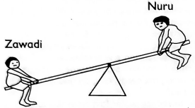
From the illustration, it is true that;
  - Both Nuru and Zawadi act as the pivot.
  - Nuru acts as the load.
  - Nuru acts as the effort.
  - Zawadi acts as the fulcrum.
- Which of the following is not a way of reducing air pollution in the environment?
  - Sprinkling water on earthen floors before sweeping.
  - Sprinkling water on dusty grounds.
  - Fixing chimneys on the kitchen.
  - Fixing sewage pipes that are leaking.
- Grade 6 learners performed an experiment as shown below.
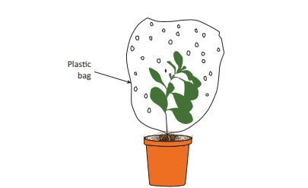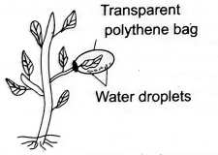
From the experiment, the learners concluded that;
  - leaves help in photosynthesis.
  - leaves help in transpiration.
  - leaves help in respiration.
  - leaves help in transportation of minerals.
- Kamwana was asked to name the blood component that transports dissolved components around the body. Which answer was he likely to give?
  - white blood cells
  - plasma
  - platelets
  - red blood cells
Mwanzia downloaded the following picture and displayed it during a science and technology lesson. Use it to answer question 5-7.
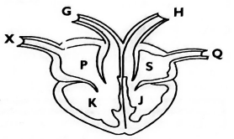
- Blood is pumped to all parts of the body organs by the contraction of the part labeled ______________________.
  - J
  - s
  - P
  - K
- Deoxygenated blood is received into the heart through the part labeled _____________________.
  - X
  - Q
  - H
  - G
- Blood is pumped through all the parts of the body through the part labeled;
  - G
  - X
  - Q
  - H
- Grade 4 learners discovered that an egg sinks in fresh water. The same egg floated on salty water as shown below.
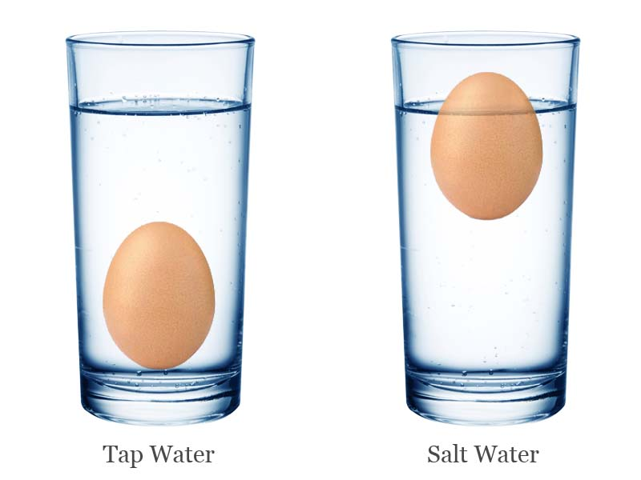
Which factor that affects floating and sinking were they investigating?
  - material
  - shape
  - density
  - weight
- Grade 6 learners from a certain academy were asked to mention what they had learnt about snails and slugs. They gave their answers as shown below. Who gave the wrong answer?
  - They have a wet skin and no bones.
  - They have a pair of antennae.
  - Those that live on land breathe through lungs.
  - Their bodies are not segmented.
- Which of the following statements is true?
  - Blood group A can receive blood from group O and B.
  - Blood group B can receive blood from group A and B.
  - Blood group AB can receive blood from any of the groups.
  - Blood group O can receive blood from group A, B and AB.
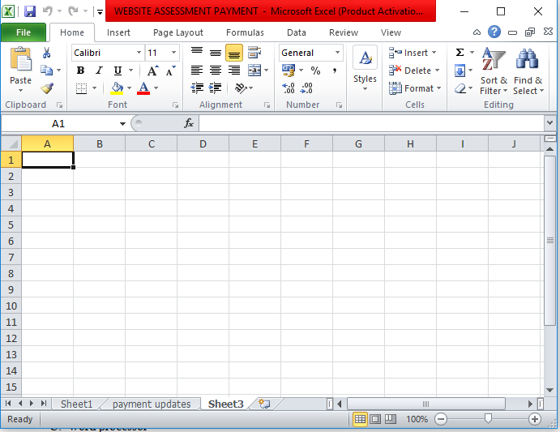
- The diagram below shows a ___________________________.

  - spreadsheet
  - power point
  - word processor
  - graphics software
- Which of the following is not part of deciduous teeth?
  - premolars
  - molars
  - canines
  - incisors
- Kimani observed the following phase of the moon in the sky.
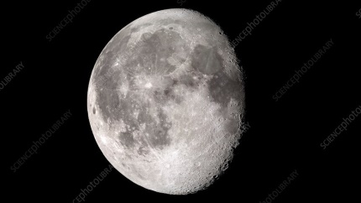
What is the name given to the phase of the moon?
  - Waxing gibbous moon
  - Waxing crescent moon
  - Waning crescent moon
  - Waning gibbous moon
- Tunu put water in a basin and kept it outside in the sun. After an hour, the water was very warm. She used it for bathing. How did the heat from the sun reach the water in the basin?
  - By radiation
  - By convection
  - By conduction
  - By hydrolysis
- Digestion of proteins takes place in the ______________________.
  - mouth
  - duodenum
  - stomach
  - colon
AGRICULTURE AND NUTRITION
- Mwahangila noticed that seedlings on his nursery bed were congested. Which practice would you advise him to carry out?
  - pruning
  - thinning
  - shading
  - weeding
- When preparing a vegetable nursery bed, grade 5 learners placed some mulch after planting the seeds. Why do you think they did so?
  - To reduce water loss from the soil, to keep the seeds and the soil from being eroded.
  - To reduce water loss from the soil, to keep the seedlings from drying.
  - To increase the fertility of the soil, to prevent soil erosion.
  - To increase the rate of growth of the seeds, to keep the seedlings from drying.
- Re-using plastic containers for innovative gardening helps in;
  - conserving water.
  - conserving the environment.
  - increasing water sources.
  - increasing crop yields.
- Which of the following practices enables the seedling to grow straight in the nursery?
  - Removing mulches.
  - Reducing the number of watering times.
  - Removing the shade.
  - Uprooting unwanted plants.
- The following are indigenous root crops except;
  - Irish potatoes
  - Cassava
  - Arrowroots
  - Yams
- Grade 5 learners from Little Angels Academy made a sack garden during an Agriculture lesson. They were guided by their teacher to arrange some stones in the middle of the sack. Why were the stones put in the middle of the sack?
  - To enable water to drain from the sack.
  - To allow water to flow to the lower level of the sack.
  - To make the sack to be very firm.
  - For the sack not to grow old easily.
- Which of the following statements is not true about innovative gardening?
  - It can be practiced both horizontally and vertically.
  - It requires large farms for it to be effective.
  - It enables families to have food at all times.
  - It can be done at home.
- Which of the following domestic animals have the same use?
  - donkey and cow
  - sheep and cat
  - dog and camel
  - camel and horse
- Fixing gutters on the roof of houses can help ____________________ in controlling erosion.
  - sheet
  - rill
  - splash
  - gulley
- Training climbing fruit plants involves;
  - allowing them to grow in a particular direction.
  - allowing them to grow in a particular speed.
  - allowing them to grow at a specific time.
  - allowing them to grow on a selected garden.
- Which of the following statements is true about the soil with particles of medium size?
  - It retains the highest amount of water.
  - It retains the least amount of water.
  - Most crops can be grown on it.
  - It supports farming of rice.
- The practice of planting crops to cover soil so that little water evaporates is called
  - intercropping
  - covercropping
  - mulching
  - shading.
- The following are ways of conserving water in farming. Which one is not?
  - using sunken beds
  - mulching
  - shading
  - practicing irrigation
- What is the meaning of organic gardening?
  - growing crops without use of soil
  - growing crops without use agro-chemicals
  - growing crops using vertical or horizontal containers
  - growing crops that do not have strong stems
- Amina has a bull that she bought after selling surplus maize from her farm. The bull cannot be used;
  - as a pet.
  - to plough on the farm.
  - to provide meat.
  - as a source of income.
- Grade 6 learners were asked to name a method that would be used to preserve meat only for a short period. Which of the following answers were they likely to mention?
  - Sun drying
  - Smoking
  - Salting
  - Refrigeration
- Which of the following houses is common in cities?
  - Bungalows
  - Flats
  - Maisonette
  - Storeyed house
- Halima went to buy food from a general grocery. Which of the following should she consider first?
  - The type of material the packaging is made of.
  - The weight of the item that has been packaged.
  - The price of the item that has been packaged.
  - The date of expiry written on the package.
- Grade 4 learners were asked to name the fuels that can only be used to cook and provide light. It is likely that the fuels are:
  - Charcoal and firewood
  - Electricity and firewood
  - Paraffin and gas
  - Gas and charcoal
- At lunch time, Oxanna ate Ugali, sukumawiki and an orange. What else should she eat to make her diet balanced?
  - An egg
  - A ripe banana
  - A cooked banana
  - Watermelon
- Identify the type of house that is described below.
  - It is oblong in shape.
  - It uses poles, sticks, grass leaves which are smeared with a plaster of cow dung and mud on both walls and roof.
  - It has small openings for ventilation.
    - Kikuyu hut
    - Manyatta hut
    - Borana hut
    - Luo hut
- Which of the following is an advantage of charcoal jiko over a gas cooker?
  - It can be used anywhere.
  - It is a bit cheap.
  - It can be used in doors and outdoors.
  - It cooks faster.
- Awino was asked by her mother to prepare food for her sick father. Which of the following is the main factor to consider as she goes to buy the food?
  - Fuel needed for cooking.
  - Dietary needs.
  - Availability of the food.
  - Time to be used to prepare the food.
- Which of the following types of food cannot be stewed?
  - Beans
  - Spinach
  - Green bananas
  - Poultry
- When we eat foods rich in calcium like milk and yoghurt, we are not likely to suffer from;
  - goiter
  - scurvy
  - anaemia
  - rickets

MARKING SCHEME
- C
- D
- B
- B
- A
- A
- D
- C
- D
- C
- A
- B
- D
- A
- C
- B
- A
- B
- A
- A
- B
- B
- D
- C
- A
- C
- B
- D
- B
- A
- C
- B
- D
- C
- A
- B
- B
- B
- B
- D

