COMPETENCE BASED CURRICULUM
KENYA PRIMARY SCHOOL EDUCATION ASSESSMENT
GRADE 5

SOCIAL STUDIES ACTIVITIES

Learner’s name:...............................................................................................

School’s Name: .................................................................................................

Assessment No...................................... Date: ...............................................

INSTRUCTIONS TO LEARNER

- Answer ALL the questions in the spaces provided.

Time: 1 hour 30 minutes

FOR OFFICIAL USE ONLY


Number of Maximum Candidates’

Questions Score Score
50

ASSESSMENT RUBRICS
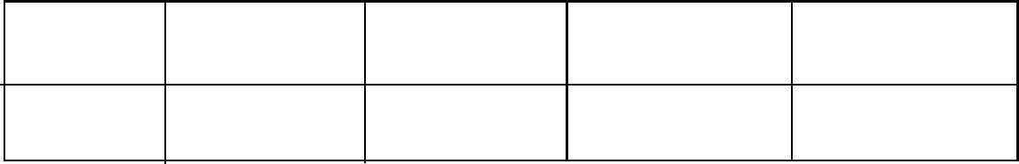

Performance Exceeds Meets Approaching Below

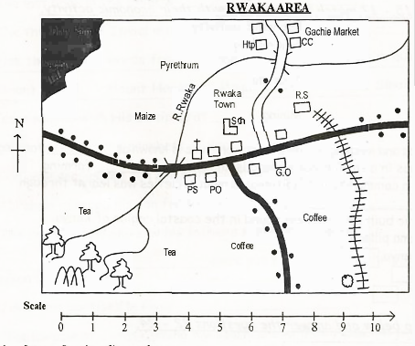
Study' the map of Rwaka area below and answer questions 1 -

1. River Rwaka flows from to _____________________________.
2. The symbol 1111 shows that there is in Rwaka area.
_____________________________.
3. Name two physical features that are found in Rwaka area.
a. _____________________________.
b. _____________________________.

4. People in Rwaka area lives near the _______________.
5. State two economic activities practised by the people of Rwaka area.
a. _____________________________.
b. _____________________________.
6. The border that is drawn around a map is called ______________________________.
7. Kenya is found to the________________ of Ethiopia:
8.Nyika and Yatta are .examples of ________ (plains, plateaus)
9. Name one physical feature that is shared by Kenya, Uganda and Tanzania.
_____________________________.
10. Another name for hot and wet climatic region is ____________________________. (tropical, equitorial)
11.Complete the list
Turkana, Njemps, Iteso, Samburu,_______________
12. Areas with good climate and fertile soils have_____________________________. population.
13. What is apprenticeship? _______________________________________________________________________________________________.•

14. The following are duties of a school administrator.
(i) Prepares and maintains school timetable .
(ii) Maintains school discipline.
(iii)Provide guidance and counselling to pupils.
The school administrator who performs the above duties is ________________________________
For questions 15 - 17 match the resource with their economic activity.
Resource Economic activity
15. Wild life Saw milling
16. Mineral Tourism
17. Forests Mining
18. Growing of crops and keeping of animals for home use is known as________________________ farming.
19. Growing of crops in a small piece of land is known as _____________________ farming.
20. The history of a community in traditional Kenyan societies was learnt through _____________________.

21. Tick the historic built environment found in the coastal region of Kenya.
(i) Vasco da Gama pillar
(ii) Bomas of Kenya
(iii) Koobi Fora
(iv) Fort Jesus.
Study the map below and answer the questions 22 - 24.
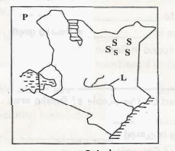
22. The country marked P is known as __________________ .
23. State two importance of the river marked L.
(i)______________________________________.
(ii)_______________________________________.
24. The language group found in the region marked SSS is _________________________________________.
25. Kenya is made up of___________________ counties.

Study the map of Rwaka area below and answer questions 1 -

1. River Rwaka flows from to North-East.
2. The symbol 1111 shows that there is a railway line in Rwaka area.
3. Name two physical features that are found in Rwaka area.
b. river.
c. forest

4. People in Rwaka area lives near the tarmac road.
5. State two economic activities practised by the people of Rwaka area.
a. trading.
b. farming .
6. The border that is drawn around a map is called frame.
7. Kenya is found to the south of Ethiopia:
8.Nyika and Yatta are .examples of plateaus
9. Name one physical feature that is shared by Kenya, Uganda and Tanzania.
Lake Victoria
10. Another name for hot and wet climatic region is equitorial
11.Complete the box
Turkana, Njemps, Iteso, Samburu, maasai
12. Areas with good climate and fertile soils have high population.
13. What is apprenticeship? Traditional method of earning through observation •
14. The following are duties of a school administrator.
(i) Prepares and maintains school timetable.
(ii) Maintains school discipline.
(iii)Provide guidance and counselling to learners.
The school administrator who performs the above duties is deputy head teacher
For questions 15 - 17 match the resource with their economic activity.
Resource Economic activity
15. Wild life Saw milling
16. Mineral Tourism
17. Forests Mining
18. Growing of crops and keeping of animals for home use is known as mixed farming.
19. Growing of crops in a small piece of land is known as subsistence/small scale farming.
20. The history of a community in traditional Kenyan societies was learnt through story telling.

21. Tick the historic built environment found in the coastal region of Kenya.
(i) Vasco da Gama pillar
(ii) Bomas of Kenya
(iii) Kobi Fora
(iv) Fort Jesus.
Study the map below and answer the questions 22 - 24.
22. The country marked P is known as South Sudan .
23. State two importance of the river marked L.
(i) irrigation .
(ii) provide H.E.P.
(iii) Fishing
24. The language group found in the region marked SSS is Cushites.
25. Kenya is made up of 47 counties.

