COMPETENCE BASED CURRICULUM

KENYA PRIMARY SCHOOL EDUCATION ASSESSMENT
GRADE 5

MATHEMATICS ACTIVITIES

Learner’s name:...............................................................................................

School’s Name: .................................................................................................

Assessment No...................................... Date: ...............................................

INSTRUCTIONS TO LEARNER

- Answer ALL the questions in the spaces provided.

Time: 1 hour 30 minutes

FOR OFFICIAL USE ONLY
SCORE GRID

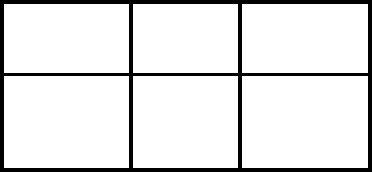
Number of Maximum Candidates’

Questions Score Score
50

ASSESSMENT RUBRICS
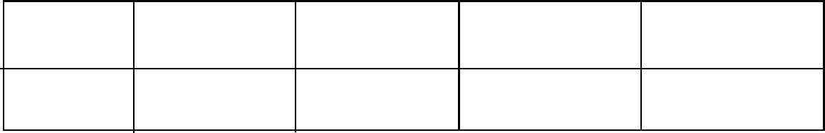

Performance Exceeds Meets Approaching Below

Expectations(4) expectations(3) Expectations(2) Expectations(1)

- The population of people living in a certain county is 686234. What is the place value of digit 4 in the number? (2 marks)

- What is the total value of digit 4 in the number 48021? (2 marks)

- Write the following number in words. 245 396. (2 Marks)

- The mass of millet in kilograms sold by six large scale farmers was:
23 460, 45 850, 17 690, 54 670, 36 420, 84 001
Arrange the mass of millet in a descending order. (2 marks)

- Roundoff the following numbers to the nearest 1000
- 2978 (1 mark)

- 7400 (1 mark)

- 92 346 (1 mark)

- Kennedy had sh 55 to share among his 5 friends equally.
- How much money did each friend get? (2 marks)

- Is sh 55 divisible by 5? (1 mark)

- List the divisors of the number below. (2 marks)
16

- What is the LCM of 9, 8 and 12 (2 marks)

- Add the numbers below (1 mark)

4560 + 345 =

- Subtract the numbers below (1 mark)

32103 – 234 =

- Multiply the following number (1 mark)
34 × 5 =

- Divide (2 marks)

21 ÷ 3

- Convert the following mixed fraction into improper fractions (2 marks)

3 $\frac{1}{3}$

- Convert 123 meters into Centimeters (2 marks)

- Solve the below algebraic equation (2 marks)

2a + 3b+ 4a =

MARKING SCHEME
- 4 –ONES
- 40000
- four hundred and forty five thousands three hundred and ninety six
- 84001,54670,45850,36420,23460,17690
- a) 3000
b) 7000
c) 92400
- a) 11
b) yes
- 2,4,8,16
- 72
- 4905
- 31869
- 170
- 7
- 10/3 or 3 ½
- 123000cm
- 6a+3b

