COMPETENCE BASED CURRICULUM

KENYA PRIMARY SCHOOL EDUCATION ASSESSMENT
GRADE 5

ENGLISH ACTIVITIES
ENGLISH SECTION A

Learner’s name:...............................................................................................

School’s Name: .................................................................................................

Assessment No...................................... Date: ...............................................

INSTRUCTIONS TO LEARNER

- Answer ALL the questions in the spaces provided.

Time: 1 hour 30 minutes
SCORE GRID

ASSESSMENT RUBRICS
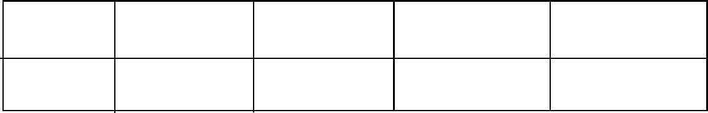

Performance Exceeds Meets Approaching Below

Expectations(4) expectations(3) Expectations(2) Expectations(1)

SECTION I: LISTENING AND SPEAKING.
1 Hygiene and healthy life
A long, long time ago there was a wizard who accidentally invented a rather unusual spell. Whoever the spell was used on would get perfect teeth. As he didn't know what to do with this discovery, the wizard decided to use it on one of his toads. After the spell was cast, the toad became a very smiley happy amphibian. Not only could he now eat all sorts of foods, but he also started speaking.
"I'm delighted with the change", repeated the toad, proudly, "I much prefer the consumption of candy to feeding on filthy flies".
The wizard noticed that the toad was taking little care about choosing what to eat, and he kept telling the toad,
"Look after your teeth, Mr. Toad. Brush them so you don't get a toothache. And, above all, don't eat so many sweets..."
But the toad didn't pay much attention. He thought his teeth were too strong for him to have to brush them, and he liked sweets so much that he didn't even try to eat less.
- What did the Wizard invent?
- How was Mr. Toad to look after his teeth?
- After the spell was cast what did toad turn to.

SECTION II: READING ALOUD
Read the story below fluently
There was once a boy whose parents were the custodians of an impressive old castle. The place was full of old paintings, arms and armour. One day, the boy noticed something strange about one of the main paintings. Normally, it showed one of the old Kings, with sceptre in hand, standing next to his son and some members of the court. But the King had disappeared from the painting.
The boy was very worried by this, and he thought he must have made some mistake; but a while later he walked past the painting once more, and noticed that the sceptre had been left there by the King, and was leaning over. The boy was intrigued. Even more so when, soon after, he saw that the angle of the scepter had increased. At that rate, in a few hours it would end up hitting the Prince on the head. So the boy started looking throughout the castle for the missing King.

MARKING SCHEME
AWARD POINTS ACCORDING TO LEANERS CAPABILITY

