COMPETENCE BASED CURRICULUM

KENYA PRIMARY SCHOOL EDUCATION ASSESSMENT
GRADE 5

CREATIVE ARTS ACTIVITIES

Learner’s name:...............................................................................................

School’s Name: .................................................................................................

Assessment No...................................... Date: ...............................................

INSTRUCTIONS TO LEARNER

- Answer ALL the questions in the spaces provided.

Time: 1 hour 30 minutes

FOR OFFICIAL USE ONLY
SCORE GRID


Number of Maximum Candidates’

Questions Score Score
60

ASSESSMENT RUBRICS


Performance Exceeds Meets Approaching Below

Expectations(4) expectations(3) Expectations(2) Expectations(1)

- What type of pass has been demonstrated below? (1mk)
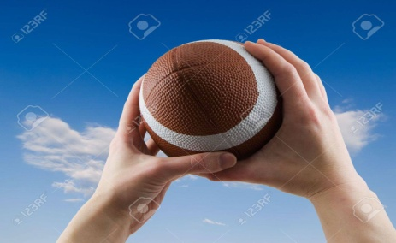

…………………………………………………….
- Observe the picture below and answer the questions that follow
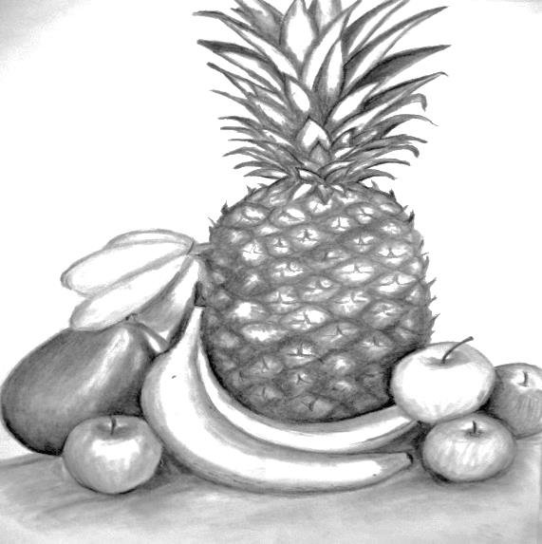

- Name the fruits in the picture (3 marks)

- Identify the technique being used to show light and dark parts In the drawing (1 mark)

- State the fruit that has a smooth surface (1 mark)

- Name the fruit placed in front of the other (1 mark)

- 
What does the picture above show? (1 mark)

- Name the method that has been used in creating the above picture. (2 marks)
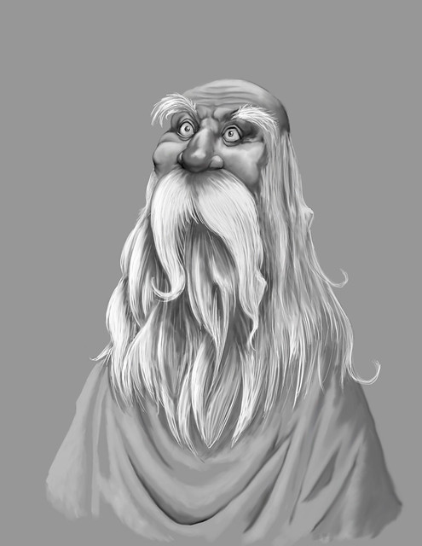

- Use the picture below to answer the questions that follow.

- How do we call the object above. (1 mark)

- Name any three colours in the above-named object (3 marks)

- What colour do we get when we mix the following list of colours (4 marks)
- Red + Yellow =
- Red + Blue =
- Blue + Yellow =
- Red + orange =

- List two items in your locality that are made of leather (2 marks)

- Which method or process is used in making the leather products (1 mark)

- Redraw the following letter graphics. (4 marks)



Project: (20 marks)
- You are required to make and expandable folder to be used for keeping past papers. Refer to the topic Design Media and Technology (Papercraft) to complete the process either at school or at home.
Activity | Marks | Score
Utilization of materials | 2 marks
Application of other art techniques | 3
Proper mounting of art work | 5 marks
Equal measurement of sides (no overlaps) | 5 marks
Completion of the work stepwise | - marks

- List 3 types of passes in soccer (3 marks)

- Below is a method used in transporting injured victim. Name the method (2 marks)
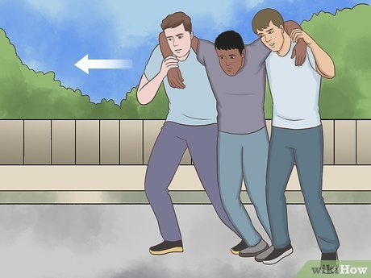

- Below is picture of a tool used during sports.
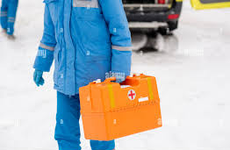

- What is the name? (1 mark)
- Name any three items found inside the tool you have mentioned above. (3 marks)

- Name 2 ailments and injuries that can be treated using the materials in the box. (2 marks)
…………..

- State three stages of a hurdle (3 marks)

- Name any two types of field events (2 marks)

- Below is a method used to start a race in athletics. How do we call this step? (1 mark)
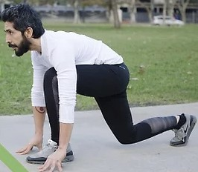
- Name the exercise being shown in the picture. (2 mark)
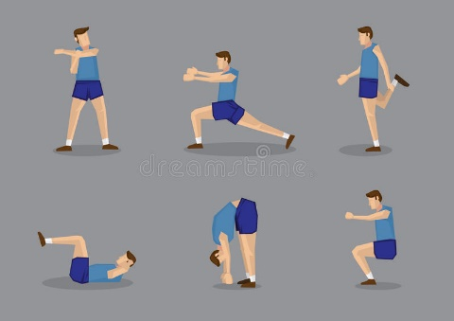
a)

b) How important is the exercise you have mentioned (2 marks)?

- Name one Equipment used in playing frisbee game (1 mark)

PRACTICALS
- You and your classmates are going to be guided by the teacher to demonstrate a handstand balance using a wall within the school. (10 marks)
Score card/Checklist
Activity | Marks | score | Comment on performance
Squat and place hands on the mat shoulder width apart | 2
Hands and the top of the head should form a triangle shape | 2
Raise the knees and extend the legs up | 2
Sit and push backwards to begin roll | 2
Hold the balance for a few minutes | 2

- The loudness and softness of a sound is ……………………………………………………………………………………………………………………………….
- List the 5 aspects of a folk song.
- ……………………………………………………………………………………………………..
- ……………………………………………………………………………………………………..
- ……………………………………………………………………………………………………..
- Write down the four roles of a soloist
- ……………………………………………………………………………………………………….
- …………………………………………………………………………………………………………
- …………………………………………………………………………………………………………
- …………………………………………………………………………………………………………
- State any three messages that can be found in a folk song.
- ………………………………………………………………………………………………………………….
- ………………………………………………………………………………………………………………….
- …………………………………………………………………

MARKING SCHEME
- Overhead pass

- apple, pineapple, banana
- still life drawing
- banana
- pineapple
- tonal gradation trip
- smudge technique( drawing human forms)
- a color wheel
b. blue,purple,orange
c. i. blue
ii. Violet
iii. Green
iv. Red – Orange
- shoes,bags,wallet
- thonging process
- to be based on teachers assessment
- Teacher to refer to the strand: Designed Mixed media and Technology – sub strand: paper craft page 77 (K.L.B Visionary art and craft grade 4 book or any other CBC approved book with the same strand).
- Back heel Pass.
Through Pass.
Give and Go Pass.
Long Pass.
Forward Pass.
One-Touch Pass.
Hospital Pass.
Back Pass.
- crutch method
- a) first Aid kit
b) Plasters in a variety of different sizes and shapes.
- Small, medium and large sterile gauze dressings.
- At least 2 sterile eye dressings.
- Triangular bandages.
- Crêpe rolled bandages.
- Safety pins.
- Disposable sterile gloves.
- Tweezers
c) Minor Wounds.
- Minor Cuts & Scrapes.
- Burns. ...
- Nosebleeds. ...
- Splinters. ...
- Wrist & Ankle Sprains. ...
- Heat Exhaustion & Heatstroke.
- accelerations
Top speed
Decelerations
- Sprints (100m, 200m, 400m)
Middle distance (800m, 1500m)
Long distance (3000m Steeplechase, 5000m, 10,000m)
Hurdles (110/100m, 400m)
Relays (4x100m, 4x400m, mixed 4x400m)

15. Crouch start
16. a) flexibility exercise
b) make you flexible
17. Discs and Frisbees.
- Cleats.
- Shirts.
- Shorts.
- Leggings.
- Sand Socks.
- Compression Wear.
- Gloves
18. award marks according to learners capability
  - pitch

20. Occasions
- Messages
- Instrumentation
- Participants
21. Roles of a soloist in a folk song
- Pitching singers so that they sing without straining
- To cue singers on the change of melody or body movements
- Address the audience while commanding singers
- To coordinate the movements during the performance.
The choral groups/response sings the same tune/ melody throughout the performance of folk song. This referred to as singing in unison
The vocal power of the choral response must match the vocal strength of the soloist
- Folk songs serve the following roles
- Preserves community culture
- Define cultural identity/helps to distinguish one community from the other.
- Used as a medium of communication
- Enhance or strengthen unity or solidarity within the community.
- Enhances conformity to social norms of the community.
- Creates/provides a medium forum of emotional expression

