COMPETENCE BASED CURRICULUM
KENYA PRIMARY SCHOOL EDUCATION ASSESSMENT
GRADE 5

CRE ACTIVITIES

Learner’s name:...............................................................................................

School’s Name: .................................................................................................

Assessment No...................................... Date: ...............................................

INSTRUCTIONS TO LEARNER

- Answer ALL the questions in the spaces provided.

Time: 1 hour 30 minutes
SCORE GRID

ASSESSMENT RUBRICS
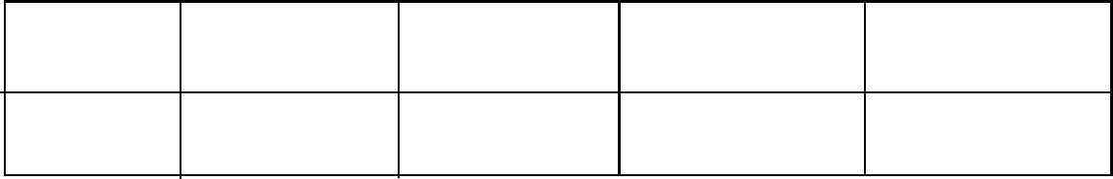

Performance Exceeds Meets Approaching Below

Expectations(4) expectations(3) Expectations(2) Expectations(1)

Strand/Sub strand | Questions | Total marks | Score | Performance Level
Creation
The Holy Bible
The Life of Jesus Christ
Christian Values
TOTAL |  | 50

- Why are we a special creation before God? (2 marks)

- Tell whether its good thought or bad thought.
- Kositany likes helping the poor (1 mark)
- While at break time, Tina sees his friend’s apple and steals it unknowingly. What thought did Tina have? (1 marks)
- Name 3 use of bible in the society . (2 marks)

- give a reason why Jesus was killed (2marks)

- Who led the Israelites to the Promised Land

- a) At Kanyabol primary school, as the children are playing during break time, Onyango gets angry at his friend and decides to fight him. What kind of choice did Onyango make?
b) Name 3 effects of the choice that Onyango Made in fighting his friend(3 marks)

- In the Garden of Eden God gave Adam and Eve responsibilities. What were they to do in the Garden of Eden? (2 marks)
- Christine is a Grade 5 learner at BONDE primary school. She goes to school two days a week and the remaining 3 days he goes to a nearby quarry to work. This is called child (1 mark)

- Name 3 things that might have forced Christine to work in a quarry (3 marks)

- List 2 effects of Christine work at the quarry (2 marks)

- What was the name of the Tax collector? (1 mark)

- The story of the Tax collector teaches us about? (2 marks)

- Give the initial names of the two patriarchs below (2 marks)
- Sarah
- Abraham
- Who announced the birth of Jesus Christ? (1 mark)

- Jesus Christ Healed a man with a blind eye. This shows that Jesus had power over? (1 mark)

- Jesus Christ raised the widows’ only son. This showed that Jesus had power over? (1 mark)

- The parable of the lost coin Teaches us to always show __________ to sinners. (1 mark)

- Apart from the parable of lost coin. Mention 3 other parables that Jesus Christ taught. (3 marks)

- Our body is the temple of the Holy spirit. We should therefore be ________________ (1 mark)
- Honor you father and mother that your days maybe long on earth are commandment number? (2 marks)
- Name two disciples of Jesus Christ during the early Church. (2 marks)

- While using the digital devices, Fatuma on his desk watches pornography on social media on her tablet. How would you advise Fatuma on use the social medial well. (2 marks)

MARKING SCHEME
- we were created in Gods image and likeness
- a) good thought
b) good thought
- to preach in church
Reference
Taking oaths
- to save us from sin
- Moses
- a) unkindness
b) punishment when issue reported to the teacher
injury
- taking care of the creatures
- child labour
- lack of fees
Lack of food
Lack of clothes
Peer pressure
- landslide during mining
Improper syllabus coverage as she will miss taught syllabus
Failing in exams
- zacheous
- to be kind
- a) Sarai
b) Abram
- angel Gabriel
- healing
- death
- forgiveness
- prodigal son
good samarittan
friends at night
parable of the leaven
- holly
- five
- john
Peter
Andrew
- pornographic films causes immorality

