COMPETENCE BASED CURRICULUM

KENYA PRIMARY SCHOOL EDUCATION ASSESSMENT
GRADE 5

AGRICULTURE AND NUTRITION ACTIVITIES

Learner’s name:...............................................................................................

School’s Name: .................................................................................................

Assessment No...................................... Date: ...............................................

INSTRUCTIONS TO LEARNER

- Answer ALL the questions in the spaces provided.

Time: 1 hour 30 minutes
SCORE GRID


Number of Maximum Candidates’

Questions Score Score
50

ASSESSMENT RUBRICS
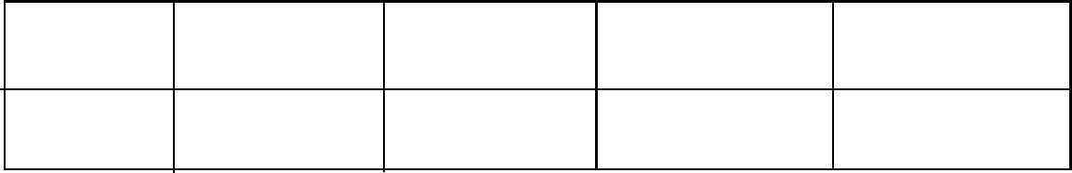

Performance Exceeds Meets Approaching Below

Expectations(4) expectations(3) Expectations(2) Expectations(1)

ANSWER ALL QUESTIONS IN THE SPACES PROVIDED BELOW
- Demonstrate how a runoff occurs through drawing (4 marks)

- List 3 methods used in conserving water during farming (3 marks)

- Name 3 domestic animals and their uses (3 marks)

- Explain 2 ways we can use to scare wild animals without harming them.(4 marks)

- Mention 3 types of crops that are suitable for gardening (3 marks)

- What are some of the ways we can use to care for the container gardens? (3 marks)

- a. name the tools below (3 marks)
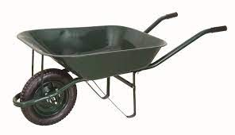

__________________________________
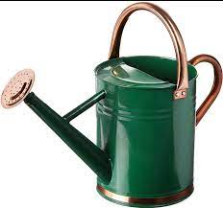

__________________________________

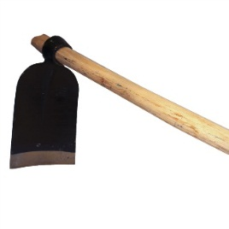

__________________________________

- . State the uses of the above-named tools (3 marks)

- what are the safety measures to be observed when using the above tools? (3 marks)

- Describe any one method we can use to conserve soil ( 2 marks)

- What is thinning? (2 marks)

- Name any three methods you can use to sow seeds on a seedbed (3 marks)

- Name the fruit that the planting material can be obtained through the following materials.
- Seeds (1 mark)

- Stem cuttings (1 mark)

- Name two games played in the locality. (2 marks)

- Name any 3 locally available materials that can be used to improvise play items (3 marks)

- List 3 qualities to consider when choosing play items for a child (3 marks)

- Identify 3 common illness in your locality (3 marks)

- Name 3 causes of illness of in the society (3 marks)

- What is tippy tap used for? (1 mark)

- Using the space provided, draw and colour a tippy tap. (4 marks)

- Name two illnesses in the locality that can prevented by washing hands (2 marks)

- State whether the following situations are healthy or unhealthy practices.
- Eating fruits before washing them ( 1 mark)
- Washing vegetables before cooking (1 mark)
- Drinking contaminated water ( 1 mark)
- Eating soil or soft stones ( 1 mark)
- Opening windows while sweeping the house ( 1 mark)
- Mention 2 ways you can use to care for play items (2 marks)

- Discuss 2 safety measures to be observed while handling play items (2 marks)

Marking scheme
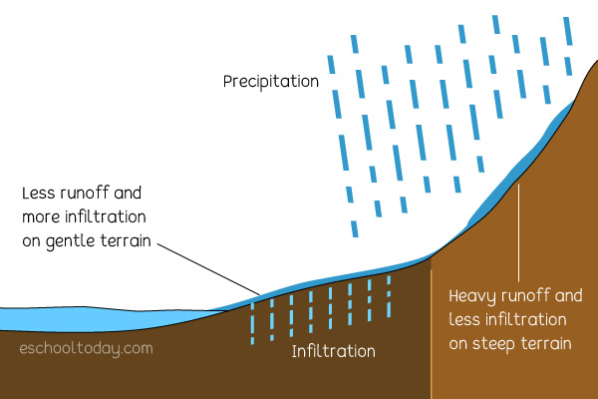

- Runoff occurs when there is more water than land can absorb. The excess liquid flows across the surface of the land and into nearby creeks, streams, or ponds.(award any diagram showing water runoff accordingly)

- dams
Using tanks
Mulching
(Mark relevant points)
- donkey – transport
Dog -security
Cows – milk
Pig – meat
- scarecrows
Fire crackers
Bright lights
Use of dog
- kales
Water melons
Onions
Bean
- pick good container
Provide soil reach in nutrient
Groom and remove dead flowers
fertilize regularly

- .
- wheelbarrow –
- sprinkler
- jembe
- wheelbarrow – transport
sprinkle - watering
jembe - ploughing/digging

- wheelbarrow - grease part movable parts
sprinkle - clean and store after use
jembe - digging
- contour cultivation
crop rotations
Planting cover crops
- thinning – is the removal of excess seedlings from the nursery bed
- dibbling
row planting
broadcasting
drilling
- a)beans/maize/millet
b) sugarcane

- Name two games played in the locality. (2 marks)
Football
Hide and seek
(award marks for any other correct answer)
- Name any 3 locally available materials that can be used to improvise play items (3 marks)
Strings
Old newspapers
Old socks
(award marks for any other correct answer)

- List 3 qualities to consider when choosing play items for a child (3 marks)
appropriate age
child interest
creativity
Identify 3 common illness in your locality (3 marks)

- Stomachache
- Headache
- Coughing
- Name 3 causes of illness of in the society (3 marks)
Drinking untreated water
Wrong use of toilet
Eating without washing hands
(mark any three relevant point)
- What is tippy tap used for? (1 mark)
Washing hands
- Using the space provided, draw and colour a tippy tap. (4 marks)
(award marks accordingly)
- Name two illnesses in the locality that can prevented by washing hands (2 marks)
Stomache
cholera
- State whether the following situations are healthy or unhealthy practices.
- Eating fruits before washing them unhealthy ( 1 mark)
- Washing vegetables before cooking healthy (1 mark)
- Drinking contaminated water unhealthy ( 1 mark)
- Eating soil or soft stones unhealthy ( 1 mark)
- Opening windows while sweeping the house healthy ( 1 mark)
- Mention 2 ways you can use to care for play items (2 marks)
Keeping at a safe place after use
Repair when worn out ( award correct points)
- Discuss 2 safety measures to be observed while handling play items (2 marks)
Balls should be kept after the game
Wash games skits after match

