COMPETENCE BASED CURRICULUM

KENYA PRIMARY SCHOOL EDUCATION ASSESSMENT
GRADE 4

SOCIAL STUDIES ACTIVITIES

Learner’s name:...............................................................................................

School’s Name: .................................................................................................

Assessment No...................................... Date: ...............................................

INSTRUCTIONS TO LEARNER

- Answer ALL the questions in the spaces provided.

Time: 1 hour 30 minutes

FOR OFFICIAL USE ONLY


Number of Maximum Candidates’

Questions Score Score
50

ASSESSMENT RUBRICS
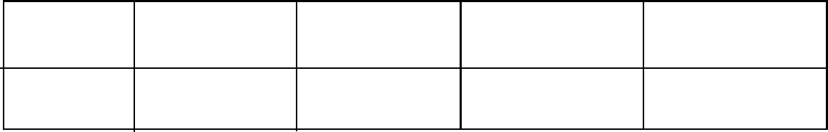

Performance Exceeds Meets Approaching Below

Expectations(4) expectations(3) Expectations(2) Expectations(1)

- Name the four cardinal points of a compass (4 marks)

- State 3 uses of a compass (3 marks)

- What is the direction of Grade 4 class from the school gate? (1 mark)

- a. what is the name of your county? (1 mark)

b.Name 3 other counties that border your county. (3 marks)

- Name 3 rivers that are found in your county (3 marks)

- How many seasons are there in a year? (1 mark)

- Write down the names of the seasons (4 marks)

- How should we conserve physical features in the following situations?
- A river full of waste products dumped inside.(2 marks)

- A forest whose trees have been cut down (2 marks)

- Discuss the activities that farmers do during the following seasons
- Dry season (1 mark)
- Wet season ( 1 mark)
- Rainy season ( 1 mark)
- Draw a compass point with the four cardinal points (3 marks)

- We grow rice in our county. We (buy, sell) to other counties (1 mark)
- Who do we depend on to make our school uniforms? (1 mark)
- During Madaraka Day Celebrations, grade 4 learners saw the following president addressing the people. What is his name?
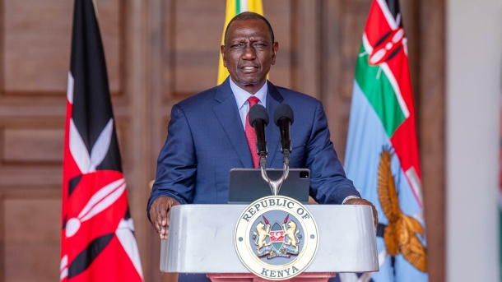……………………………………………………………………………………………..

- Describe the population distribution as shown in the pictures (6 marks)
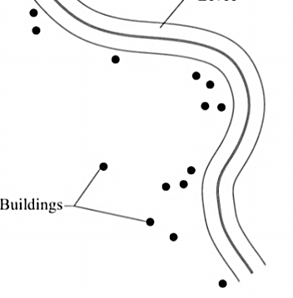
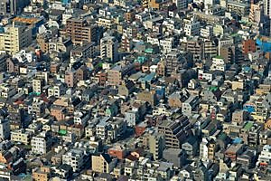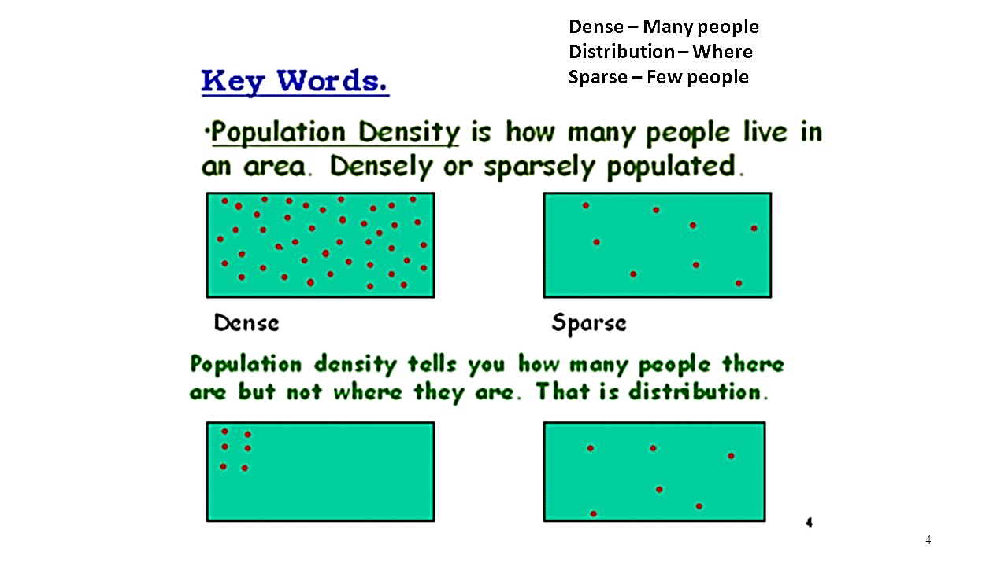
…………………………………………………………

- Name the following features ( 8 marks)
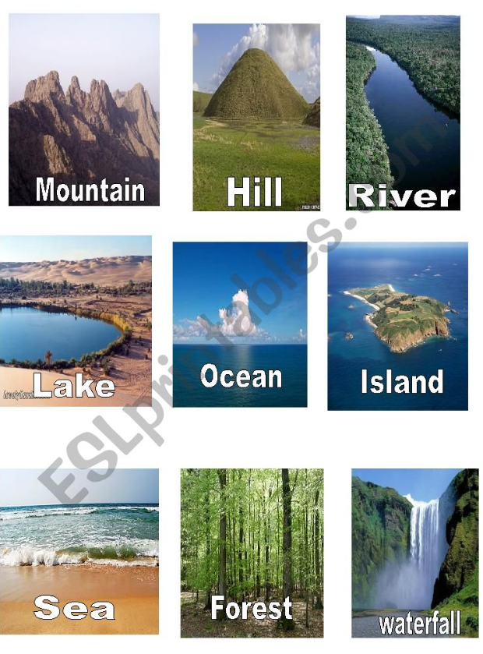

- Grade 4 learners visited a certain cultural centre ad saw the following cultural house.it is called …………………………………………………………………………..

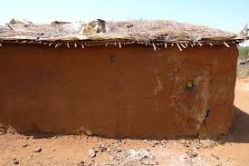

MARKING SCHEME

- Name the four cardinal points of a compass (4 marks)
- North
- South
- East
- West
- State 3 uses of a compass (3 marks)
To show direction
Navigation
Location
- What is the direction of Grade 4 class from the school gate? (1 mark)
(Award accurate answer)
- a. what is the name of your county? (1 mark)
Award for the correct answer
b.Name 3 other counties that border your county. (3 marks)
- Award for the correct answers
- Name 3 rivers that are found in your county (3 marks)
- Award for the correct answers
- How many seasons are there in a year? (1 mark)
4 seasons

- Write down the names of the seasons (4 marks)
Summer
Winter
Autumn
Spring
- How should we conserve physical features in the following situations?
- A river full of waste products dumped inside.(2 marks)
Removing the waste
- A forest whose trees have been cut down (2 marks)
Planting more trees
- Discuss the activities that farmers do during the following seasons
- Dry season ploughing (1 mark)
- Wet season weeding ( 1 mark)
- Rainy season planting ( 1 mark)
- Draw a compass point with the four cardinal points (3 marks)
Award accordingly
- We grow rice in our county. We SELL (buy, sell) to other counties (1 mark)
- Who do we depend on to make our school uniforms? PARENTS
(1 mark)
- H.E Dr.Wiliam Samoei Ruto
- Describe the population distribution as shown in the pictures (6 marks)
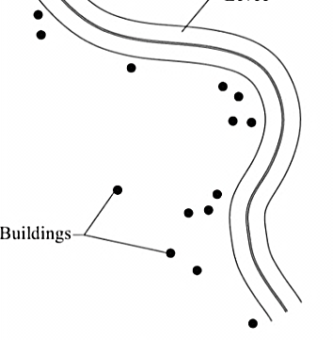
Densily linear

Sparsely

- Name the following features ( 8 marks)

- manyatta

