COMPETENCE BASED CURRICULUM

KENYA PRIMARY SCHOOL EDUCATION ASSESSMENT
GRADE 4

SCIENCE AND TECHNOLOGY ACTIVITIES

Learner’s name:...............................................................................................

School’s Name: .................................................................................................

Assessment No...................................... Date: ...............................................

INSTRUCTIONS TO LEARNER

- Answer ALL the questions in the spaces provided.

Time: 1 hour 30 minutes

FOR OFFICIAL USE ONLY


Number of Maximum Candidates’

Questions Score Score
50
ASSESSMENT RUBRICS


Performance Exceeds Meets Approaching Below

Expectations(4) expectations(3) Expectations(2) Expectations(1)

- Farmers keeps cows for…………………….. and ……………………..( 2mks )
- The diagram below indicates …………………………. Weather Day(1mk)
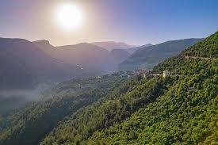
- The part of a computer shown below is …………………….. (1mk)

- Animals with backbones are called ………………………….. (1mk)
- Name four characteristics of plants as a living thing (4mks}
- …………………………………………………………
- …………………………………………………………
- …………………………………………………………
- ………………………………………………………...
6 name one example of a dental disease…………………………………………..(1mk)
7 Name three uses of water at home (3mks)
- …………………………………………………….
- …………………………………………………….
- ………………………………………………………
- We clean our hands with …………………………………………. And ………………………………… (2mks)

- The doctor who treats our teeth is called……………………………… (1mk)

- Objects that floats on water are called ……………………………(1mk)

- Name three examples of invertebrates and vertebrates

invertebrates | vertebrates

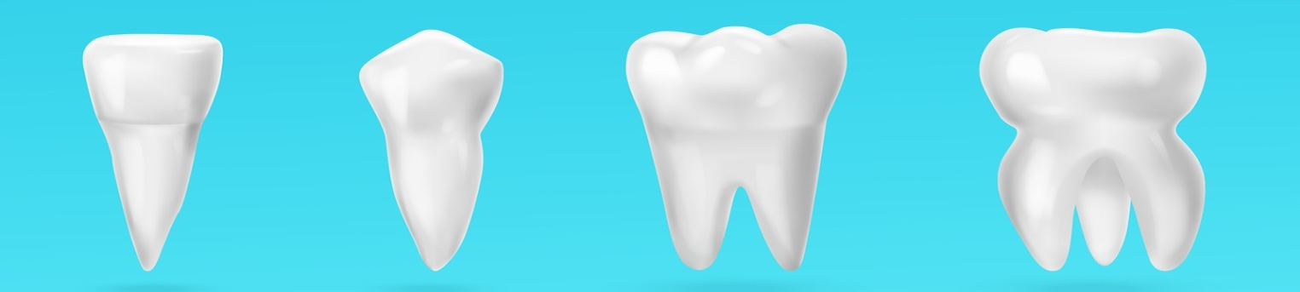
- How many teeth does a grown-up human being have in total?............................ (1mk)
- Name the following types of teeth ( 4 mks )

- Name the four environmental pollutants.(4mks)
- …………………………………..
- ………………………………….
- ……………………………………
- …………………………………….
- Name four sense organs (4mks)
- …………………………………………..
- ……………………………………………
- …………………………………………….
- …………………………………………….
- Moving air is called ………………………… (1mk)
- . Which characteristic do this animal possess as a living organism.……………………………………………..(1mk)

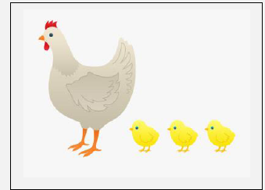

- . Define the term digestion …………………………………………………………………………………………………………………………………………………………………………………………………………(1mk)

- . When we breathe in, the chest moves …………………………. (1mk)
- . Digestion begins in the ………………………….. And ends at ………………………….. (2mks)
- . Name the parts of the digestive system (5mk)
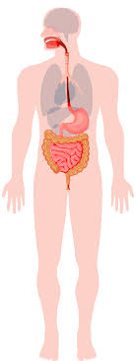

Marking schemes
- Farmers keeps cows for…meat. and ……milk ( 2mks )
- The diagram below indicates …sunny Day (1mk)
- Monitor/screen (1mk)
- Animals with backbones are called vertebrates (1mk)
- Name four characteristics of plants as a living thing (4mks}
Reproduce
Movement
Irritability
Excretion
- Gingivitis,dental carries,bad smell,tooth decay,etc (1mk)
- Name three uses of water at home (3mks)
Domestic use
Watering crops
(Award any correct domestic use)
- Clean warm water and soap and cleaning towel.
- dentist
- floaters
- must be named accordingly1mk)

- 32
- Incisor, canine, premolar, molar
- Sewage,smoke,pesticides,chemicals,oil,etc
- Mouth,skin,ear,tongue,eye
- Moving air is called …wind (1mk)

- . Which characteristic do this animal possess as a living organism.reproduction..(1mk)

- . Define the term digestion
Break down of food into smaller particles which can easily be absorbed by the body (1mk)
- . When we breathe in, the chest moves ……upward (1mk)
- . Digestion begins in the ……mouth And ends at ……small intestine . (2mks)
- . label the parts correctly (5mk)
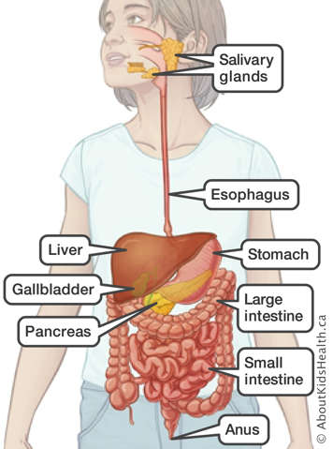
(Award 5 marks accordingly)

